Supplementary Materials

Supplementary Table 1：The means, SD, skewness and kurtosis of SWB items.
Supplementary Figure 1：Estimation of node strength differences by bootstrapped difference test.
Supplementary Figure 2：Estimation of node closeness differences by bootstrapped difference test.
Supplementary Figure3: Estimation of edge weight differences by bootstrapped difference test.
Supplementary Figure 4：Network Analysis of Subjective Well-being of high School Boys.
Supplementary Figure 5：Network Analysis of Subjective Well-being of high School girls.
Supplementary Figure 6：Node strength based on subgroups by gender.
Supplementary Figure 7：Network analysis of rural high school students' subjective well-being.
Supplementary Figure 8：Network analysis of urban high school students' subjective well-being.
Supplementary Figure 9：Node strength based on subgroups by residence.

Supplementary Table S1: The means, SD, skewness, and kurtosis (n = 4,282)
Item | Means | SD | Skewness | kurtosis
SWB-1 | 4.080 | 1.254 | 0.178 | -0.800
SWB-2 | 3.640 | 1.003 | -0.395 | -0.116
SWB-3 | 4.410 | 1.050 | -0.565 | 0.486
SWB-4 | 4.230 | 1.295 | -0.700 | 0.146
SWB-5 | 3.460 | 1.102 | -0.444 | -0.264
SWB-6 | 3.360 | 1.090 | 0.159 | -0.853
SWB-7 | 3.920 | 1.004 | -0.692 | -0.182
SWB-8 | 4.310 | 1.231 | -0.735 | 0.562
SWB-9 | 3.510 | 1.356 | 0.247 | -0.521
SWB-10 | 4.970 | 1.219 | -1.296 | 1.331
SWB-11 | 3.510 | 1.372 | 0.075 | -0.865
SWB-12 | 4.430 | 1.260 | -0.753 | 0.117
SWB-13 | 3.950 | 1.416 | -0.309 | -0.869
SWB-14 | 4.170 | 1.219 | -0.521 | -0.287
SWB-15 | 2.630 | 2.845 | 0.999 | 0.222
SWB-16 | 4.870 | 2.688 | 0.121 | -0.443
SWB-17 | 6.520 | 2.677 | -0.476 | -0.327
SWB-18 | 6.720 | 2.572 | -0.491 | -0.2

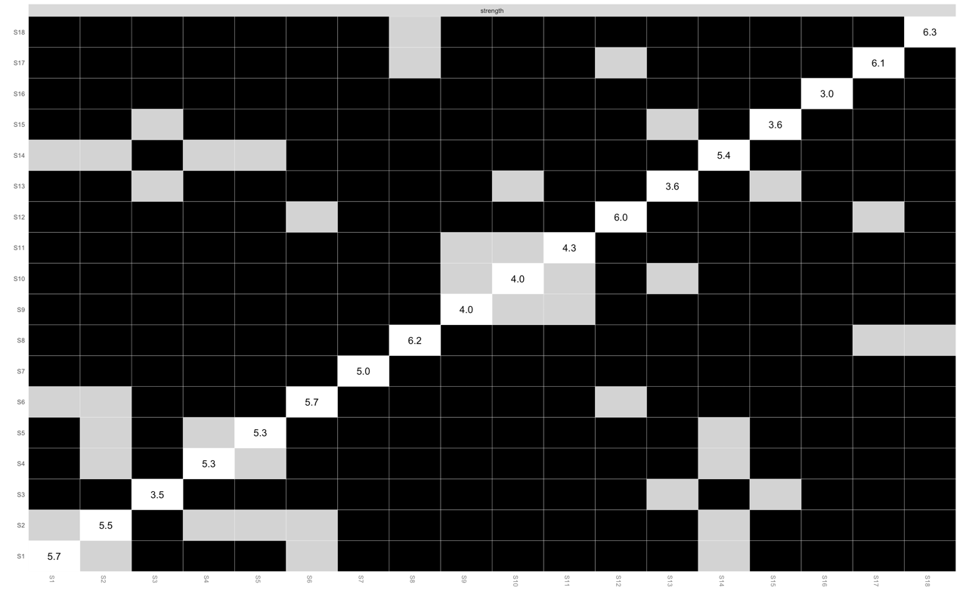
Supplementary Figure 1: Estimation of node strength differences by bootstrapped difference test
Note: Nonparametric bootstrapped difference test for strength. Gray boxes indicate no difference between nodes, whereas black boxes indicate significant difference (α = 0.05). Values reported in the diagonal represent the strength values of each node.

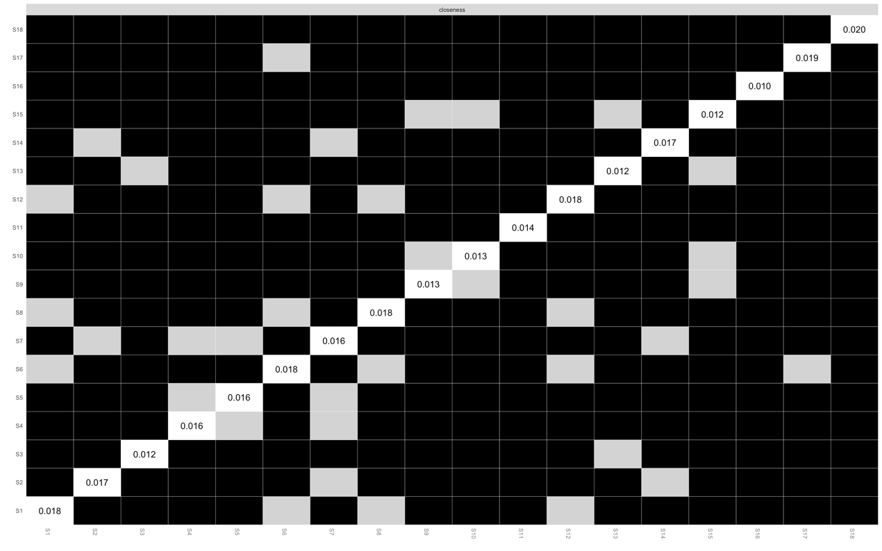
Supplementary Figure 2: Estimation of node closeness differences by bootstrapped difference test
Note: Nonparametric bootstrapped difference test for closeness. Gray boxes indicate no difference between nodes, whereas black boxes indicate significant difference (α = 0.05). Values reported in the diagonal represent the strength values of each node.

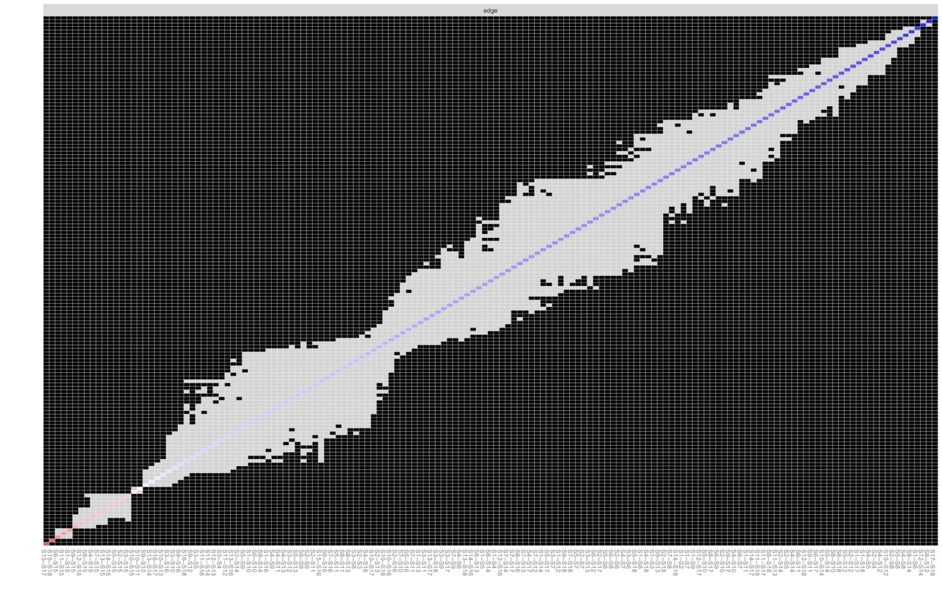
Supplementary Figure3: Estimation of edge weight differences by bootstrapped difference test
Note: Nonparametric bootstrapped difference test for edge weight. Gray boxes indicate no difference between nodes, whereas black boxes indicate significant difference (α = 0.05). Values reported in the diagonal represent the strength values of each edge.

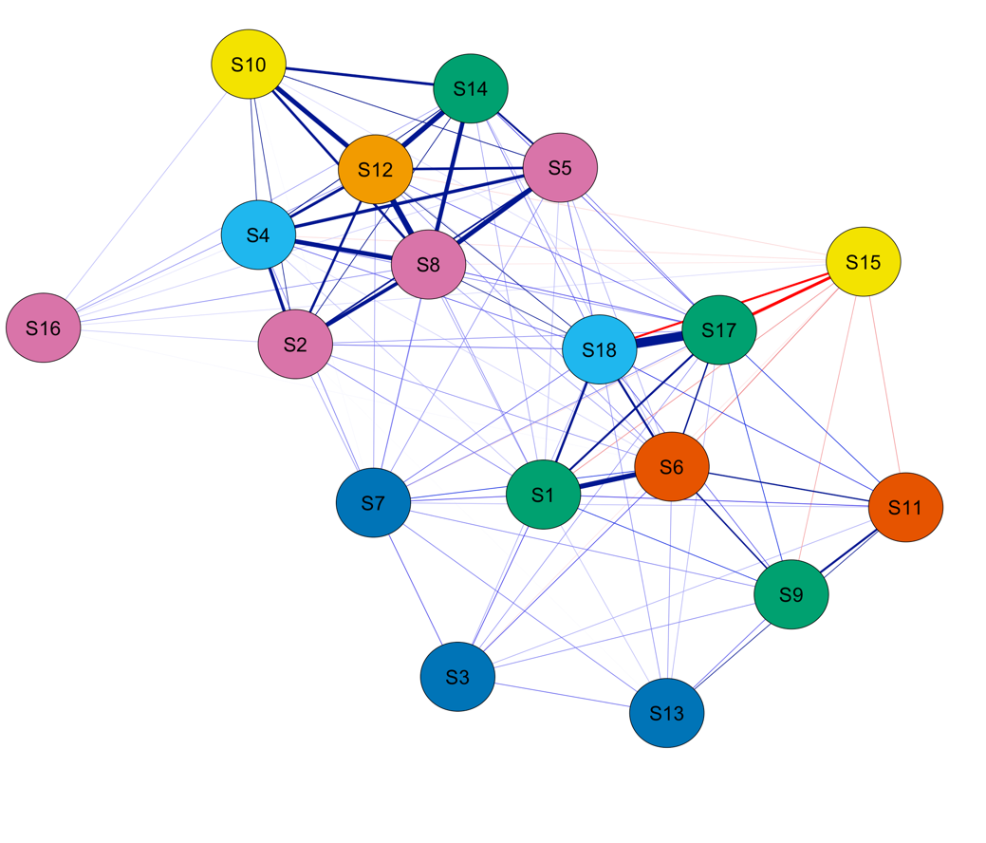
Supplementary Figure 4: Network Analysis of Subjective Well-being of high School Boys
Note：S1: How have you been feeling in general, S2: Have you been bothered by nervousness or you “nerves”, S3: Have you been in firm control of your behavior, thoughts, emotions or feeling, S4: Have you felt so sad, discouraged, hopeless, or had so many problems that you wondered if anything was worthwhile, S5: Have you been under or felt you were under any strain, stress, or pressure, S6: How happy, satisfied, or pleased have you been with your personal life, S7: Have you had any reason to wonder if you were losing your mind, or losing control over the way you act, talk, think, feel, or of your memory, S8: Have you been anxious, worried, or upset, S9: Have you been waking up fresh rested, S10: Have you been waking up fresh and rested, S11: Has your daily life been full of things that were interesting to you, S12: Have you felt down-hearted and blue, S13: Have you been feeling emotionally stable and sure of yourself, S14: Have you felt tired, worn out, used-up, or exhausted, S15: How concerned or worried about your health have you been How much do you care or worry about your health, S16: How relaxed or tense have you been, S17: How much energy, pep, vitality have you felt, S18: How depressed or cheerful have you been. The same below.
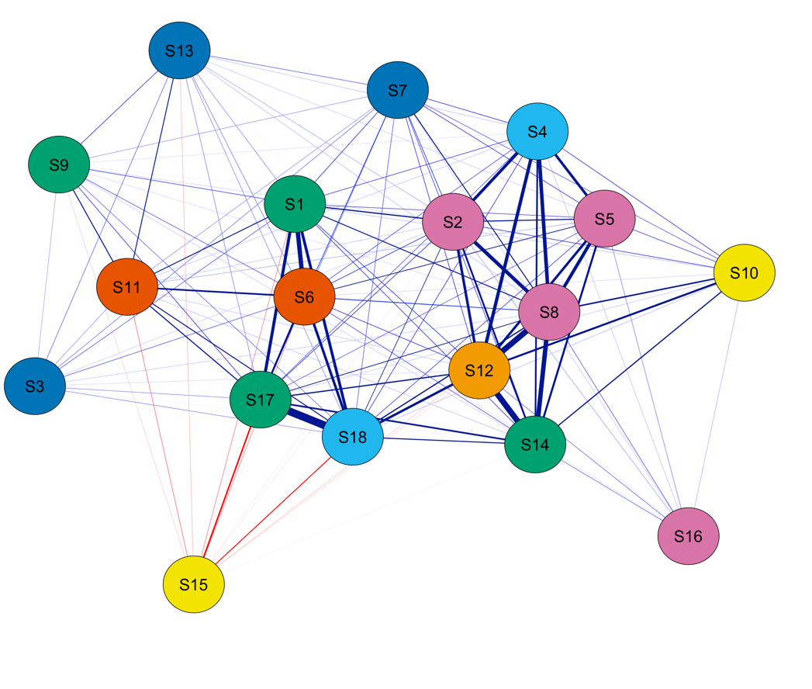
Supplementary Figure 5: Network Analysis of Subjective Well-being of high School girls

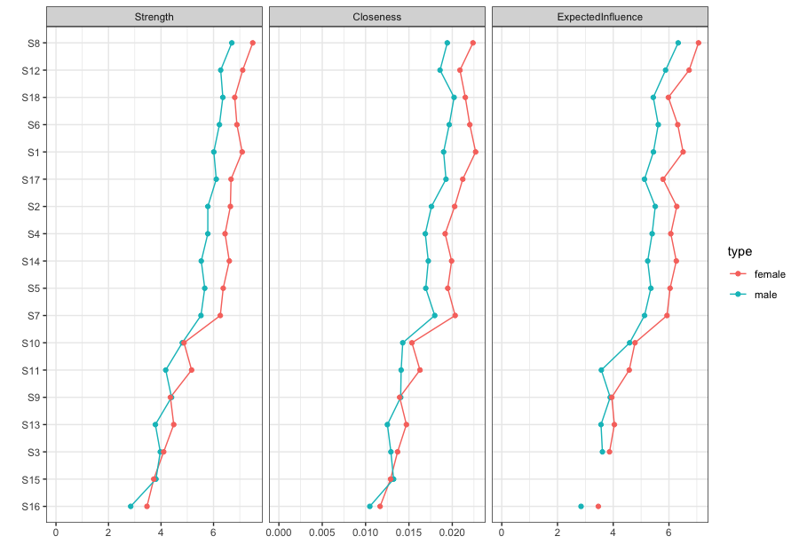

Supplementary Figure 6: Node strength based on subgroups by gender

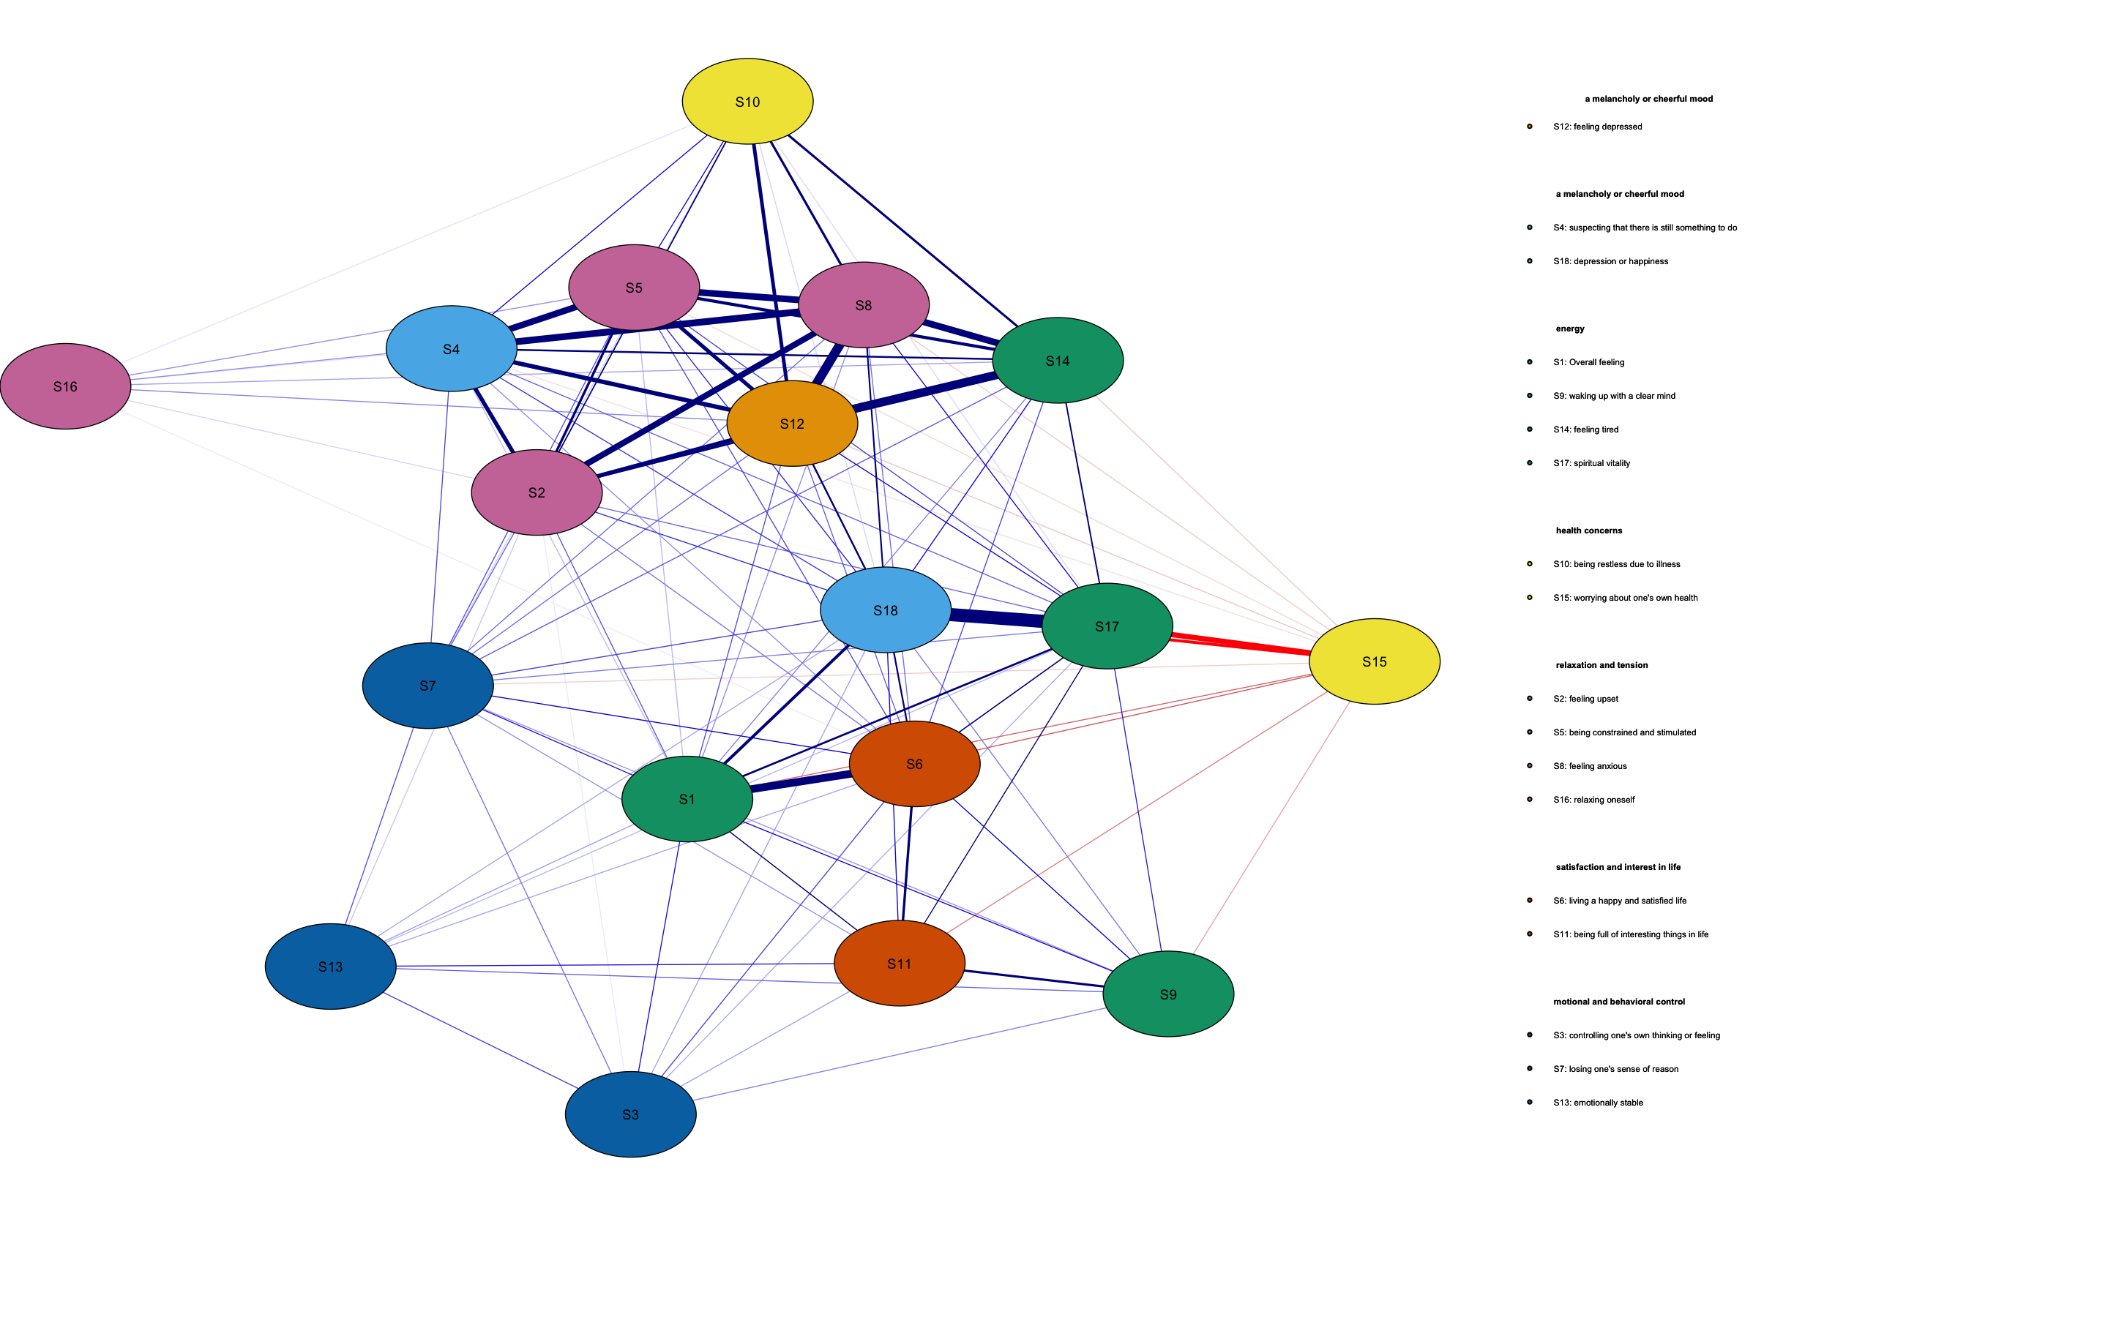
Supplementary Figure 7：Network analysis of rural high school students' subjective well-being.

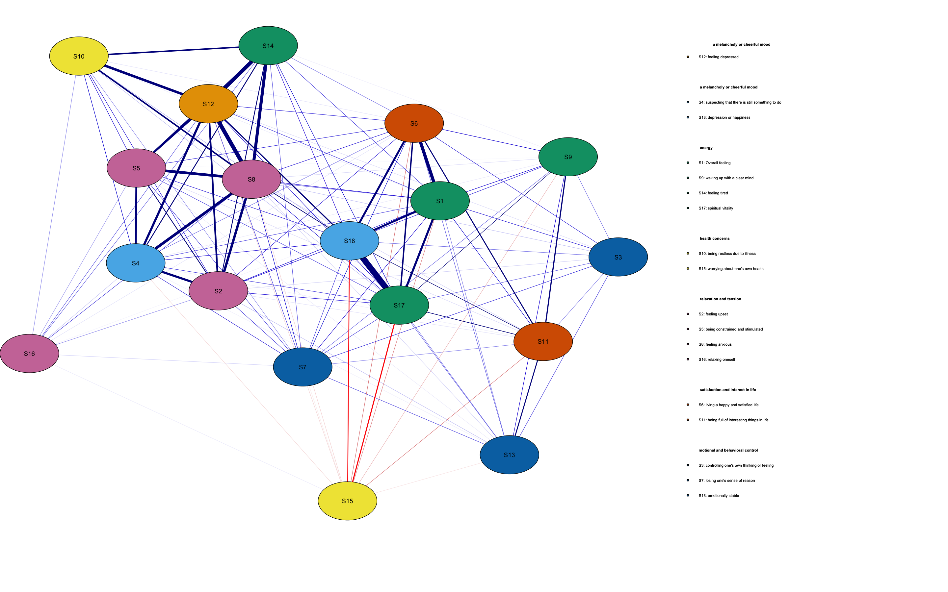
Supplementary Figure 8：Network analysis of urban high school students' subjective well-being.

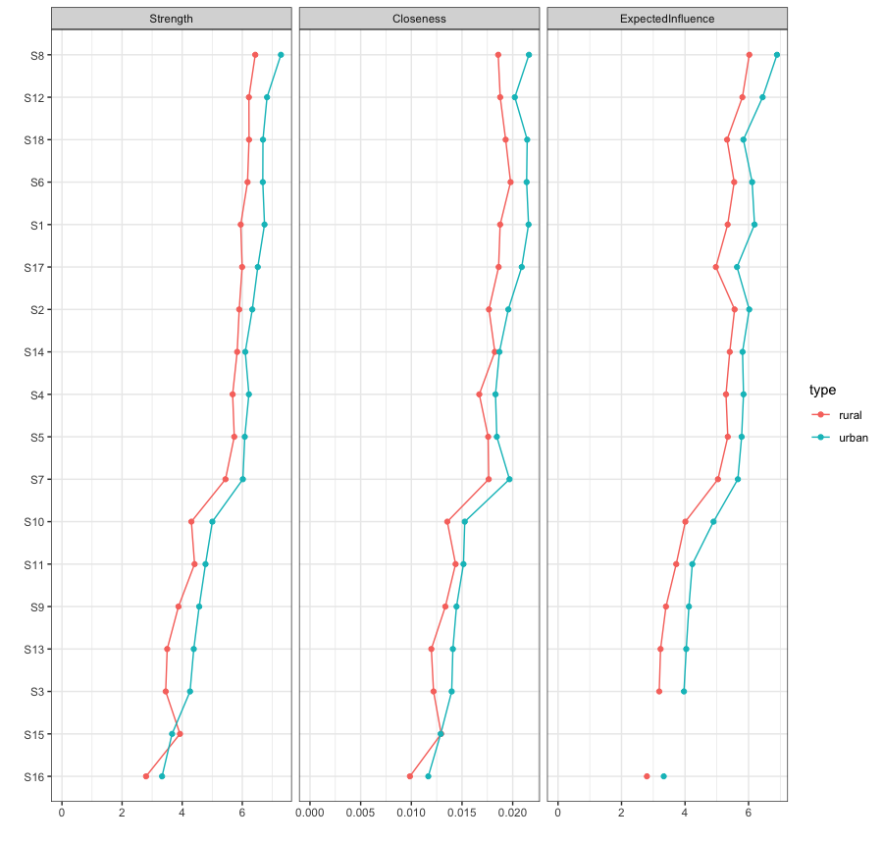
Supplementary Figure 9：Node strength based on subgroups by residence.

