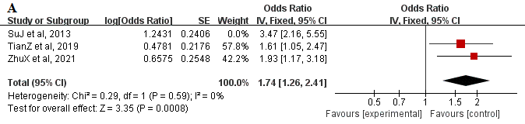
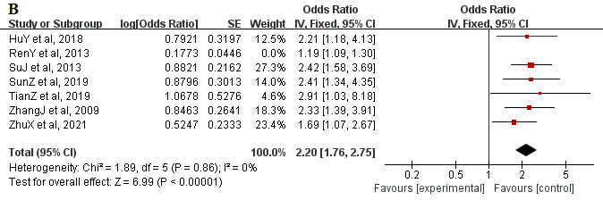
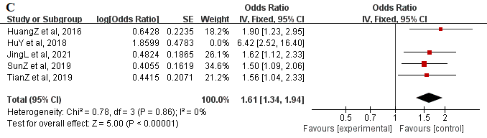
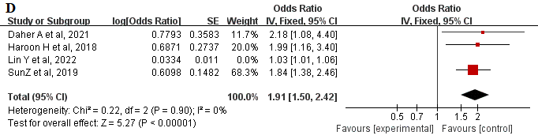
Supplementary figure 1. Sensitivity analysis of risk factors for neck pain in college students (A:Improper use of the pillow, B:Improper sitting posture, C:Staying up late, D:High stress)

