Supplementary File 5.
Evidence Review Results and Inclusion/Exclusion Criteria

Table of Contents
Review One – Public Acceptability of Local Climate Change Mitigation Actions Public
Review Two – Understanding of the Impact of Climate Change on Health
Review Three – Cost Effectiveness and Budgetary Implications of Climate Change Mitigation
Included Studies Tables
PRISMA Diagrams
Inclusion/Exclusion Criteria
References

Review One – Public Acceptability of Local Climate Change Mitigation Actions
Overview
110 research studies (based on 117 publications) were found dealing with public acceptability of local action related to climate change (for PRISMA diagram, see Figure 7). Figure 1 demonstrates the broader categories within which these studies have been placed, highlighting the relative abundance of studies looking at the public acceptance of energy-related and recycling action. Figure 2 shows the location of studies that stated the town or city in which the participants were recruited, across Great Britain and Northern Ireland. An account of included studies can be found in Table 1.

Figure 1. Pie chart showing broader categories of included studies (Other category includes the subcategories Pollution, Planning, Finance, and Policy).

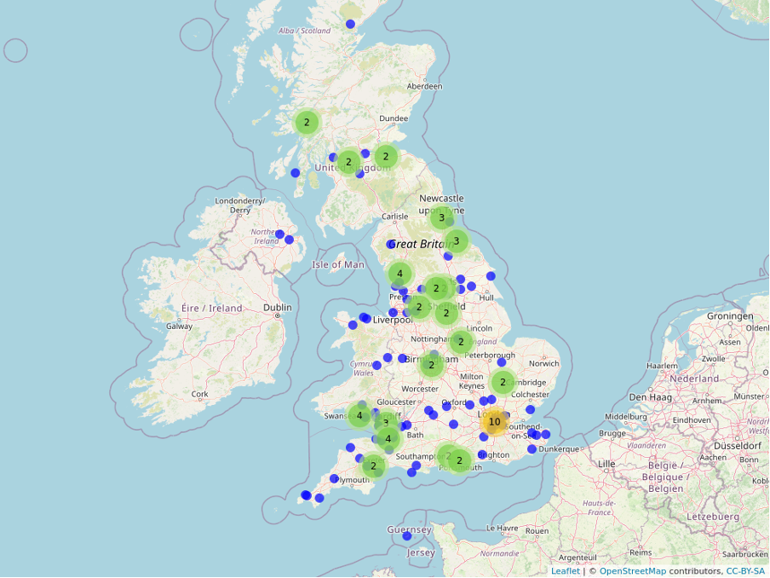
Figure 2. Location of included studies across the UK.
The majority of studies found looking at the public acceptability of local action that relate in some way to climate change are based on energy sources and renewable energy development siting. Figure 3 shows the location of these studies in the UK. Studies around wind power and wind turbines were the most common (n=20), followed by bioenergy or biomass (n=4), blue energy (wave or tidal, n=3), and solar power (n=2). Two further studies looked more broadly at renewable energy in their studies. Alternative and fossil fuel sources of energy are also explored for their public acceptance, including around nuclear (n=4), hydrogen (n=3), shale gas extraction (n=6), and coal (n=1).
Further studies, in the area of energy use and infrastructure, relate to the acceptability of high voltage pylons (n=5), local carbon capture and storage (n=8), reduced street lighting (n=1), and energy efficiency schemes in the home (n=1). With only one study each on the latter interventions – reduced street lighting and energy efficiency in the home – and given their potential for health impact, these mark potential gaps of note for the NIHR. In addition, neither engages with the impact of socio-economic status or ethnic group on their findings – the need for which was foregrounded by the survey of Directors of Public Health more generally.

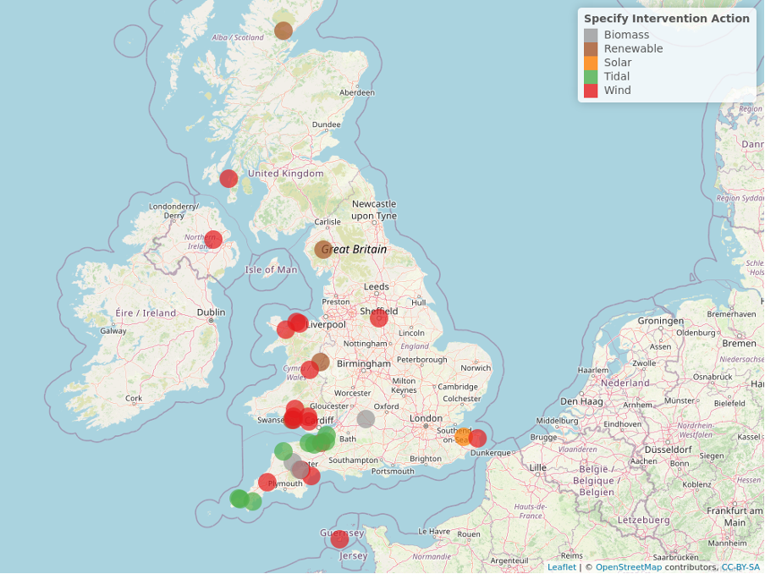
Figure 3. Map demonstrating locations of energy siting-related studies in the UK.
A relatively large number of included studies explore existing recycling schemes. These make up the bulk of recycling studies, with 61% of recycling studies covering acceptability of a recycling scheme. Despite this, our other search highlights that there is very little, if any, economic evaluation of recycling schemes. In addition, while there is a relative abundance of studies compared to other interventions, 16 of the 20 included studies (80%) in this area were published between 2000 and 2010, with potential scope for studies to demonstrate more up-to-date analyses. Only seven of these studies included a break down by other variables, such as socio-economic status or ethnic group, demonstrating the need for analysis of how public acceptability of recycling schemes are stratified by other factors.
A number of studies in our search sit in the area between transport and pollution, which may be of direct interest to a variety of NIHR groups. A collection of publications look at the use of air quality information (e.g. uptake, presentation, interpretation, and impact on behaviour), all of which are based on English populations or broader survey data from the UK as a whole (without any meaningful breakdown). There is therefore a gap in studies of air quality information use in Wales, Scotland and Northern Ireland. In addition, none of these studies separate their findings by any socio-demographic or socio-economic variable, indicating another gap in the stratified utilisation of such technologies.
Very few studies were located at the transport-pollution nexus, but those that were included two looking at clean air or low emission zones (covering England and Scotland), two exploring public acceptability of congestion charges (covering England and Scotland), one looking at road pricing (in an English setting), and one more looking at traffic demand management more broadly (in an English setting). There is little coverage, therefore, of Wales and Northern Ireland in the small amount of research available. While the clean air zone research separated its findings by socio-demographic variables (including age, ethnic group, and employment status), and the road pricing studies did so by age, none of the other studies in this area provided a meaningful breakdown that demonstrated the stratification of public acceptability, indicating a clear gap.
Three other interventions within this general theme, with little traction in the research, are also worth highlighting due to their potential relevance to the NIHR. One study exists on vehicle idling, in England, with the intervention being appealing to the self-interest (and therefore shared moral inclinations) of idling drivers. Another is around the public acceptability of speed restrictions in local areas, for which there are two studies (Scotland and Northern Ireland). A final study of interest is around acceptability in relation to banning diesel engines, based in Wales. None of these studies - around idling (or (dis)incentivising the practice), speed restrictions, or the banning of polluting engines - explore how their findings relate to socio-demographic or socio-economic factors. This, and the fact that there are very few studies, indicate significant gaps for potentially relevant areas.

Review Two – Public Understanding of the Impact of Climate Change on Health
Overview
27 research studies (based on 30 publications) – a relatively small amount of research – were found (for PRISMA diagram, see Figure 8) based in the UK looking at perceptions of the impact of climate change or a climate-related exposure on health, with the majority of this being undertaken within English settings. An account of included studies can be found in Table 2.
The outcome of this search demonstrates the need for more research in the area. Only six studies explore the perceptions of the health impacts of climate change more broadly (see Figure 4). Of these, three explore health only as a secondary objective (Parry et al., 2022; Steentjes et al., 2020; Taylor et al., 2019) and two, with more open-ended methodologies, only include health as part of their findings (Darier & Schüle, 1999; Lorenzoni et al., 2006). Both of these latter two studies use data split with other nations than those in the UK. Only one study (Hilary Graham et al., 2019) explores specifically the relationship between climate change and health, though this as part of a contingent valuation methodology, demonstrating a gap of textual and contextual studies looking at perceptions specifically of health impacts. This is particularly the case given that research shows a potentially positive impact of a health framing of climate change across various publics (Dasandi et al., 2022; Myers et al., 2012; Rossa-Roccor et al., 2021), something that may be relevant to local authorities.

Figure 4. Number of studies researching climate change more broadly and/or specific exposure by health focus within article
Six studies also looked at public perceptions of heatwaves, half of which treated health as their primary objective, the other half as a secondary objective. Papers looking at flooding (n=7, 26% coverage across all studies) predominantly treated health as a secondary objective (n=7, 26%), with only two papers exploring health as their primary objective. The importance of health in relation to flooding in the perception of the public is clear with one study treating health as part of its findings. Only one study looked at infectious diseases and did so with health as its primary focus. 12 studies (44%) looked at the public’s perception of air pollution as a health concern, with six of these treating health as its primary focus, four as its secondary objective, and two with health as implicit, despite a lack of naming “health” per se. Where climate-related exposures are the key component of the study, more research is needed based on the extent to which the public connect this to climate change.

Figure 5. Annual number of studies looking at specific exposure or climate change more broadly
Figure 5 demonstrates that these studies are not evenly distributed over time. For example, comparing with pre-2010, there have been fewer studies looking at public perceptions of air pollution in relation to health, while there have been a greater number looking at public perceptions of heatwaves and flooding.
In terms of national coverage, England is covered by 16 of the studies (59% of all studies), Wales by three (11%), and Scotland by just one (4%). Northern Ireland had no coverage across the studies. Nine studies (33%) were broader studies covering the UK more generally. This is demonstrated in Figure 6. Figure 7 shows more detail regarding where in those nations, in cases where a specific sample is reported, these studies took place. It is clear from Figure 6 that there is a lack of research within Scotland, Wales, and Northern Ireland. It is also clear from Figure 7 that London is overrepresented, while places such as mid-Wales, the Southwest of England, and the Midlands are also poorly represented.

Figure 6. Coverage of UK nations in studies looking at public perceptions of health and climate change or climate-related exposure.
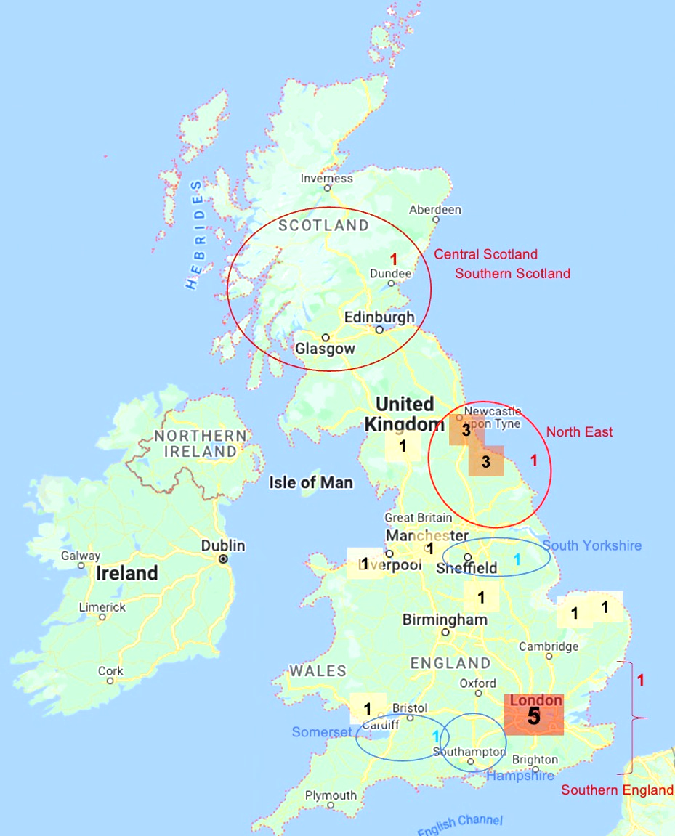
Figure 7. Map of study locations across the UK (circles indicate broader catchment areas, with blue circles indicating county and red circles indicating a still broader area).
In terms of methodology, 17 studies used questionnaires (63%), nine studies used interviews (3% of all studies), three used focus groups (11%), and two used contingent valuation methods (7%, e.g. willingness to pay). With the majority of studies using closed question-based methods, there is a clear gap of in-depth qualitative studies to build a meaningful profile of why particular groups are more or less likely to engage with climate change and climate-related exposures as a health issue.
Of those that used interview or focus group data, three studies sampled purposefully across different socio-economic groups or levels of deprivation (Abrahamson et al., 2009; J. Bush et al., 2001; Day, 2007). Further indicators of socio-economic status include: income or financial strain, covered by four studies (15%); educational attainment, also covered by four studies (15%); employment status, covered by one study; and housing tenure, also covered by one study. In all, eight studies (30%) cover socio-economic status in some, by no means homogenous, way. Three studies look specifically at different age groups, meaning that this variable is built into their sample (Abrahamson et al., 2009; Myers et al., 2004; Walkling & Haworth, 2020). Nine other studies separate their findings by age in some way, whether by “generation”, age, or age group. Seven studies separate out their findings by gender. Only one study (Khare et al., 2015) incorporates ethnicity (and this as a binary variable) into its study.

Review Three – Cost Effectiveness and Budgetary Implications of Climate Change Mitigation
Overview
Very little research has explored the short-, medium-, or long-term budgetary implications of climate change mitigation and adaptation or measured the health and non-health costs and benefits of investing in climate change mitigation (see Table 3). Given how few relevant studies emerged in the review, two searches were combined. For the PRISMA diagram, see Figure 10.
In total only five studies were identified which attempted to quantify either the cost-effectiveness of climate change mitigation actions or their budgetary implications. There was no evidence which measured short-, medium-, or long-term impacts on local authorities, or other local level UK decision-making entities, despite calls for more information from the Directors of Public Health when surveyed.
The five economics studies attempted to quantify either cost-effectiveness or the cost-benefit of a climate mitigation action compared to a do-nothing option. The climate-related exposures within these studies related to waste management, ecology restoration, home energy, air pollution, and transport.
Each of these studies used data from local changes/initiatives, two of which were London-based, but all attempted to generalize findings across the UK narratively and not quantitatively.
All but one study, relating to waste management, included a limited time horizon to quantify comparative costs and outcomes, likely resulting in an inaccurate understanding of the cost-effectiveness of the various climate actions.
All five studies were UK based, with 2/5 conducted in London and the remaining three in Wales, Cambridge and Milton Keynes. Locations seem to be based on what local initiatives exist rather than explicit consideration of the generalisability of the study site. Furthermore, none of the studies explicitly considered the generalisability of the results across other regions. There are therefore significant gaps in the evidence regarding cost-effectiveness and budgetary impacts of climate change mitigation interventions across the UK.

Included Studies Tables
Table 1. Public Acceptability Included Studies
Study | National context | Intervention theme | SES variable separated out? | Other variable separated out?
Aitken (2009) | Scotland | Energy
Alexander et al. (2009) | England | Recycling
Allen et al. (2006) | Scotland | Transport
Allison et al. (2022) | "UK" | Recycling | Income | Gender, household structure
Andersson-Hudson et al. (2019) | "UK" | Energy
Bailey et al. (2011) | England | Energy
Barr et al. (2003) | England | Recycling
Batel et al. (2015) | England; Wales | Energy
Batel and Devine‐Wright (2017) | "UK" | Energy
Beaumont et al. (1999) | "UK" | Other: Information
Beebeejaun (2017) | England | Energy
Bees and Williams (2017) | England; Wales | Recycling
Gray et al. (2020) | England | Energy | Housing tenure
Belton et al. (1994) | Scotland | Recycling | Discusses in relation to employment status | Discusses in relation to age
Bench et al. (2005) | England | Recycling
Berry et al. (2011) | Wales | Energy
Bishop and Proctor (1994) | Wales | Energy
Braunholtz (2003) | Scotland | Energy
Broecks et al. (2021) | "UK" | Other: Pollution | Educational attainment | Gender, age
Brunsting et al. (2013) | Scotland | Other: Pollution
Judith Bush et al. (2001) | England | Other: Information
CAST (2022) | Wales | Transport
Cotterill et al. (2009) | England | Recycling
Cotton and Devine-Wright (2013) | England | Energy
Davies et al. (2002) | England | Recycling
Davis et al. (2006) | England | Recycling
Davis (2021) | England | Other: Finance
Devine-Wright (2005) | Wales | Energy | Employment status | Gender, age
Devine-Wright and Howes (2010) | Wales | Energy
Devine-Wright (2011) | Northern Ireland | Energy
Devine-Wright and Batel (2013) | "UK" | Energy | Education, socio-economic gradient | Gender, age, area of residence, voting intention
Devine-Wright (2013) | England | Energy | Education | Gender, age
Devine-Wright and Wiersma (2020) | "UK" | Energy | Education, income (representative of island) | Gender, age (representative of island)
Dudleston (2000) | Scotland | Energy
Eiser et al. (1988) | England | Energy | Employment status | Gender, age
Ellis et al. (2007) | Northern Ireland | Energy
Evans et al. (2011) | England; Scotland | Energy
Evison and Read (2001) | England | Recycling
Gardiner (2012) | "UK" | Energy
Gilbertson et al. (2006) | "UK" | Recycling
Gough et al. (2014) | England | Energy |  | Gender, age (briefly separated)
Gough et al. (2018) | England | Energy
Green et al. (2015) | England | Energy
Haddad and de Nazelle (2018) | England; Wales | Energy
Hanley and Nevin (1999) | England | Other: air quality - awareness
Harthorn et al. (2019) | Scotland | Energy
Hinshelwood and McCallum (2001) | England; Wales | Energy
Hooper et al. (2020) | Wales | Energy |  | Gender, age
Jesson (2009) | England | Energy |  | Age
Jones and Eiser (2009) | England | Recycling
Karousakis and Birol (2008) | England | Energy | Housing tenure, employment status | Gender, age
Kurz et al. (2007) | England | Recycling | Education, income
Lee and Hickman (1989) | Northern Ireland | Recycling | Socio-economic status
Brook Lyndhurst (2009) | England | Energy
Mabon et al. (2014) | England | Recycling
Mabon et al. (2015) | Scotland | Energy
Martin et al. (2006) | Scotland | Energy
McDonald and Ball (1998) | England | Recycling | Employment status, tax band | Housing type, household structure
McDonald et al. (2002) | Scotland | Recycling | Socio-economic status | Age
McDonald and Oates (2003) | England | Other: air quality management
McNally et al. (2018) | England | Recycling
Mee and Clewes (2004) | England | Energy | Educational attainment | Age, gender, political orientation
Mee and Clewes (2004) | England | Recycling; Other: information, awareness
Mee (2005) | England | Recycling; Other: information, awareness | Employment status, education (degree or not), housing tenure | Ethnic group
Morton et al. (2021) | England | Recycling
Nikitas et al. (2018) | Scotland | Transport | Employment status | Sex, age
O’Garra and Mourato (2007) | England | Transport
Odioso and Smith (2008) | England | Transport; Energy | Educational attainment, employment status, income | Sex, age, car ownership
Parkhill et al. (2014) | England | Transport
Perrin and Barton (2001) | England; Wales | Energy
Perry and Williams (2007) | England | Recycling
Pidgeon, Lorenzoni, et al. (2008) | England | Recycling |  | Gender, age, ethnic group
Pidgeon, Henwood, et al. (2008) | England; Wales; Scotland | Energy
Rashid et al. (2021) | England | Energy
Read (1999) | England | Transport |  | Ethnic group
Ricci et al. (2006) | England | Recycling
Rispo et al. (2015) | England; Wales | Energy
Robinson and Read (2005) | England | Recycling
Roddis et al. (2018) | England | Recycling
Roddis et al. (2020) | England; Wales; Scotland | Energy
Rogers et al. (2008) | England | Energy
Semwal et al. (2021) | England | Energy
Shammut et al. (2019) | Northern Ireland; Scotland | Transport
Shaw and Maynard (2008) | England | Transport
Shearer et al. (2017) | England | Recycling
Sims and Dent (2007) | England | Recycling
Tatchley et al. (2016) | England | Energy
Thomas et al. (2018) | "UK" | Energy |  | Age
Thorpe et al. (2000) | England | Energy
Timlett and Williams (2008) | England | Transport
Tucker and Speirs (2003) | England | Recycling
Turner et al. (2018) | England; Scotland | Recycling
Upham (2009) | Scotland | Transport
Upreti and van der Horst (2004) | England | Energy
Van Alstine and Bastin (2019) | England | Energy
Van de Vyver et al. (2018) | England | Energy
Walker et al. (2014) | England | Transport
Walker et al. (2018) | England | Energy
Warren et al. (2005) | England | Transport; Other: general climate policy
Warren and McFadyen (2010) | Scotland | Energy
West (2004) | Scotland | Energy
Westrom (2020) | England | Energy
Whitmarsh et al. (2015) | Scotland | Energy
Wicki et al. (2022) | England; Wales | Energy | Educational attainment | Gender, age, area type
Williams and Kelly (2003) | England | Other: planning
Williams and Cole (2013) | England | Recycling |  | Gender, age
Williams et al. (2017) | England | Recycling
Williams et al. (2021) | England | Energy
Wilson and Williams (2007) | Wales | Energy

Table 2. Public Understanding Included Studies
Study | National context | Health as… | SES variable separated out? | Other variable separated out?
Abrahamson et al. (2009) | England | Primary | Socio-economic status, due to where studies were undertaken (built in) | Age groups (built in)
Beaumont et al. (1999) | England; "UK" | Secondary
J. Bush et al. (2001) | England | Primary | Socio-economic status, due to where studies were undertaken (built in)
Capstick et al. (2013) | Wales | In findings | Housing tenure, employment status | Gender, age
Capstick et al. (2015) | England; Wales | Secondary
Carroll et al. (2009) | England | Primary
Darier and Schüle (1999) | England | In findings
Day (2006) | England | Primary | Socio-economic status, due to choice of areas (built in)
Edgley et al. (2011) | England | Primary | Location (built in) | Age, health status (built in)
Erens et al. (2021) | England | Primary | Household type | Age, health
H. Graham et al. (2019) | "UK" | Primary | Income band, educational attainment | Gender, age (generation),
Graham et al. (2022) | "UK" | Primary
Hodgson and Hitchings (2018) | England | Primary
Howel et al. (2002) | England | Secondary |  | Gender, age, health (chronic illness or not)
Istamto et al. (2014) | "UK" | Primary | Educational attainment, financial position (strain), income | Age, gender, health, air pollution concern, policy position
Khare et al. (2015) | "UK" | Primary | Location, educational attainment, income | Age group, sex, ethnicity (binary)
Lorenzoni et al. (2006) | "UK" | In findings |  | “Representative sample” (built in)
Myers et al. (2004) | England | Secondary |  | Age, due to younger sample (built in)
Palutikof et al. (2004) | England; Scotland | Secondary |  | Country (i.e. location), age, gender
Parry et al. (2022) | England | Secondary
Steentjes et al. (2020) | "UK" | Secondary
Taylor et al. (2019) | "UK" | Secondary
van Wijk et al. (2020) | "UK" | Primary |  | Education (background in natural sciences)
Walkling and Haworth (2020) | Wales | Secondary |  | Age (built in)
Wall (1973) | England | Implicit
Whitmarsh and Capstick (2018) | England | Secondary | Educational attainment, income | Attainment of vocational science qualification, age, political party, gender
Williams and Bird (2003) | England | Implicit

Table 3. Economic Reviews Included Studies
Study | National context | Exposure | Perspective | Type of study
Craighill and Powell (1996) | England (Milton Keynes) | Waste management | Societal at the LA level | CBA and life cycle assessment: single study comparative assessment
Peh et al. (2014) | England (Cambridge) | Ecology restoration | Ecosystem but also includes nature based recreation | CBA: single study comparative assessment
Poortinga et al. (2018) | Wales | Housing energy performance investment programme targeting those with low income | Health system; health service for costs but also includes non-health outcomes (food poverty) | CCA and CUA; Single before and after cohort study. ITSA for effects.
Peng et al. (2017) | England (London) | Air pollution/air quality using a smart parking system | Individual and city-level | CBA; single study
Santos and Fraser (2006) | England (London) | Transport (Central charging scheme) | City-level | CBA: single study

PRISMA Diagrams

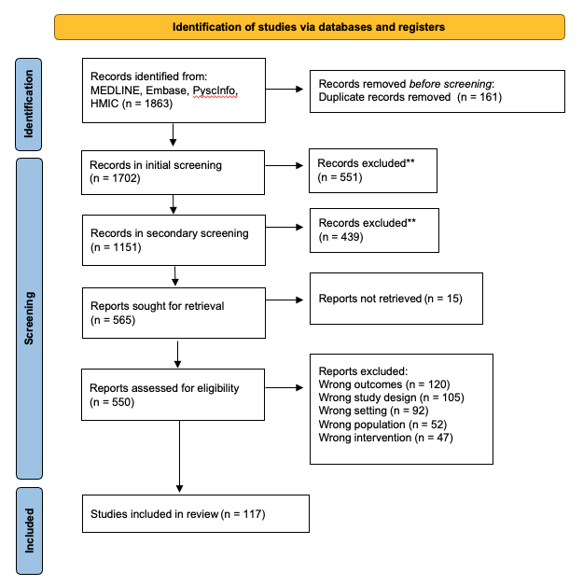
Figure 8. PRISMA diagram for Review One (Public Acceptability of Local Climate Change Mitigation Action)
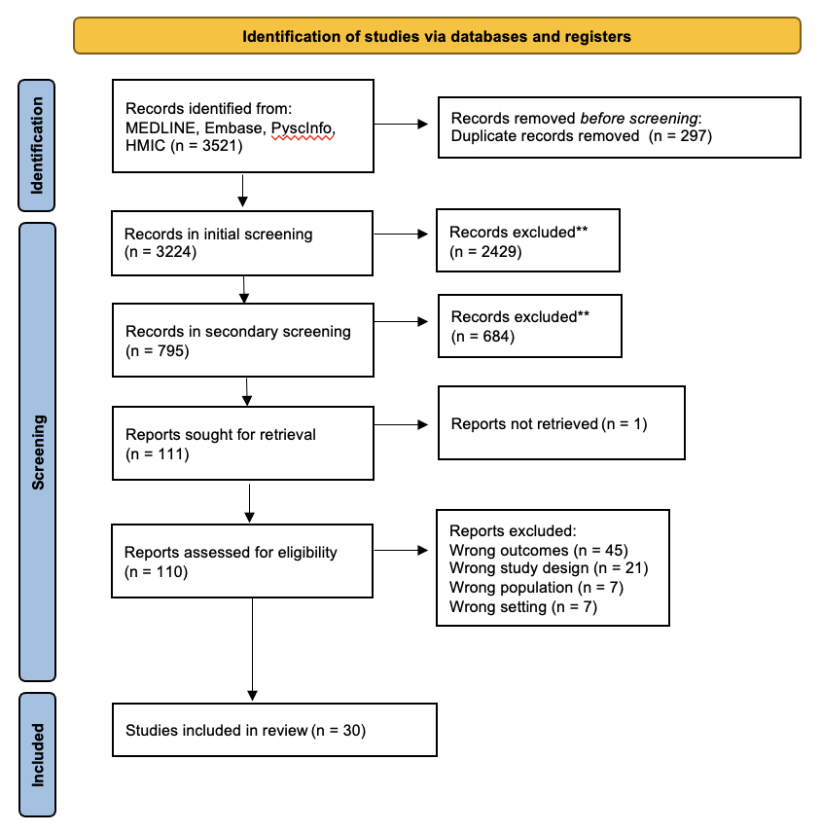
Figure 9. PRISMA diagram for Review Two (Public Understanding of the Health Impacts of Climate Change)

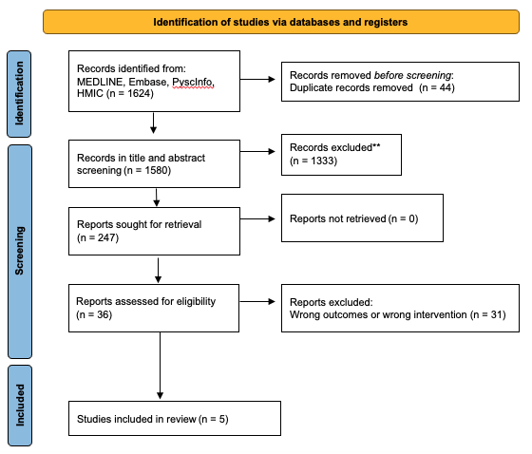
Figure 10. PRISMA diagram for Review Three (Economic Evaluation)

Inclusion/exclusion criteria

Review One – Public Acceptability of Local Climate Change Mitigation Actions
 | Inclusion Criteria | Exclusion Criteria
Sample | Any sample of people residing in the UK. No minimum sample size will be implemented. | Any sample of people residing outside of the UK, or predominately outside the UK.
Phenomenon of Interest | Local actions (such as those involving transport, housing, food, green spaces, land and waste management and water supply and quality) to mitigate against climate change or provide adaptation and resilience strategies. | National or international actions to mitigate against climate change or provide adaptation and resilience strategies.
Design | Any qualitative or quantitative data collection methods (eg, surveys, questionnaires, interviews, observations, or focus groups) independent of the analysis conducted. | Discussion papers and descriptive papers will be excluded.
Evaluation | Any information on public attitudes or public acceptability of local actions. Such information may be the primary or secondary focus of the study. | Any studies which do not measure or evaluate public acceptability.
Research type | Qualitative (such as interviews or focus groups, social media analysis), quantitative (such as surveys or questionnaires with fixed responses) or mixed methods (such as research which collates a combination of fixed and open-ended responses). Content analyses of social media-based research. | Non-research
The search string for this review included terms within three facets:
- Climate change
- Public acceptability
- Local government
The search also incorporated, where possible, the National Institute for Health and Care Excellence’s (NICE) UK study filter. Further information for the search strategy can be found here.
Databases searched were OVID Medline(R) and Epub Ahead of Print, In-Process, In-Data-Review & Other Non-Indexed Citations and Daily, Embase, APA PsycINFO, and HMIC Health Management.

Review Two – Public understandings of climate change and its impact on people’s health
 | Inclusion Criteria | Exclusion Criteria
Sample | Any sample of people residing in the UK. No minimum sample size will be implemented. | Any sample of people residing outside of the UK, or predominately outside the UK.
Phenomenon of Interest | Public understandings of climate change and its impact on health. | Understandings of those with climate-related expertise regarding the health impacts of climate change
Design | Any data collection methods (eg, surveys, questionnaires, interviews, observations, or focus groups) independent of the analysis conducted. | Discussion papers and descriptive papers will be excluded.
Evaluation | Any information on public understandings of the health impacts of climate change. Such information may be the primary or secondary focus of the study | Any studies which do not measure public understandings of the health impacts of climate change.
Research type | Qualitative (such as interviews or focus groups, social media analysis), quantitative (such as surveys or questionnaires with fixed responses) or mixed methods (such as research which collates a combination of fixed and open-ended responses). Content analyses of social media-based research. | Non-research
The search string for this review included terms within three facets:
- Climate change
- Public understanding
- Local government
The search also incorporated, where possible, the National Institute for Health and Care Excellence’s (NICE) UK study filter. Further information for the search strategy can be found here.
Databases searched were OVID Medline(R) and Epub Ahead of Print, In-Process, In-Data-Review & Other Non-Indexed Citations and Daily, Embase, APA PsycINFO, and HMIC Health Management.

Review Three – Cost Effectiveness and Budgetary Implications of Climate Change Mitigation
 | Inclusion Criteria | Exclusion Criteria
Sample | UK study | Non-UK study
Phenomenon of Interest | Research evidence measuring or evaluating the costs and benefits (however defined and including health and non-health outcomes) of interventions to mitigate against climate change or research looking at the financial (across all sectors) implications of interventions to mitigate against climate change | Research evidence measuring or evaluating the costs and benefits or research looking at the financial (across all sectors) implications of interventions unrelated to climate change mitigation and adaptation
Design | Cost-effectiveness analysis, Cost-utility analysis, Cost-benefit analysis, Cost-minimisation, Budget impact analyses, SROI, ROI, business case forecasting. | Discussion papers and descriptive papers will be excluded.
Evaluation | Any studies looking at either costs and benefits or financial implications. Such information may be the primary or secondary focus of the study. | Any studies not looking at either costs and benefits or financial implications
Research type | Original research. | Non-research
The search string for this review included terms within three facets:
- Climate change and Net Zero policy
- Economic terms
- Local (within the concept of “local action”)
The search also incorporated, where possible, the National Institute for Health and Care Excellence’s (NICE) UK study filter. Further information for the search strategy can be found here.
Databases searched were OVID Medline(R) and Epub Ahead of Print, In-Process, In-Data-Review & Other Non-Indexed Citations and Daily, Embase, APA PsycINFO, HMIC Health Management, IDEAS, and econLit.

References
Abrahamson, V., Wolf, J., Lorenzoni, I., Fenn, B., Kovats, S., Wilkinson, P., Adger, W. N., & Raine, R. (2009). Perceptions of heatwave risks to health: interview-based study of older people in London and Norwich, UK. Journal of Public Health, 31(1), 119-126. https://ovidsp.ovid.com/ovidweb.cgi?T=JS&CSC=Y&NEWS=N&PAGE=fulltext&D=med7&AN=19052099
Aitken, M. (2009). Wind Power Planning Controversies and the Construction of ‘Expert’ and ‘Lay’ Knowledges. Science as Culture, 18(1), 47-64. https://doi.org/10.1080/09505430802385682
Alexander, C., Smaje, C., Timlett, R., & Williams, I. (2009). Improving social technologies for recycling. Proceedings of the Institution of Civil Engineers - Waste and Resource Management, 162(1), 15-28. https://doi.org/10.1680/warm.2009.162.1.15
Allen, S., Gaunt, M., & Rye, T. (2006). An investigation into the reasons for the rejection of congestion charging by the citizens of Edinburgh.
Allison, A. L., Lorencatto, F., Michie, S., & Miodownik, M. (2022). Barriers and Enablers to Food Waste Recycling: A Mixed Methods Study amongst UK Citizens. International Journal of Environmental Research and Public Health, 19(5) (no pagination). https://doi.org/https://dx.doi.org/10.3390/ijerph19052729
Andersson-Hudson, J., Rose, J., Humphrey, M., Knight, W., & O'Hara, S. (2019). The structure of attitudes towards shale gas extraction in the United Kingdom. Energy Policy, 129, 693-697. https://doi.org/https://doi.org/10.1016/j.enpol.2019.02.056
Bailey, I., West, J., & Whitehead, I. (2011). Out of Sight but Not out of Mind? Public Perceptions of Wave Energy. Journal of Environmental Policy & Planning, 13(2), 139-157. https://doi.org/10.1080/1523908X.2011.573632
Barr, S., Ford, N. J., & Gilg, A. W. (2003). Attitudes towards Recycling Household Waste in Exeter, Devon: Quantitative and qualitative approaches. Local Environment, 8(4), 407-421. https://doi.org/10.1080/13549830306667
Batel, S., Devine-Wright, P., Wold, L., Egeland, H., Jacobsen, G., & Aas, O. (2015). The role of (de-)essentialisation within siting conflicts: An interdisciplinary approach. Journal of Environmental Psychology, 44, 149-159. https://doi.org/https://dx.doi.org/10.1016/j.jenvp.2015.10.004
Batel, S., & Devine‐Wright, P. (2017). Energy colonialism and the role of the global in local responses to new energy infrastructures in the UK: A critical and exploratory empirical analysis. Antipode, 49(1), 3-22.
Beaumont, R., Hamilton, R. S., Machin, N., Perks, J., & Williams, I. D. (1999). Social awareness of air quality information. Science of the Total Environment, 235(1-3), 319-329. https://ovidsp.ovid.com/ovidweb.cgi?T=JS&CSC=Y&NEWS=N&PAGE=fulltext&D=emed6&AN=29565270
Beebeejaun, Y. (2017). Exploring the intersections between local knowledge and environmental regulation: A study of shale gas extraction in Texas and Lancashire. Environment and Planning C: Politics and Space, 35(3), 417-433. https://doi.org/10.1177/0263774x16664905
Bees, A. D., & Williams, I. D. (2017). Explaining the differences in household food waste collection and treatment provisions between local authorities in England and Wales. Waste Management, 70, 222-235. https://ovidsp.ovid.com/ovidweb.cgi?T=JS&CSC=Y&NEWS=N&PAGE=fulltext&D=med14&AN=28918870
Belton, V., Crowe, D. V., Matthews, R., & Scott, S. (1994). A survey of public attitudes to recycling in Glasgow (U.K.). Waste Management and Research, 12(4), 351-367. https://doi.org/https://dx.doi.org/10.1006/wmre.1994.1024
Bench, M. L., Woodard, R., Harder, M. K., & Stantzos, N. (2005). Waste minimisation: Home digestion trials of biodegradable waste. Resources, Conservation and Recycling, 45(1), 84-94. https://doi.org/https://doi.org/10.1016/j.resconrec.2005.02.003
Berry, R., Higgs, G., Fry, R., & Langford, M. (2011). Web-based GIS Approaches to Enhance Public Participation in Wind Farm Planning [https://doi.org/10.1111/j.1467-9671.2011.01240.x]. Transactions in GIS, 15(2), 147-172. https://doi.org/https://doi.org/10.1111/j.1467-9671.2011.01240.x
Bishop, K., & Proctor, A. (1994). Love them or loathe them?: public attitudes towards wind farms in Wales. Department of City and Regional Planning, University of Wales Cardiff.
Braunholtz, S. (2003). Public Attitudes to Windfarms: A Survey of Local Residents inScotland. Http://www.scotland.gov.uk/library5/environment/pawslr.pdf, Scottish ExecutiveSocial Research/MORI Scotland.
Broecks, K., Jack, C., Ter Mors, E., Boomsma, C., & Shackley, S. (2021). How do people perceive carbon capture and storage for industrial processes? Examining factors underlying public opinion in the Netherlands and the United Kingdom. Energy Research & Social Science, 81, 102236.
Brook Lyndhurst. (2009). Enhancing participation in kitchen waste collections. Defra Waste & Resources Evidence Programme (WR0209), Final Project Report.
Brunsting, S., Pol, M., Mastop, J., Kaiser, M., Zimmer, R., Shackley, S., Mabon, L., Howell, R., Hepplewhite, F., Loveridge, R., Mazurowski, M., & Rybicki, C. (2013). Social Site Characterisation for CO2 Storage Operations to Inform Public Engagement in Poland and Scotland. Energy Procedia, 37, 7327-7336. https://doi.org/https://doi.org/10.1016/j.egypro.2013.06.671
Bush, J., Moffatt, S., & Dunn, C. (2001). 'Even the birds round here cough': stigma, air pollution and health in Teesside. Health & Place, 7(1), 47-56. https://ovidsp.ovid.com/ovidweb.cgi?T=JS&CSC=Y&NEWS=N&PAGE=fulltext&D=med4&AN=11165155
Bush, J., Moffatt, S., & Dunn, C. E. (2001). Keeping the public informed? Public negotiation of air quality information. Public Understanding of Science, 10(2), 213-229. https://doi.org/10.3109/a036866
Capstick, S. B., Demski, C. C., Sposato, R. G., Pidgeon, N. F., Spence, A., & Corner, A. J. (2015). Public perception of climate change in Britain following the winter 2013/2014 flooding.
Capstick, S. B., Pidgeon, N., & Whitehead, M. (2013). Public perceptions of climate change in Wales: Summary findings of a survey of the Welsh public conducted during November and December 2012.
Carroll, B., Morbey, H., Balogh, R., & Araoz, G. (2009). Flooded homes, broken bonds, the meaning of home, psychological processes and their impact on psychological health in a disaster. Health & Place, 15(2), 540-547.
CAST. (2022). CAST BRIEFING 15: Travel attitudes and behaviours in Cardiff 2021: Results from the first wave of the Cardiff Travel Survey conducted in May-July 2021 (CAST BRIEFINGS, Issue. https://cast.ac.uk/wp-content/uploads/2022/09/Briefing-15.pdf
Cotterill, S., John, P., Liu, H., & Nomura, H. (2009). Mobilizing citizen effort to enhance environmental outcomes: A randomized controlled trial of a door-to-door recycling campaign. Journal of Environmental Management, 91(2), 403-410. https://doi.org/https://doi.org/10.1016/j.jenvman.2009.09.010
Cotton, M., & Devine-Wright, P. (2013). Putting pylons into place: a UK case study of public perspectives on the impacts of high voltage overhead transmission lines. Journal of Environmental Planning and Management, 56(8), 1225-1245. https://doi.org/10.1080/09640568.2012.716756
Craighill, A. L., & Powell, J. C. (1996). Lifecycle assessment and economic evaluation of recycling: A case study. Resources, Conservation and Recycling, 17(2), 75-96. https://doi.org/https://doi.org/10.1016/0921-3449(96)01105-6
Darier, E., & Schüle, R. (1999). Think globally, act locally'? Climate change and public participation in Manchester and Frankfurt. Local environment, 4(3), 317-329.
Dasandi, N., Graham, H., Hudson, D., Jankin, S., vanHeerde-Hudson, J., & Watts, N. (2022). Positive, global, and health or environment framing bolsters public support for climate policies. Communications Earth & Environment, 3(1), 239. https://doi.org/10.1038/s43247-022-00571-x
Davies, J., Foxall, G. R., & Pallister, J. (2002). Beyond the Intention–Behaviour Mythology: An Integrated Model of Recycling. Marketing Theory, 2(1), 29-113. https://doi.org/10.1177/1470593102002001645
Davis, G., Phillips, P. S., Read, A. D., & Iida, Y. (2006). Demonstrating the need for the development of internal research capacity: Understanding recycling participation using the Theory of Planned Behaviour in West Oxfordshire, UK. Resources, Conservation and Recycling, 46(2), 115-127. https://doi.org/https://dx.doi.org/10.1016/j.resconrec.2005.07.001
Davis, M. (2021). Community Municipal Investments: Accelerating the Potential of Local Net Zero Strategies.
Day, R. (2007). Place and the experience of air quality. Health & Place, 13(1), 249-260. https://ovidsp.ovid.com/ovidweb.cgi?T=JS&CSC=Y&NEWS=N&PAGE=fulltext&D=med6&AN=16500135
Day, R. J. (2006). Traffic-related air pollution and perceived health risk: Lay assessment of an everyday hazard. Health, Risk & Society, 8(3), 305-322. https://ovidsp.ovid.com/ovidweb.cgi?T=JS&CSC=Y&NEWS=N&PAGE=fulltext&D=psyc5&AN=2006-13210-007
Devine-Wright, P. (2005). Local aspects of UK renewable energy development: exploring public beliefs and policy implications. Local Environment, 10(1), 57-69. https://doi.org/10.1080/1354983042000309315
Devine-Wright, P. (2011). Enhancing local distinctiveness fosters public acceptance of tidal energy: A UK case study. Energy Policy, 39(1), 83-93. https://doi.org/https://doi.org/10.1016/j.enpol.2010.09.012
Devine-Wright, P. (2013). Explaining “NIMBY” Objections to a Power Line:The Role of Personal, Place Attachment and Project-Related Factors. Environment and Behavior, 45(6), 761-781. https://doi.org/10.1177/0013916512440435
Devine-Wright, P., & Batel, S. (2013). Explaining public preferences for high voltage pylon designs: An empirical study of perceived fit in a rural landscape. Land Use Policy, 31, 640-649. https://doi.org/https://doi.org/10.1016/j.landusepol.2012.09.011
Devine-Wright, P., & Howes, Y. (2010). Disruption to place attachment and the protection of restorative environments: A wind energy case study. Journal of Environmental Psychology, 30(3), 271-280. https://doi.org/https://dx.doi.org/10.1016/j.jenvp.2010.01.008
Devine-Wright, P., & Wiersma, B. (2020). Understanding community acceptance of a potential offshore wind energy project in different locations: An island-based analysis of ‘place-technology fit’. Energy Policy, 137, 111086. https://doi.org/https://doi.org/10.1016/j.enpol.2019.111086
Dudleston, A. (2000). Public attitudes towards wind farms in Scotland: results of a residents survey.
Edgley, A., Pilnick, A., & Clarke, M. (2011). 'The air still wasn't good ... everywhere I went I was surrounded': Lay perceptions of air quality and health. Health Sociology Review, 20(1), 97-108. https://ovidsp.ovid.com/ovidweb.cgi?T=JS&CSC=Y&NEWS=N&PAGE=fulltext&D=psyc8&AN=2011-11002-008
Eiser, J., Spears, R., & Webley, P. (1988). Predicting attitudes to oil and to nuclear energy. Journal of Environmental Psychology, 8(2), 141-147. https://doi.org/https://dx.doi.org/10.1016/S0272-4944%2888%2980004-5
Ellis, G., Barry, J., & Robinson, C. (2007). Many ways to say ‘no’, different ways to say ‘yes’: Applying Q-Methodology to understand public acceptance of wind farm proposals. Journal of Environmental Planning and Management, 50(4), 517-551. https://doi.org/10.1080/09640560701402075
Erens, B., Williams, L., Exley, J., Ettelt, S., Manacorda, T., Hajat, S., & Mays, N. (2021). Public attitudes to, and behaviours taken during, hot weather by vulnerable groups: results from a national survey in England. BMC Public Health, 21(1), 1631. https://ovidsp.ovid.com/ovidweb.cgi?T=JS&CSC=Y&NEWS=N&PAGE=fulltext&D=med19&AN=34488695
Evans, B., Parks, J., & Theobald, K. (2011). Urban wind power and the private sector: community benefits, social acceptance and public engagement. Journal of Environmental Planning and Management, 54(2), 227-244. https://doi.org/10.1080/09640568.2010.505829
Evison, T., & Read, A. D. (2001). Local Authority recycling and waste — awareness publicity/promotion. Resources, Conservation and Recycling, 32(3), 275-291. https://doi.org/https://doi.org/10.1016/S0921-3449(01)00066-0
Gardiner, B. (2012). Wind farms: For or against? https://yougov.co.uk/topics/politics/articles-reports/2012/04/03/wind-farms-and-renewable-energy
Gilbertson, J., Stevens, M., Stiell, B., Thorogood, N., & Warm Front Study, G. (2006). Home is where the hearth is: grant recipients' views of England's home energy efficiency scheme (Warm Front). Soc Sci Med, 63(4), 946-956. https://ovidsp.ovid.com/ovidweb.cgi?T=JS&CSC=Y&NEWS=N&PAGE=fulltext&D=med6&AN=16616807http://openurl.york.ac.uk/openurl/44YORK/44YORK_services_page?sid=OVID:medline&id=pmid:16616807&id=doi:10.1016%2Fj.socscimed.2006.02.021&issn=0277-9536&isbn=&volume=63&i
Gough, C., Cunningham, R., & Mander, S. (2018). Understanding key elements in establishing a social license for CCS: An empirical approach. International Journal of Greenhouse Gas Control, 68, 16-25. https://doi.org/https://doi.org/10.1016/j.ijggc.2017.11.003
Gough, C., O׳Keefe, L., & Mander, S. (2014). Public perceptions of CO2 transportation in pipelines. Energy Policy, 70, 106-114. https://doi.org/https://doi.org/10.1016/j.enpol.2014.03.039
Graham, H., de Bell, S., Hanley, N., Jarvis, S., & White, P. C. (2019). Willingness to pay for policies to reduce future deaths from climate change: evidence from a British survey. public health, 174, 110-117.
Graham, H., Harrison, A., & Lampard, P. (2022). Public Perceptions of Climate Change and Its Health Impacts: Taking Account of People's Exposure to Floods and Air Pollution. International Journal of Environmental Research and Public Health, 19(4) (no pagination). https://ovidsp.ovid.com/ovidweb.cgi?T=JS&CSC=Y&NEWS=N&PAGE=fulltext&D=emexa&AN=2015677415
Graham, H., White, P., Cotton, J., & McManus, S. (2019). Flood- and Weather-Damaged Homes and Mental Health: An Analysis Using England's Mental Health Survey. International Journal of Environmental Research & Public Health [Electronic Resource], 16(18), 05. https://ovidsp.ovid.com/ovidweb.cgi?T=JS&CSC=Y&NEWS=N&PAGE=fulltext&D=med16&AN=31491859
Gray, D., Snodin, H., & Bullen, A. (2020). Exploring the evidence on potential issues associatedwith trialling hydrogen heating in communities: A Literature Review and Focus Group Study.
Green, J., Perkins, C., Steinbach, R., & Edwards, P. (2015). Reduced street lighting at night and health: A rapid appraisal of public views in England and Wales. Health and Place, 34, 171-180. https://doi.org/https://dx.doi.org/10.1016/j.healthplace.2015.05.011
Haddad, H., & de Nazelle, A. (2018). The role of personal air pollution sensors and smartphone technology in changing travel behaviour. Journal of Transport & Health, 11, 230-243. https://doi.org/https://dx.doi.org/10.1016/j.jth.2018.08.001
Hanley, N., & Nevin, C. (1999). Appraising renewable energy developments in remote communities: the case of the North Assynt Estate, Scotland. Energy Policy, 27(9), 527-547. https://doi.org/https://doi.org/10.1016/S0301-4215(99)00023-3
Harthorn, B. H., Halcomb, L., Partridge, T., Thomas, M., Enders, C., & Pidgeon, N. (2019). Health risk perception and shale development in the UK and US. Health, Risk & Society, 21(1-2), 35-56. https://doi.org/10.1080/13698575.2019.1601685
Hinshelwood, E., & McCallum, D. (2001). Examining approaches to renewables consultation. Lessons from Awel Aman Tawe community wind farm project.
Hodgson, A., & Hitchings, R. (2018). Urban air pollution perception through the experience of social practices: Talking about breathing with recreational runners in London. Health & Place, 53, 26-33. https://ovidsp.ovid.com/ovidweb.cgi?T=JS&CSC=Y&NEWS=N&PAGE=fulltext&D=psyc15&AN=2018-47047-005
Hooper, T., Hattam, C., Edwards-Jones, A., & Beaumont, N. (2020). Public perceptions of tidal energy: Can you predict social acceptability across coastal communities in England? Marine Policy, 119, 104057. https://doi.org/https://doi.org/10.1016/j.marpol.2020.104057
Howel, D., Moffatt, S., Prince, H., Bush, J., & Dunn, C. E. (2002). Urban air quality in North-East England: Exploring the influences on local views and perceptions. Risk Analysis, 22(1), 121-130. https://ovidsp.ovid.com/ovidweb.cgi?T=JS&CSC=Y&NEWS=N&PAGE=fulltext&D=emed7&AN=34258739
Istamto, T., Houthuijs, D., & Lebret, E. (2014). Willingness to pay to avoid health risks from road-traffic-related air pollution and noise across five countries. Science of the Total Environment, 497-498, 420-429. https://ovidsp.ovid.com/ovidweb.cgi?T=JS&CSC=Y&NEWS=N&PAGE=fulltext&D=emed15&AN=600013963
Jesson, J. (2009). Household waste recycling behavior: A market segmentation model. Social Marketing Quarterly, 15(2), 25-38. https://doi.org/https://dx.doi.org/10.1080/15245000902957326
Karousakis, K., & Birol, E. (2008). Investigating household preferences for kerbside recycling services in London: A choice experiment approach. Journal of Environmental Management, 88(4), 1099-1108. https://doi.org/https://doi.org/10.1016/j.jenvman.2007.05.015
Khare, S., Hajat, S., Kovats, S., Lefevre, C. E., de Bruin, W. B., Dessai, S., & Bone, A. (2015). Heat protection behaviour in the UK: results of an online survey after the 2013 heatwave. BMC Public Health, 15, 878. https://ovidsp.ovid.com/ovidweb.cgi?T=JS&CSC=Y&NEWS=N&PAGE=fulltext&D=med12&AN=26357923
Kurz, T., Linden, M., & Sheehy, N. (2007). Attitudinal and community influences on participation in new curbside recycling initiatives in Northern Ireland. Environment and Behavior, 39(3), 367-391. https://doi.org/https://dx.doi.org/10.1177/0013916506294152
Lorenzoni, I., Leiserowitz, A., De Franca Doria, M., Poortinga, W., & Pidgeon, N. F. (2006). Cross-National Comparisons of Image Associations with "Global Warming" and "Climate Change" Among Laypeople in the United States of America and Great Britain. Journal of Risk Research, 9(3), 265-281. https://ovidsp.ovid.com/ovidweb.cgi?T=JS&CSC=Y&NEWS=N&PAGE=fulltext&D=psyc5&AN=2006-06158-006
Mabon, L., Shackley, S., Blackford, J. C., Stahl, H., & Miller, A. (2015). Local perceptions of the QICS experimental offshore CO2 release: Results from social science research. International Journal of Greenhouse Gas Control, 38, 18-25. https://doi.org/https://doi.org/10.1016/j.ijggc.2014.10.022
Mabon, L., Shackley, S., & Bower-Bir, N. (2014). Perceptions of sub-seabed carbon dioxide storage in Scotland and implications for policy: A qualitative study. Marine Policy, 45, 9-15. https://doi.org/https://doi.org/10.1016/j.marpol.2013.11.011
Martin, M., Williams, I. D., & Clark, M. (2006). Social, cultural and structural influences on household waste recycling: A case study. Resources, Conservation and Recycling, 48(4), 357-395. https://doi.org/https://doi.org/10.1016/j.resconrec.2005.09.005
McDonald, J. S., Hession, M., Rickard, A., Nieuwenhuijsen, M. J., & Kendall, M. (2002). Air quality management in UK local authorities: Public understanding and participation. Journal of Environmental Planning and Management, 45(4), 571-590. https://doi.org/10.1080/09640560220143567
McDonald, S., & Ball, R. (1998). Public participation in plastics recycling schemes. Resources, Conservation and Recycling, 22(3), 123-141. https://doi.org/https://doi.org/10.1016/S0921-3449(97)00044-X
McDonald, S., & Oates, C. (2003). Reasons for non-participation in a kerbside recycling scheme. Resources, Conservation and Recycling, 39(4), 369-385. https://doi.org/https://doi.org/10.1016/S0921-3449(03)00020-X
McNally, H., Howley, P., & Cotton, M. (2018). Public perceptions of shale gas in the UK: framing effects and decision heuristics. Energy, Ecology and Environment, 3(6), 305-316. https://doi.org/10.1007/s40974-018-0102-2
Mee, N. (2005). A Communications Strategy for Kerbside Recycling. Journal of Marketing Communications, 11(4), 297-308. https://doi.org/https://dx.doi.org/10.1080/13527260500124265
Mee, N., & Clewes, D. (2004). The influence of corporate communications on recycling behaviour. Corporate Communications, 9(4), 265-275. https://doi.org/https://dx.doi.org/10.1108/13563280410571004
Morton, C., Mattioli, G., & Anable, J. (2021). Public acceptability towards Low Emission Zones: The role of attitudes, norms, emotions, and trust. Transportation Research Part A: Policy and Practice, 150, 256-270. https://doi.org/https://doi.org/10.1016/j.tra.2021.06.007
Myers, G., Boyes, E., & Stanisstreet, M. (2004). School students' ideas about air pollution: Knowledge and attitudes. Research in Science & Technological Education, 22(2), 133-152. https://ovidsp.ovid.com/ovidweb.cgi?T=JS&CSC=Y&NEWS=N&PAGE=fulltext&D=psyc4&AN=2004-21982-001
Myers, T. A., Nisbet, M. C., Maibach, E. W., & Leiserowitz, A. A. (2012). A public health frame arouses hopeful emotions about climate change. Climatic Change, 113(3), 1105-1112.
Nikitas, A., Avineri, E., & Parkhurst, G. (2018). Understanding the public acceptability of road pricing and the roles of older age, social norms, pro-social values and trust for urban policy-making: The case of Bristol. Cities, 79, 78-91. https://doi.org/https://doi.org/10.1016/j.cities.2018.02.024
O’Garra, T., & Mourato, S. (2007). Public Preferences for Hydrogen Buses: Comparing Interval Data, OLS and Quantile Regression Approaches. Environmental and Resource Economics, 36(4), 389-411. https://doi.org/10.1007/s10640-006-9024-0
Odioso, M. S., & Smith, M. C. (2008, 25-25 April 2008). Perceptions of congestion charging: Lessons for U.S. cities from London and Stockholm. 2008 IEEE Systems and Information Engineering Design Symposium,
Palutikof, J. P., Agnew, M. D., & Hoar, M. R. (2004). Public perceptions of unusually warm weather in the UK: impacts, responses and adaptations. Climate Research, 26(1), 43-59.
Parkhill, K. A., Butler, C., & Pidgeon, N. F. (2014). Landscapes of Threat? Exploring Discourses of Stigma around Large Energy Developments. Landscape Research, 39(5), 566-582. https://doi.org/10.1080/01426397.2013.775232
Parry, S., McCarthy, S. R., & Clark, J. (2022). Young people's engagement with climate change issues through digital media - a content analysis. Child & Adolescent Mental Health, 27(1), 30-38. https://ovidsp.ovid.com/ovidweb.cgi?T=JS&CSC=Y&NEWS=N&PAGE=fulltext&D=med20&AN=34904349
Peh, K. S. H., Balmford, A., Field, R. H., Lamb, A., Birch, J. C., Bradbury, R. B., Brown, C., Butchart, S. H. M., Lester, M., Morrison, R., Sedgwick, I., Soans, C., Stattersfield, A. J., Stroh, P. A., Swetnam, R. D., Thomas, D. H. L., Walpole, M., Warrington, S., & Hughes, F. M. R. (2014). Benefits and costs of ecological restoration: Rapid assessment of changing ecosystem service values at a U.K. wetland [https://doi.org/10.1002/ece3.1248]. Ecology and Evolution, 4(20), 3875-3886. https://doi.org/https://doi.org/10.1002/ece3.1248
Peng, G. C. A., Nunes, M. B., & Zheng, L. (2017). Impacts of low citizen awareness and usage in smart city services: the case of London’s smart parking system. Information Systems and e-Business Management, 15, 845-876.
Perrin, D., & Barton, J. (2001). Issues associated with transforming household attitudes and opinions into materials recovery: a review of two kerbside recycling schemes. Resources, Conservation and Recycling, 33(1), 61-74. https://doi.org/https://doi.org/10.1016/S0921-3449(01)00075-1
Perry, G. D. R., & Williams, I. D. (2007). The participation of ethnic minorities in kerbside recycling: A case study. Resources, Conservation and Recycling, 49(3), 308-323. https://doi.org/https://doi.org/10.1016/j.resconrec.2006.02.006
Pidgeon, N. F., Henwood, K., Parkhill, K. A., Venables, D., & Simmons, P. (2008). Living with nuclear power in Britain: A mixed-methods study.
Pidgeon, N. F., Lorenzoni, I., & Poortinga, W. (2008). Climate change or nuclear power—No thanks! A quantitative study of public perceptions and risk framing in Britain. Global Environmental Change, 18(1), 69-85. https://doi.org/https://doi.org/10.1016/j.gloenvcha.2007.09.005
Poortinga, W., Rodgers, S. E., Lyons, R. A., Anderson, P., Tweed, C., Grey, C., Jiang, S., Johnson, R., Watkins, A., & Winfield, T. G. (2018). The health impacts of energy performance investments in low-income areas: a mixed-methods approach. Public Health Research, 6(5), 1-182.
Rashid, R., Chong, F., Islam, S., Bryant, M., & McEachan, R. R. C. (2021). Taking a deep breath: a qualitative study exploring acceptability and perceived unintended consequences of charging clean air zones and air quality improvement initiatives amongst low-income, multi-ethnic communities in Bradford, UK. BMC Public Health, 21(1), 1305. https://ovidsp.ovid.com/ovidweb.cgi?T=JS&CSC=Y&NEWS=N&PAGE=fulltext&D=emed22&AN=635527970
Read, A. D. (1999). 'A weekly doorstep recycling collection, I had no idea we could!': Overcoming the local barriers to participation. Resources, Conservation and Recycling, 26(3-4), 217-249. https://doi.org/https://dx.doi.org/10.1016/S0921-3449%2899%2900008-7
Ricci, M., Flynn, R., & Bellaby, P. (2006). Public Attitudes towards Hydrogen energy: Preliminary analysis of findings from focus groups in London, Teesside and Wales. University of Salford.
Rispo, A., Williams, I. D., & Shaw, P. J. (2015). Source segregation and food waste prevention activities in high-density households in a deprived urban area. Waste Management, 44, 15-27. https://doi.org/https://dx.doi.org/10.1016/j.wasman.2015.04.010
Robinson, G. M., & Read, A. D. (2005). Recycling behaviour in a London Borough: Results from large-scale household surveys. Resources, Conservation and Recycling, 45(1), 70-83. https://doi.org/https://doi.org/10.1016/j.resconrec.2005.02.002
Roddis, P., Carver, S., Dallimer, M., Norman, P., & Ziv, G. (2018). The role of community acceptance in planning outcomes for onshore wind and solar farms: An energy justice analysis. Applied Energy, 226, 353-364. https://doi.org/https://doi.org/10.1016/j.apenergy.2018.05.087
Roddis, P., Roelich, K., Tran, K., Carver, S., Dallimer, M., & Ziv, G. (2020). What shapes community acceptance of large-scale solar farms? A case study of the UK’s first ‘nationally significant’solar farm. Solar Energy, 209, 235-244.
Rogers, J. C., Simmons, E. A., Convery, I., & Weatherall, A. (2008). Public perceptions of opportunities for community-based renewable energy projects. Energy Policy, 36(11), 4217-4226. https://doi.org/https://doi.org/10.1016/j.enpol.2008.07.028
Rossa-Roccor, V., Giang, A., & Kershaw, P. (2021). Framing climate change as a human health issue: enough to tip the scale in climate policy? The Lancet Planetary Health, 5(8), e553-e559.
Santos, G., & Fraser, G. (2006). Road pricing: lessons from London. Economic Policy, 21(46), 264-310.
Semwal, T., Milton, K., Jepson, R., & Kelly, M. P. (2021). Tweeting about twenty: an analysis of interest, public sentiments and opinion about 20mph speed restrictions in two UK cities. BMC public health, 21(1), 2016. https://doi.org/https://dx.doi.org/10.1186/s12889-021-12084-x
Shammut, M., Cao, M., Zhang, Y., Papaix, C., Liu, Y., & Gao, X. (2019). Banning Diesel Vehicles in London: Is 2040 Too Late? Energies, 12(18), 3495. https://www.mdpi.com/1996-1073/12/18/3495
Shaw, P. J., & Maynard, S. J. (2008). The potential of financial incentives to enhance householders’ kerbside recycling behaviour. Waste Management, 28(10), 1732-1741. https://doi.org/https://doi.org/10.1016/j.wasman.2007.08.008
Shearer, L., Gatersleben, B., Morse, S., Smyth, M., & Hunt, S. (2017). A problem unstuck? Evaluating the effectiveness of sticker prompts for encouraging household food waste recycling behaviour. Waste Management, 60, 164-172. https://doi.org/https://doi.org/10.1016/j.wasman.2016.09.036
Sims, S., & Dent, P. (2007). Property stigma: wind farms are just the latest fashion. Journal of Property Investment & Finance, 25(6), 626-651. https://doi.org/10.1108/14635780710829315
Steentjes, K., Demski, C., Seabrook, A., Corner, A., & Pidgeon, N. (2020). British public perceptions of climate risk, adaptation options and resilience (RESiL RISK): topline findings of a GB survey conducted in October 2019.
Tatchley, C., Paton, H., Robertson, E., Minderman, J., Hanley, N., & Park, K. (2016). Drivers of Public Attitudes towards Small Wind Turbines in the UK. PLOS ONE, 11(3), e0152033. https://doi.org/10.1371/journal.pone.0152033
Taylor, A., Dessai, S., & Bruine de Bruin, W. (2019). Public priorities and expectations of climate change impacts in the United Kingdom. Journal of Risk Research, 22(2), 150-160. https://ovidsp.ovid.com/ovidweb.cgi?T=JS&CSC=Y&NEWS=N&PAGE=fulltext&D=psyc16&AN=2019-18263-002
Thomas, G., Pidgeon, N., & Roberts, E. (2018). Ambivalence, naturalness and normality in public perceptions of carbon capture and storage in biomass, fossil energy, and industrial applications in the United Kingdom. Energy Research & Social Science, 46, 1-9. https://doi.org/https://doi.org/10.1016/j.erss.2018.06.007
Thorpe, N., Hills, P., & Jaensirisak, S. (2000). Public attitudes to TDM measures: a comparative study. Transport Policy, 7(4), 243-257. https://doi.org/https://doi.org/10.1016/S0967-070X(00)00007-X
Timlett, R. E., & Williams, I. D. (2008). Public participation and recycling performance in England: A comparison of tools for behaviour change. Resources, Conservation and Recycling, 52(4), 622-634. https://doi.org/https://doi.org/10.1016/j.resconrec.2007.08.003
Tucker, P., & Speirs, D. (2003). Attitudes and behavioural change in household waste management behaviours. Journal of environmental planning and management, 46(2), 289-307.
Turner, K., Jepson, R., MacDonald, B., Kelly, P., Biggs, H., & Baker, G. (2018). Developing and refining a programme theory for understanding how twenty mile per hour speed limits impact health. Journal of Transport & Health, 10, 92-110. https://doi.org/https://dx.doi.org/10.1016/j.jth.2018.08.004
Upham, P. (2009). Applying environmental-behaviour concepts to renewable energy siting controversy: Reflections on a longitudinal bioenergy case study. Energy Policy, 37(11), 4273-4283. https://doi.org/https://doi.org/10.1016/j.enpol.2009.05.027
Upreti, B. R., & van der Horst, D. (2004). National renewable energy policy and local opposition in the UK: the failed development of a biomass electricity plant. Biomass and Bioenergy, 26(1), 61-69. https://doi.org/https://doi.org/10.1016/S0961-9534(03)00099-0
Van Alstine, J., & Bastin, C. (2019). Establishing the UK Hydrogen Corridor: Socio-Economic, Environmental & Regulatory Issues.
Van de Vyver, J., Abrams, D., Hopthrow, T., Purewal, K., de Moura, G. R., & Meleady, R. (2018). Motivating the selfish to stop idling: Self-interest cues can improve environmentally relevant driver behaviour. Transportation Research Part F: Traffic Psychology and Behaviour, 54, 79-85. https://doi.org/https://doi.org/10.1016/j.trf.2018.01.015
van Wijk, M., Naing, S., Diaz Franchy, S., Heslop, R. T., Novoa Lozano, I., Vila, J., & Balleste-Delpierre, C. (2020). Perception and knowledge of the effect of climate change on infectious diseases within the general public: A multinational cross-sectional survey-based study. PLoS ONE [Electronic Resource], 15(11), e0241579. https://ovidsp.ovid.com/ovidweb.cgi?T=JS&CSC=Y&NEWS=N&PAGE=fulltext&D=med18&AN=33151991
Walker, B. J. A., Kurz, T., & Russel, D. (2018). Towards an understanding of when non-climate frames can generate public support for climate change policy. Environment and Behavior, 50(7), 781-806. https://doi.org/10.1177/0013916517713299
Walker, B. J. A., Wiersma, B., & Bailey, E. (2014). Community benefits, framing and the social acceptance of offshore wind farms: an experimental study in England. Energy Research & Social Science, 3, 46-54.
Walkling, B., & Haworth, B. T. (2020). Flood risk perceptions and coping capacities among the retired population, with implications for risk communication: A study of residents in a north Wales coastal town, UK. International Journal of Disaster Risk Reduction, 51, 101793. https://ovidsp.ovid.com/ovidweb.cgi?T=JS&CSC=Y&NEWS=N&PAGE=fulltext&D=pmnm5&AN=32834976
Wall, G. (1973). Public response to air pollution in South Yorkshire, England. Environment and Behavior, 5(2), 219-248. https://ovidsp.ovid.com/ovidweb.cgi?T=JS&CSC=Y&NEWS=N&PAGE=fulltext&D=psyc2&AN=1974-05024-001
Warren, C. R., Lumsden, C., O'Dowd, S., & Birnie, R. V. (2005). ‘Green On Green’: Public perceptions of wind power in Scotland and Ireland. Journal of Environmental Planning and Management, 48(6), 853-875. https://doi.org/10.1080/09640560500294376
Warren, C. R., & McFadyen, M. (2010). Does community ownership affect public attitudes to wind energy? A case study from south-west Scotland. Land Use Policy, 27(2), 204-213. https://doi.org/https://doi.org/10.1016/j.landusepol.2008.12.010
West, M. S. R. I. f. R. S. (2004). Attitudes Towards Renewable Energy in Devon. (July 8, 2006). http://www.regensw.co.uk/content-download/DevonMORIPollReport091104.pdf
Westrom, M. (2020). Winds of change: Legitimacy, withdrawal, and interdependency from a decentralized wind-to-hydrogen regime in Orkney, Scotland. Energy Research & Social Science, 60, 101332. https://doi.org/https://doi.org/10.1016/j.erss.2019.101332
Whitmarsh, L., & Capstick, S. (2018). Perceptions of climate change. Clayton, Susan [Ed]; Manning, Christie [Ed] (2018) Psychology and climate change: Human perceptions, impacts, and responses (pp 13-33) xii, 299 pp San Diego, CA, US: Elsevier Academic Press; US, 13-33. https://ovidsp.ovid.com/ovidweb.cgi?T=JS&CSC=Y&NEWS=N&PAGE=fulltext&D=psyc15&AN=2018-00751-002
Whitmarsh, L., Nash, N., Upham, P., Lloyd, A., Verdon, J. P., & Kendall, J. M. (2015). UK public perceptions of shale gas hydraulic fracturing: The role of audience, message and contextual factors on risk perceptions and policy support. Applied Energy, 160, 419-430. https://doi.org/https://doi.org/10.1016/j.apenergy.2015.09.004
Wicki, M., Hofer, K., & Kaufmann, D. (2022). Planning instruments enhance the acceptance of urban densification. Proc Natl Acad Sci U S A, 119(38), e2201780119. https://doi.org/https://dx.doi.org/10.1073/pnas.2201780119
Williams, I. D., & Bird, A. (2003). Public perceptions of air quality and quality of life in urban and suburban areas of London. Journal of Environmental Monitoring, 5(2), 253-259. https://ovidsp.ovid.com/ovidweb.cgi?T=JS&CSC=Y&NEWS=N&PAGE=fulltext&D=emed8&AN=36469514
Williams, I. D., & Cole, C. (2013). The impact of alternate weekly collections on waste arisings. Science of The Total Environment, 445-446, 29-40. https://doi.org/https://doi.org/10.1016/j.scitotenv.2012.12.024
Williams, I. D., & Kelly, J. (2003). Green waste collection and the public's recycling behaviour in the Borough of Wyre, England. Resources, Conservation and Recycling, 38(2), 139-159. https://doi.org/https://doi.org/10.1016/S0921-3449(02)00106-4
Williams, L., Macnaghten, P., Davies, R., & Curtis, S. (2017). Framing ‘fracking’: Exploring public perceptions of hydraulic fracturing in the United Kingdom. Public Understanding of Science, 26(1), 89-104. https://doi.org/10.1177/0963662515595159
Williams, R., Jack, C., Gamboa, D., & Shackley, S. (2021). Decarbonising steel production using CO2 Capture and Storage (CCS): Results of focus group discussions in a Welsh steel-making community. International Journal of Greenhouse Gas Control, 104, 103218. https://doi.org/https://doi.org/10.1016/j.ijggc.2020.103218
Wilson, C. D. H., & Williams, I. D. (2007). Kerbside collection: A case study from the north-west of England. Resources, Conservation and Recycling, 52(2), 381-394. https://doi.org/https://doi.org/10.1016/j.resconrec.2007.02.006

