Supplemental materials for
Spatiotemporal distribution of migraine in China: analyses based on Baidu Index
Liling Lin, Mengyi Zhu, Junxiong Qiu, Qiang Li, Junmeng Zheng, Yanni Fu, Jianwei Lin

This file includes:
Figure S1. Normality test for the remainder of the Seasonal-Trend decomposition procedure based on Loess method.
Figure S2. Ordinary Kriging method of migraine-related BI data in Mainland China.
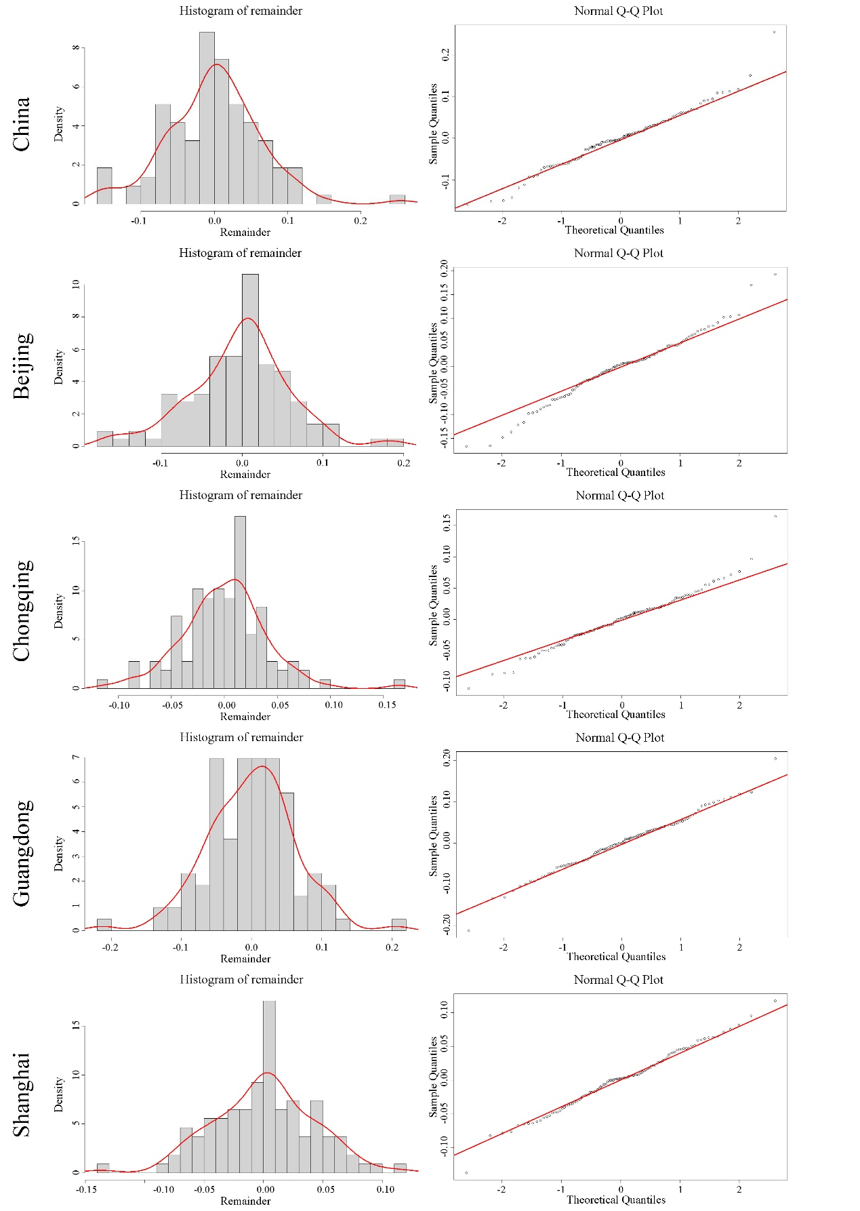

Figure S1. Normality test for the remainder of the Seasonal-Trend decomposition procedure based on Loess method.

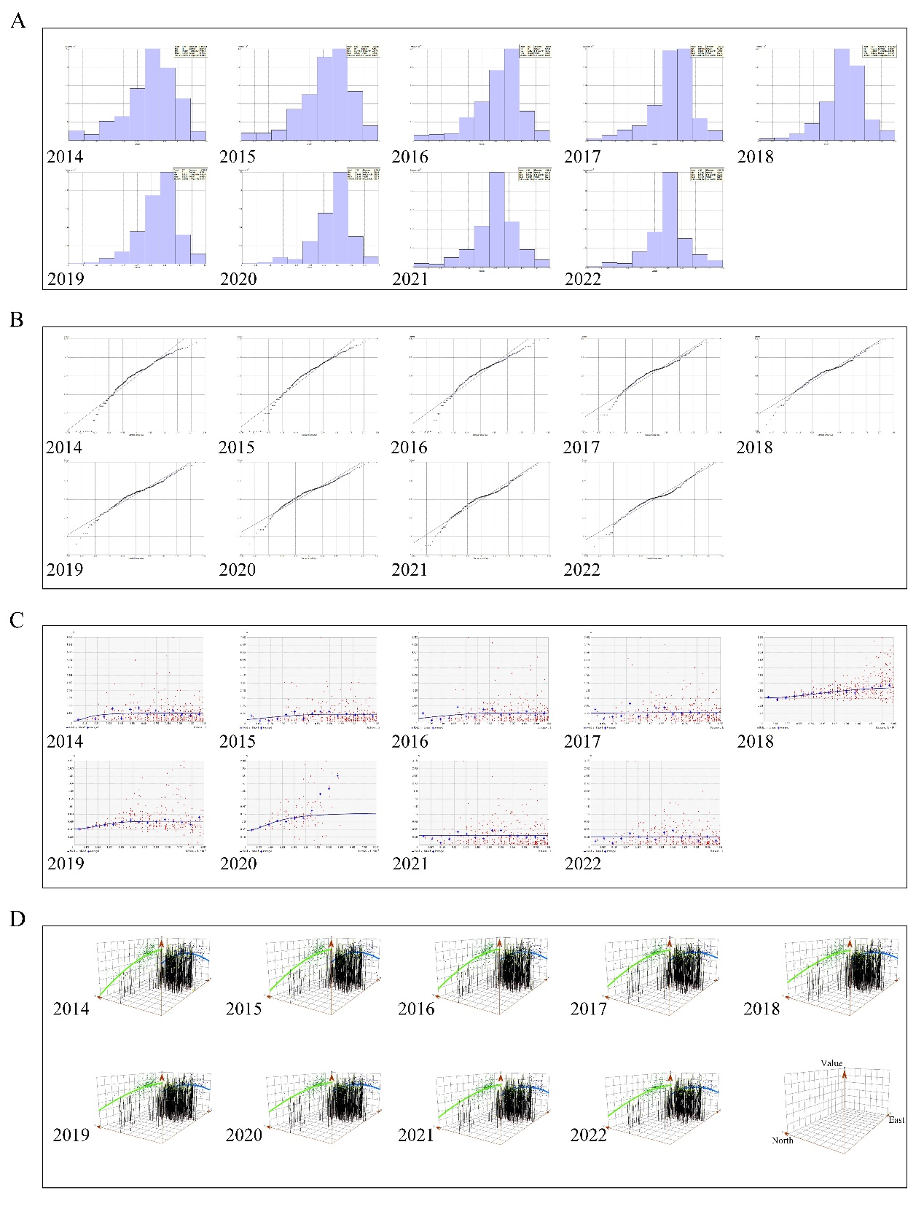
Figure S2. Ordinary Kriging method of migraine-related BI data in Mainland China. Data were log-transformed before analyses. (A) Histograms of BI in mainland China; (B) Normal QQ Plot of BI in mainland China; (C) Trend analysis of BI in mainland China; (D) Semivariogram of BI in mainland China. BI, Baidu Index.

