Supplementary Material
Figure S1. Comparison plots of average annual household spending and household healthcare expenditure (as a percent of total annual household spending^{b}) across five wealth indices

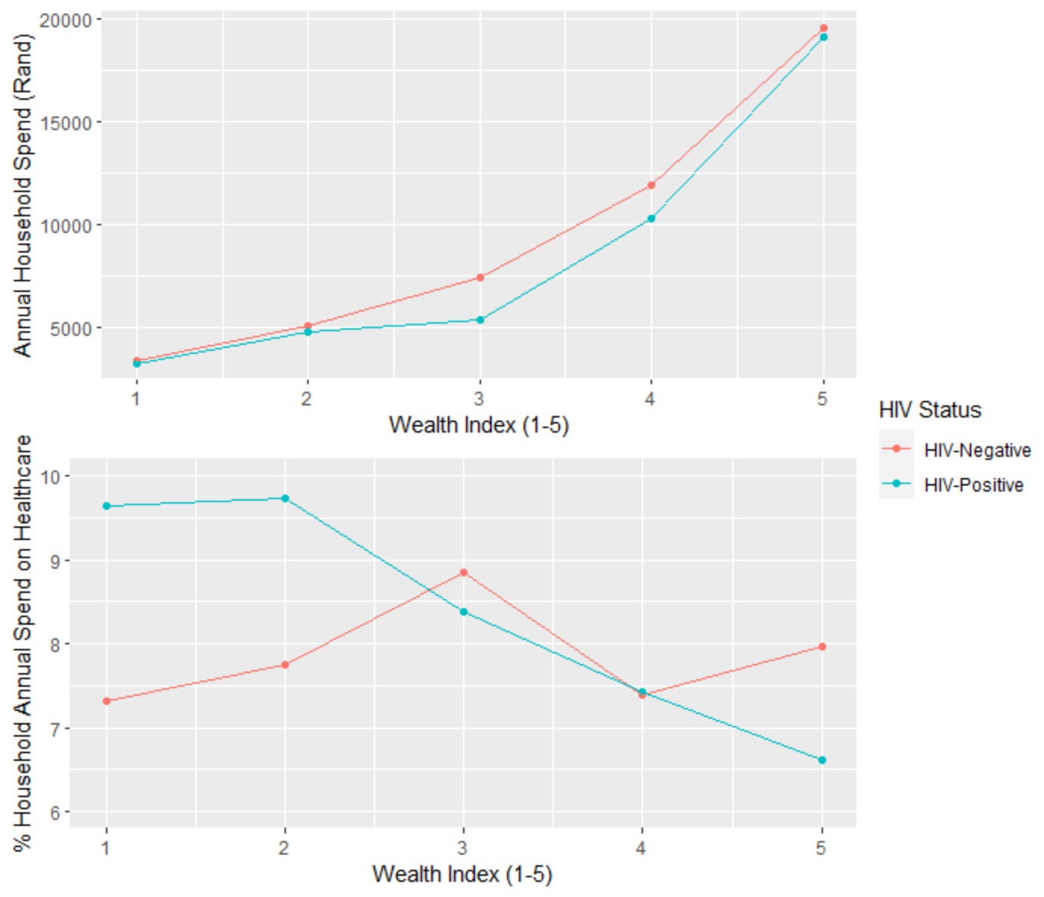

ªHealthcare expenditure includes doctor’s fees, nurse’s fees, dentist fees, clinic fees, hospital fees, medications, bandages, supplies, and other pharmacy/chemist purchases ^{b}Total annual household spending includes long distance travel, wedding expenses, birthdays, funerals, festivals, education, insurance premiums, home maintenance, vehicle service charges, taxes/fees/registration to government, healthcare, loan repayments, donations, and other expenses

