Supplementary material
Index
Supplementary methods 1
Peripheral temperature 1
Data analysis 1
Supplementary Figures 2
Supplementary Figure 1. 2
Supplementary Tables 3
Supplementary table 1 3
Supplementary table 2 4
Supplementary table 3 5
Supplementary table 4 6
References 6

Supplementary methods

Peripheral temperature
Corporal peripheral temperature rhythm was assessed using a 16 mm X 6 mm temperature sensor (Thermochron iButton DS1291H, Dallas Maxim) placed next to the actigraph. Distal skin temperature is considered as a proxy for the circadian rhythm of core temperature; both measures are similar with an approximate 12-h phase difference between them (distal skin temperature reaches its maximum levels during the sleeping period)¹. The original sample was reduced to 25 individuals (Figure 1) who were the ones that had a recording of almost 3 days and complete the medical error subsection of the questionaire. They were divided into two groups based on their medical error reporting: the no medical error group (n=11) and the medical error group (n=14). Cosinor was calculated using the library “CATkit” from R software and we obtained the following measures: amplitude (difference between the maximum and the midline-estimating statistic of rhythm, % rhythm (percent of the variance explained by the model), acrophase of the rhythm (time at which the maximum of the rhythm occurs), and mesor (midline-estimating statistic of rhythm or the rhythm-adjusted mean).

Data analysis
Variables derived from cosinor analysis of peripheral temperature rhythm are shown as mean with 95% CI, normality was tested using Kolmogorov-Smirnov test, and groups were compared by means of an unpaired t-test with Welch’s correction for independent samples.

Supplementary Figures
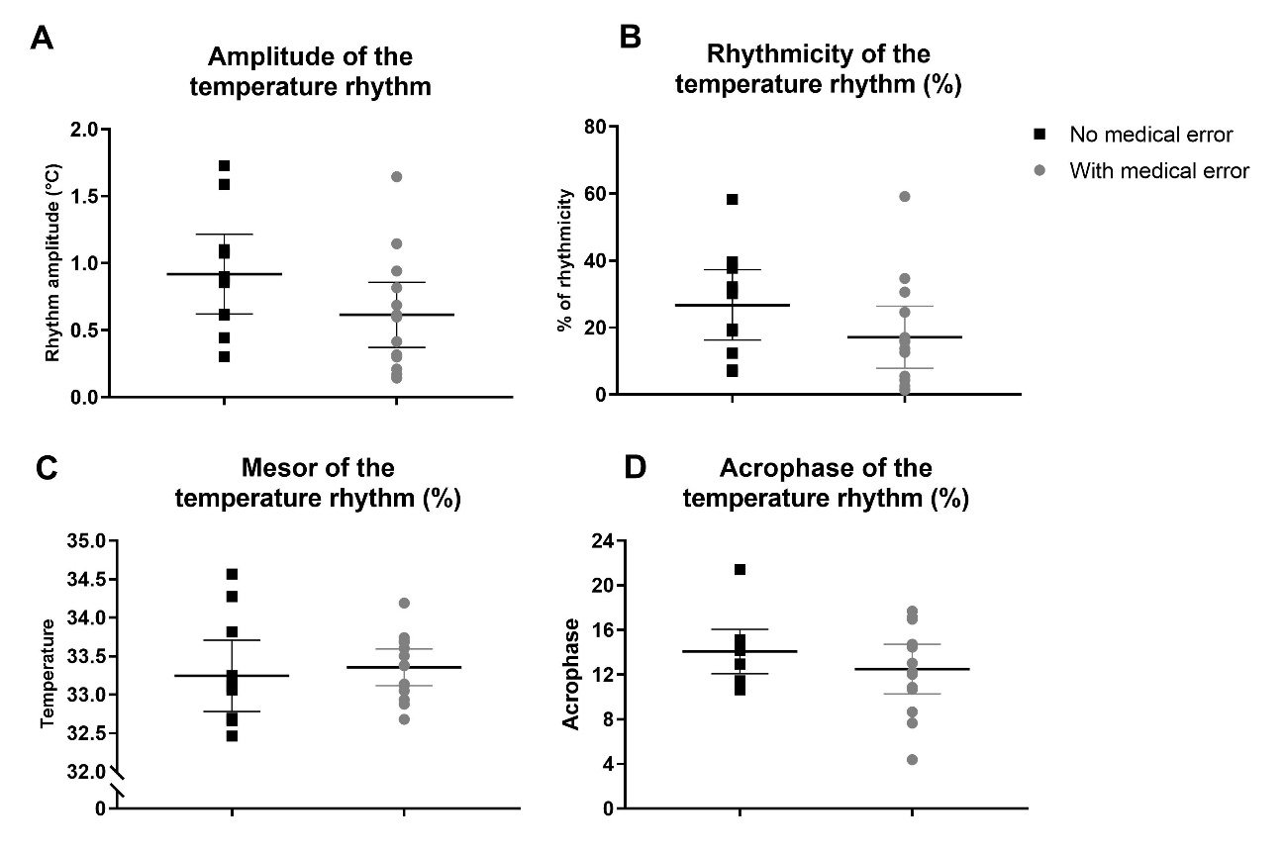
Supplementary Figure 1. Characteristics of the temperature circadian rhythm of medical residents. Mean with 95% CI of the A) amplitude, B) percentage of rhythmicity, C) mesor and D) acrophase of the temperature rhythm (No medical error group: n=11; Medical error group: n=14).

Supplementary Tables
Supplementary table 1 – Characteristics of the participants that did not complete the medical error subsection (excluded)
Variable | Included |  |  | Excluded |  |  | Test
Variable | Valid n | Mean/n | SD/% | Valid n | Mean/n | SD/% | p
Mean age | 433 | 28.0 | 2.3 | 224 | 28.6 | 3.2 | *0.006
Year of residency program | 436 | 2.4 | 1.1 | 225 | 2.2 | 1.1 | 0.06
Specialty (internal medicine) | 444 | 342 | 83.4 | 212 | 158 | 84.5 | 0.57
Total weekly hours on duty in hospital | 384 | 66.7 | 21.4 | 182 | 65.2 | 23.0 | 0.46
Longest continuous shift (hs) | 389 | 29.3 | 10.3 | 194 | 26.7 | 12.0 | *0.006
Monthly on-call shifts | 414 | 6.0 | 3.0 | 200 | 6.1 | 3.1 | 0.78
Typical anchor sleep (hs) in a work day | 433 | 6.0 | 1.6 | 221 | 6.2 | 1.6 | 0.33
Non-anchor sleep (min) in a work day | 474 | 21.4 | 57.0 | 253 | 24.7 | 65.0 | 0.49
Total sleep (hs) in a work day | 433 | 6.4 | 1.8 | 221 | 6.6 | 2.1 | 0.18
Sleep debt (min) in workdays | 425 | 97.3 | 123.0 | 216 | 86.1 | 140.1 | 0.21
Typical anchor sleep (hs) in free days | 426 | 9.3 | 2.1 | 220 | 9.3 | 1.8 | 0.95
Non-anchor sleep (min) in free days | 474 | 66.0 | 85.8 | 253 | 62.3 | 86.0 | 0.59
Total sleep (hs) in free days | 426 | 10.5 | 2.8 | 220 | 10.4 | 2.5 | 0.81
Sleep debt free-work day (min) | 424 | 241.6 | 183.6 | 219 | 228.7 | 186.2 | 0.40
Pittsburgh Sleep Quality Index score | 436 | 11.7 | 2.2 | 225 | 11.7 | 2.2 | 0.78
Epworth Sleepiness Scale score | 436 | 14.4 | 4.9 | 225 | 13.8 | 5.1 | 0.17
Beck Anxiety Inventory score | 436 | 9.8 | 8.0 | 225 | 9.0 | 7.8 | 0.21
Beck Depression Inventory score | 436 | 5.2 | 4.0 | 225 | 4.8 | 4.4 | 0.35
Maslach Emotional Exhaustion score | 436 | 29.3 | 11.6 | 225 | 26.3 | 12.0 | *0.001
Maslach Depersonalization score | 436 | 10.5 | 7.3 | 225 | 8.4 | 7.2 | *0.001
Maslach Personal Acomplishment score | 436 | 35.2 | 8.6 | 225 | 34.2 | 11.0 | 0.207
Mean is reported for numerical and percentage for categorical data.
*Significant difference in the independent sample t-test (for numerical variables) and in the Chi-square test (for categorical variables).

Supplementary table 2 – Bivariate correlation between working characteristics, sleep habits and
psyco-affective variables
Variable |  | PSQI score | ESS score | BAI score | BDI score | MEE score | MDP score | MPA score | Longest cont. shift | Monthly active guards
Monthly on-call shifts | r | 0115 | 0.191 | 0.025 | 0.103 | 0.137 | 0.147 | 0.015 | 0.409 | 1
Monthly on-call shifts | p | *0.004 | *<0.001 | 0.530 | *0.011 | *<0.001 | *<0.001 | 0.717 | *<0.001 | -
Longest continuous shift | r | 0.088 | 0.141 | 0.039 | 0.054 | 0.133 | 0.132 | -0.015 | 1 | 0.409
Longest continuous shift | p | *0.034 | *<0.001 | 0.344 | 0.190 | *0.001 | *0.001 | 0.721 | - | *<0.001
Typical anchor sleep in a work day | r | -0.159 | -0.172 | -0.092 | -0.169 | -0.144 | -0.147 | 0.085 | -0.104 | -0.196
Typical anchor sleep in a work day | p | *<0.001 | *<0.001 | *0.018 | *<0.001 | *<0.001 | *<0.001 | *0.029 | *0.013 | *<0.001
% non-anchor sleep in a work day | r | -0.019 | -0.076 | 0.000 | -0.041 | -0.009 | 0.096 | -0.022 | -0.038 | 0.059
% non-anchor sleep in a work day | p | 0.629 | 0.050 | 0.993 | 0.289 | 0.809 | *0.013 | 0.578 | 0.361 | 0.141
Total sleep in work days | r | -0.136 | -0.188 | -0.064 | -0.159 | -0.117 | -0.067 | 0.057 | -0.106 | -0.131
Total sleep in work days | p | *<0.001 | *<0.001 | 0.104 | *<0.001 | *0.003 | 0.088 | 0.146 | *0.011 | *0.001
Total sleep in free days | r | -0.039 | 0.129 | 0.032 | 0.002 | 0.076 | 0.079 | -0.031 | 0.078 | 0.087
Total sleep in free days | p | 0.328 | *0.001 | 0.410 | 0.958 | 0.054 | *0.044 | 0.435 | 0.063 | *0.034
Sleep debt (with total sleep) in work days | r | 0.089 | 0.242 | 0.068 | 0.192 | 0.151 | 0.082 | -0.073 | 0.092 | 0.142
Sleep debt (with total sleep) in work days | p | *0.024 | *<0.001 | 0.084 | *<0.001 | *<0.001 | *0.038 | 0.065 | *0.028 | *<0.001
Sleep debt free-work days (with total sleep) | r | 0.012 | 0.184 | 0.063 | 0.111 | 0.100 | 0.081 | -0.037 | 0.071 | 0.119
Sleep debt free-work days (with total sleep) | p | 0.752 | *<0.001 | 0.111 | *0.005 | *0.011 | *0.039 | 0.354 | 0.089 | *0.004
PSQI, Pittsburgh Sleep Quality Index; ESS, Epworth Sleepiness Scale; BAI, Beck Anxiety Inventory; BDI, Beck Depression Inventory; MEE, Maslach Emotional Exhaustion; MDP, Maslach Depersonalization; MPA, Maslach Personal Accomplishment.
Total n was 661.
r, Pearson’s correlation coefficient
*Significant p-value for the Pearson Correlation analysis.

Supplementary table 3 - Demographic, working, sleep and psycho-affective characteristics of the objective study sample
Variable | Valid n | Mean/n | SD/%
Mean age | 38 | 27.7 | 2.0
Year of residency program | 38 | 2.5 | 1.9
Specialty (internal medicine) | 35 | 33 | 100
Total weekly hours on duty in hospital | 34 | 76.4 | 20.8
Longest continuous shift (hs) | 34 | 32.3 | 8.1
Monthly on-call shifts | 35 | 7.0 | 2.2
Typical anchor sleep (hs) in a work day | 37 | 6.2 | 1.3
Non-anchor sleep (min) in a work day | 38 | 15 | 34.4
Total sleep (hs) in a work day | 37 | 6.5 | 1.4
Sleep debt (min) in workdays | 36 | 91.7 | 74.6
Typical anchor sleep (hs) in free days | 38 | 9.8 | 2.0
Non-anchor sleep (min) in free days | 38 | 63.9 | 81.4
Total sleep (hs) in free days | 38 | 10.8 | 2.6
Sleep debt free-work day (min) | 37 | 265.1 | 157.0
Pittsburgh Sleep Quality Index score | 38 | 11.9 | 2.0
Epworth Sleepiness Scale score | 38 | 14.8 | 5.3
Beck Anxiety Inventory score | 38 | 9.9 | 8.3
Beck Depression Inventory score | 38 | 5.7 | 3.0
Maslach Emotional Exhaustion score | 38 | 32.3 | 12.6
Maslach Depersonalization score | 38 | 12.3 | 7.5
Maslach Personal Acomplishment score | 38 | 36.1 | 9.5
Mean is reported for numerical and percentage for categorical data.

Supplementary table 4 – Bivariate correlation between objective working and sleep characteristics, and sleep and psyco-affective scales.
Variable |  | PSQI score | ESS score | BAI score | BDI score | MEE score | MDP score | MAP score | % of diurnal sleep
Total weekly hours of extended shift | r | 0.39 | 0.49 | 0.59 | 0.39 | 0.51 | 0.23 | -0.11 | 0.50
Total weekly hours of extended shift | p | 0.07 | *0.02 | *0.004 | 0.08 | *0.02 | 0.31 | 0.62 | *0.02
% of diurnal sleep | r | 0.41 | 0.33 | 0.52 | 0.24 | 0.47 | 0.53 | -0.14 | 1
% of diurnal sleep | p | 0.06 | 0.14 | *0.01 | 0.29 | *0.03 | *0.01 | 0.54
PSQI, Pittsburgh Sleep Quality Index; ESS, Epworth Sleepiness Scale; BAI, Beck Anxiety Inventory; BDI, Beck Depression Inventory; MEE, Maslach Emotional Exhaustion; MDP, Maslach Depersonalization; MPA, Maslach Personal Accomplishment.
Total n was 19.
r, Pearson’s correlation coefficient
*Significant p-value for the Pearson Correlation analysis.

References
1. Sarabia JA, Rol MA, Mendiola P, Madrid JA. Circadian rhythm of wrist temperature in normal-living subjects. A candidate of new index of the circadian system. Physiol Behav. 2008;95(4):570-580. doi:10.1016/j.physbeh.2008.08.005

