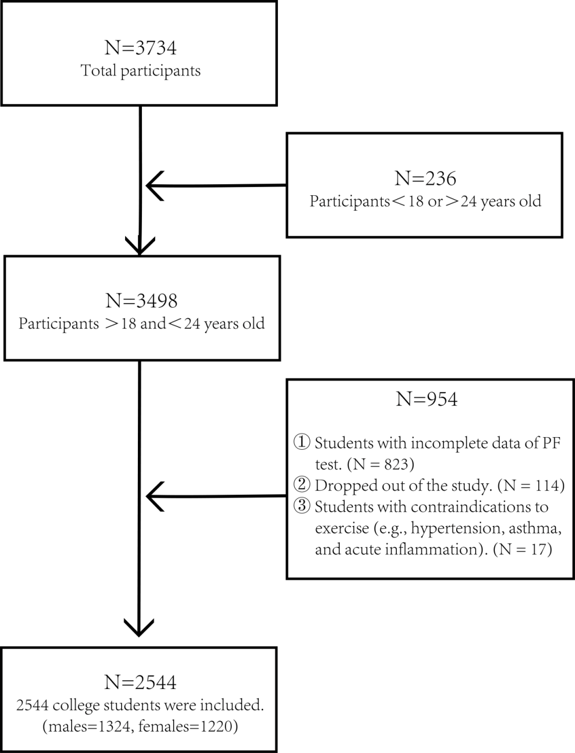
Supplementary Fig 1. Sample selection flowchart.

