Supplementary file

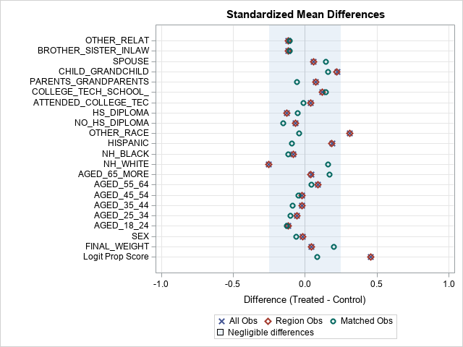
Supplementary Figure 1: Standardized mean difference by covariate for complete case data after matching

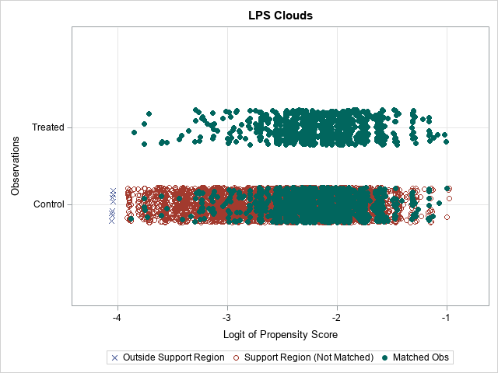
Supplementary Figure 2: Logit propensity score (LPS) cloud plot by group for complete case data after matching

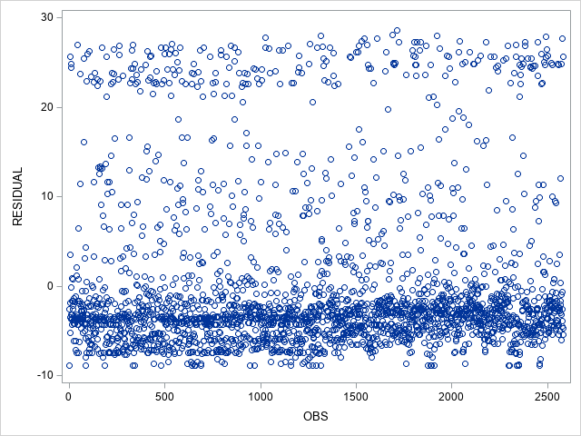
Supplementary Figure 3: Residual plot for the model estimating number of days of poor physical health (matched data)

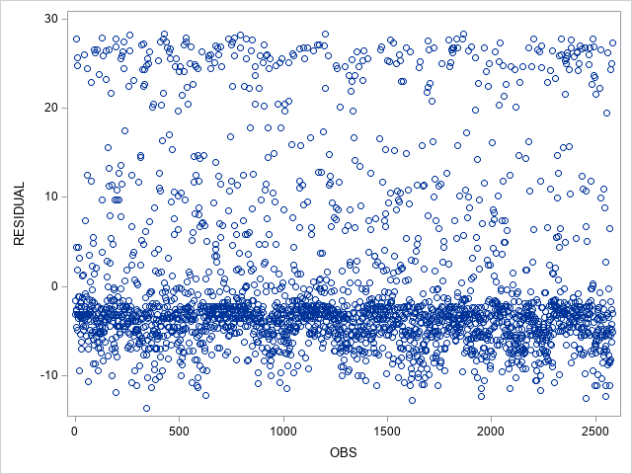
Supplementary Figure 4: Residual plot for the model estimating number of days of poor mental health (matched data)

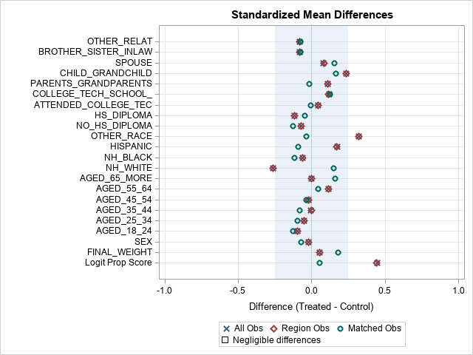
Supplementary Figure 5: Standardized mean difference by covariate for matched data after imputation (n=2,006 cases matched)

Supplementary Table 1: Weighted baseline characteristics of informal caregivers (unweighted counts and weighted percentages) from imputed data
 |  | Period of care provision
 | Total Sample | Before COVID-19 NED | After COVID-19 NED
N | 10,141 (100.0) | 9,138 (89.28) | 1,003 (10.72)
Age Category (%)
18-24 | 423 (7.6) | 362 (7.17) | 61 (11.03)
25-34 | 774 (12.2) | 684 (11.63) | 90 (16.68)
35-44 | 1,110 (15.2) | 990 (15.33) | 110 (14.38)
45-54 | 1,630 (18.1) | 1,461 (18.02) | 169 (19.02)
55-64 | 2,430 (22.4) | 2,232 (23.25) | 198 (14.92)
65+ | 3,784 (24.5) | 3,409 (24.60) | 375 (23.98)
Sex (%)
Male | 3,835 (42.6) | 3,446 (42.9) | 389 (40.7)
Female | 6,306 (57.4) | 5,692 (57.1) | 614 (59.3)
Race Ethnicity (%)
Non-Hispanic, Black | 854 (13.0) | 753 (12.9) | 101 (14.2)
Non-Hispanic, Multiple Race | 458 (1.8) | 440 (1.72) | 18 (2.2)
Non-Hispanic, Other races | 816 (14.5) | 762 (5.3) | 23 (3.2)
Hispanic | 785 (5.0) | 774 (15.1) | 42 (9.5)
Non-Hispanic, White | 7,228 (65.7) | 6,409 (65.0) | 819 (70.9)
Education (%)
Did not graduate High School | 609 (10.2) | 533 (9.8) | 76 (12.9)
Graduated High School | 2,584 (27.7) | 2,280 (27.6) | 304 (28.5)
Attended college/Tech school | 3,163 (35.3) | 2,866 (35.5) | 297 (33.9)
Graduated from College/Tech | 3,785 (26.9) | 3,459 (27.1) | 326 (24.7)
Relation (%)
Sibling/Spouse/in-laws^{(a)} | 2,822 (24.6) | 2,538 (24.8) | 284 (22.3)
Other relatives | 2,742 (23.8) | 2,410 (23.0) | 332 (29.4)
Intergenerational^{(b)} | 4,577 (51.8) | 4,190 (52.2) | 387 (48.3)
Note: ^{(a)} in-laws include brother- and sister-in-laws. ^{(b)} include father, mother, children, grandparents, parents-in-laws, and grandchildren

Supplementary Table 2: Weighted average number of poor physical and mental health days by baseline characteristics (2:1 matched sample and imputed data)
Characteristics | Number of poor physical days | Number of poor mental health days
 | Mean (Std. Error) | Mean (Std. Error)
Caregiving before or after declared national emergency
Provided care before COVID-19 | 5.16 (0.37) | 5.40 (0.39)
Provided care during COVID-19 | 3.72 (0.48) | 6.28 (0.58)
Age Group
18-24 | 2.62 (0.71) | 9.15 (1.20)
25-34 | 2.88 (0.46) | 7.31 (1.12)
35-44 | 5.47 (1.00) | 7.18 (1.19)
45-54 | 5.12 (0.86) | 5.72 (0.73)
55-64 | 5.18 (0.71) | 5.61 (0.78)
65+ | 4.75 (0.42) | 3.26 (0.35)
Sex
Male | 4.87 (0.48) | 5.01 (0.59)
Female | 4.36 (0.37) | 6.25 (0.40)
Race Ethnicity
Non-Hispanic, Black | 3.46 (0.73) | 5.30 (1.01)
Multiracial, Non-Hispanic | 3.11 (0.93) | 9.88 (2.63)
Non-Hispanic, Other races | 3.49 (1.09) | 6.71 (2.31)
Hispanic | 3.78 (1.36) | 8.94 (2.48)
Non-Hispanic, White | 4.89 (0.34) | 5.51 (0.33)
Level of education
Did not graduate High School | 4.34 (0.88) | 9.04 (1.75)
Graduated High School | 6.06 (0.65) | 6.28 (0.61)
Attended college/Technical school | 4.76 (0.54) | 5.95 (0.51)
Graduated from College/Technical | 2.81 (0.28) | 3.80 (0.51)
Relationship with care recipient
Sibling/Spouse/in-laws^{(a)} | 4.81 (0.53) | 6.15 (0.57)
Other relatives or friends | 4.11 (0.40) | 5.51 (0.59)
Intergenerational ^{(b)} | 4.67 (0.49) | 5.30 (0.46)
Note: ^{(a)} in-laws include brother- and sister-in-laws. ^{(b)} include father, mother, children, grandparents, parents-in-laws, and grandchildren

Supplementary Table 3: Incidence rate ratios (IRR) from the weighted negative binomial using the 2:1 matched sample and imputed data
Characteristics | IRR | p-value | IRR | p-value
Caregiving period
Provided care after COVID-19 NED | 0.68 | <0.001 | 1.15 | 0.075
Provided care before COVID-19 NED | Ref |  | Ref.
Age Group
18-24 | 0.46 | <0.001 | 2.95 | <0.001
25-34 | 0.55 | <0.001 | 2.52 | <0.001
35-44 | 1.01 | 0.907 | 2.33 | <0.001
45-54 | 1.06 | 0.673 | 1.88 | <0.001
55-64 | 0.99 | 0.967 | 1.60 | <0.001
65+ | Ref |  | Ref.
Sex
Male | 1.11 | 0.223 | 0.66 | <0.001
Female | Ref. |  | Ref.
Race Ethnicity
Non-Hispanic, Black | 0.72 | 0.011 | 0.93 | 0.513
Non-Hispanic, Multiracial | 0.94 | 0.875 | 1.32 | 0.371
Non-Hispanic, Other races | 0.84 | 0.510 | 1.02 | 0.920
Hispanic | 1.08 | 0.698 | 1.14 | 458
Non-Hispanic, White | Ref. |  | Ref
Level of education
Did not graduate High School | 1.88 | <0.001 | 1.13 | <0.001
Graduated High School | 2.28 | <0.001 | 1.66 | <0.001
Attended college/Technical school | 1.74 | <0.001 | 1.58 | <0.001
Graduated from college/Tech school | Ref. |  | Ref.
Relationship with care recipient
Sibling/Spouse/in-laws^{(a)} | 1.94 | 0.583 | 1.22 | 0.048
Other relatives or friends | 1.01 | 0.911 | 1.03 | 0.746
Intergenerational ^{(b)} | Ref. |  | Ref.
Note: ^{(a)} in-laws include brother- and sister-in-laws. ^{(b)} include father, mother, children, grandparents, parents-in-laws, and grandchildren

