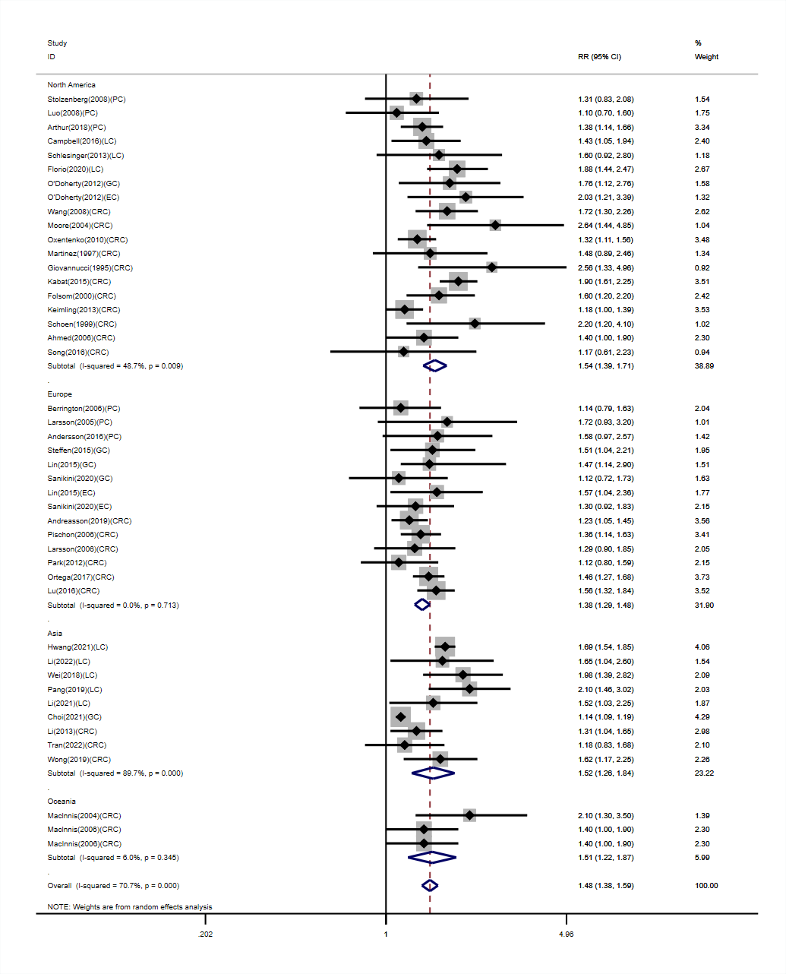
Figure S1. Subgroup analyses of WC and risk of DSC were performed by geographic region.

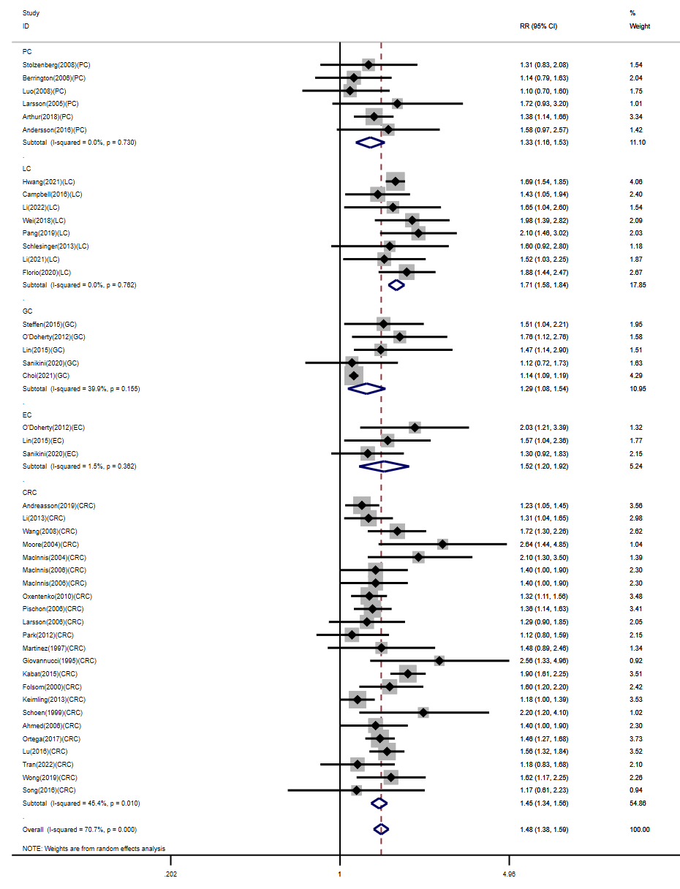

Figure S2. Subgroup analyses of WC and risk of DSC were performed by cancer type.

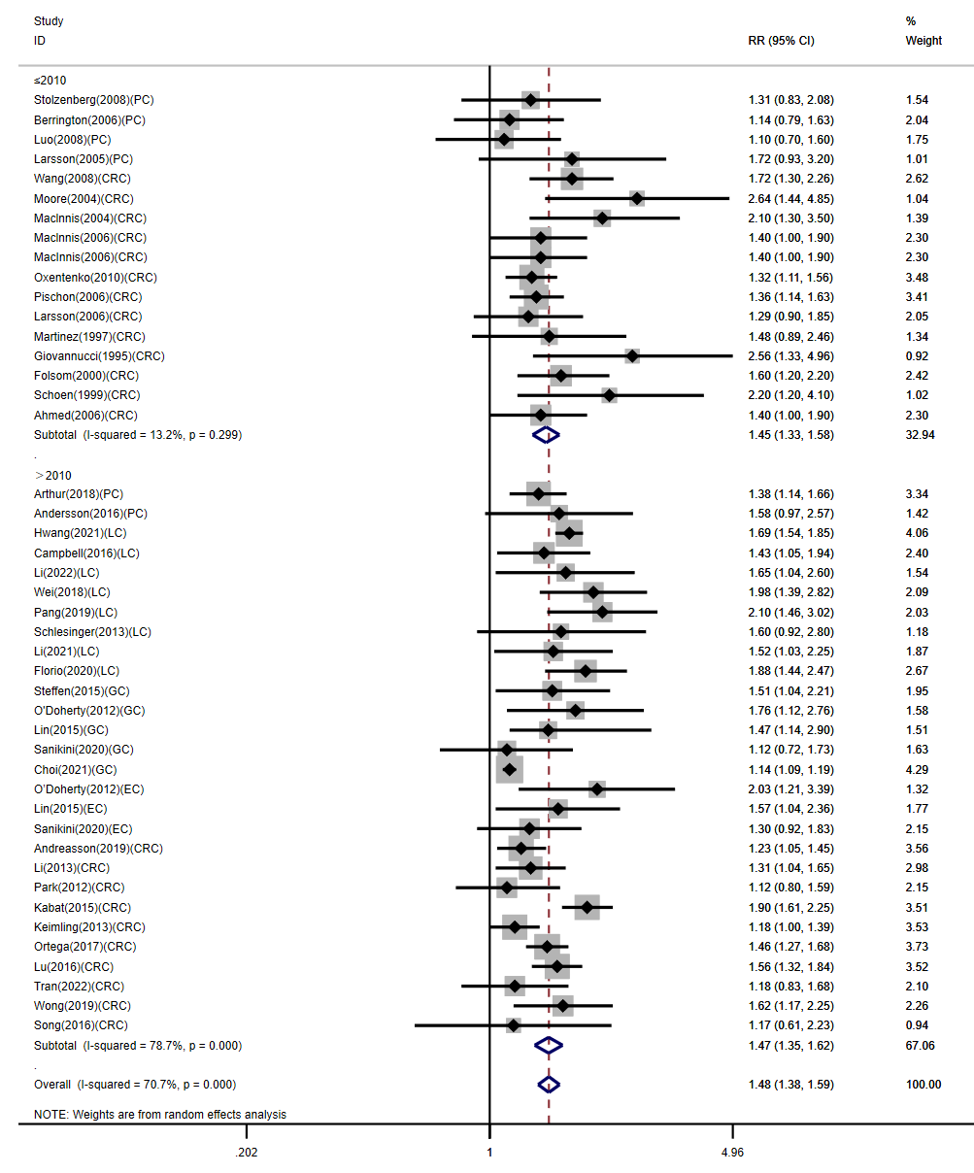

Figure S3. Subgroup analyses of WC and risk of DSC were performed by year of publication.

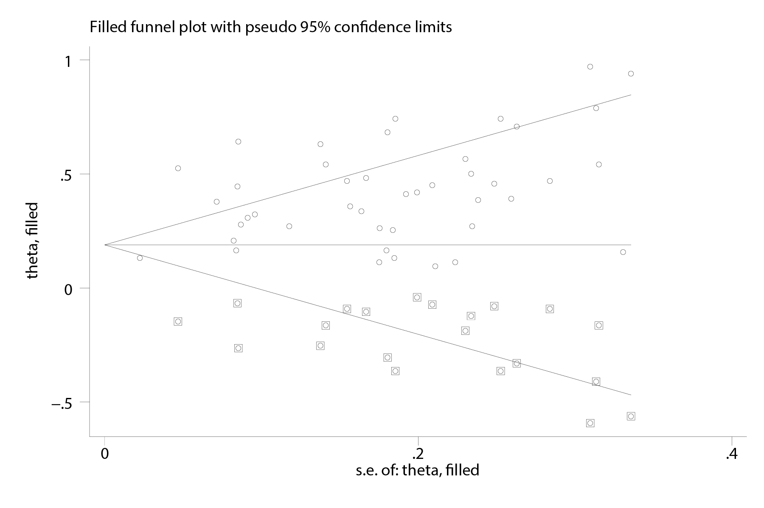
Figure S4. The trim and fill graph of the association between WC and DSC.

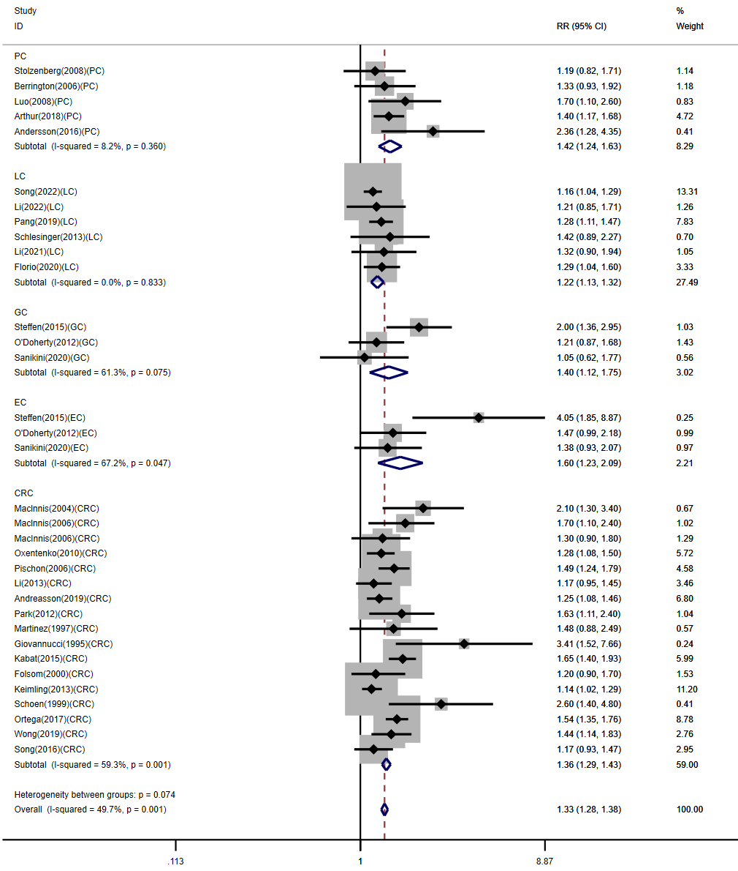
Figure S5. Subgroup analyses of WHR and risk of DSC were performed by cancer type.

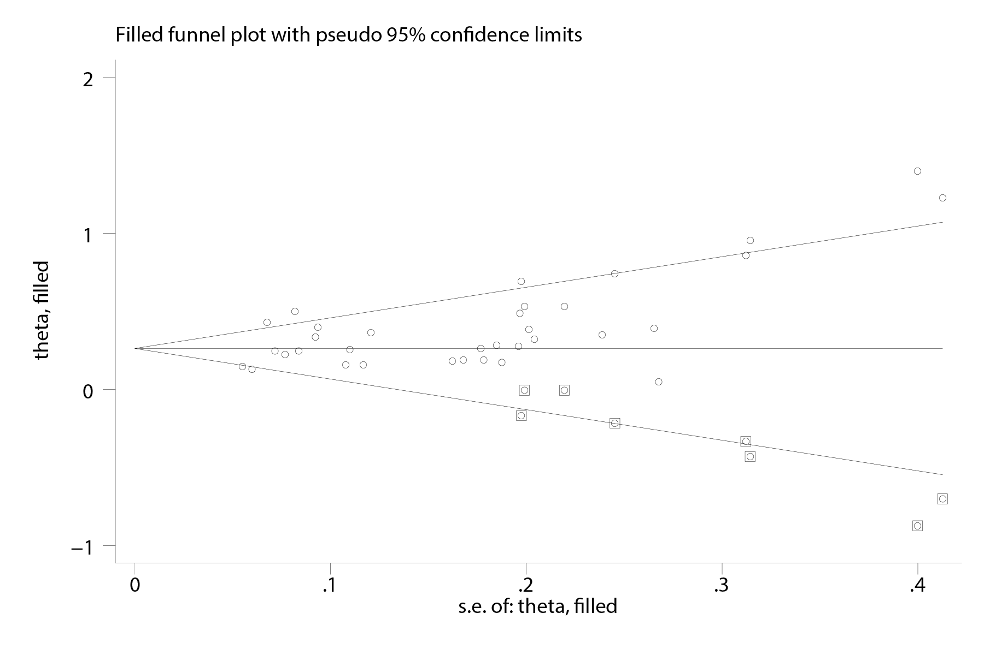
Figure S6. The trim and fill graph of the association between WHR and DSC.

