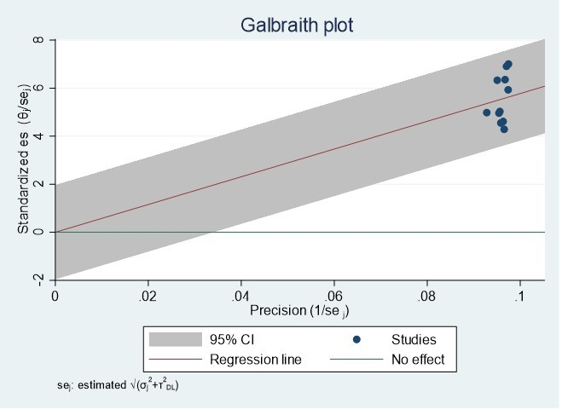
Supplementary figure 1 Galbraith plot showing no evidence of presence of outlier for estimating the prevalence of anemia in children aged 6-23 months in Ethiopia, 2023.
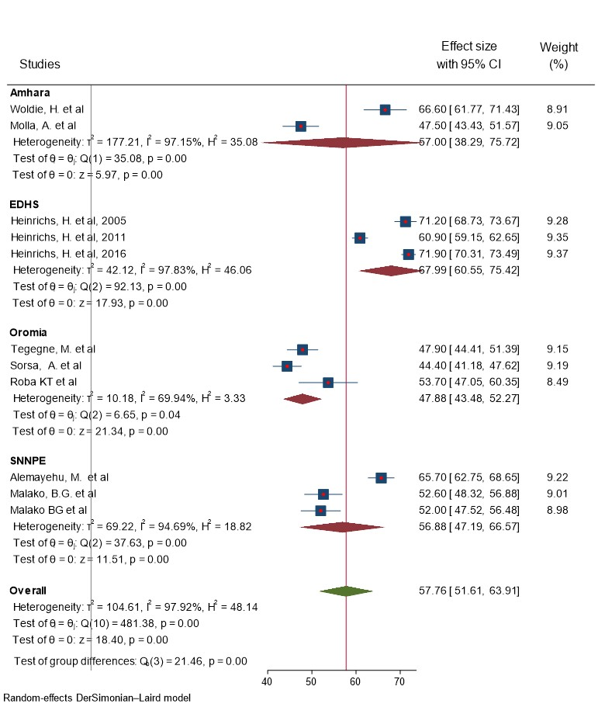
Supplementary figure 2 Forest plot of the included studies showing subgroup pooled prevalence of anemia using region among children aged 6-23 months in Ethiopia, 2023.

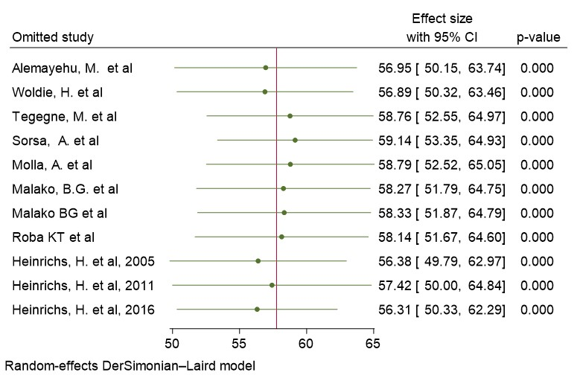
Supplementary figure 3 Forest plot of the included studies showing sensitivity analysis of the included studies on anemia among children aged 6-23 months in Ethiopia, 2023.
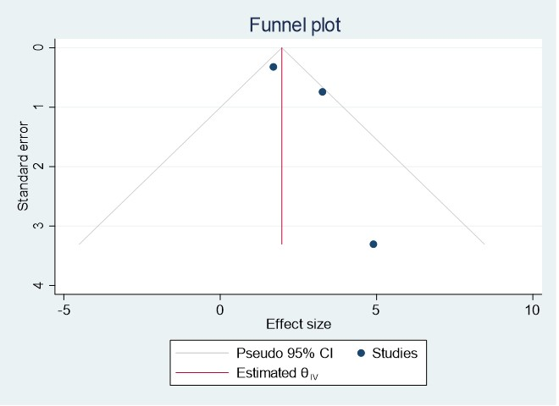
Supplementary figure 4 Funnel plot showing no evidence of publication bias estimating the AOR of the association between diarrhea and anemia in children aged 6-23 months in Ethiopia, 2023.
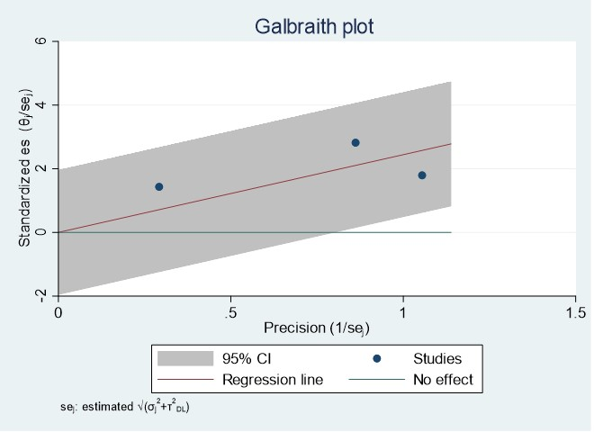
Supplementary figure 5 Galbraith plot showing no evidence of presence of outlier for estimating the prevalence of anemia in children aged 6-23 months in Ethiopia.
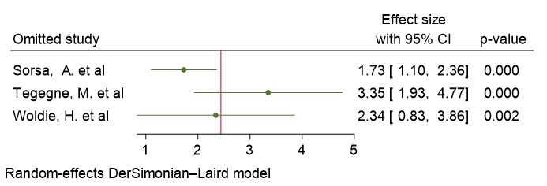
Supplementary figure 6 Forest plot showing sensitivity analysis by omitting one study at time to diagnose one study effect on the pooled AOR of diarrhea and anemia association among children aged 6-23 month in Ethiopia, 2023
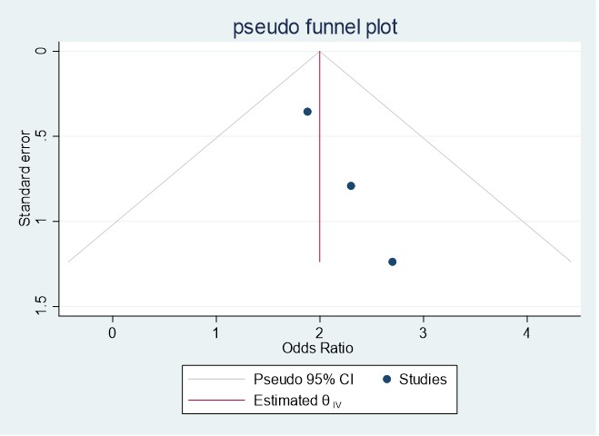

Supplementary figure 7 Funnel plot showing no evidence of publication bias estimating the AOR of the association between stunting and anemia in children aged 6-23 months in Ethiopia, 2023.
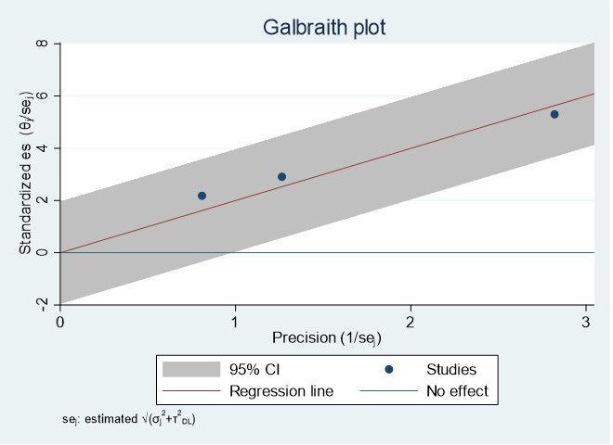
Supplementary figure 8 Galbraith plot showing no evidence of presence of outlier for estimating the prevalence of anemia in children aged 6-23 months in Ethiopia.
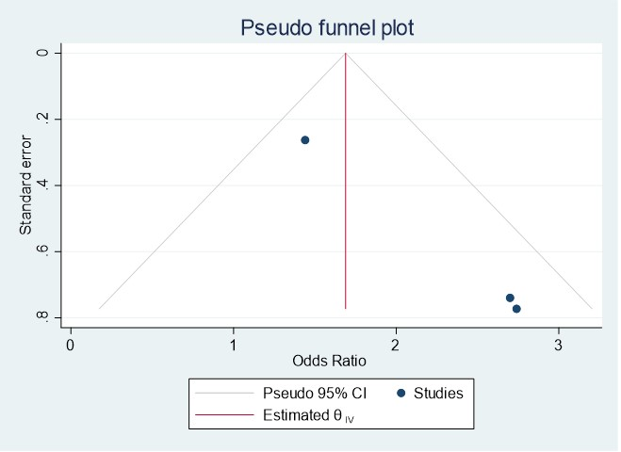
Supplementary figure 9 Funnel plot showing no evidence of publication bias estimating the AOR of the association between house hold food insecurity and anemia in children aged 6-23 months in Ethiopia, 2023.
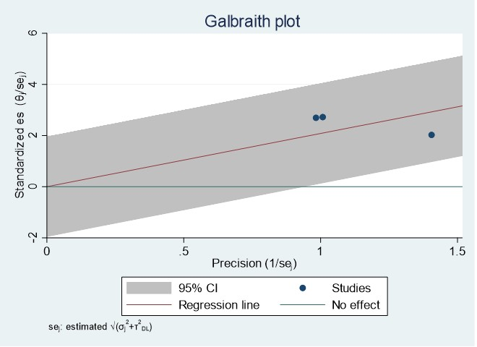 `
Supplementary figure 10 Galbraith plot showing no evidence of presence of outlier for estimating the prevalence of anemia in children aged 6-23 months in Ethiopia, 2023.
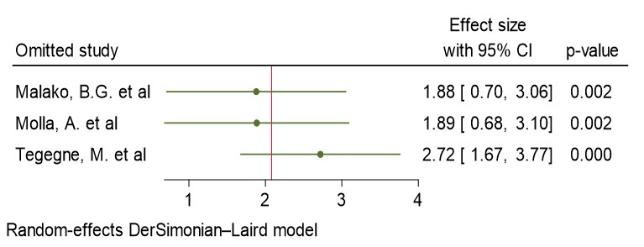 Supplementary figure 11 Forest plot showing sensitivity analysis by omitting one study at time to diagnose one study effect on the pooled AOR of house hold food insecurity and anemia association among children aged 6-23 month in Ethiopia, 2023
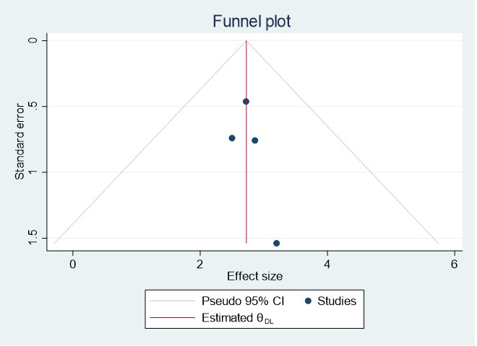
Supplementary figure 12 Funnel plot showing no evidence of publication bias estimating the AOR of the association between dietary diversity and anemia in children aged 6-23 months in Ethiopia, 2023.
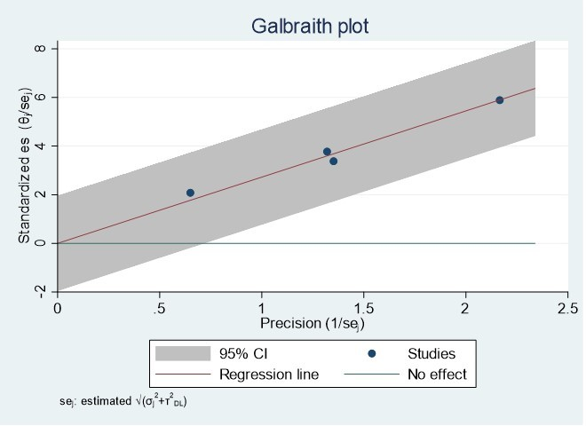
Supplementary figure 13 Galbraith plot showing no evidence of presence of outlier for estimating the prevalence of anemia in children aged 6-23 months in Ethiopia.
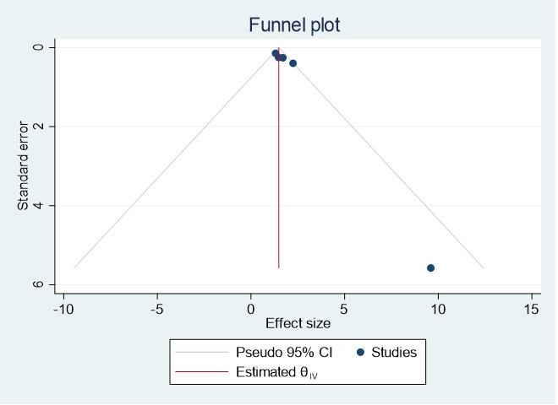
Supplementary figure 14 Funnel plot showing no evidence of publication bias estimating the AOR of the association between age and anemia in children aged 6-23 months in Ethiopia, 2023.
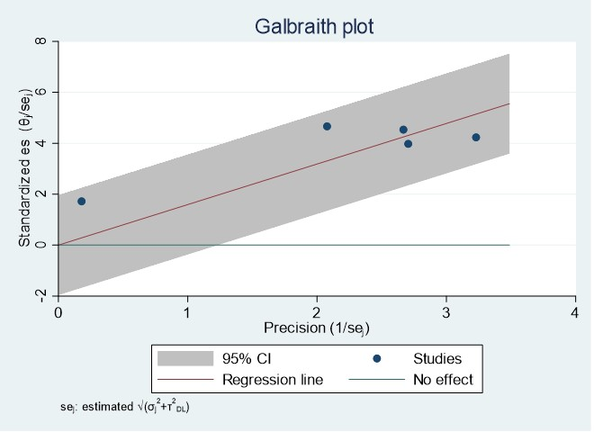
Supplementary figure 15 Galbraith plot showing no evidence of presence of outlier for estimating the prevalence of anemia in children aged 6-23 months in Ethiopia, 2023.
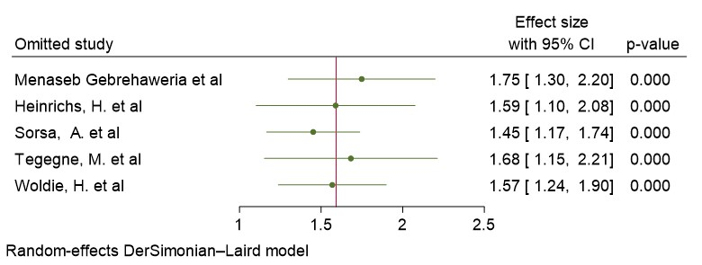
Supplementary figure 16 Forest plot showing sensitivity analysis by omitting one study at time to diagnose one study effect on the pooled AOR of age and anemia association among children aged 6-23 month in Ethiopia, 2023

