Cost-utility and budget impact analyses of cervical cancer screening using self-collected samples for HPV DNA testing in Thailand
Chayanis Kositamongkol¹, Sukrit Kanchanasurakit^{2–5}, Euarat Mepramoon¹, Pattarawalai Talungchit⁶, Pattama Chaopotong⁶, Kirati Kengkla², Thanet Chaisathaphol¹, Surasak Saokaew^{2,4–5*}, Pochamana Phisalprapa^{1*}
¹Division of Ambulatory Medicine, Department of Medicine, Faculty of Medicine Siriraj Hospital, Mahidol University, Bangkok, Thailand
²Division of Pharmacy Practice, Department of Pharmaceutical Care, School of Pharmaceutical Sciences, University of Phayao, Phayao, Thailand
³Division of Pharmaceutical Care, Department of Pharmacy, Phrae Hospital, Phrae, Thailand
⁴Center of Health Outcomes Research and Therapeutic Safety (Cohorts), School of Pharmaceutical Sciences, University of Phayao, Phayao, Thailand
⁵Unit of Excellence on Clinical Outcomes Research and IntegratioN (UNICORN), School of Pharmaceutical Sciences, University of Phayao, Phayao, Thailand
⁶Department of Obstetrics and Gynecology, Faculty of Medicine Siriraj Hospital, Mahidol University, Bangkok, Thailand

* Correspondence:
Pochamana Phisalprapa (coco_a105@hotmail.com);
Surasak Saokaew (surasak.sa@up.ac.th)

Keywords: budget impact, cervical cancer, cost-utility, HPV, human papillomavirus, policy, screening
Supplementary Appendix 1: Mortality rates
Supplementary Appendix 2: Costs of management of cervical intraepithelial neoplasia and cervical cancer
Supplementary Appendix 3: Thai female population
Supplementary Appendix 4: Model outputs
Supplementary Appendix 5: Model validation
Supplementary Appendix 1: Mortality rates
Table S1 Mortality rates
Age (years) | ASMR (1) | All-cause mortality in women with cervical cancer (2) |  |  | Cervical cancer-specific mortality rate
Age (years) | ASMR (1) | Stage 1 | Stage 2-3 | Stage 4 | Stage 1 | Stage 2-3 | Stage 4
25-29 | 0.0007 | 0.0990 | 0.1920 | 0.4120 | 0.0983 | 0.1913 | 0.4113
30-34 | 0.0009 | 0.0410 | 0.3600 | 0.7880 | 0.0401 | 0.3591 | 0.7871
35-39 | 0.0010 | 0.0410 | 0.3600 | 0.7880 | 0.0400 | 0.3590 | 0.7870
40-44 | 0.0020 | 0.1070 | 0.3880 | 0.5475 | 0.1050 | 0.3860 | 0.5455
45-49 | 0.0020 | 0.1070 | 0.3880 | 0.5475 | 0.1050 | 0.3860 | 0.5455
50-54 | 0.0030 | 0.1575 | 0.3850 | 0.6075 | 0.1545 | 0.3820 | 0.6045
55-59 | 0.0040 | 0.1575 | 0.3850 | 0.6075 | 0.1535 | 0.3810 | 0.6035
60-64 | 0.0070 | 0.3300 | 0.4235 | 0.7325 | 0.3230 | 0.4165 | 0.7255
65-69 | 0.0120 | 0.3300 | 0.4235 | 0.7325 | 0.3180 | 0.4115 | 0.7205
70-74 | 0.0180 | 0.1820 | 0.4150 | 0.7030 | 0.1640 | 0.3970 | 0.6850
75-79 | 0.0300 | 0.1820 | 0.4150 | 0.7030 | 0.1520 | 0.3850 | 0.6730
80-84 | 0.0510 | 0.1820 | 0.4150 | 0.7030 | 0.1310 | 0.3640 | 0.6520
≥85 | 0.1200 | 0.1820 | 0.4150 | 0.7030 | 0.0620 | 0.2950 | 0.5830
ASMR, age-, sex- and race-specific mortality rate
Supplementary Appendix 2: Costs of management of cervical intraepithelial neoplasia and cervical cancer
Direct medical costs
Data were extracted from the Siriraj electronic database using the following inclusion criteria:
- Women aged ≥15 years
- ICD-10: C53 (malignant neoplasm of cervix uteri), D06 (carcinoma in situ of cervix uteri), and N87 (dysplasia of cervix uteri)
- Diagnosis period between January 1, 2015, and December 31, 2021
Exclusion criteria included cases with undocumented disease severity and missing data that prevented cost calculations. The Figure S1 shows the number of women used to calculate the costs.

Figure S1 Number of women used to calculate the costs of cervical intraepithelial neoplasia and cervical cancer management
A total of 1423 women were included in the cost analysis, with an average age of 54.7 ± 14.7 years. The median follow-up time was 1.5 years (interquartile range: 0.4, 3.5). Outpatient department visits totaled 43 295, while inpatient department visits amounted to 4871. The annual number of visits and median costs per visit for each disease stage are presented in Table S2.
Table S2 Costs of cervical intraepithelial neoplasia and cervical cancer management
Health states | Number of visits  per year | Median costs  (THB per visit) | SE | Range  (P5, P95)
Outpatient department
CIN1 | 2 | 268 | 148 | 34, 885
CIN2 | 4 | 818 | 192 | 185, 2978
CIN3 | 5 | 911 | 220 | 46, 6790
Stage 1 | 10 | 2145 | 93 | 381, 5401
Stage 2 | 16 | 3632 | 123 | 502, 6741
Stage 3 | 19 | 3933 | 159 | 684, 7882
Stage 4 | 24 | 3282 | 218 | 768, 8280
Inpatient department
CIN1 | 1 | 33 724 | 9100 | 7209, 69 124
CIN2 | 1 | 26 200 | 24 924 | 13 440, 104 676
CIN3 | 1 | 39 333 | 4663 | 17 863, 88 450
Stage 1 | 1 | 66 401 | 2788 | 8863, 144 817
Stage 2 | 2 | 25 105 | 4095 | 5514, 156 374
Stage 3 | 2 | 26 120 | 4128 | 5001, 161 374
Stage 4 | 4 | 27 921 | 5523 | 5899, 172 960
P5, 5th percentile; P95, 95th percentile; SE, standard error
Supplementary Appendix 3: Thai female population
Table S3 Number of Thai female population (3)
Age (years) | Female population (people) | Age (years) | Female population (people)
25 | 478 437 | 46 | 531 361
26 | 488 485 | 47 | 521 791
27 | 484 247 | 48 | 532 804
28 | 467 172 | 49 | 523 406
29 | 472 009 | 50 | 541 371
30 | 479 796 | 51 | 551 285
31 | 475 921 | 52 | 538 636
32 | 471 308 | 53 | 532 115
33 | 451 904 | 54 | 551 273
34 | 442 779 | 55 | 524 238
35 | 443 535 | 56 | 515 287
36 | 458 754 | 57 | 520 273
37 | 476 576 | 58 | 519 014
38 | 480 383 | 59 | 483 306
39 | 493 445 | 60 | 469 053
40 | 511 709 | 61 | 447 543
41 | 511 974 | 62 | 448 965
42 | 522 686 | 63 | 426 963
43 | 525 009 | 64 | 393 606
44 | 510 156 | 65 | 377 736
45 | 535 634

Supplementary Appendix 4: Model outputs
Table S4 Model outputs
Outcomes | No screening | Clinician-collected samples for cytology test | Clinician-collected samples for  HPV DNA testing | Self- and clinician-  collected samples  for HPV DNA testing
Base-case analysis (women age ≥25 years, screening age 25–65 years)
Cervical cancer incidence (cases per 100 000 women) | 25.3 | 17.7 | 17.5 | 10.3
Death from cervical cancer (deaths per 100 000 women) | 22.9 | 16.1 | 15.8 | 9.8
Death from other causes (deaths per 100 000 women) | 963.6 | 970.4 | 970.6 | 976.6
Screening rate (%) |  | 26% | 25% | 70%
Completed screening rate with follow-up colposcopy (%) |  | 25% | 24% | 68%
Total screening costª (THB per 100 000 women) |  | 1 311 357 | 781 063 | 1 884 813
Total cancer prevention cost^{b} (THB per 100 000 women) | 41 134 051 | 35 620 955 | 34 395 576 | 29 950 372
Total cancer treatment cost^{c} (THB per 100 000 women) | 6 516 748 | 4 502 636 | 4 454 744 | 3 101 396
Cervical cancer incidence^{d} (cases) | 6228 | 4370 | 4308 | 2547
Death from cervical cancer^{d} (deaths) | 5638 | 3962 | 3906 | 2423
Scenario analysis (women age ≥30 years, screening age 30–65 years)
Cervical cancer incidence (cases per 100 000 women) | 27.9 | 20.0 | 19.8 | 12.8
Death from cervical cancer (deaths per 100 000 women) | 25.2 | 18.1 | 17.9 | 12.0
Death from other causes (deaths per 100 000 women) | 926.9 | 970.0 | 970.2 | 976.0
Screening rate (%) |  | 25% | 24% | 71%
Completed screening rate with follow-up colposcopy (%) |  | 23% | 22% | 68%
Total screening costª (THB per 100 000 women) |  | 1 145 695 | 696 149 | 1 797 017
Total cancer prevention cost^{b} (THB per 100 000 women) | 49 219 113 | 43 145 345 | 42 034 241 | 37 320 527
Total cancer treatment cost^{c} (THB per 100 000 women) | 6 774 009 | 4 808 614 | 4 768 373 | 3 436 733
Cervical cancer incidence^{d} (cases) | 6214 | 4452 | 4405 | 2841
Death from cervical cancer^{d} (deaths) | 5615 | 4028 | 3985 | 2679
ª Screening cost = screening costs in normal and HPV-infected health states
^{b} Cancer prevention cost = screening costs + CIN1–3 treatment costs
^{c} Cancer treatment cost = cervical cancer stage 1–4 treatment costs
^{d} Calculated based on the total number of Thai women aged ≥ 25 = 24 644 349 women and aged ≥ 30 = 22 253 999 women
Table S5 Model relative outputs
Outcomes | Clinician-collected samples for  cytology test  versus  no screening | Clinician-collected samples for  HPV DNA testing  versus  clinician-collected samples for  cytology test | Self- and clinician-  collected samples  for HPV DNA testing  versus  clinician-collected samples for  HPV DNA testing | Unit (per year)
Base-case analysis (women age ≥25 years, screening age: 25-65 years)
Incidence case prevented | 7.5 | 0.2 | 7.1 | cases per 100 000 women
New case prevented | 1858 | 61 | 1762 | women
Cervical cancer death averted | 7 | 0.2 | 6 | deaths per 100 000 women
Cervical cancer death avertedª | 1676 | 56 | 1483 | deaths
Number needed to screenª | 13 264 | 401 082 | 13 990 | women
Scenario analysis (women age ≥30 years, screening age: 30-65 years)
Incidence case prevented | 7.9 | 0.2 | 7.0 | cases per 100 000 women
New case prevented | 1761 | 48 | 1564 | women
Cervical cancer death averted | 7 | 0.2 | 6 | deaths per 100 000 women
Cervical cancer death avertedª | 1587 | 43 | 1306 | deaths
Number needed to screenª | 12 636 | 468 172 | 14 232 | women
ª Calculated based on the total number of Thai women aged ≥ 25 = 24 644 349 women and aged ≥ 30 = 22 253 999 women

Supplementary Appendix 5: Model validation
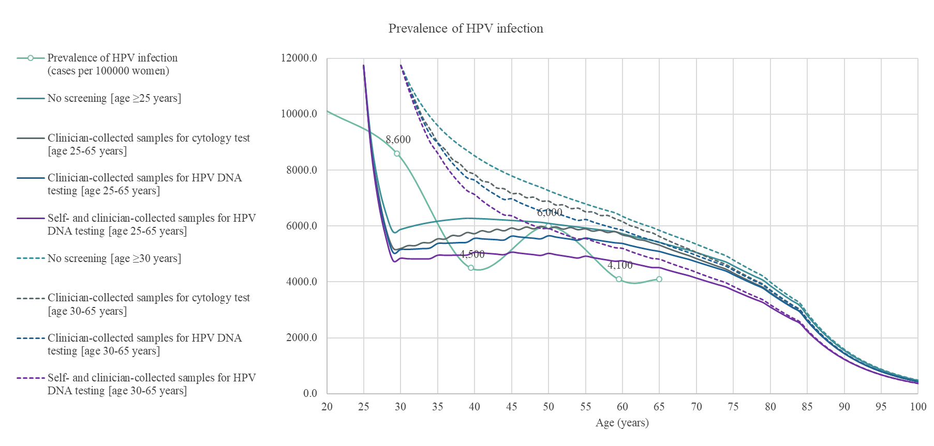
Figure S2 Prevalence of HPV infection

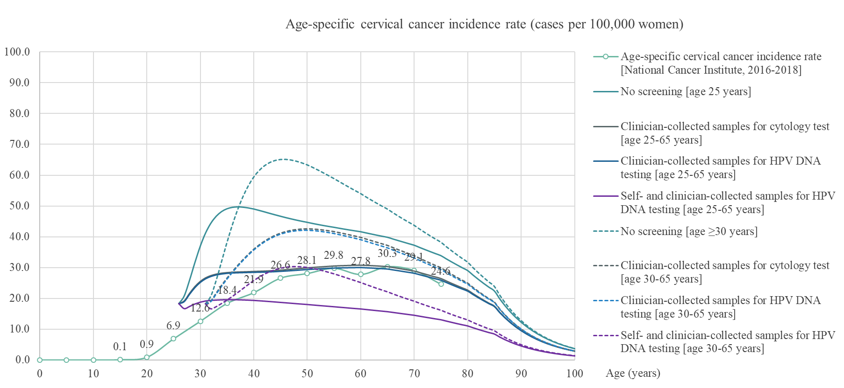
Figure S3 Age-specific cervical cancer incidence rate

References
1. Life tables by country: Thailand. World Health organization. 2019. [Internet]. Available from: https://www.who.int/data/gho/data/indicators/indicator-details/GHO/gho-ghe-life-tables-nmx-age-specific-death-rate-between-ages-x-and-x-plus-n.
2. Termrungruanglert W, Khemapech N, Vasuratna A, Havanond P, Deebukkham P, Kulkarni AS, et al. The epidemiologic and economic impact of a quadrivalent human papillomavirus vaccine in Thailand. PLoS One. 2021;16(2):e0245894.
3. Civil Registration Population Statistics [Internet]. 2022 [cited Jan 1, 2023]. Available from: https://stat.bora.dopa.go.th/stat/statnew/statMONTH/statmonth/#/displayData.

