Supplementary Materials

Table 1: Mean of daily energy and nutrient intake estimated by the FFQ and the 3-day food record (FR)
Energy/nutrient | Total  (n = 126) |  | Female  (n = 80) |  | Male  (n = 46)
Energy/nutrient | FFQ | 3-day FR | FFQ | 3-day FR | FFQ | 3-day FR
Energy (kcal) | 1834 ± 367 | 1717 ± 381 | 1652 ± 296 | 1535 ± 316 | 2150 ± 243 | 2033 ± 259
Protein (g) | 71 ± 19 | 65 ± 18 | 61 ± 13 | 56 ± 13 | 88 ± 14 | 80 ± 16
Carbohydrate (g) | 250 ± 50 | 221 ± 58 | 233 ± 48 | 200 ± 50 | 279 ± 39 | 260 ± 53
Total Fat (g) | 64 ± 19 | 66 ± 20 | 56 ± 16 | 59 ± 19 | 79 ± 14 | 77 ± 18
SFA (g) | 21 ± 6 | 24 ± 20 | 18 ± 5 | 19 ± 7 | 25 ± 6 | 32 ± 31
MUFA (g) | 18 ± 6 | 15 ± 6 | 16 ± 6 | 13 ± 6 | 21 ± 4 | 18 ± 6
PUFA (g) | 9 ± 4 | 8 ± 5 | 8 ± 5 | 8 ± 4 | 10 ± 3 | 11 ± 6
Cholesterol (mg) | 231 ± 103 | 258 ± 138 | 181 ± 54 | 196 ± 92 | 317 ± 111 | 366 ± 140
Fiber (g) | 16 ± 5 | 12 ± 5 | 16 ± 4 | 12 ± 5 | 16 ± 6 | 11 ± 4
Vit. A (RE) | 1027 ± 485 | 734 ± 763 | 942 ± 388 | 615 ± 779 | 1175 ± 594 | 941 ± 695
Vit. C (mg) | 133 ± 67 | 65 ± 59 | 136 ± 70 | 60 ± 48 | 129 ± 62 | 74 ± 74
Calcium (mg) | 696 ± 199 | 568 ± 243 | 669 ± 160 | 539 ± 203 | 743 ± 248 | 619 ± 297
Iron (mg) | 12 ± 3 | 10 ± 3 | 11 ± 3 | 9 ± 3 | 13 ± 3 | 12 ± 2
Total Sugar (g) | 114 ± 35 | 89 ± 45 | 108 ± 37 | 70 ± 28 | 124 ± 29 | 112 ± 59
SFA: saturated fatty acids; MUFA: monounsaturated fatty acids; PUFA: polyunsaturated fatty acids; FFQ: food frequency questionnaire; 3-dayFR: 3-day food records
Data are presented as mean ± SD

Table 2: Mean of daily protein intake estimated by the FFQ, 3-day food record (FR), and 24-hr urine urea nitrogen
Energy/nutrient | Total  (n = 118) |  |  | Female  (n = 72) |  |  | Male  (n = 46)
Energy/nutrient | FFQ | 3-day FR | 24-hr UUN | FFQ | 3-day FR | 24-hr UUN | FFQ | 3-day FR | 24-hr UUN
Protein (g) | 71 ± 19 | 65 ± 19 | 66 ± 17 | 61 ± 14 | 55 ± 13 | 60 ± 15 | 88 ± 14 | 80 ± 16 | 75 ± 16
FFQ: food frequency questionnaire; 3-dayFR: 3-day food records; 24-hr UUN: 24 hour urinary urea nitrogen
Data are presented as mean ± SD

Figure 1: Blond Altman plots for energy, macronutrients, and micronutrients intake with mean difference and limits of agreements. A) Energy. B) Protein. C) Carbohydrates. D) Total fat. E) Saturated fatty acids. F) Monounsaturated fatty acids. G) Polyunsaturated fatty acids. H) Cholesterol. I) Fiber. J) Vit. A. K) Vit. C. L) Calcium. M) Iron. N) Total sugar
- Energy
Total Sample

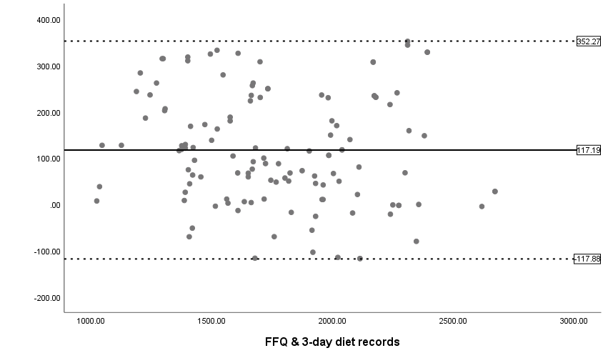
Female
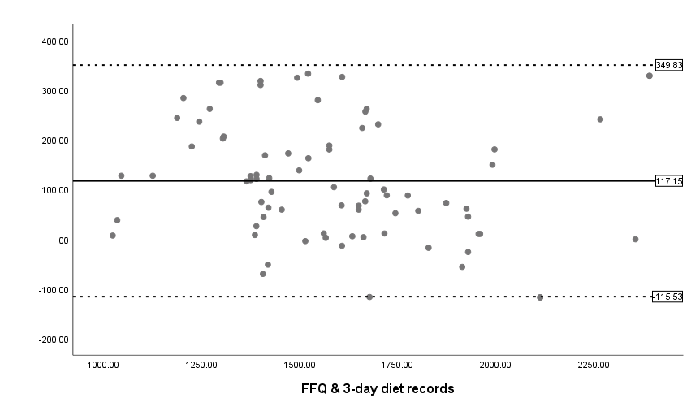

Male
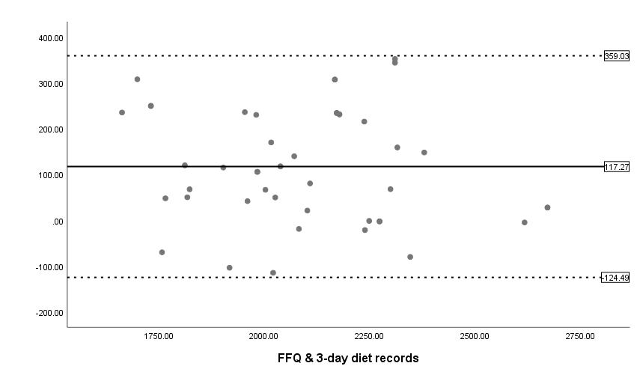

- Protein
Total Sample

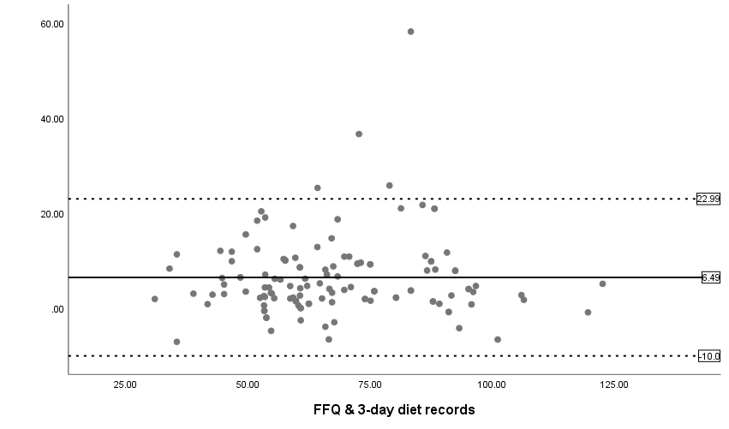
Female
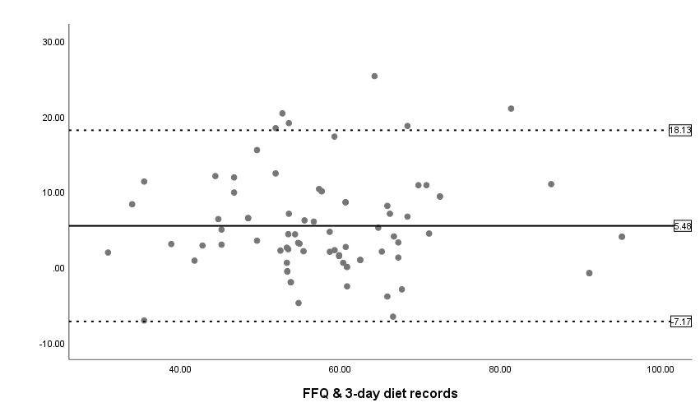
Male
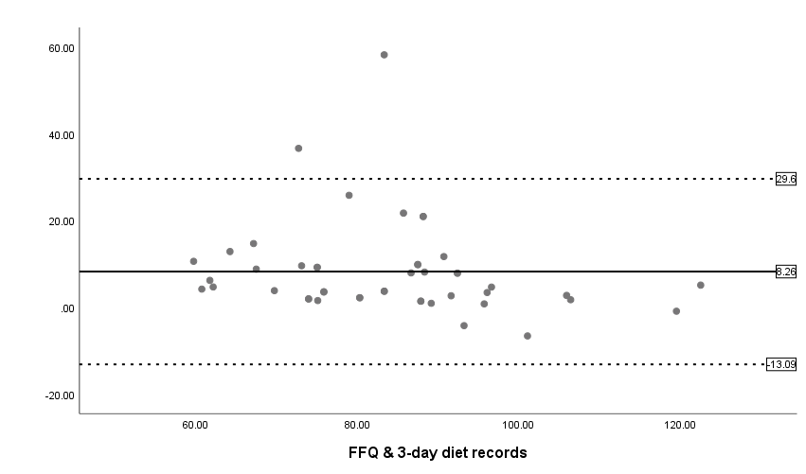

- Carbohydrate
Total Sample
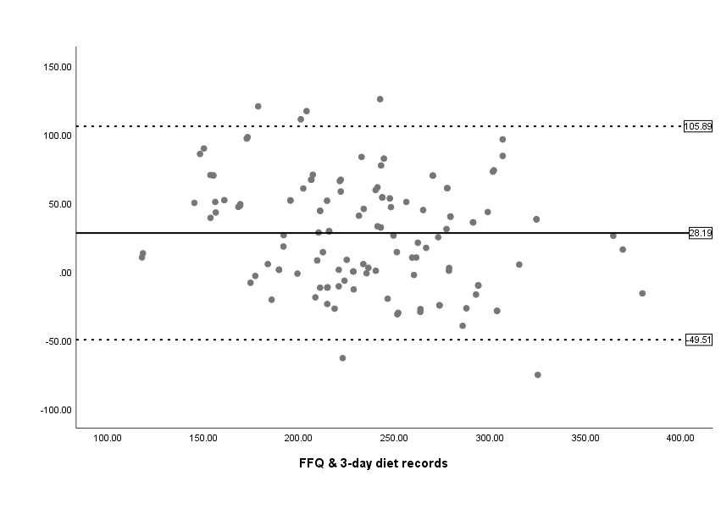
Female
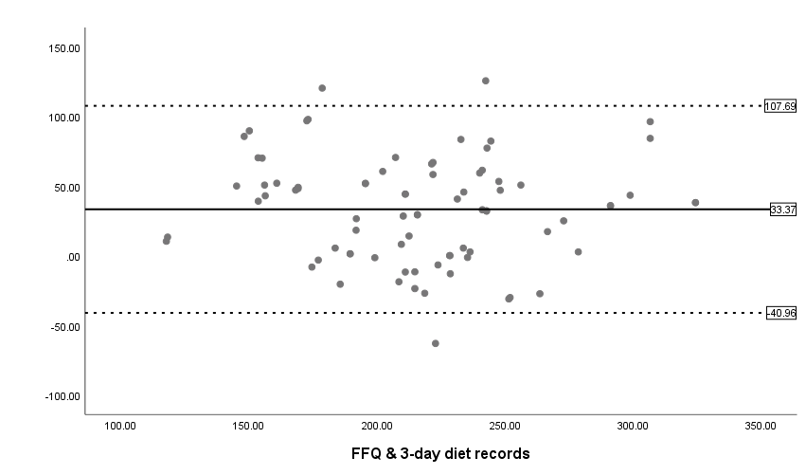

Male
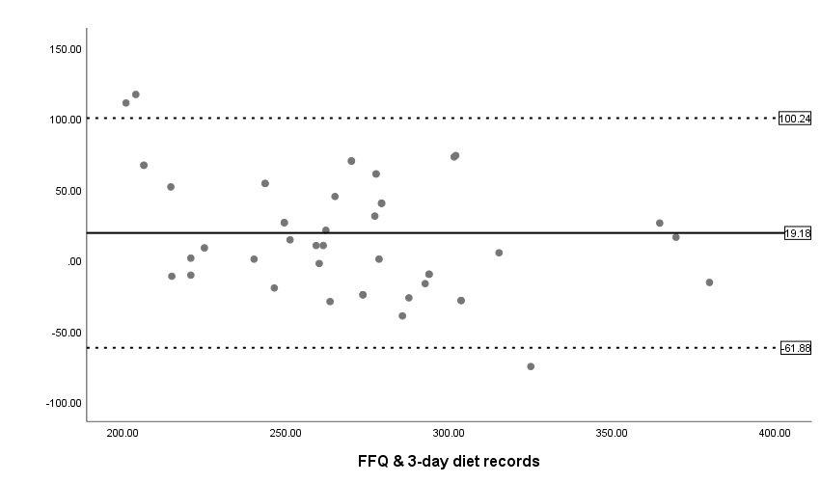

- Total fat
Total Sample
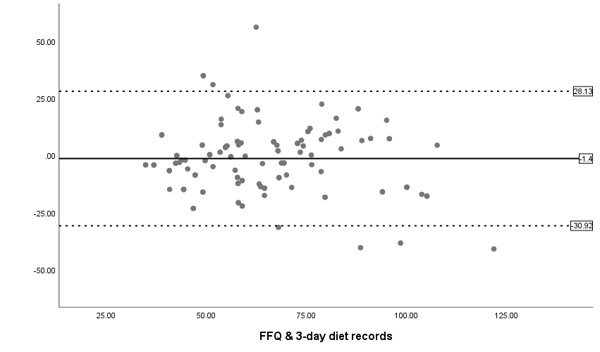
Female
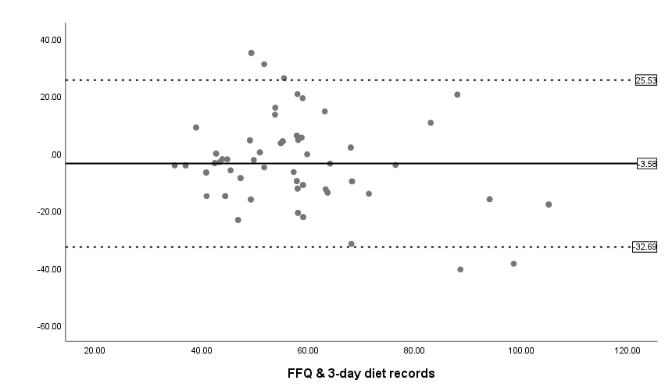
Male
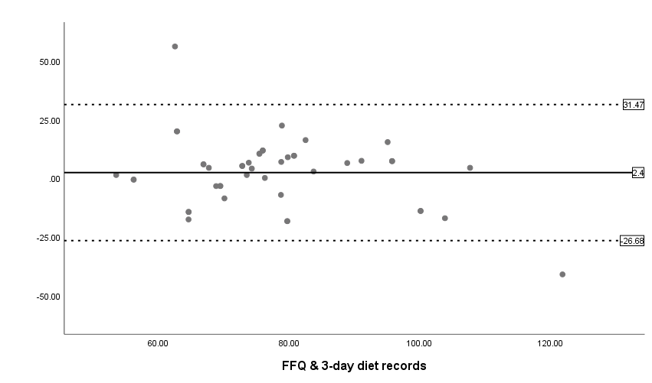

- Saturated fatty acids (SFA)
Total Sample
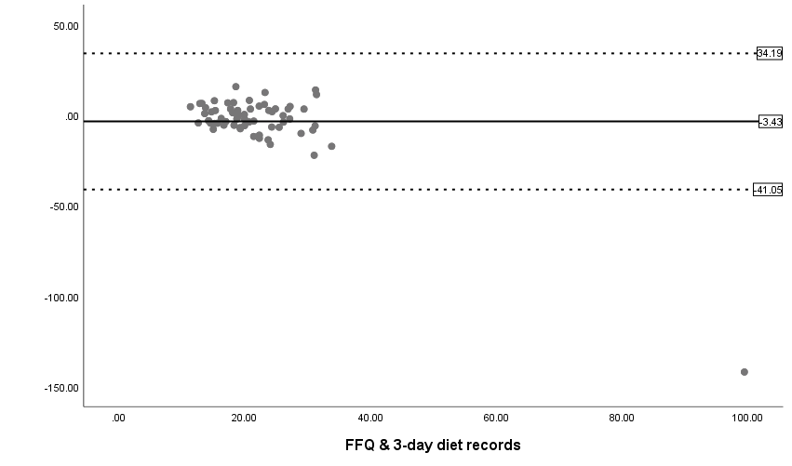
Female
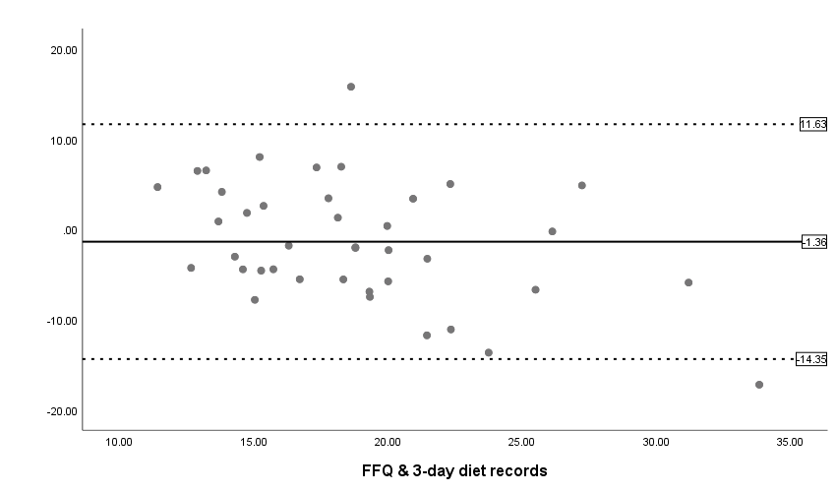

Male
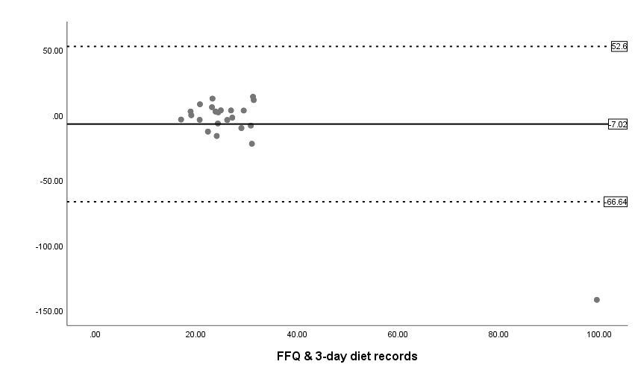

- Monounsaturated fatty acids
Total Sample
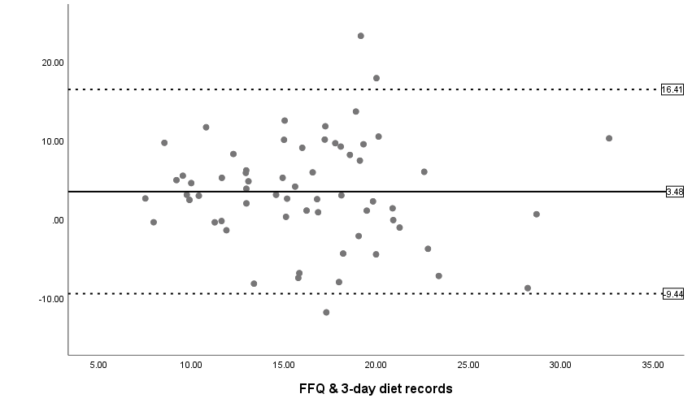
Female
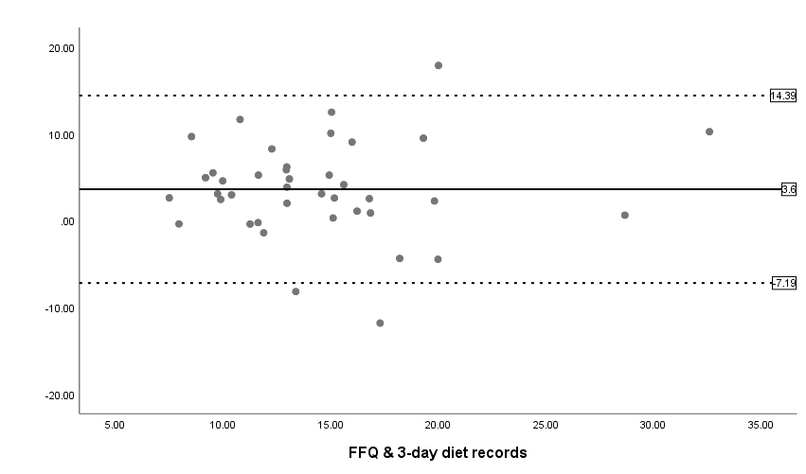

Male
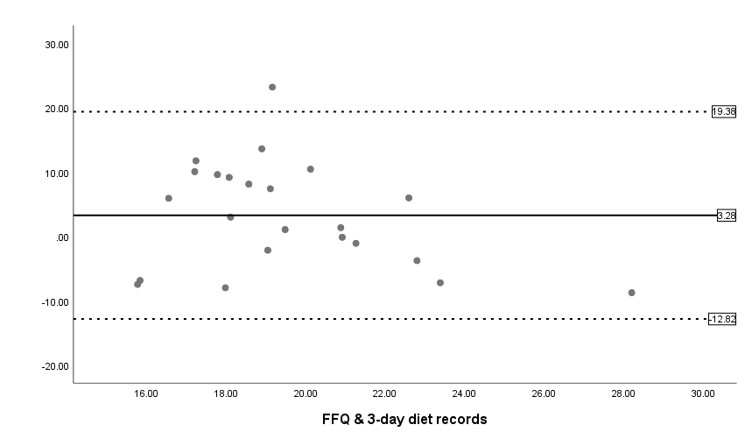

- Polyunsaturated fatty acids (PUFA)
Total Sample
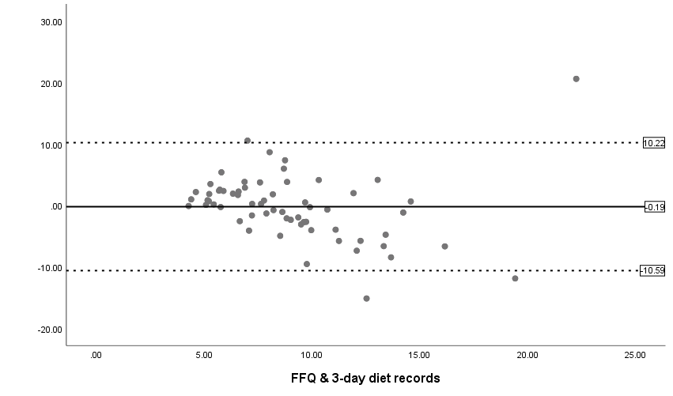
Female
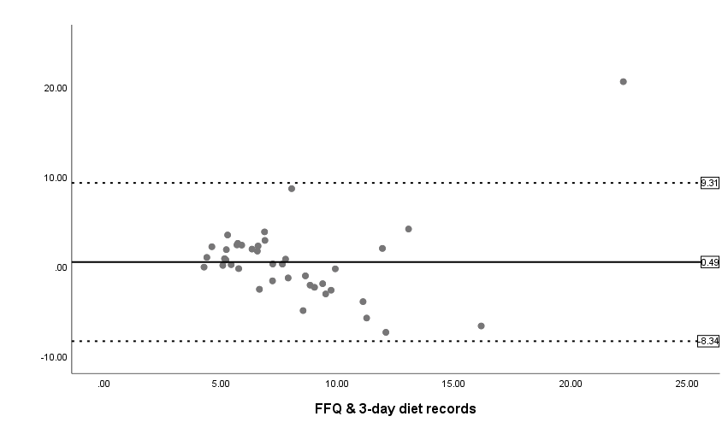

Male
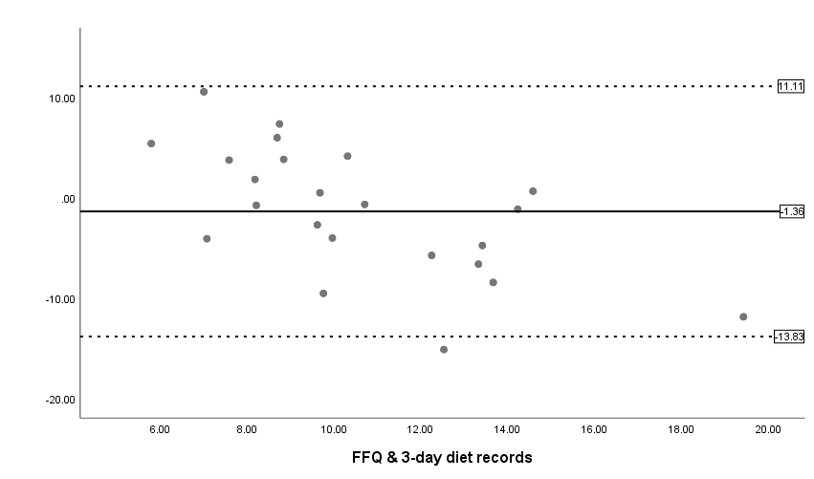

- Cholesterol
Total Sample
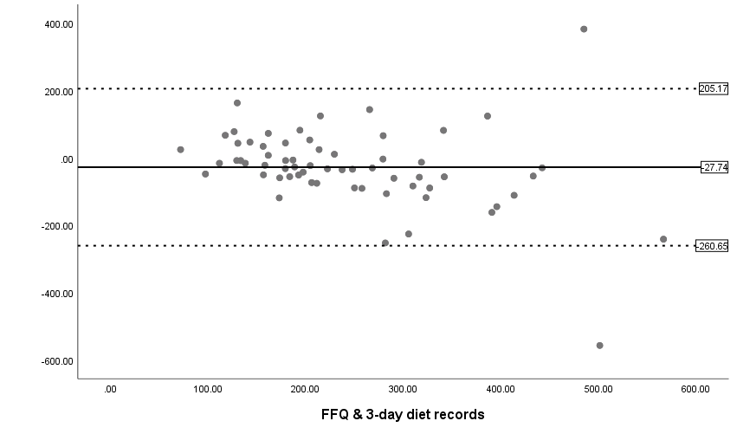
Female
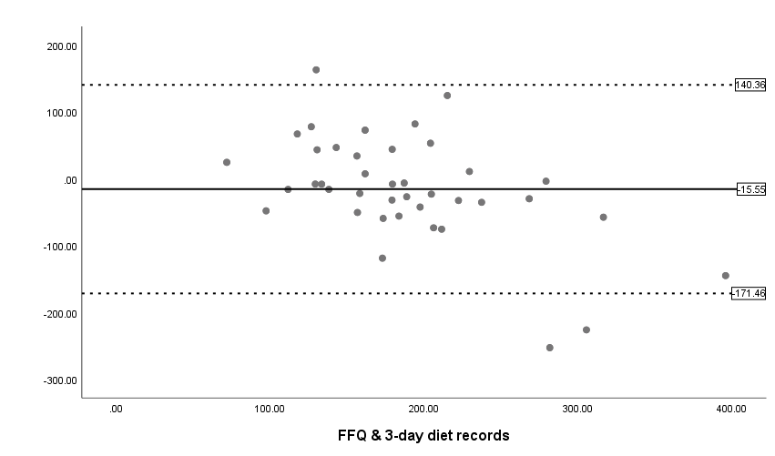

Male
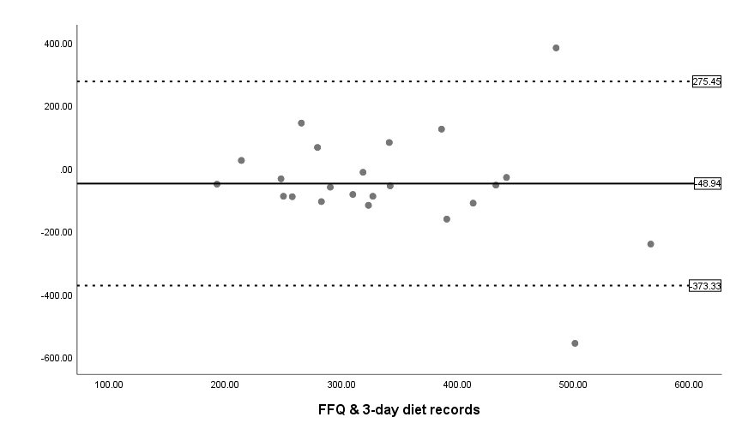

- Fiber
Total Sample
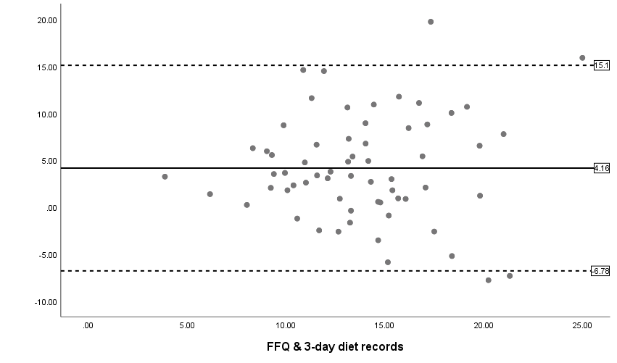

Female
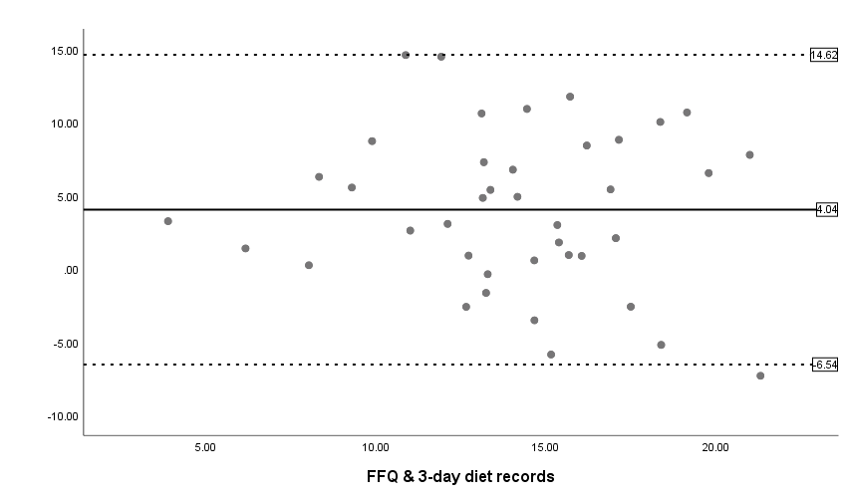

Male
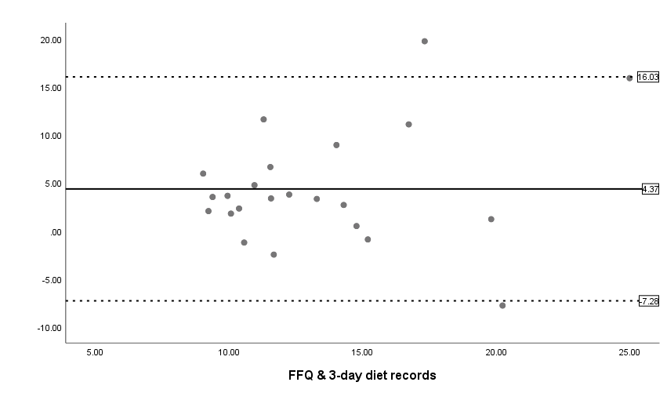

- Vit. A
Total Sample

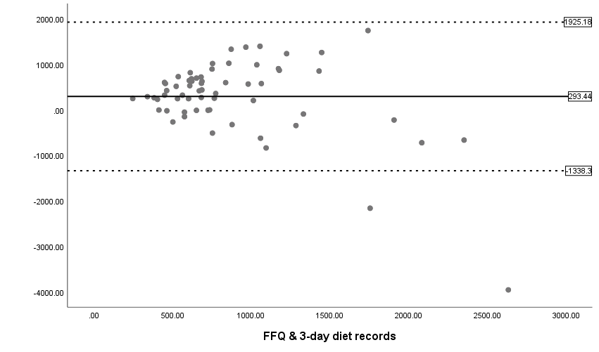
Female
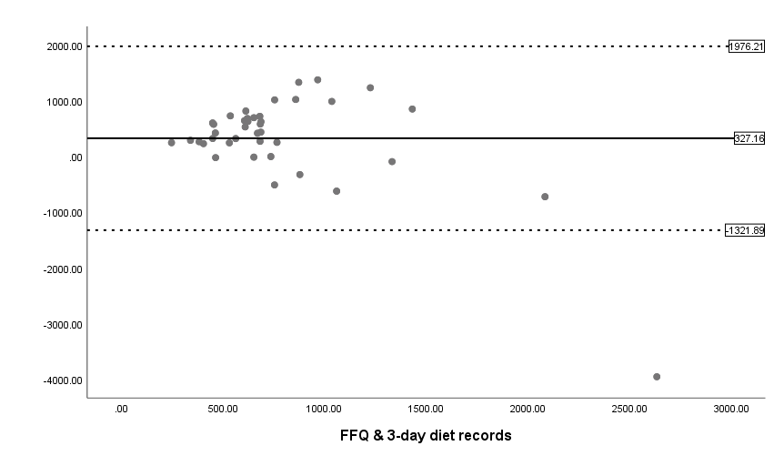
Male
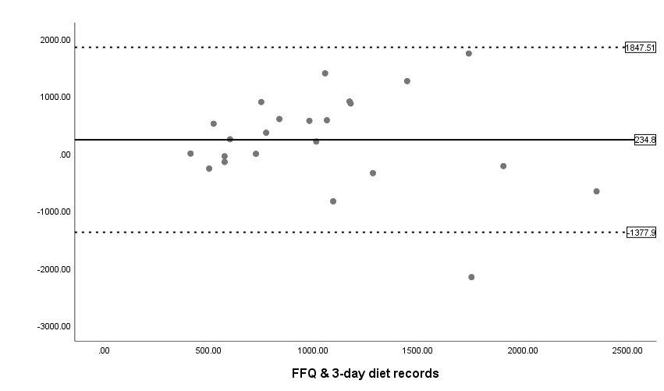

- Vit. C
Total Sample

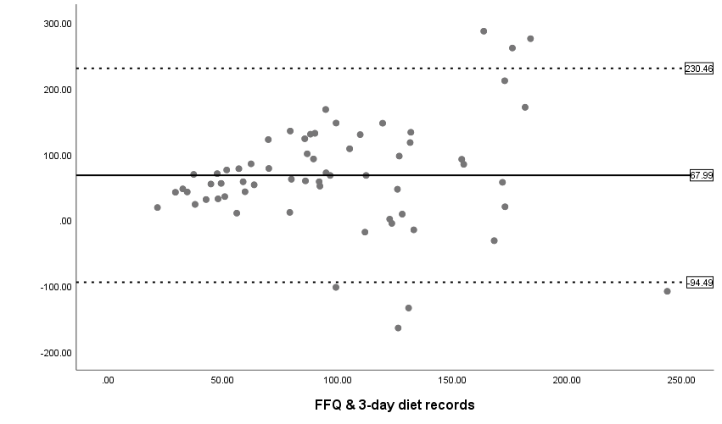
Female
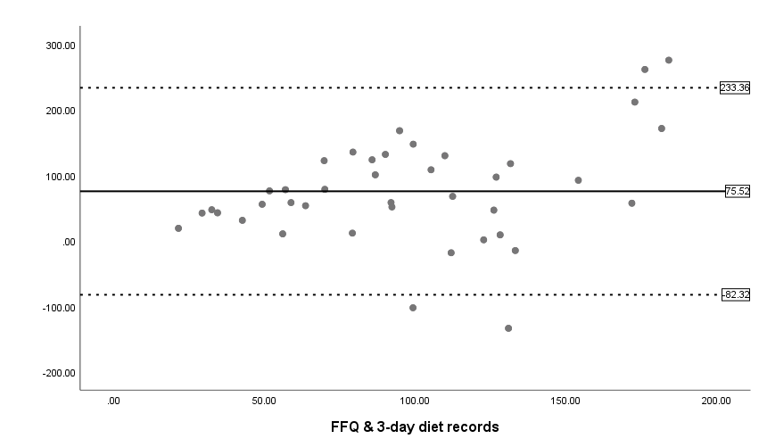

Male
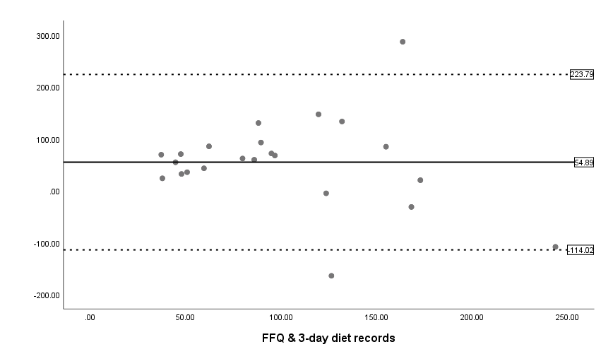

- Calcium
Total Sample
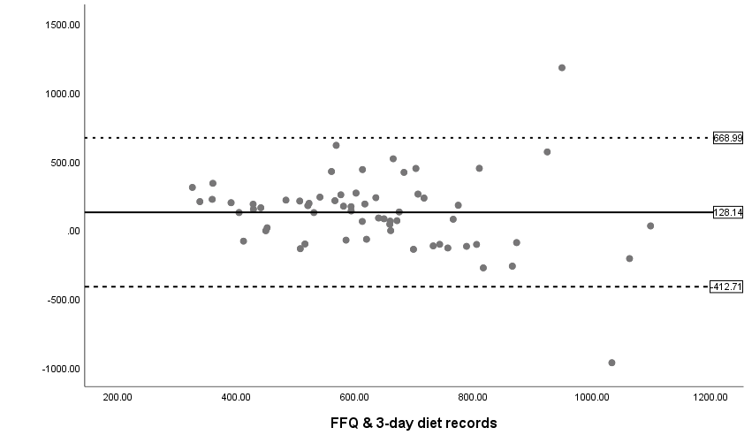
Female
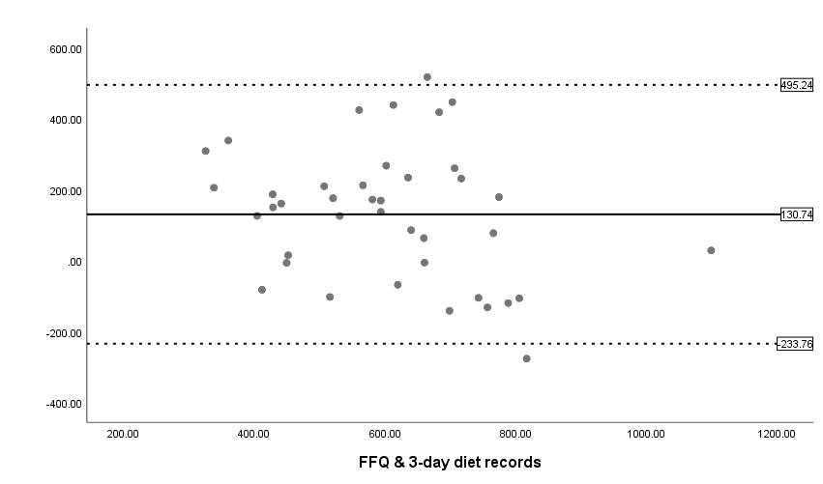

Male
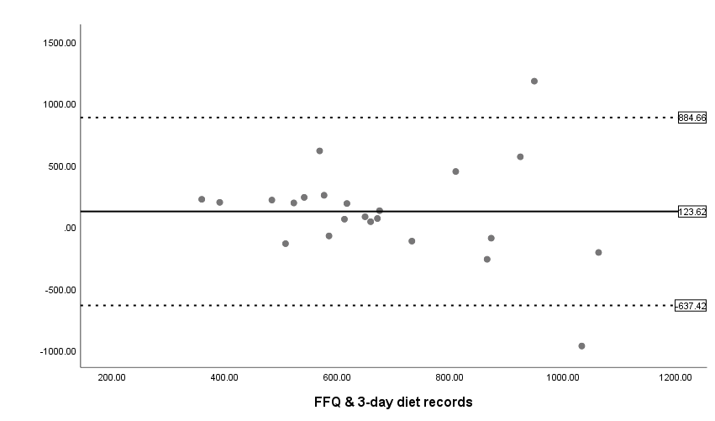

- Iron
Total Sample
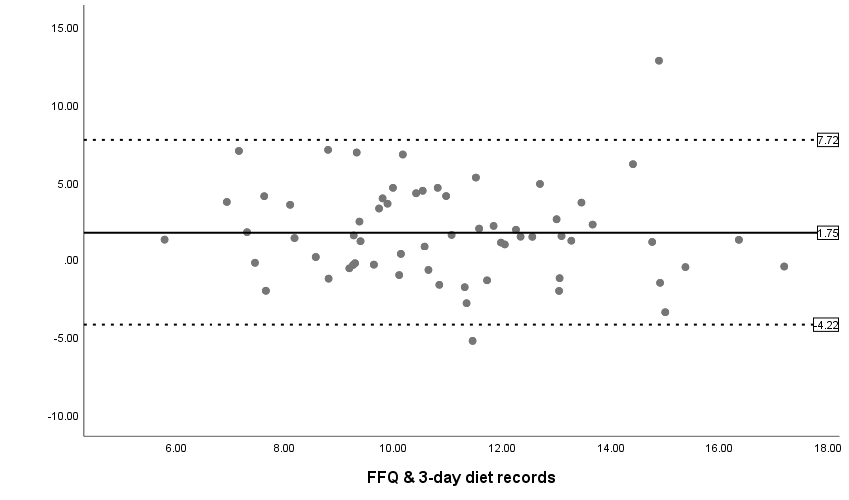
Female
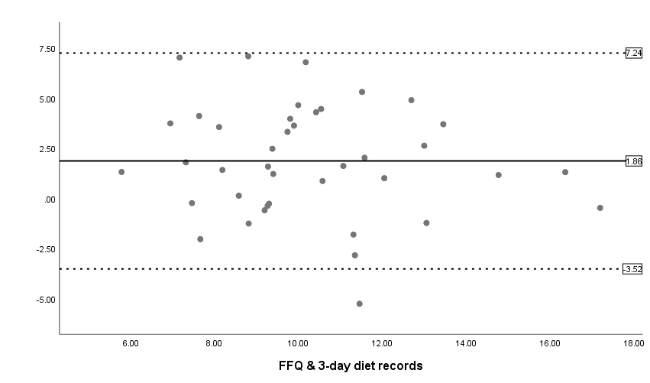

Male
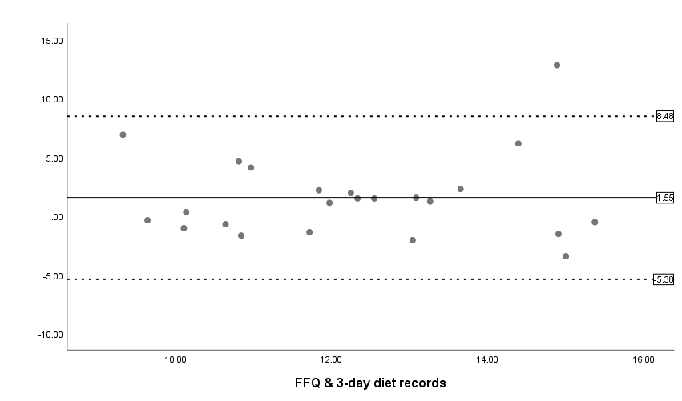

- Total sugar
Total Sample
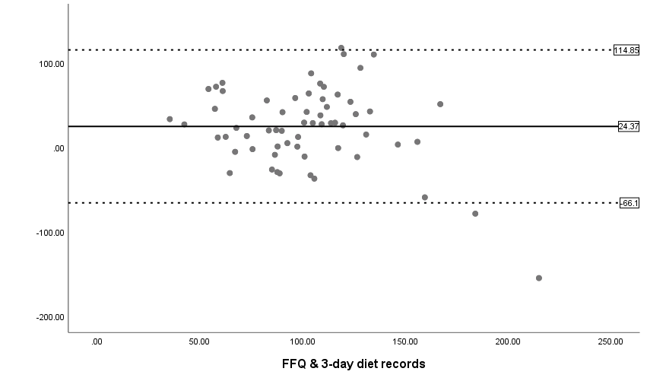
Female
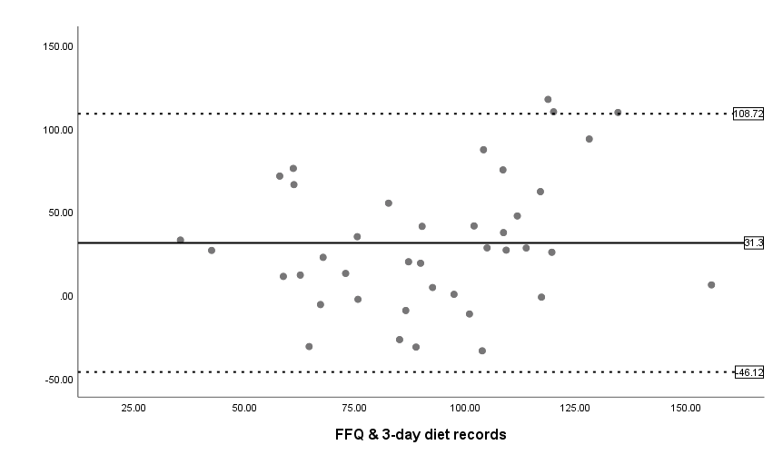

Male
