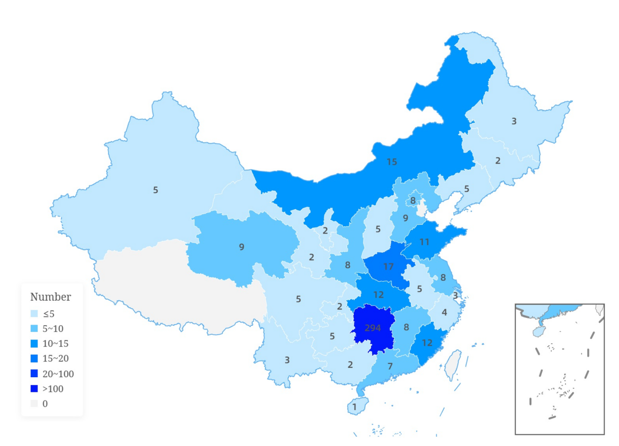
Figure S1 The geographic distribution of the participants

