Additional files
Additional file 1: PRISMA checklist
Section and Topic | Item # | Checklist item | Location where item is reported
TITLE
Title | 1 | Identify the report as a systematic review, meta-analysis, or both. | Title
ABSTRACT
Abstract | 2 | Provide a structured summary including, as applicable: background; objectives; data sources; study eligibility criteria, participants, and interventions; study appraisal and synthesis methods; results; limitations; conclusions and implications of key findings; systematic review registration number. | Abstract
INTRODUCTION
Rationale | 3 | Describe the rationale for the review in the context of what is already known. | Introduction
Objectives | 4 | Provide an explicit statement of questions being addressed with reference to participants, interventions, comparisons, outcomes, and study design (PICOS). | Introduction
METHODS
Protocol and registration | 5 | Indicate if a review protocol exists, if and where it can be accessed (e.g., Web address), and, if available, provide registration information including registration number. | Methods
Eligibility criteria | 6 | Specify study characteristics (e.g., PICOS, length of follow-up) and report characteristics (e.g., years considered, language, publication status) used as criteria for eligibility, giving rationale. | Methods  Section “Inclusion and exclusion criteria”
Information sources | 7 | Describe all information sources (e.g., databases with dates of coverage, contact with study authors to identify additional studies) in the search and date last searched. | Methods  Section “Information source”
Search | 8 | Present full electronic search strategy for at least one database, including any limits used, such that it could be repeated. | Methods  Section “Information source”
Study selection | 9 | State the process for selecting studies (i.e., screening, eligibility, included in systematic review, and, if applicable, included in the meta-analysis). | Methods  Section “Studies selection”
Data collection process | 10 | Describe method of data extraction from reports (e.g., piloted forms, independently, in duplicate) and any processes for obtaining and confirming data from investigators. | Methods  Section “Data extraction”
Data items | 11 | List and define all variables for which data were sought (e.g., PICOS, funding sources) and any assumptions and simplifications made. | Methods  Section “Data extraction”
Risk of bias of individual studies | 12 | Describe methods used for assessing risk of bias of individual studies (including specification of whether this was done at the study or outcome level), and how this information is to be used in any data synthesis. | Methods  Section “Data synthesis and analysis”
Summary measures | 13 | State the principal summary measures (e.g., risk ratio, difference in means). | Methods  Section “Data synthesis and analysis”
Synthesis of results | 14 | Describe the methods of handling data and combining results of studies, if done, including measures of consistency (e.g., I²) for each meta-analysis. | Methods  Section “Data synthesis and analysis”
Risk of bias across studies | 15 | Risk of bias across studies 15 Specify any assessment of risk of bias that may affect the cumulative evidence (e.g., publication bias, selective reporting within studies). | Methods  Section “Data synthesis and analysis”
Additional analyses | 16 | Describe methods of additional analyses (e.g., sensitivity or subgroup analyses, meta-regression), if done, indicating which were pre-specified. | Methods
Study selection | 17 | Give numbers of studies screened, assessed for eligibility, and included in the review, with reasons for exclusions at each stage, ideally with a flow diagram. | Methods
RESULTS
Study characteristics | 18 | For each study, present characteristics for which data were extracted (e.g., study size, PICOS, follow-up period) and provide the citations. | Results table 1
Risk of bias within studies | 19 | Present data on risk of bias of each study and, if available, any outcome level assessment (see item 12). | Results  Section “Bias of publication”
Results of individual studies | 20 | For all outcomes considered (benefits or harms), present, for each study: (a) simple summary data for each intervention group (b) effect estimates and confidence intervals, ideally with a forest plot. | Results Table 2, 3, and 4
Synthesis of results | 21 | Present results of each meta-analysis done, including confidence intervals and measures of consistency. | Results Table 2, 3, and 4
Risk of bias across studies | 22 | Present results of any assessment of risk of bias across studies (see Item 15). | Results  Section “Bias of publication”
Additional analyses | 23 | Give results of additional analyses, if done (e.g., sensitivity or subgroup analyses, meta-regression [see Item 16]). | None
DISCUSSION
Summary of evidence | 24 | Summarize the main findings including the strength of evidence for each main outcome; consider their relevance to key groups (e.g., healthcare providers, users, and policy makers). | Discussion
Limitations | 25 | Discuss limitations at study and outcome level (e.g., risk of bias), and at review-level (e.g., incomplete retrieval of identified research, reporting bias). | Discussion
Conclusions | 26 | Provide a general interpretation of the results in the context of other evidence, and implications for future research. | Conclusions
Funding
Funding | 27 | Describe sources of funding for the systematic review and other support (e.g., supply of data); role of funders for the systematic review | No funding

Additional file 2
Figure 1. Forest representation of overall COPD prevalence during 2016-2019 and 2020-2022 by FR and LLN criteria. 1. a) Forest representation of overall COPD prevalence during 2016-2019 by FR criteria. 1.b) Forest representation of COPD prevalence during 2020-2022 by FR criteria. 1.c) Forest representation of overall COPD prevalence during 2016-2019 by LLN criteria. 1.d) Forest representation of COPD prevalence during 2020-2022 by LLN criteria.
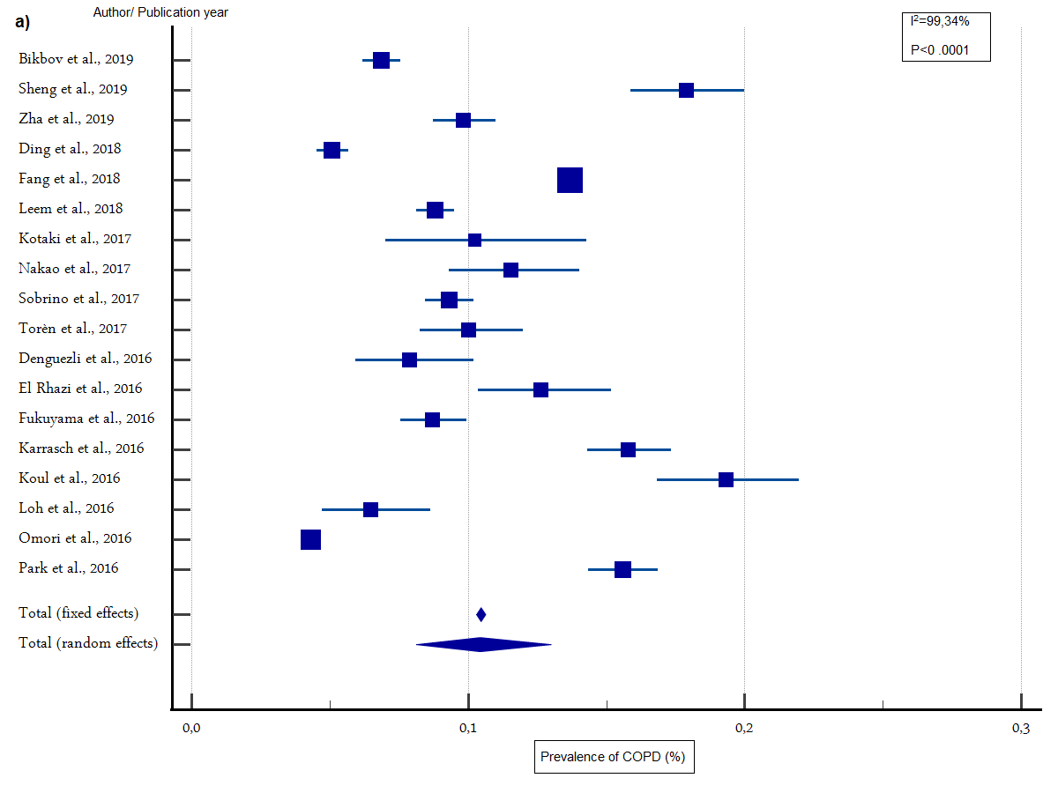
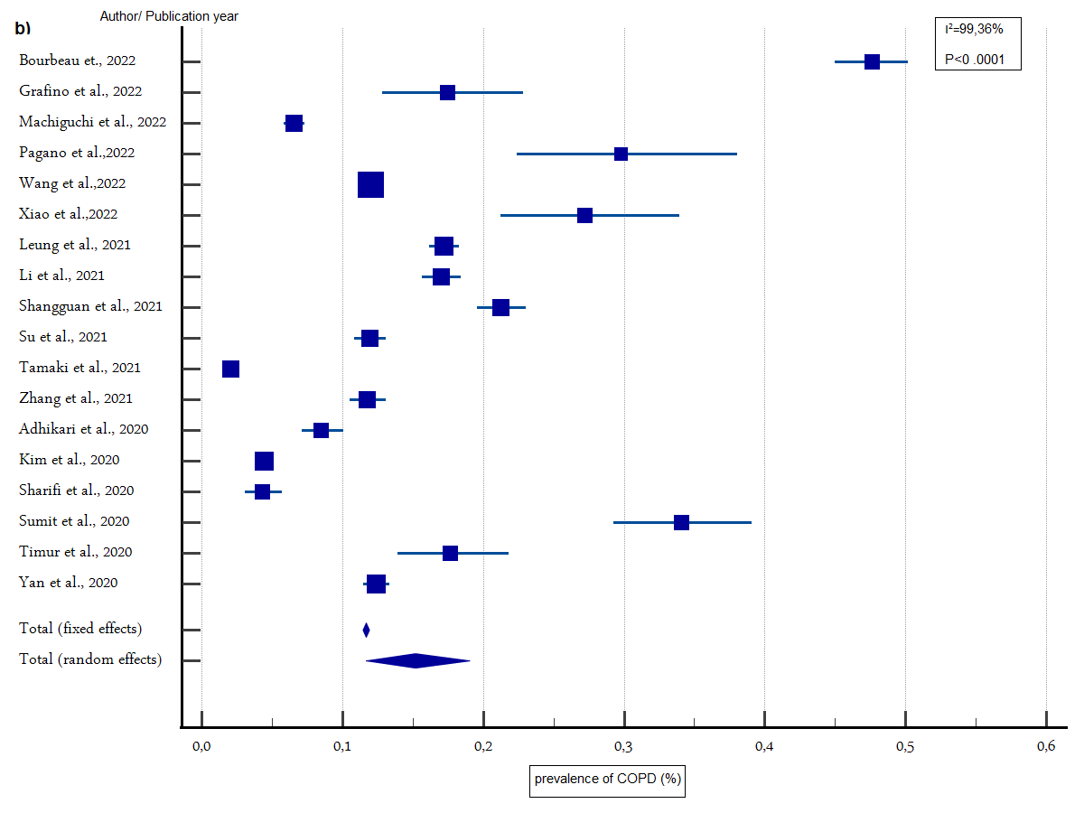

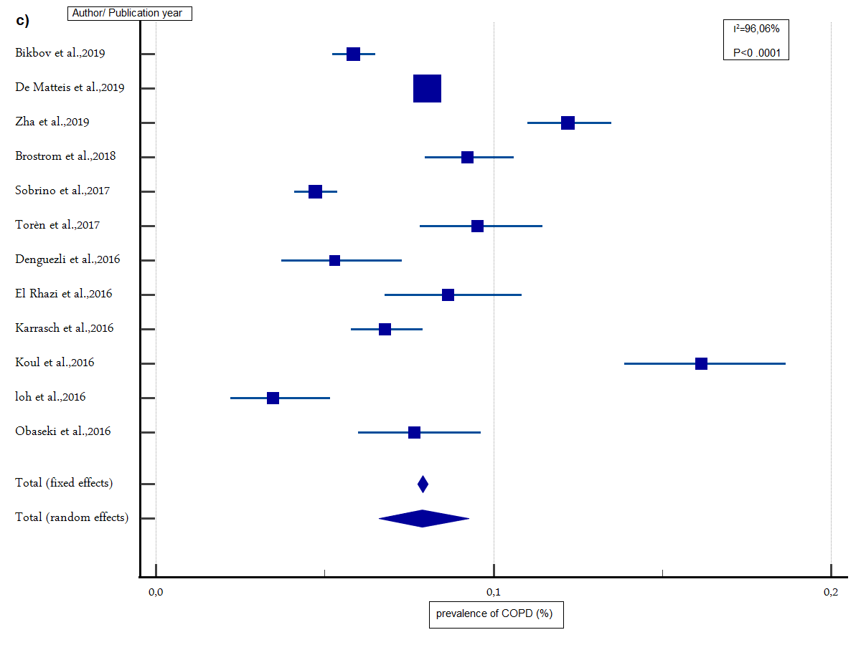
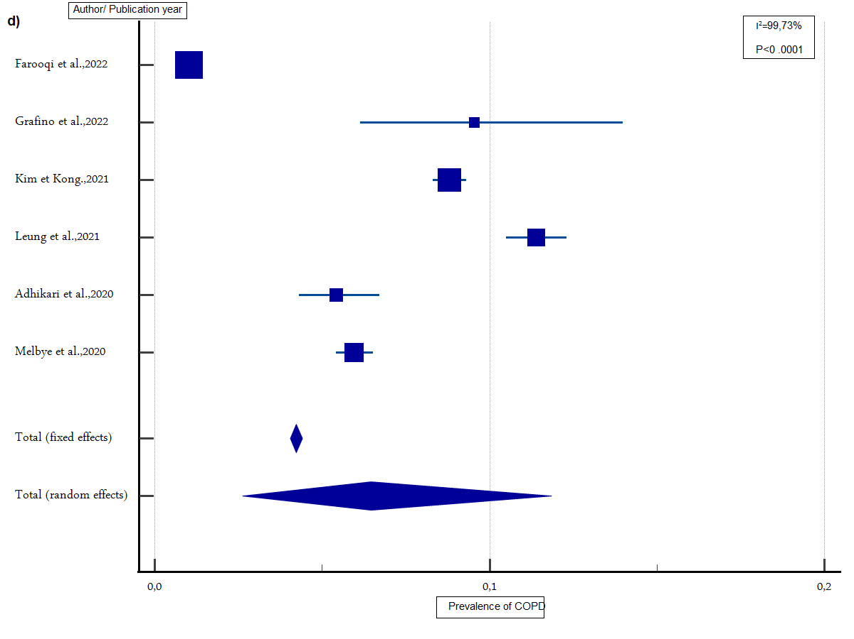
Additional file 3. Search strategy of included studies
Database | Search strategy
MEDLINE | ("prevalence" OR "epidemiology") AND " chronic obstructive pulmonary disease "[Mesh]
Scopus | TITLE-ABS KEY ( "chronic obstructive pulmonary disease" AND ( "prevalence" OR "epidemiology" )
Web of science | Topic=( "chronic obstructive pulmonary disease" AND "prevalence" OR "epidemiology" )

