Supplementary material 3 – Only Quality Appraisal = High

Forest plots with estimates restricted to studies conducted with quality appraisal as high (max n=67)

Figure S3.1 - Forest plot of (“any” type of) intimate partner violence against women (VAW) prevalence pooled by method of administration, between-study variance τ²= 0.00552919.
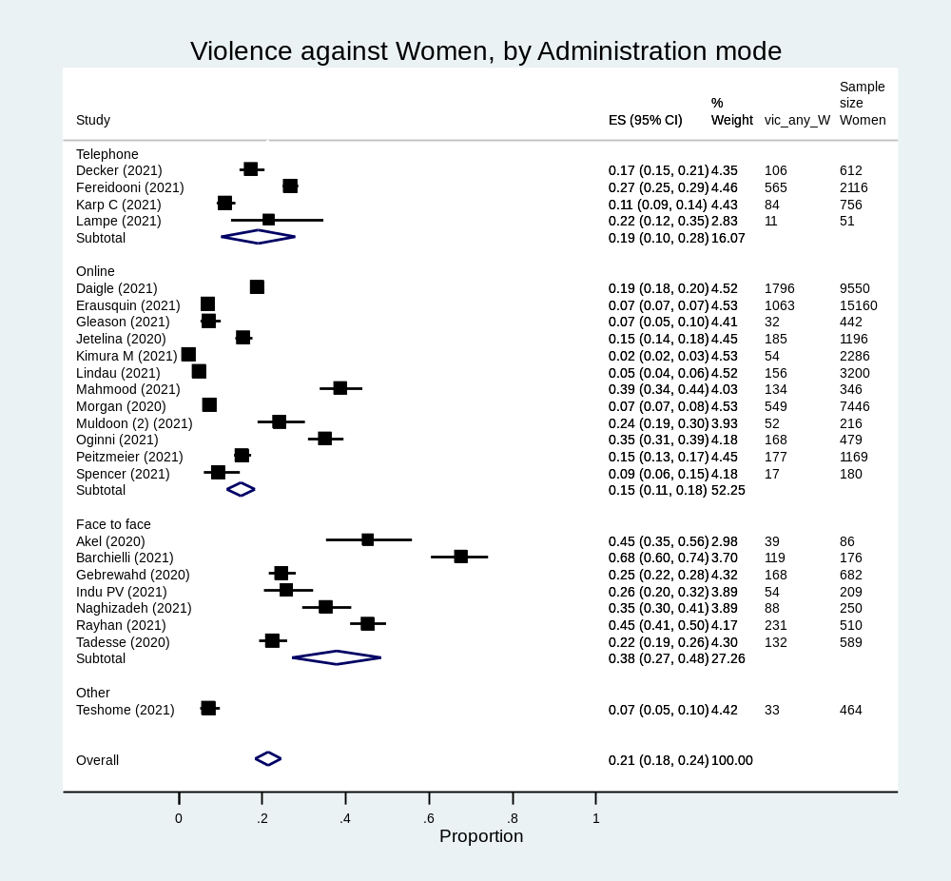

Figure S3.2 - Forest plot of (“any” type of) intimate partner violence against men (VAM) prevalence pooled by method of administration (only “online” observed), between-study variance τ²= 0.00729038
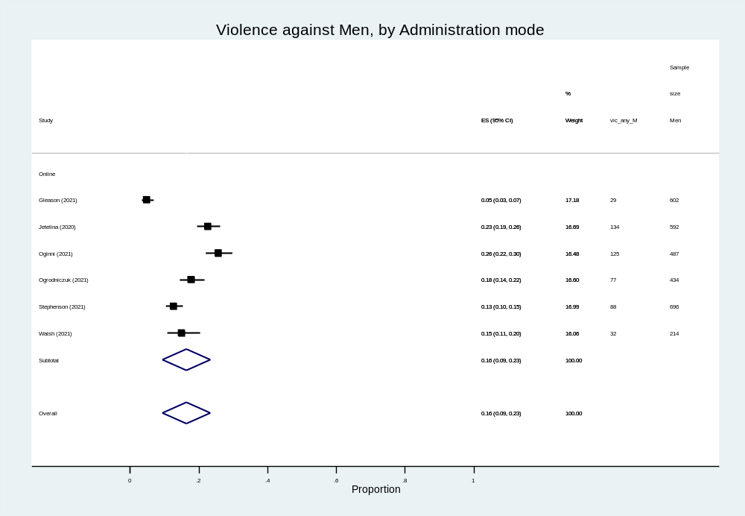

Figure S3.3 - Forest plot of (“any” type of) intimate partner violence against women & men (VAM) prevalence pooled by method of administration in online and other, between-study variance τ²= .09240205
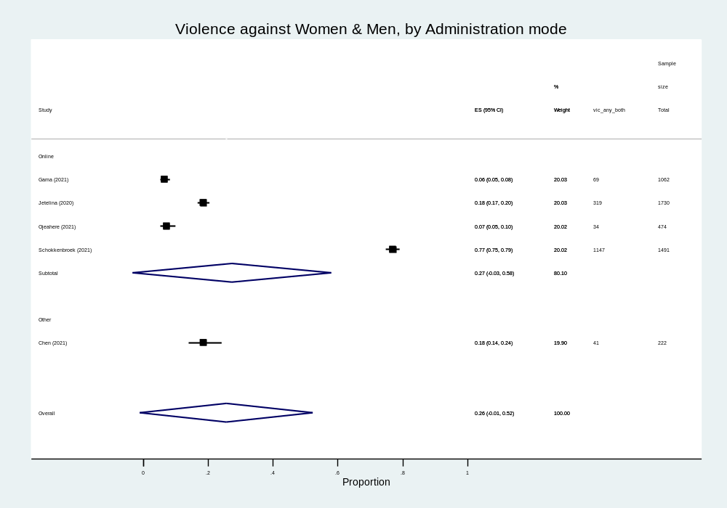

Figure S3.4 - Forest plot of (“any” type of) intimate partner violence against women (VAW) prevalence pooled by type of sample in clinical, convenience or general population/community sample, between-study variance, τ²= 0.00552919
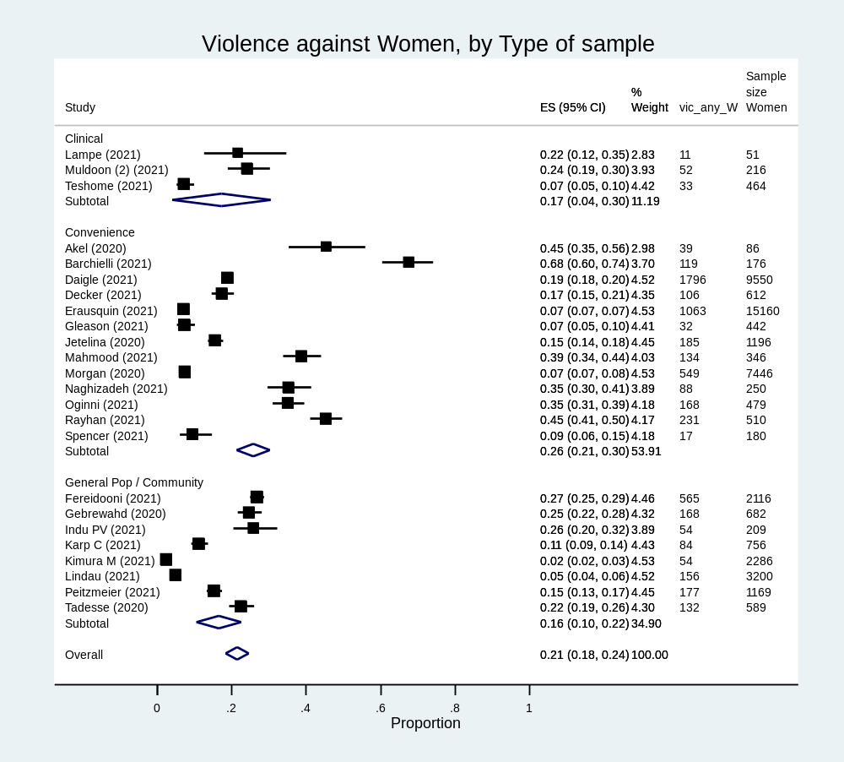

Figure S3.5 - Forest plot of (“any” type of) intimate partner violence against men (VAM) prevalence pooled by type of sample (only “convenience” observed), between-study variance, τ²= 0.00729038
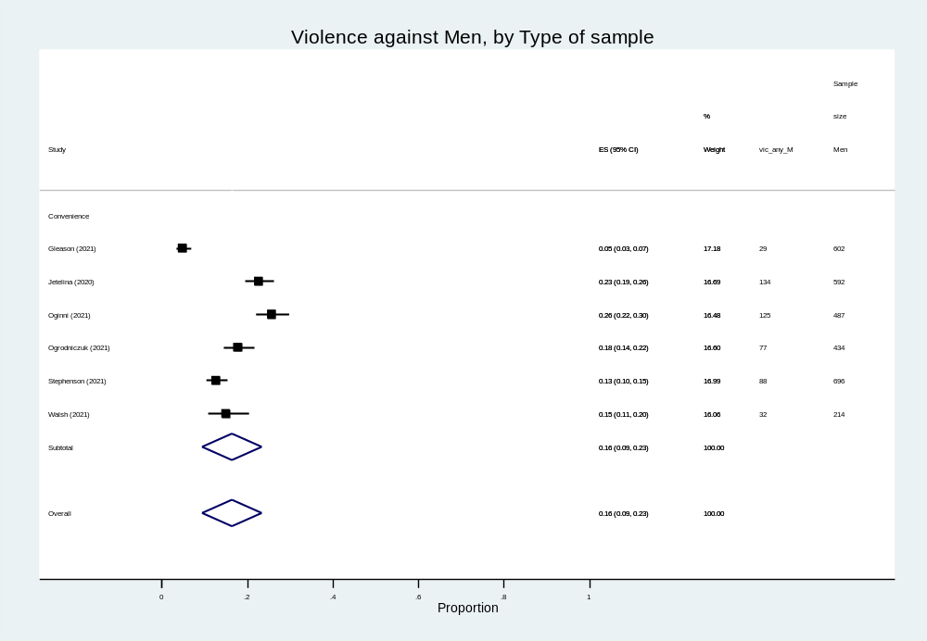

Figure S3.6 - Forest plot of (“any” type of) intimate partner violence against women and men prevalence pooled by type of sample (only “convenience” observed), between-study variance, τ2= .09240205
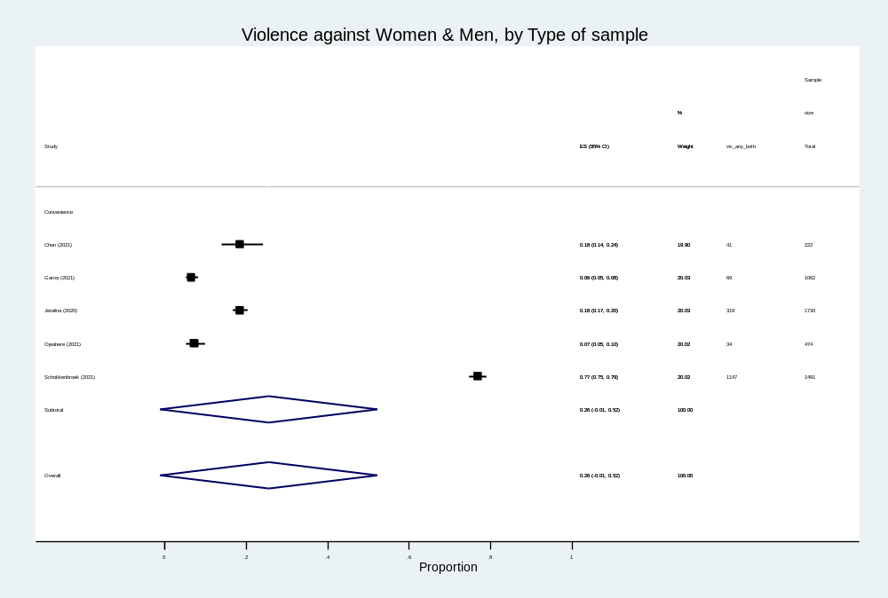

Figure S3.7 - Forest plot of (“any” type of) intimate partner violence against women prevalence pooled by instrument used for assessment in standardized tool, specifically created questions, between-study variance, τ2= 0.00552919
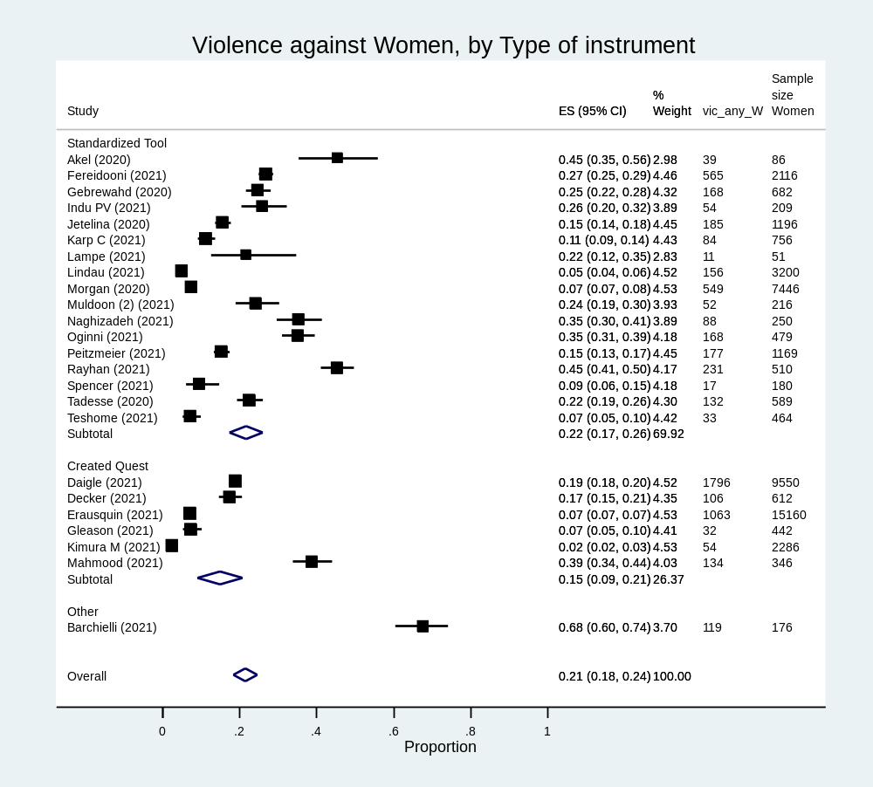

Figure S3.8 - Forest plot of (“any” type of) intimate partner violence against men prevalence pooled by instrument used for assessment in standardized tool and specifically created questions, between-study variance, τ²= 0.00729038
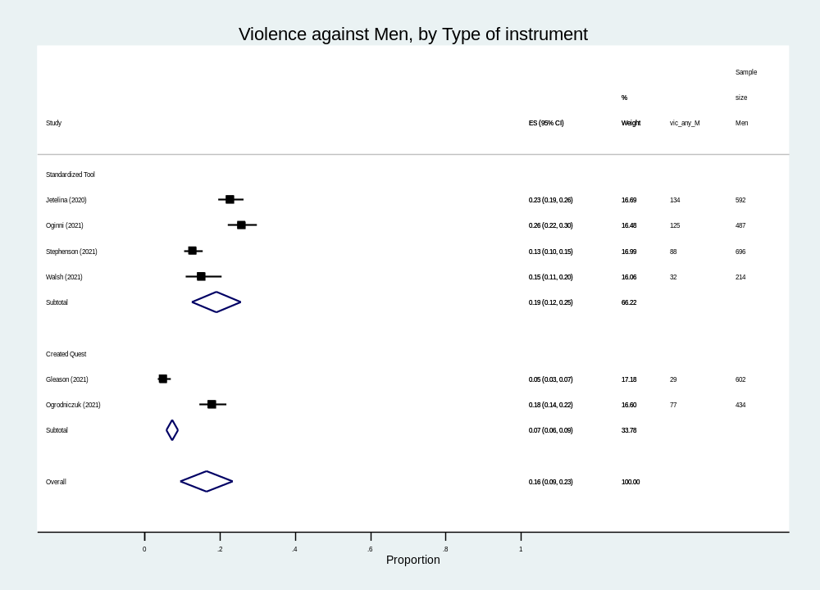

Figure S3.9 - Forest plot of (“any” type of) intimate partner violence against women and men prevalence pooled by instrument used for assessment in standardized tool and specifically created questions (from studies where sex-disaggregated prevalence estimates were not available), between-study variance, τ²= 0.09240205
