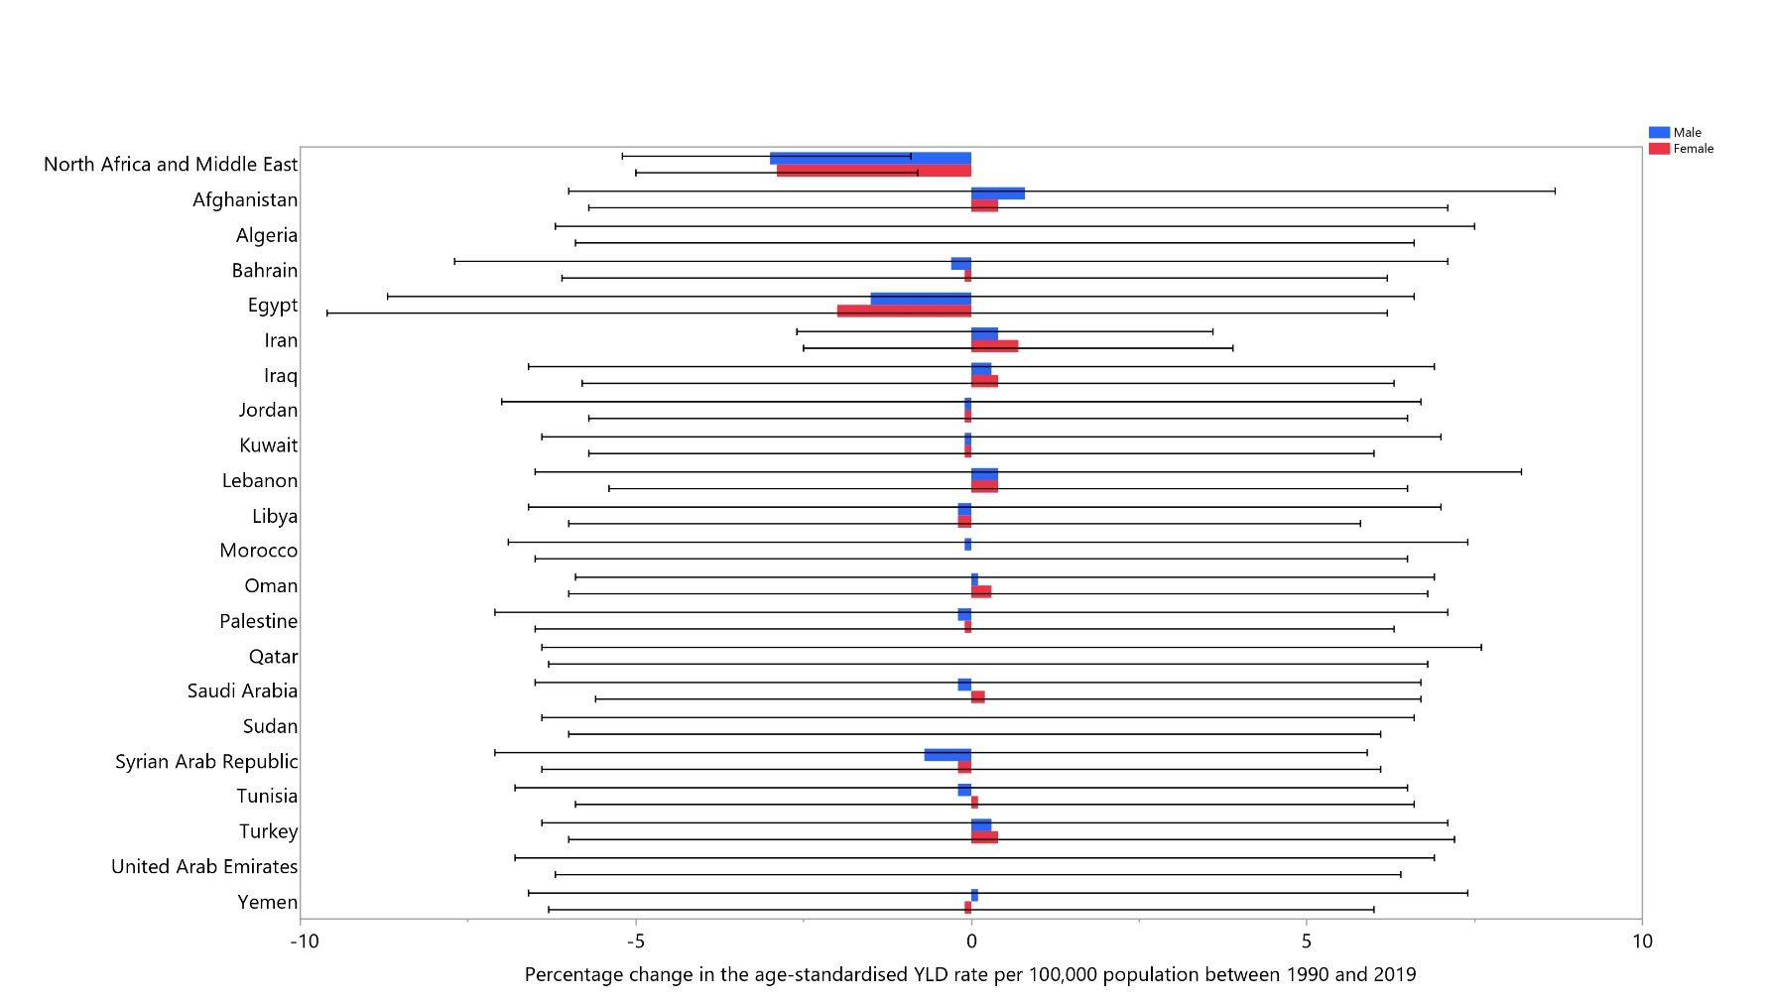
Figure S3: The percentage change in the age-standardised YLD rate of dermatitis in the Middle East and North Africa region from 1990 to 2019, by sex and country. YLD= year-lived with disability. (Generated from data available from http://ghdx.healthdata.org/gbd-results-tool).

