The identification of keywords in this study can be shown in the flowchart in Figure S1. Firstly, by using “allergic rhinitis” as the search term, we gathered weekly search terms related to allergic rhinitis in the past six months (between December 20, 2021 and June 19, 2022) from the “demand mapping” tool in the Baidu Index database. A total of 108 related terms were originally extracted. Other 17 keywords related to allergic rhinitis were included lately from literatures [1, 2]. Secondly, 27 duplicate keywords, 6 irrelevant keywords, and 4 keywords that were not recruited by the Baidu index were all removed. Finally, in order to eliminate differences in idiomatic terms, synonyms were combined and a total of 33 keywords were generated for the subsequent analysis. The 33 search terms were further grouped into the four categories of “disease", “etiology”, “symptoms/complications”, and “disease treatment/management”, which are listed in Table S1. The daily BSIs of each term were extract and used for subsequent analysis.

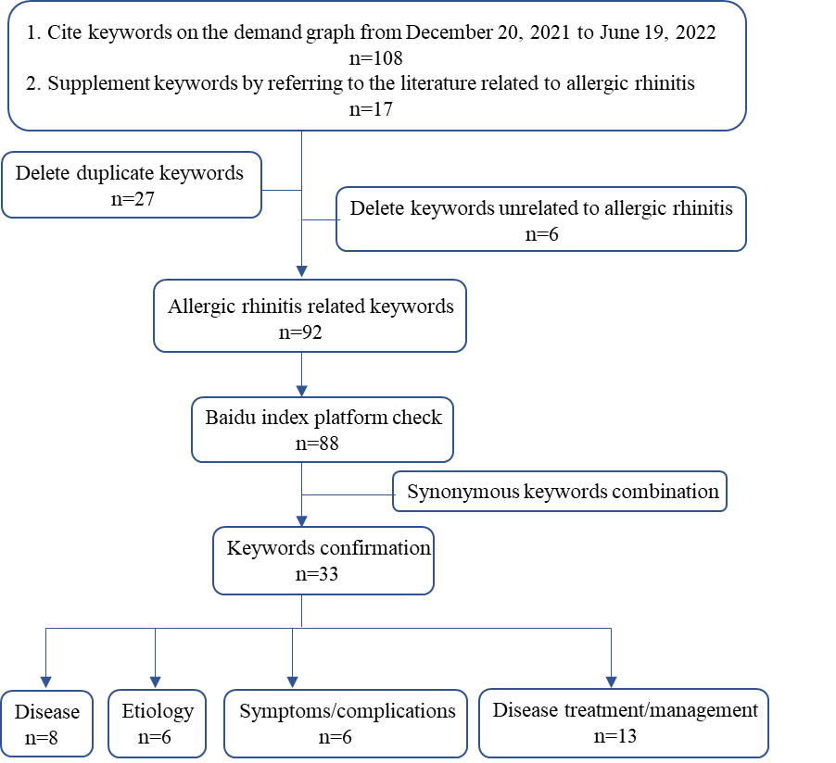
Figure S1 Allergic rhinitis keywords selection process

Table S1 keywords under each theme of allergic rhinitis
Themes | Available term in Search engine | English equivalent terms
Disease | 过敏性鼻炎 | Allergic rhinitis
Disease | 过敏鼻炎 | Allergic rhinitis
Disease | 什么是过敏性鼻炎 | Allergic rhinitis
Disease | 慢性过敏性鼻炎 | Chronic allergic rhinitis
Disease | 尘螨过敏性鼻炎 | Dust mites-related allergic rhinitis
Disease | 冷空气过敏性鼻炎 | Cold air-related allergic rhinitis
Disease | 季节性鼻炎 | Seasonal allergic rhinitis
Disease | 季节性过敏性鼻炎 | Seasonal allergic rhinitis
Disease | 春季 过敏性鼻炎 | Seasonal allergic rhinitis
Disease | 花粉症 | Hay fever
Disease | 小孩过敏性鼻炎 | Allergic rhinitis in children
Disease | 儿童过敏性鼻炎 | Allergic rhinitis in children
Disease | 幼儿过敏性鼻炎 | Allergic rhinitis in children
Disease | 小儿过敏性鼻炎 | Allergic rhinitis in children
Disease | 婴儿过敏性鼻炎 | Allergic rhinitis in infants
Etiology | 过敏性鼻炎是怎么引起的 | Causes of allergic rhinitis
Etiology | 过敏性鼻炎原因 | Causes of allergic rhinitis
Etiology | 过敏性鼻炎遗传吗 | Is allergic rhinitis hereditary
Etiology | 过敏性鼻炎传染吗 | Is allergic rhinitis contagious
Etiology | 过敏性鼻炎会传染吗 | Is allergic rhinitis contagious
Etiology | 过敏性体质 | Allergic constitution
Etiology | 春天花粉过敏 | Pollen allergy
Etiology | 花粉 | Pollen allergy
Etiology | 花粉过敏 | Pollen allergy
Etiology | 尘螨 | Dust mites allergic
Etiology | 尘螨过敏 | Dust mites allergic
Symptoms/complications | 过敏性鼻炎症状 | Symptoms of allergic rhinitis
Symptoms/complications | 过敏性鼻炎 症状 | Symptoms of allergic rhinitis
Symptoms/complications | 过敏性鼻炎的症状 | Symptoms of allergic rhinitis
Symptoms/complications | 过敏性鼻炎的主要症状 | Symptoms of allergic rhinitis
Symptoms/complications | 过敏性鼻炎的症状有哪些表现 | Symptoms of allergic rhinitis
Symptoms/complications | 过敏性鼻炎咳嗽 | Allergic rhinitis cough
Symptoms/complications | 过敏性鼻炎 咳嗽 | Allergic rhinitis cough
Symptoms/complications | 经常打喷嚏 | Frequent sneezing and runny nose
Symptoms/complications | 经常打喷嚏流鼻涕 | Frequent sneezing and runny nose
Symptoms/complications | 过敏性鼻炎鼻塞 | Allergic rhinitis nasal congestion
Symptoms/complications | 过敏性鼻炎哮喘 | Combined Allergic Rhinitis and Asthma Syndrome（CARAS）
Symptoms/complications | 过敏性鼻炎 哮喘 | Combined Allergic Rhinitis and Asthma Syndrome（CARAS）
Symptoms/complications | 过敏性鼻炎伴哮喘 | Combined Allergic Rhinitis and Asthma Syndrome（CARAS）
Symptoms/complications | 过敏性鼻炎引发哮喘 | Combined Allergic Rhinitis and Asthma Syndrome（CARAS）
Symptoms/complications | 过敏性鼻炎结膜炎 | Allergic rhinoconjunctivitls
Disease treatment/management | 过敏性鼻炎 治疗 | How to treat allergic rhinitis
Disease treatment/management | 过敏性鼻炎怎么办 | How to treat allergic rhinitis
Disease treatment/management | 过敏性鼻炎怎么治 | How to treat allergic rhinitis
Disease treatment/management | 过敏性鼻炎怎么根治 | How to treat allergic rhinitis
Disease treatment/management | 过敏性鼻炎如何治疗 | How to treat allergic rhinitis
Disease treatment/management | 过敏性鼻炎如何根治 | How to treat allergic rhinitis
Disease treatment/management | 过敏性鼻炎怎样治 | How to treat allergic rhinitis
Disease treatment/management | 过敏性鼻炎解决方法 | How to treat allergic rhinitis
Disease treatment/management | 过敏性鼻炎能根治吗 | How to treat allergic rhinitis
Disease treatment/management | 过敏性鼻炎怎么治能除根 | How to treat allergic rhinitis
Disease treatment/management | 过敏性鼻炎怎么治最有效的方法 | How to treat allergic rhinitis
Disease treatment/management | 过敏性鼻炎能治好吗 | Can allergic rhinitis be cured
Disease treatment/management | 过敏性鼻炎治得好吗 | Can allergic rhinitis be cured
Disease treatment/management | 过敏性鼻炎好治吗 | Can allergic rhinitis be cured
Disease treatment/management | 过敏性鼻炎的最佳治疗 | The best treatment for allergic rhinitis
Disease treatment/management | 过敏性鼻炎的最佳治疗方法 | The best treatment for allergic rhinitis
Disease treatment/management | 过敏性鼻炎 中医 | Allergic rhinitis Chinese medicine treatment
Disease treatment/management | 过敏性鼻炎中医治疗 | Allergic rhinitis Chinese medicine treatment
Disease treatment/management | 过敏性鼻炎用什么药效果最好 | What medication to take for allergic rhinitis
Disease treatment/management | 过敏性鼻炎吃什么药好 | What medication to take for allergic rhinitis
Disease treatment/management | 过敏性鼻炎用什么药 | What medication to take for allergic rhinitis
Disease treatment/management | 过敏性鼻炎吃什么药 | What medication to take for allergic rhinitis
Disease treatment/management | 过敏性鼻炎药 | Medications for allergic rhinitis
Disease treatment/management | 过敏性鼻炎药物 | Medications for allergic rhinitis
Disease treatment/management | 过敏性鼻炎的药物 | Medications for allergic rhinitis
Disease treatment/management | 过敏性鼻炎 药物 | Medications for allergic rhinitis
Disease treatment/management | 过敏性鼻炎用药 | Medications for allergic rhinitis
Disease treatment/management | 治过敏性鼻炎的药 | Medications for allergic rhinitis
Disease treatment/management | 治疗过敏性鼻炎的药物 | Medications for allergic rhinitis
Disease treatment/management | 过敏性鼻炎 中药 | Allergic rhinitis herbal medicine
Disease treatment/management | 过敏性鼻炎中药 | Allergic rhinitis herbal medicine
Disease treatment/management | 抗过敏药 | Antiallergic drug
Disease treatment/management | 盐酸西替利嗪片 | Antiallergic drug
Disease treatment/management | 西替利嗪 | Antiallergic drug
Disease treatment/management | 开瑞坦 | Antiallergic drug
Disease treatment/management | 雷诺考特 | Antiallergic drug
Disease treatment/management | 氯雷他定片 | Antiallergic drug
Disease treatment/management | 氯雷他定 | Antiallergic drug
Disease treatment/management | 布地奈德鼻喷雾剂 | Nasal spray
Disease treatment/management | 辅舒良鼻喷雾剂 | Nasal spray
Disease treatment/management | 丙酸氟替卡松鼻喷雾剂 | Nasal spray
Disease treatment/management | 过敏性鼻炎的偏方 | Allergic rhinitis remedy
Disease treatment/management | 过敏性鼻炎小偏方 | Allergic rhinitis remedy
Disease treatment/management | 过敏性鼻炎食疗 | Allergic rhinitis diet therapy
Disease treatment/management | 过敏性鼻炎吃什么 | Allergic rhinitis diet therapy
Disease treatment/management | 过敏性鼻炎的自我疗法 | Self-treatment for allergic rhinitis
Disease treatment/management | 盐水洗鼻 | Saline nasal rinses

References
1. Small P, Keith PK, Kim H. Allergic rhinitis. Allergy, Asthma & Clinical Immunology 2018 14:2. 2018;14:1–11.
2. Bousquet J, Onorato GL, Oliver G, Basagana X, Annesi-Maesano I, Arnavielhe S, et al. Google Trends and pollen concentrations in allergy and airway diseases in France. Allergy. 2019;74:1910–9.

