Supplementary Materials

Supplementary Fig. 1. Life expectancy change by sex in Korea, 2000-2019: Findings from Korea Statistical Information Service (KOSIS).
Supplementary Fig. 2. Trends in age-standardized cause-specific mortality by sex during the study period: Findings from the Korean Statistical Information Service (KOSIS).

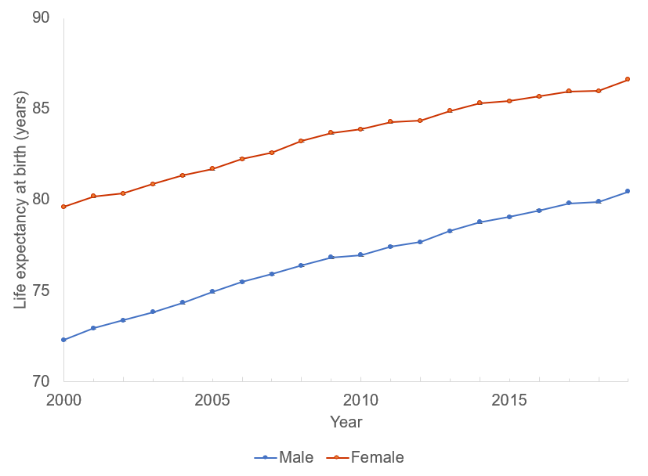
Supplementary Fig. 1. Life expectancy change by sex in Korea, 2000-2019: Findings from Korea Statistical Information Service (KOSIS).

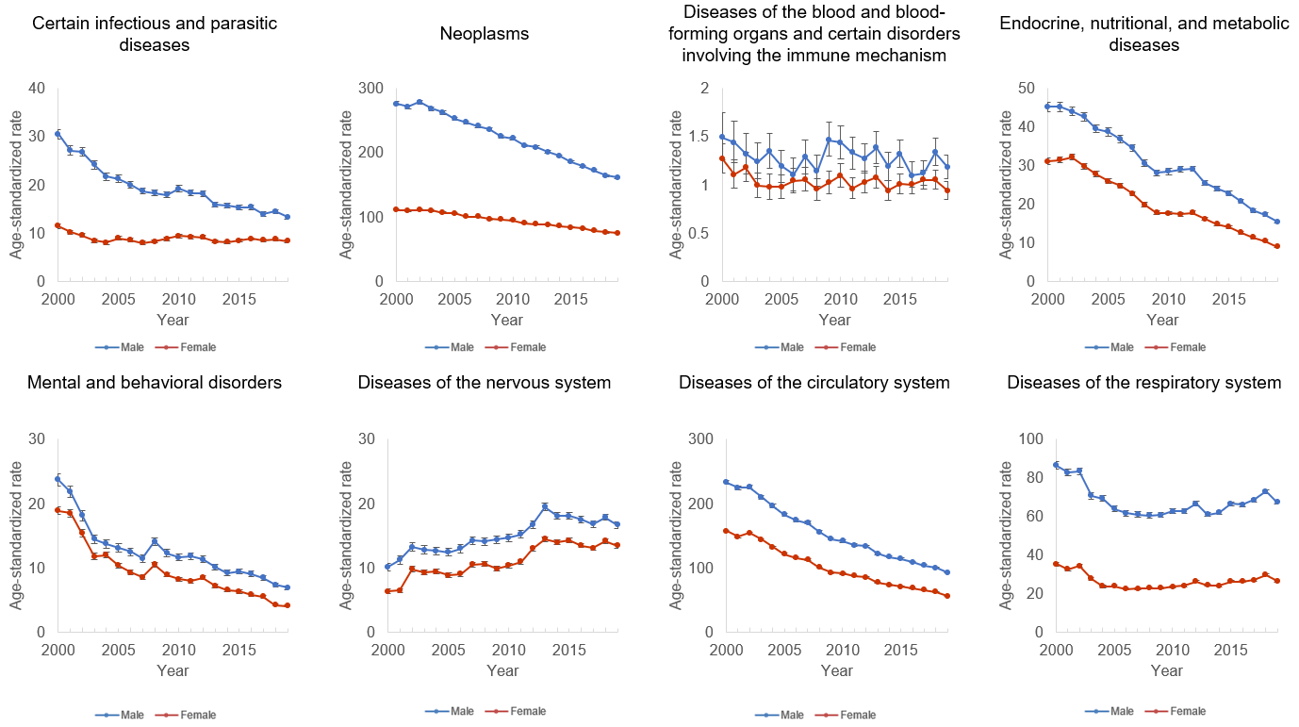

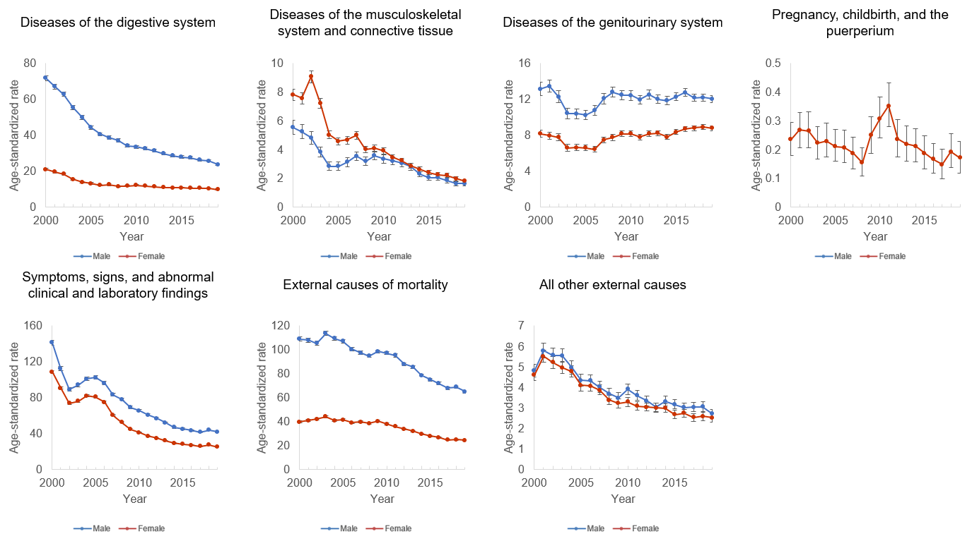
Supplementary Fig. 2. Trends in age-standardized cause-specific mortality by sex during the study period: Findings from the Korean Statistical Information Service (KOSIS).
* The standard population was the total population of Korea in 2010.

