Table S1 Risk of prevalent ISH and prehypertension associated with occupational exposure status and classification of occupational noise exposure combined with BHFTA
 | Isolated systolic hypertension (≥140/<90 mmHg) |  |  |  |  |  |  |  | Prehypertension (120~139 mmHg /80~89 mmHg)
 | Model 1 |  |  |  | Model 2 |  |  |  | Model 1 |  |  |  | Model 2
 | OR | 95%CI | P |  | OR | 95%CI | P |  | OR | 95%CI | P |  | OR | 95%CI | P
Occupational noise status
Non–exposed | 1 |  |  |  | 1 |  |  |  | 1 |  |  |  | 1
Exposed | 1.57 | 1.40,1.75 | <0.001 |  | 1.66 | 1.48,1.86 | <0.001 |  | 1.14 | 1.10,1.17 | <0.001 |  | 1.17 | 1.13,1.21 | <0.001
Classification of occupational noise exposure combined with BHFTA
Occupational noise non–exposed  with BHFTA normal | 1 |  |  |  | 1 |  |  |  | 1 |  |  |  | 1
Occupational noise exposed  with BHFTA normal | 1.47 | 1.32,1.65 | <0.001 |  | 1.65 | 1.47,1.85 | <0.001 |  | 1.11 | 1.07,1.15 | <0.001 |  | 1.17 | 1.13,1.21 | <0.001
Occupational noise exposed  with BHFTA elevated | 2.61 | 2.32,2.93 | <0.001 |  | 1.70 | 1.51,1.92 | <0.001 |  | 1.42 | 1.36,1.47 | <0.001 |  | 1.15 | 1.11,1.20 | <0.001
Model1: Unadjusted
Model2: Adjusted gender, age, years of occupational hazard exposure, high temperature exposure (Non-exposed, exposed), benzene exposure (Non-exposed, exposed), Pb exposure (Non-exposed, exposed), dust exposure (Non-exposed, exposed), classification of industry (Manufacturing, Non–manufacturing)
OR odds ratio, CI confidence interval

Table S2 Subgroup analysis by sex for the prevalence of ISH and prehypertension associated with occupational exposure status and classification of occupational noise exposure combined with BHFTA
Sex |  | Isolated systolic hypertension (≥140/<90 mmHg) |  |  |  |  |  |  |  |  | Prehypertension (120~139 mmHg /80~89 mmHg)
Sex |  | Model 1 |  |  |  | Model 2 |  |  | P for  interaction |  | Model 1 |  |  |  | Model 2 |  |  | P for  interaction
Sex |  | OR | 95%CI | P |  | OR | 95%CI | P | P for  interaction |  | OR | 95%CI | P |  | OR | 95%CI | P | P for  interaction
 | Occupational noise status |  |  |  |  |  |  |  | 0.808 |  |  |  |  |  |  |  |  | 0.962
Male | Non–exposed | 1 |  |  |  | 1 |  |  |  |  | 1 |  |  |  | 1
 | Exposed | 1.49 | 1.31,1.70 | <0.001 |  | 1.62 | 1.42,1.86 | <0.001 |  |  | 1.08 | 1.04,1.13 | <0.001 |  | 1.15 | 1.11,1.40 | <0.001
Female | Non–exposed | 1 |  |  |  | 1 |  |  |  |  | 1 |  |  |  | 1
 | Exposed | 1.56 | 1.27,1.93 | <0.001 |  | 1.87 | 1.50,2.35 | <0.001 |  |  | 1.09 | 1.03,1.16 | <0.001 |  | 1.21 | 1.14,1.29 | <0.001
 | Classification of occupational noise exposure combined with BHFTA |  |  |  |  |  |  |  | 0.002 |  |  |  |  |  |  |  |  | <0.001
Male | Occupational noise non–exposed  with BHFTA normal | 1 |  |  |  | 1 |  |  |  |  | 1 |  |  |  | 1
 | Occupational noise exposed  with BHFTA normal | 1.40 | 1.23,1.60 | <0.001 |  | 1.61 | 1.41,1.84 | <0.001 |  |  | 1.06 | 1.02,1.11 | 0.002 |  | 1.15 | 1.10,1.20 | <0.001
 | Occupational noise exposed  with BHFTA elevated | 2.29 | 2.00,2.63 | <0.001 |  | 1.72 | 1.50,1.98 | <0.001 |  |  | 1.22 | 1.17,1.28 | <0.001 |  | 1.16 | 1.10,1.21 | <0.001
Female | Occupational noise non–exposed  with BHFTA normal | 1 |  |  |  | 1 |  |  |  |  | 1 |  |  |  | 1
 | Occupational noise exposed  with BHFTA normal | 1.52 | 1.24,1.89 | <0.001 |  | 1.86 | 1.50,2.34 | <0.001 |  |  | 1.08 | 1.02,1.15 | <0.001 |  | 1.21 | 1.13,1.29 | <0.001
 | Occupational noise exposed  with BHFTA elevated | 2.71 | 2.13,3.45 | <0.001 |  | 1.96 | 1.52,2.54 | <0.001 |  |  | 1.37 | 1.26,1.48 | <0.001 |  | 1.26 | 1.16,1.37 | <0.001
OR odds ratio, CI confidence interval
Model1: Unadjusted
Model2: Adjusted age, years of occupational hazard exposure, high temperature exposure (Non-exposed, exposed), benzene exposure (Non-exposed, exposed), Pb exposure (Non-exposed, exposed), dust exposure (Non-exposed, exposed), classification of industry (Manufacturing, Non–manufacturing)

Table S3 Subgroup analysis by age for the prevalence of ISH and prehypertension associated with occupational exposure status and classification of occupational noise exposure combined with BHFTA
Age |  | Isolated systolic hypertension (≥140/<90 mmHg) |  |  |  |  |  |  |  |  | Prehypertension (120~139 mmHg /80~89 mmHg)
Age |  | Model 1 |  |  |  | Model 2 |  |  | P for  interaction |  | Model 1 |  |  |  | Model 2 |  |  | P for  interaction
Age |  | OR | 95%CI | P |  | OR | 95%CI | P | P for  interaction |  | OR | 95%CI | P |  | OR | 95%CI | P | P for  interaction
 | Occupational noise status |  |  |  |  |  |  |  | 0.345 |  |  |  |  |  |  |  |  | <0.001
18-29 | Non–exposed | 1 |  |  |  | 1 |  |  |  |  | 1 |  |  |  | 1
 | Exposed | 2.16 | 1.58,3.06 | <0.001 |  | 1.87 | 1.36,2.66 | <0.001 |  |  | 1.37 | 1.28,1.46 | <0.001 |  | 1.32 | 1.23,1.41 | <0.001
30-39 | Non–exposed | 1 |  |  |  | 1 |  |  |  |  | 1 |  |  |  | 1
 | Exposed | 1.85 | 1.45,2.42 | <0.001 |  | 1.69 | 1.31,2.21 | <0.001 |  |  | 1.19 | 1.13,1.27 | <0.001 |  | 1.17 | 1.10,1.24 | <0.001
40-49 | Non–exposed | 1 |  |  |  | 1 |  |  |  |  | 1 |  |  |  | 1
 | Exposed | 1.74 | 1.46,2.10 | <0.001 |  | 1.75 | 1.46,2.12 | <0.001 |  |  | 1.11 | 1.04,1.19 | 0.001 |  | 1.13 | 1.05,1.20 | <0.001
50-60 | Non–exposed | 1 |  |  |  | 1 |  |  |  |  | 1 |  |  |  | 1
 | Exposed | 1.56 | 1.26,1.94 | <0.001 |  | 1.58 | 1.27,1.97 | <0.001 |  |  | 0.93 | 0.82,1.04 | 0.202 |  | 0.94 | 0.83,1.06 | 0.332
 | Classification of occupational noise exposure combined with BHFTA |  |  |  |  |  |  |  | 0.035 |  |  |  |  |  |  |  |  | <0.001
18-29 | Occupational noise non–exposed  with BHFTA normal | 1 |  |  |  | 1 |  |  |  |  | 1 |  |  |  | 1
 | Occupational noise exposed  with BHFTA normal | 2.12 | 1.55,3.01 | <0.001 |  | 1.85 | 1.35,2.63 | <0.001 |  |  | 1.37 | 1.28,1.46 | <0.001 |  | 1.32 | 1.23,1.41 | <0.001
 | Occupational noise exposed  with BHFTA elevated | 2.89 | 2.05,4.20 | <0.001 |  | 2.18 | 1.54,3.18 | <0.001 |  |  | 1.47 | 1.36,1.58 | <0.001 |  | 1.29 | 1.19,1.40 | <0.001
30-39 | Occupational noise non–exposed  with BHFTA normal | 1 |  |  |  | 1 |  |  |  |  | 1 |  |  |  | 1
 | Occupational noise exposed  with BHFTA normal | 1.81 | 1.41,2.36 | <0.001 |  | 1.67 | 1.30,2.19 | <0.001 |  |  | 1.18 | 1.11,1.25 | <0.001 |  | 1.17 | 1.10,1.24 | <0.001
 | Occupational noise exposed  with BHFTA elevated | 2.40 | 1.85,3.17 | <0.001 |  | 1.82 | 1.39,2.41 | <0.001 |  |  | 1.38 | 1.29,1.47 | <0.001 |  | 1.19 | 1.11,1.27 | <0.001
40-49 | Occupational noise non–exposed  with BHFTA normal | 1 |  |  |  | 1 |  |  |  |  | 1 |  |  |  | 1
 | Occupational noise exposed  with BHFTA normal | 1.70 | 1.42,2.05 | <0.001 |  | 1.72 | 1.44,2.08 | <0.001 |  |  | 1.09 | 1.02,1.16 | 0.010 |  | 1.12 | 1.05,1.20 | 0.001
 | Occupational noise exposed  with BHFTA elevated | 2.04 | 1.70,2.48 | <0.001 |  | 1.96 | 1.63,2.39 | <0.001 |  |  | 1.27 | 1.19,1.36 | <0.001 |  | 1.17 | 1.09,1.25 | <0.001
50-60 | Occupational noise non–exposed  with BHFTA normal | 1 |  |  |  | 1 |  |  |  |  | 1 |  |  |  | 1
 | Occupational noise exposed  with BHFTA normal | 1.53 | 1.24,1.90 | <0.001 |  | 1.55 | 1.25,1.93 | <0.001 |  |  | 0.91 | 0.81,1.03 | 0.128 |  | 0.94 | 0.83,1.05 | 0.281
 | Occupational noise exposed  with BHFTA elevated | 1.70 | 1.36,2.14 | <0.001 |  | 1.74 | 1.39,2.19 | <0.001 |  |  | 0.99 | 0.87,1.12 | 0.852 |  | 0.97 | 0.86,1.11 | 0.693
OR odds ratio, CI confidence interval
Model1: Unadjusted
Model2: Adjusted gender, years of occupational hazard exposure, high temperature exposure (Non-exposed, exposed), benzene exposure (Non-exposed, exposed), Pb exposure (Non-exposed, exposed), dust exposure (Non-exposed, exposed), classification of industry (Manufacturing, Non–manufacturing)

a. 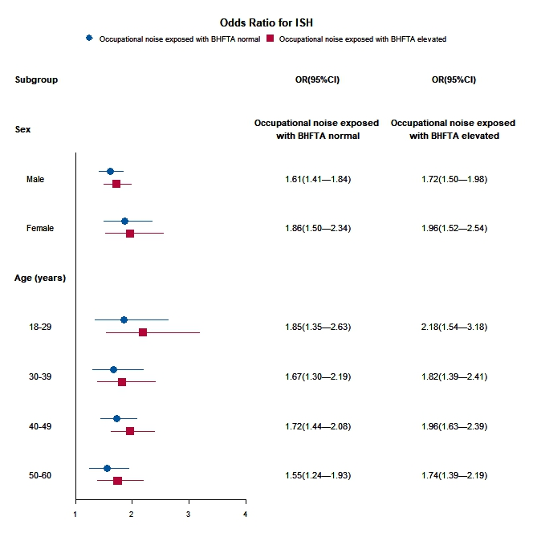 b. 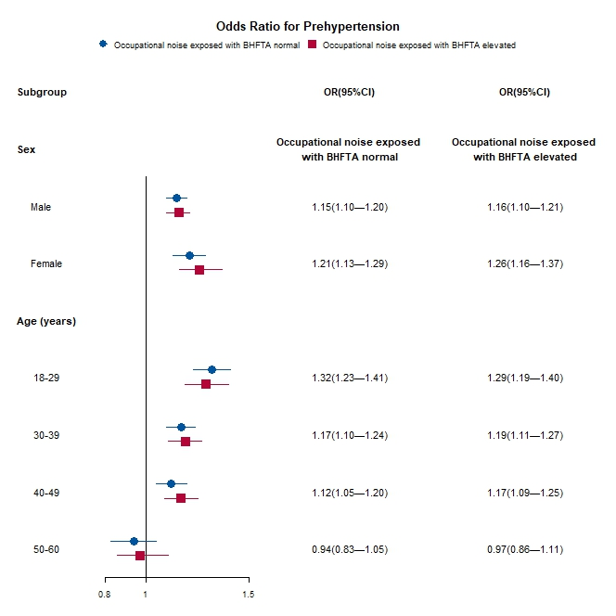

Figure S1 Subgroup analysis by sex and age for the prevalence of ISH and prehypertension associated with the classification of occupational noise exposure combined with BHFTA

Control group: Occupational noise non–exposed with BHFTA normal
OR odds ratio, CI confidence interval

