Supplementary Table 1. Total points in nomogram and the corresponding possibility of condomless sex
Total Points | Possibility of condomless sex
30 | 0.05
65 | 0.10
104 | 0.20
130 | 0.30
151 | 0.40
170 | 0.50
190 | 0.60
211 | 0.70
237 | 0.80
275 | 0.90
311 | 0.95
390 | 0.99
Total points$=48×Having heterosexual intercourse+22×types of IPV+26×Ever having anal sex+79×Condom use at first sex+7×\left(15-Attitudes towards condom use points \right)+8×(15-Condom use self efficacy points )$
Linear prediction $= 1.6844829+0.3768109×Having heterosexual intercourse+1.5875592×types of IPV+1.7474626×Ever having anal sex+5.0891775×Condom use at first sex+0.8680907×Attitudes towards condom use points+0.8379266×Condom use self efficacy points$
Possibility = 1/ (1+exp (-Linear Prediction)).
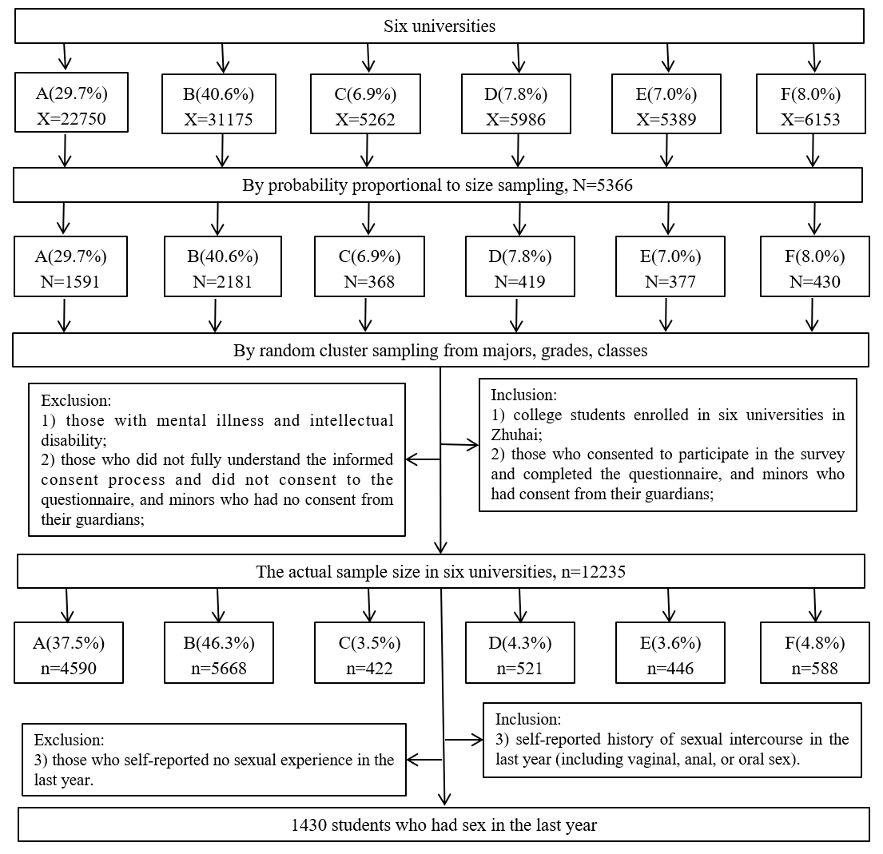
Supplementary Figure 1. A schematic presentation of sampling procedure for this study.
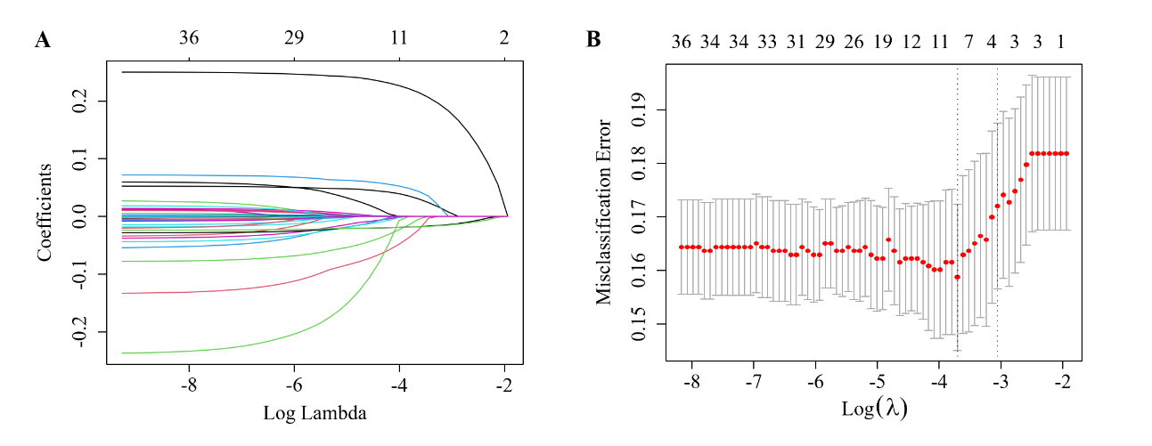
Supplementary Figure 2. Feature selection using the least absolute shrinkage and selection operator (LASSO) logistic regression model
A: LASSO coefficient profiles of the 36 features among college students who had sex in the last year
B: Tuning parameter (λ) selection in the LASSO model used 10-fold cross-validation via minimum criteria among college students who had sex last year in the last year

