Figure and legend

Fig.S1 Distribution of the number of comorbidity burdens in patients with Comorbidity of liver disease and non-liver disease comorbidity

Fig.S2 Comorbidity of liver disease

Fig.S3 Prevalence of liver comorbidity by age and geographic distribution
(a) Eastern China (b) Central China (c)Western China

Fig.S4 The prevalence of liver comorbidity among different participant groups
(a) The prevalence of liver comorbidity in different genders
(b) The prevalence of liver comorbidity in different residential areas
(c) The prevalence of liver comorbidity in different regions
(d) The prevalence of liver comorbidity in different income groups

(A) (B)

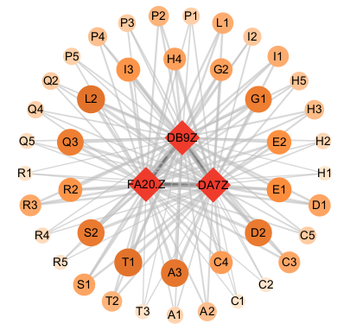
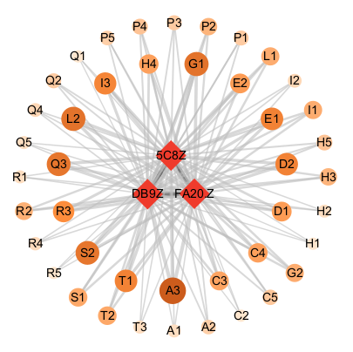
Liver disease + stomach disease + arthritis Liver disease + dyslipidemia + arthritis

(C) (D)
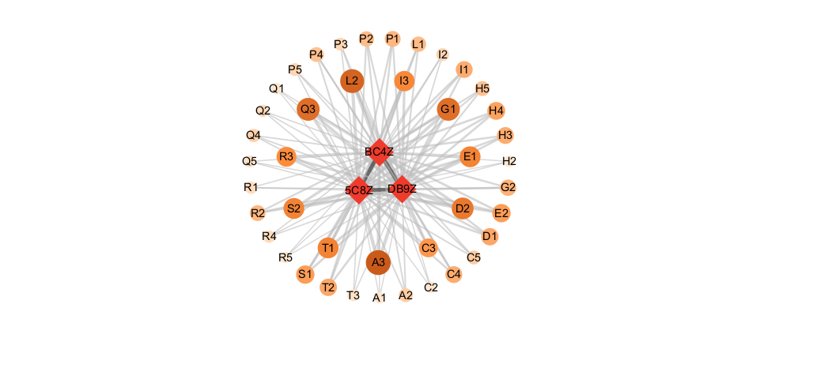
Liver disease + stomach disease + hypertension Liver disease + heart disease+dyslipidemia

(E) (F)
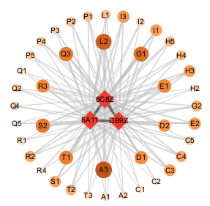
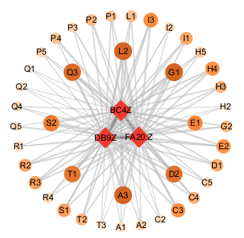

Liver disease + dyslipidemia + diabetes Liver disease + heart disease + arthritis

(G)

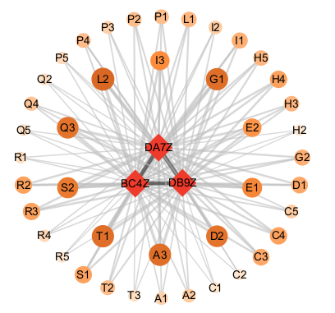
Liver disease + stomach disease + dyslipidemia
Fig.S5 The ternary liver disease co-morbid co-cause patterns in eastern China

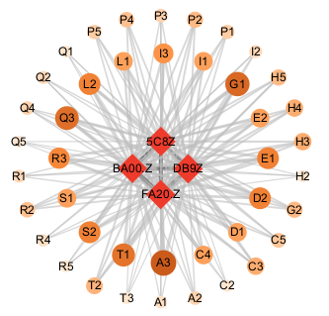
Liver disease + dyslipidemia + arthritis + hypertension

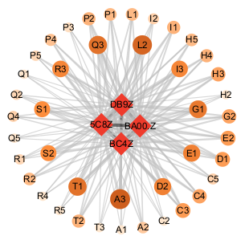

Liver disease + dyslipidemia + heart disease + hypertension
Fig.S6 The quaternary liver disease co-morbid co-cause patterns in eastern China

- (B)


Liver disease + stomach disease + arthritis Liver disease + heart disease + arthritis

(C) (D)

Liver disease + stomach disease + hypertension Liver disease + heart disease + stomach disease

(E) (F)
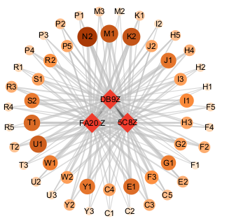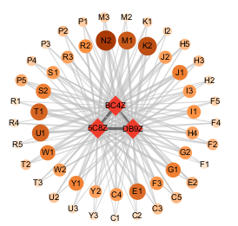
Liver disease + dyslipidemia + arthritis Liver disease + heart disease + dyslipidemia

(G) (H)
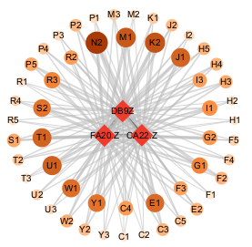
Liver disease + stomach disease + dyslipidemia Liver disease + chronic lung disease + arthritis

Fig.S7 The ternary liver disease co-morbid co-cause patterns in central China

- (B)

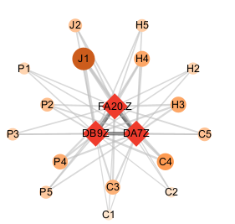
Liver disease + stomach disease + arthritis Liver disease + stomach disease + hypertension

(C) (D)

Liver disease + heart disease + arthritis Liver disease + heart disease + stomach disease

(E) (F)
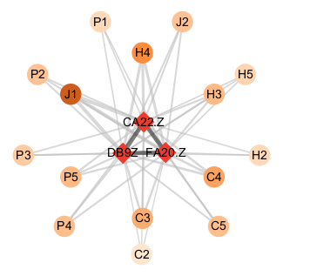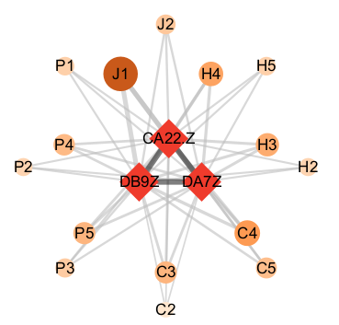
Liver disease + chronic lung disease + arthritis Liver disease + chronic lung disease + stomach disease

(G) (H)
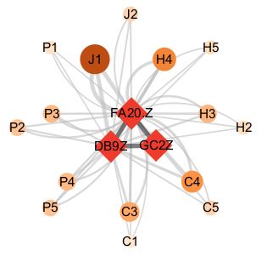
Liver disease + kidney disease + arthritis Liver disease + dyslipidemia + arthritis

(I) (J)

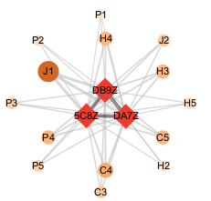
Liver disease + chronic lung disease + hypertension Liver disease + stomach disease + dyslipidemia

Fig.S8 The ternary liver disease co-morbid co-cause patterns in western China

(A)


Liver disease + stomach disease + arthritis + hypertension

(B)

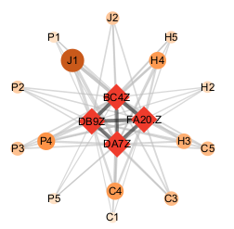

Liver disease + heart disease + stomach disease + arthritis
Fig.S9 The quaternary liver disease co-morbid co-cause patterns in western China

