Racial and Ethnic Disparities in Access to Community-Based Perinatal Mental Health Programs:
Results from a Cross-Sectional Survey

BMC Public Health

Slawa Rokicki, PhD, Mitu Patel, MPH, Patricia D. Suplee, PhD, RNC-OB, FAAN, Robyn D'Oria, MA, RNC

Slawa Rokicki, Department of Health Behavior, Society, and Policy; Rutgers School of Public Health, Piscataway, NJ, USA; slawa.rokicki@gmail.com

Appendix Table 1. Community Assessment Survey
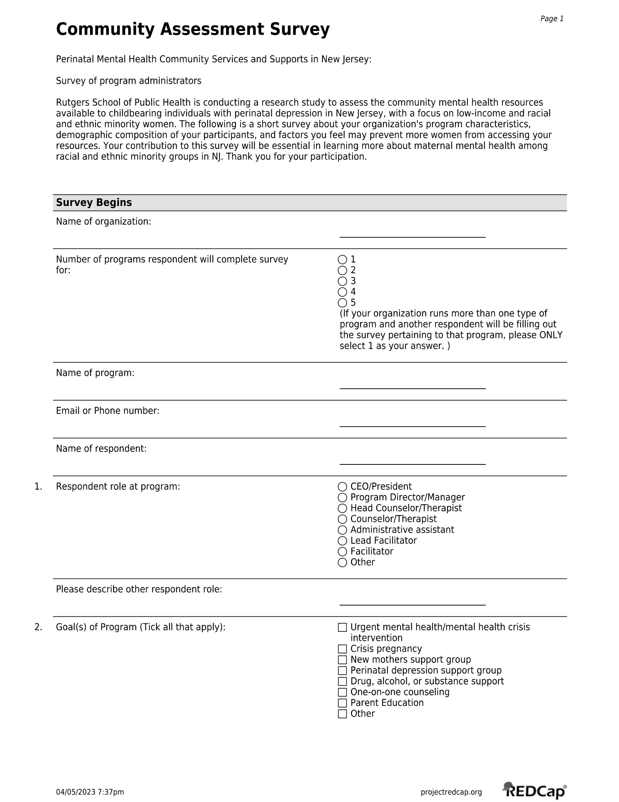

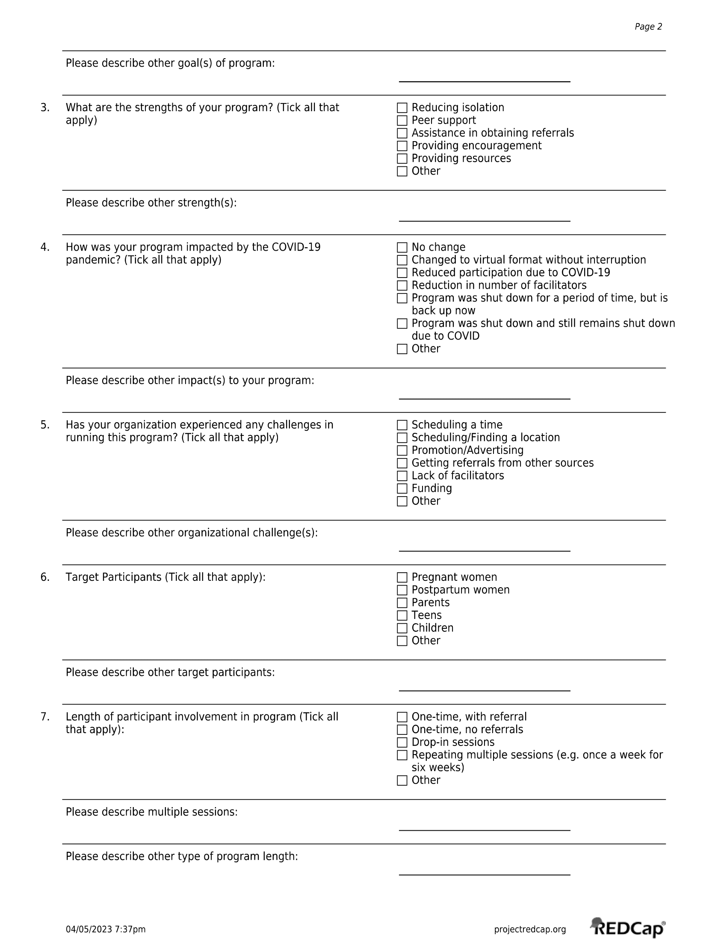

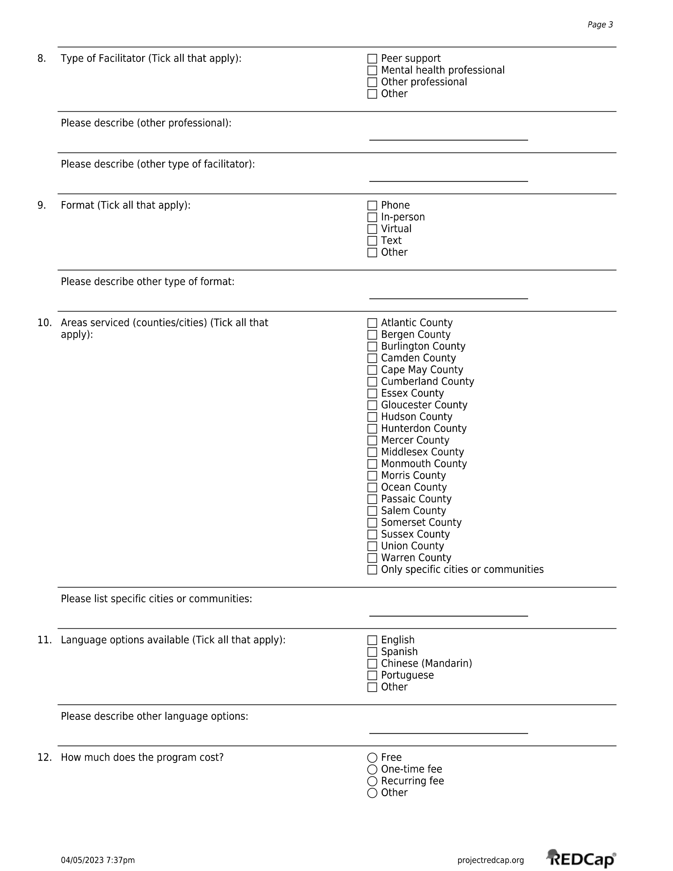

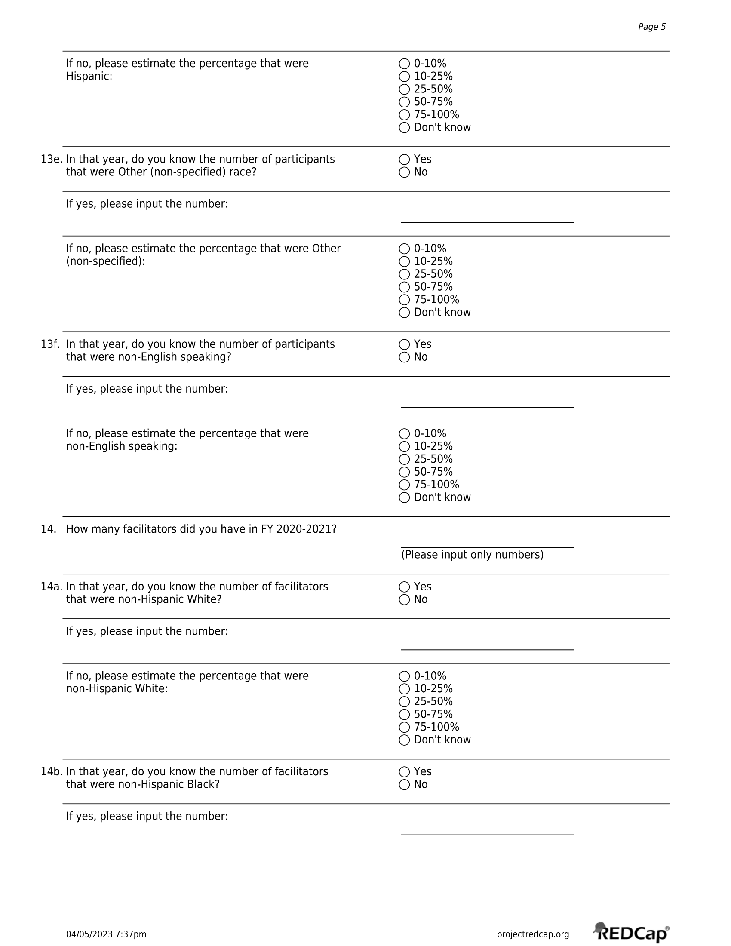

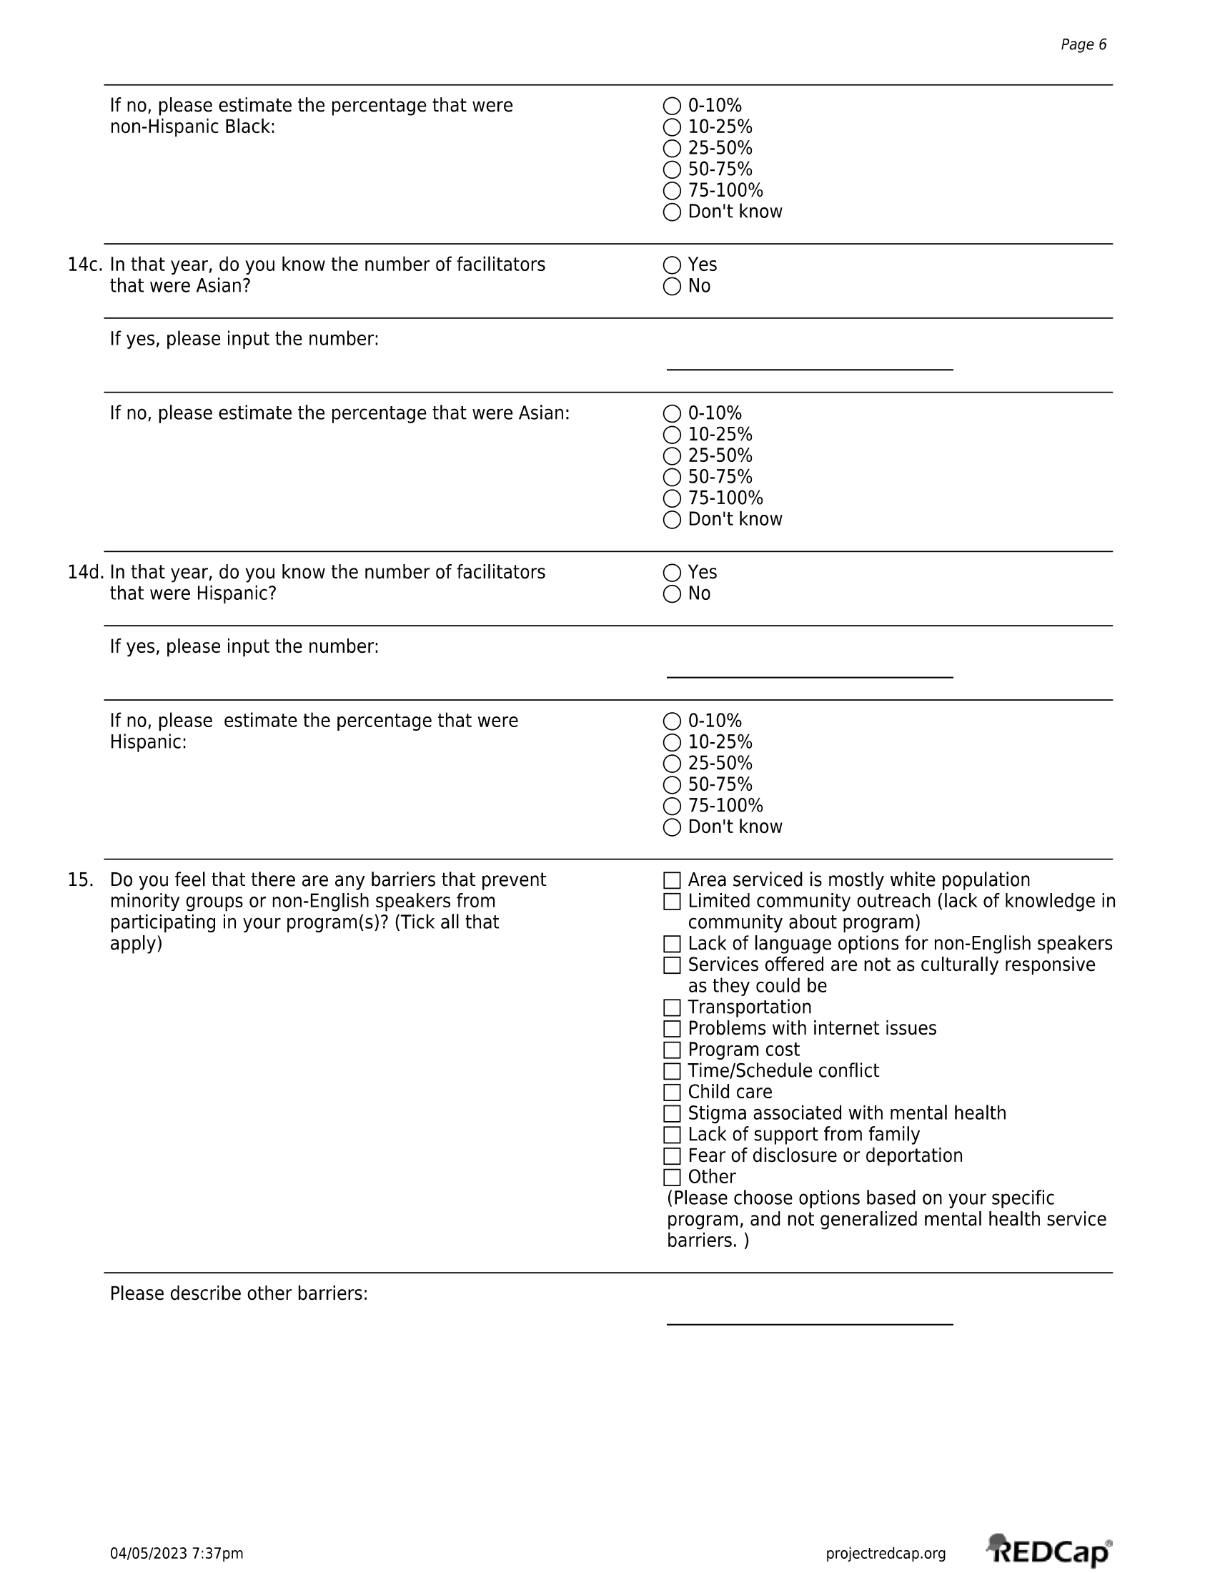

Appendix Table 2. Survey responses for respondent role at program.

Variable | Percent of programs
Respondent role at program
CEO/President | 12
Program Director/Manager | 30
Head Counselor/Therapist | 6
Counselor/Therapist | 9
Administrative assistant | 3
Lead Facilitator | 15
Facilitator | 6
Other¹ | 18
Impact of COVID-19 pandemic on program
No change | 9
Changed to virtual format without interruption | 58
Reduced participation due to COVID-19 | 21
Reduction in number of facilitators | 0
Program was shut down for a period of time, but is back up now | 15
Program was shut down and still remains shut down due to COVID | 3
Other² | 27
¹For the respondent role at program, other responses included: Perinatal Social Worker, Bilingual Family Partner, Division Director of Outpatient Services, Case Manager, Doula/Owner, Director of Development and Special Projects. ²Other comments for impact of COVID-19 included: added new program (2 programs), modified program in some way, increase in referrals and offering more support groups due to virtual platform, increase in participation, certain parts of programs were no longer running.

Appendix Table 3. Availability of programs and language options by county, compared with racial and ethnic distribution of NJ births

County | Total number of programs | Percent of programs with language availability (%) |  |  |  | Racial and ethnic distribution of births in NJ (%)
 |  | Spanish | English only | Other |  | Hisp | NHW | NHB | NHA
Atlantic | 12 | 17 | 42 | 42 |  | 30 | 45 | 18 | 7
Bergen | 15 | 13 | 60 | 27 |  | 30 | 47 | 5 | 17
Burlington | 14 | 14 | 50 | 36 |  | 14 | 60 | 18 | 8
Camden | 13 | 8 | 54 | 38 |  | 28 | 45 | 21 | 6
Cape May | 10 | 0 | 50 | 50 |  | 16 | 79 | 4 | 1
Cumberland | 10 | 0 | 50 | 50 |  | 49 | 32 | 18 | 1
Essex | 13 | 23 | 46 | 31 |  | 32 | 23 | 39 | 5
Gloucester | 11 | 0 | 55 | 45 |  | 11 | 73 | 13 | 3
Hudson | 15 | 33 | 40 | 27 |  | 43 | 24 | 11 | 22
Hunterdon | 15 | 20 | 60 | 20 |  | 15 | 77 | 2 | 6
Mercer | 14 | 14 | 64 | 21 |  | 38 | 31 | 21 | 10
Middlesex | 15 | 27 | 53 | 20 |  | 34 | 28 | 10 | 28
Monmouth | 17 | 24 | 59 | 18 |  | 20 | 70 | 7 | 4
Morris | 18 | 11 | 33 | 56 |  | 21 | 62 | 3 | 14
Ocean | 14 | 21 | 57 | 21 |  | 10 | 87 | 2 | 1
Passaic | 13 | 15 | 54 | 31 |  | 55 | 29 | 9 | 7
Salem | 11 | 9 | 45 | 45 |  | 20 | 58 | 21 | 1
Somerset | 14 | 21 | 57 | 21 |  | 27 | 43 | 10 | 21
Sussex | 12 | 17 | 50 | 33 |  | 13 | 81 | 2 | 3
Union | 11 | 27 | 55 | 18 |  | 45 | 31 | 18 | 6
Warren | 12 | 17 | 50 | 33 |  | 18 | 73 | 6 | 3
Notes: Data for distribution of births obtained for the years 2020-2021 from NJSHAD. Hisp=Hispanic (of any race). NHW=non-Hispanic White. NHB=non-Hispanic Black. NHA=non-Hispanic Asian. Other language availability refers to programs that may offer Chinese, Portuguese, Creole, French, and/or Interpretative services language availability

Appendix Table 4. Distribution of participations and facilitators across community-based perinatal mental health programs (n=33)

 | Percent of total participants (facilitators) across programs (%)
 | 0-10% | 10-25% | 25-50% | 50-75% | 75-100% | Don’t Know
Panel A. Participants
Non-Hispanic White | 15 | 6 | 18 | 27 | 27 | 6
Non-Hispanic Black | 55 | 24 | 12 | 3 | 0 | 6
Non-Hispanic Asian | 76 | 12 | 6 | 0 | 0 | 6
Hispanic | 58 | 21 | 9 | 0 | 6 | 6
Other race | 82 | 6 | 0 | 0 | 3 | 9
Non-English speaking | 73 | 6 | 9 | 3 | 6 | 3
Panel B. Facilitators
Non-Hispanic White | 18 | 0 | 3 | 12 | 64 | 3
Non-Hispanic Black | 82 | 9 | 0 | 3 | 3 | 3
Non-Hispanic Asian | 97 | 0 | 0 | 0 | 0 | 3
Hispanic | 61 | 15 | 9 | 3 | 9 | 3

