Supplementary material

Figure S1 Graph for model’s variable selection.
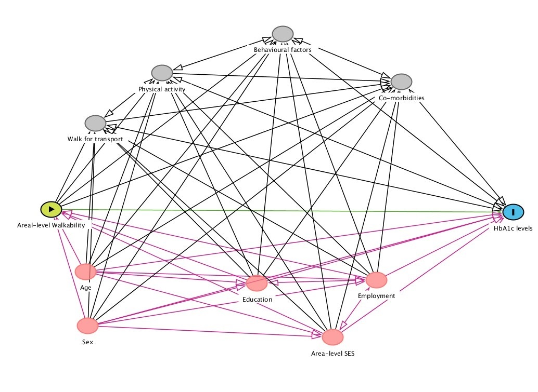
Legend: Green – ancestors, pink – confounder, grey –mediators.

Table S1 Indicators, data sources, numerator, denominator, and standardization methods used for the Walkability Index
Indicator / Index | Data source | Numerator | Denominator | Standardization method
Residential Density  (RD) | 2011 Census (INE) | Nº8 of classic family dwellings | Parish area (km2) | $$\frac{RD-RDmin}{RDmax-RDmin}$$
Land use diversity  (LUD) | 2011 Census (INE) | Sum of predominantly residential buildings and predominantly non-residential buildings (excludes exclusively residential buildings) | Parish area (km2) | $$\frac{LUD-LUDmin}{LUDmax-LUDmin}$$
Connectivity of streets (CS) | ESRI® | Nodes between three or more walkable roads | Parish area (km2) | $$\frac{CS-CSmin}{CSmax-CSmin}$$
Walkability Index (WI) | $$WI=RDst+LUDst+CSst$$

Table S2 Distribution of the glycosylated haemoglobin values (%) according to the sample characteristics
 | Classes | Average | Standard Error | IC95 |  | P-value
Sex | Female | 5.34 | 0.02 | 5.30 | 5.38 | 0.038*
Sex | Male | 5.35 | 0.02 | 5.31 | 5.39 | 0.038*
Age group | 25-29 | 5.09 | 0.03 | 5.03 | 5.14 | <0.001
Age group | 30-34 | 5.18 | 0.04 | 5.09 | 5.26 | <0.001
Age group | 35-39 | 5.18 | 0.03 | 5.13 | 5.24 | <0.001
Age group | 40-44 | 5.26 | 0.03 | 5.20 | 5.31 | <0.001
Age group | 45-49 | 5.37 | 0.05 | 5.28 | 5.47 | <0.001
Age group | 50-54 | 5.40 | 0.02 | 5.36 | 5.44 | <0.001
Age group | 55-59 | 5.50 | 0.07 | 5.35 | 5.64 | <0.001
Age group | 60-64 | 5.54 | 0.03 | 5.48 | 5.61 | <0.001
Age group | 65-69 | 5.52 | 0.04 | 5.44 | 5.59 | <0.001
Age group | 70-74 | 5.61 | 0.05 | 5.51 | 5.72 | <0.001
Level of education | No education/ 1st basic cycle | 5.50 | 0.04 | 5.43 | 5.58 | <0.001
Level of education | 2nd/3rd basic cycle | 5.35 | 0.02 | 5.31 | 5.39 | <0.001
Level of education | Secondary | 5.26 | 0.02 | 5.22 | 5.30 | <0.001
Level of education | Superior | 5.23 | 0.03 | 5.17 | 5.28 | <0.001
Employment | Employee | 5.29 | 0.02 | 5.25 | 5.32 | <0.001
Employment | Unemployed | 5.31 | 0.03 | 5.24 | 5.38 | <0.001
Employment | Another without professional activity | 5.50 | 0.04 | 5.43 | 5.58 | <0.001
Area socio-economic deprivation index (quintiles) | 1 | 5.34 | 0.03 | 5.27 | 5.40 | 0.102
Area socio-economic deprivation index (quintiles) | 2 | 5.36 | 0.04 | 5.28 | 5.44 | 0.102
Area socio-economic deprivation index (quintiles) | 3 | 5.35 | 0.03 | 5.29 | 5.41 | 0.102
Area socio-economic deprivation index (quintiles) | 4 | 5.33 | 0.02 | 5.28 | 5.38 | 0.102
Area socio-economic deprivation index (quintiles) | 5 | 5.34 | 0.03 | 5.29 | 5.40 | 0.102
Area walkability (tertiles) | 1 | 5.45 | 0.06 | 5.32 | 5.57 | 0.018
Area walkability (tertiles) | 2 | 5.33 | 0.02 | 5.28 | 5.38 | 0.018
Area walkability (tertiles) | 3 | 5.34 | 0.02 | 5.30 | 5.37 | 0.018
P-value referring to the difference test (Kruskal-Wallis) between the various groups regarding the distribution of glycosylated hemoglobin. The null hypothesis is that there is no difference in the medians between the groups. *Mann Whitney: Null hypothesis is that there are no differences in means between groups.

Table S3 Characteristics of the null model using a multilevel analysis

HBA1C | exp(b) | P>|z| | 95% CI
cons | 5,359 | 0 | 5,340 | 5,379
logs | -2,526 |  | -2,548 | -2,505
parish (variance) | 0,001 |  | 0,000 | 0,001
Mixed-effects GLM
gamma
Log link
Group variable: parish
Number of groups: 490
Observations per group:
minimum=1
average=8,9
maximum=71
Log likelihood = -2585.8883

