BMC Public Health
Supplemental material
The risk of contact between visitors and Borrelia burgdorferi-infected ticks is associated with fine-scale landscape features in a southeastern Canadian nature park
Ariane Dumas, Catherine Bouchard, Pierre Drapeau, L. Robbin Lindsay, Nicholas H. Ogden and Patrick A. Leighton.

Table of contents
Figure S1: Standard error of prediction for ordinary kriging interpolation between tick sampling sites.
Figure S2. Population exposure, tick hazard and risk levels in Mont Saint-Bruno National Park, predicted by GAM trend surface models (from low values in yellow to high values in red and classified by 5 quantile breaks¹). Circles positioned at the centroids of each trace segment represent the residuals of the predictions, in red for negative values and green for positive values. The size of the circles is proportional to the absolute value of the residuals²
Figure S3. Comparison of predictions with observations for model 1, population exposure (A), model 2, tick hazard (B), and model 3, risk (C). The uncertainty of the predictions is illustrated by the confidence intervals (CI 95%) which are represented by the dashed red lines.
Table S1: Variation statistics of fine-scale landscape features, selected as numerical variables for model building following initial data exploration. Prior to final modeling, these variables were centered and scaled.

Figure S1: Standard error of prediction for ordinary kriging interpolation between tick sampling sites (black dots).

Figure S2. Population exposure, tick hazard and risk levels in Mont Saint-Bruno National Park, predicted by GAM trend surface models (from low values in yellow to high values in red and classified by 5 quantile breaks¹). Circles positioned at the centroids of each trace segment represent the residuals of the predictions, in red for negative values and green for positive values. The size of the circles is proportional to the absolute value of the residuals².
2017 | 2018
Model 1: Population exposure
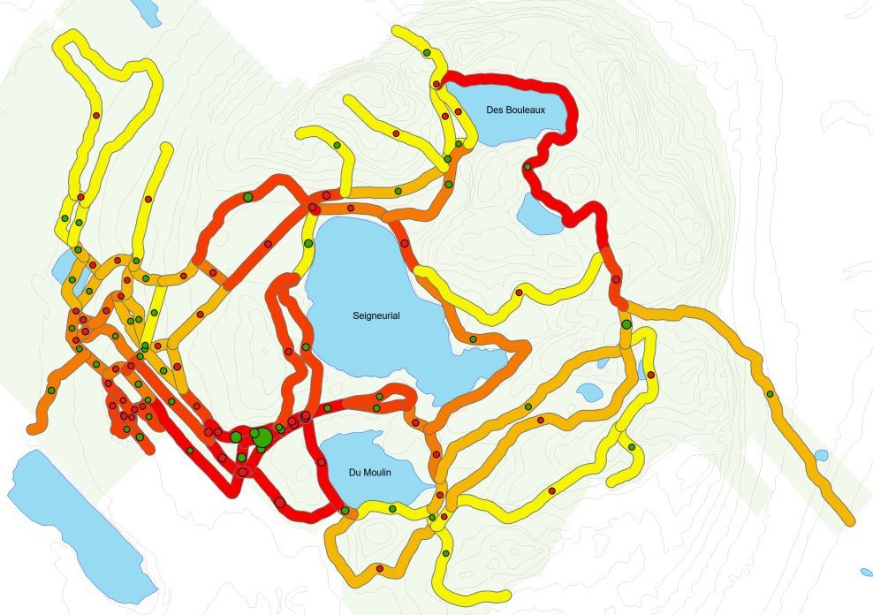 | 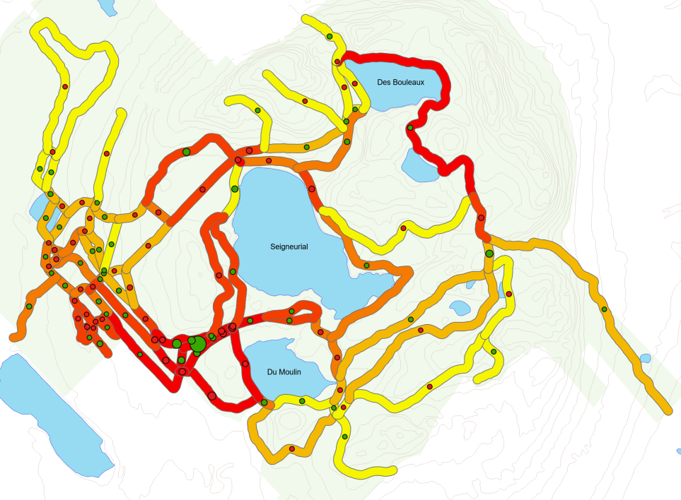
¹Predictions range: 6.53 ̶ 10.60  ²Residuals range: -0.76 ̶ 0.71 | ¹Predictions range: 6.96 ̶ 11.03  ²Residuals range: -0.76 ̶ 0.71
Model 2: Tick hazard
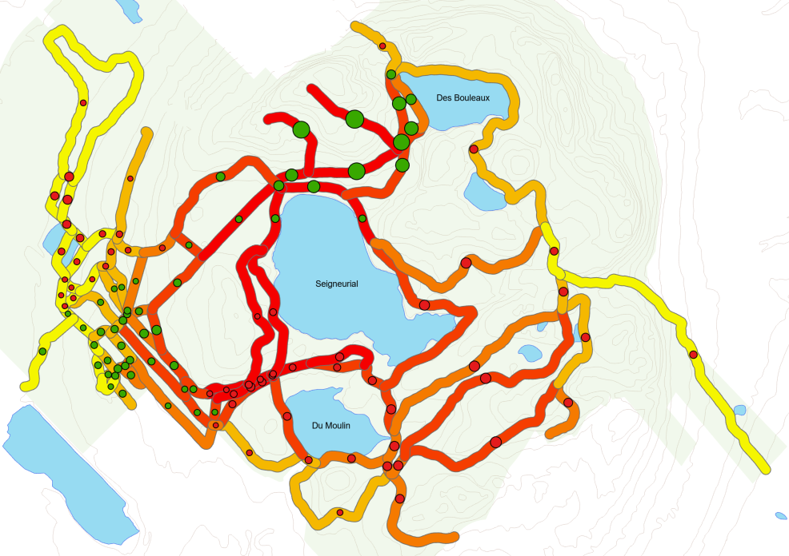 | 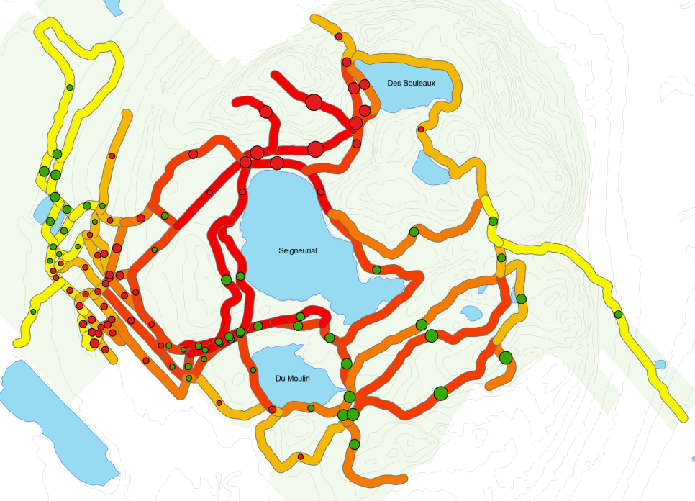
¹Predictions range: 3.62 ̶ 4.66  ²Residuals range: -0.22 ̶ 0.28 | ¹Predictions range: 1.63 ̶ 2.67  ²Residuals range: -0.28 ̶ 0.21
Model 3: Risk
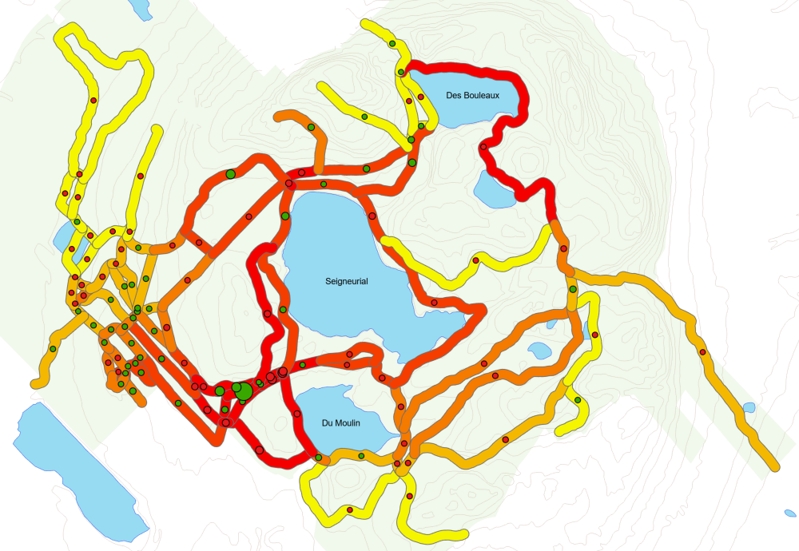 | 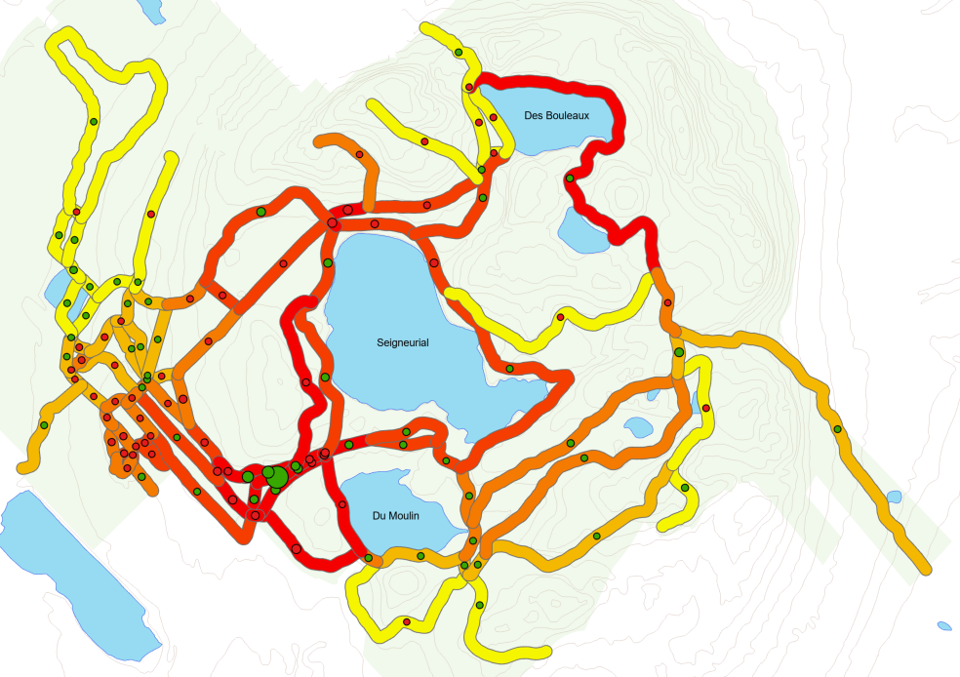
¹Predictions range: 5.57 ̶ 10.37  ²Residuals range: -0.90 ̶ 0.76 | ¹Predictions range: 4.01 ̶ 8.81  ²Residuals range: -0.72 ̶ 0.82

Figure S3: Comparison of predictions with observations for model 1, population exposure (A), model 2, tick hazard (B), and model 3, risk (C). The uncertainty of the predictions is illustrated by the confidence intervals (CI 95%) which are represented by the dashed red lines.
A
B
C

Table S1: Variation statistics of fine-scale landscape features, selected as numerical variables for model building following initial data exploration. Prior to final modeling, these variables were centered and scaled.
Variable | Mean | SD
trail_width | 2.768 | 0.975
trail_segment_length_log | 318.278 | 376.514
mean_elevation | 89.865 | 24.560
distance_nearest_entrance | 347.301 | 237.201
no_connections | 4.125 | 0.759
forest_patch_size_log | 11.311 | 2.190
forest_cover100m | 0.693 | 0.272
forest_cover200m | 0.675 | 0.213
forest_cover300m | 0.651 | 0.178
forest_cover400m | 0.638 | 0.152
forest_cover500m | 0.622 | 0.133
edges_density100m | 0.005 | 0.004
edges_density200m | 0.005 | 0.002
edges_density300m | 0.004 | 0.001
edges_density400m | 0.004 | 0.001
edges_density500m | 0.004 | 0.001

