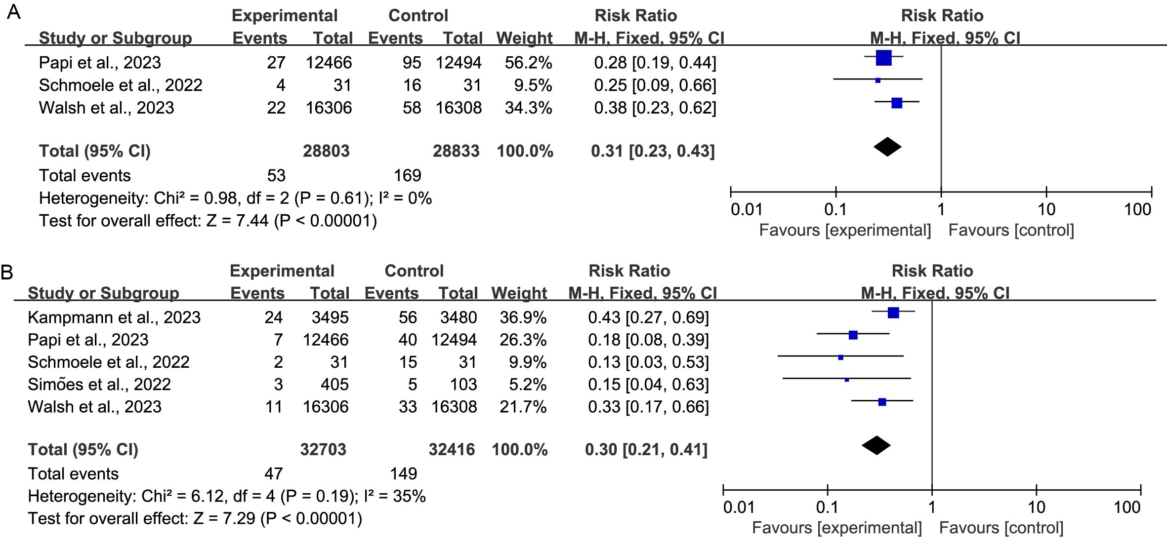
Supplementary figure 1 Sensitivity analysis of the efficacy of subunit vaccines. (A) RSV-associated acute respiratory illness. (B) Medically attended RSV-associated lower respiratory tract illness.

