Supplementary material 3: The basis for the linearity of the independent variables in the linear regression model.

Added-variable plots” (also called “partial regression plots” or “adjusted variable plots”) are refined residual plots that provide graphic information about the marginal importance of a predictor variable given the other variables already in the model.
The fact that an added-variable plot may suggest “the nature of the functional form” in which a predictor variable should be added to the regression model is more important than that the variable possible inclusion (which can be resolved without graphical help). The added-variable plots play the role that we use scatter diagrams for in simple linear regression; they would tell if data transformation or if certain polynomial model is desirable.
The partial residual (Partial Regressor Residual) plots for the three models indicated that a linear term in any of the independent variables can provide a useful contribution to the regression model, given that the other independent variables are already in the model. Therefore, with the analysis of partial residual graphs, the assumption of linearity can be verified for all independent variables in the multiple linear regression models analyzed (Figure 1, 2 and 3).

Parameter Estimates
Variable | Label | DF | Parameter  Estimate | Standard  Error | t Value | Pr > |t|
Intercept | Intercept | 1 | 23.26502 | 18.88797 | 1.23 | 0.2219
Percentual_Population_ages65_abo | Percentual_Population_ages65_above | 1 | 7.54564 | 1.46786 | 5.14 | <.0001
Percentual_Estimated_population1 | Percentual_Estimated_population500m_elevation | 1 | -0.50655 | 0.16848 | -3.01 | 0.0036
High_body_mass_index | High_body_mass_index | 1 | 3.50782 | 0.67028 | 5.23 | <.0001
Social__safety_nets_2020 | Social_ safety_nets_2020 | 1 | -14.26407 | 4.89618 | -2.91 | 0.0047
Unemployment_2019 | Unemployment_2019 | 1 | -1.18521 | 0.58087 | -2.04 | 0.0449
Covid_related_disorder_events | Covid_related_disorder_events | 1 | 0.11111 | 0.03426 | 3.24 | 0.0018
Table 1: Multiple linear regression models for daily and cumulative excess deaths due to COVID-19 per 100 thousand, in 2020, by sociodemographic, vaccination, health, social cohesion and risk communication variables (n = 81).
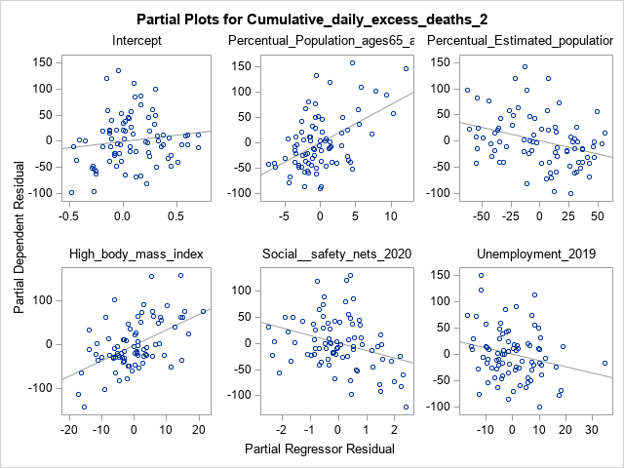
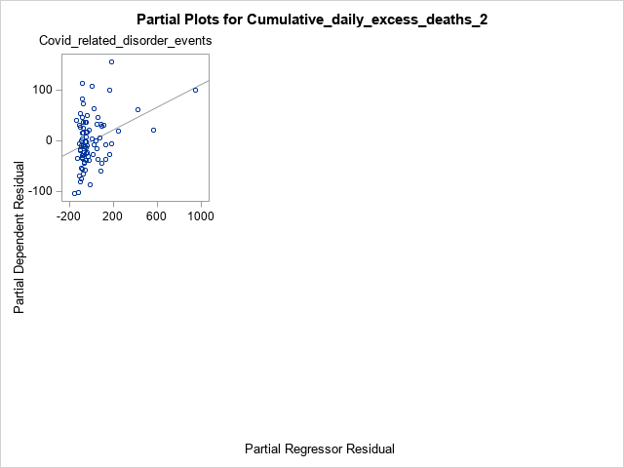
Figure 1: Partial Plots for daily and cumulative excess deaths due to COVID-19 per 100 thousand in 2020.

Parameter Estimates
Variable | Label | DF | Parameter  Estimate | Standard  Error | t Value | Pr > |t|
Intercept | Intercept | 1 | 17.02687 | 79.74209 | 0.21 | 0.8315
Percentual_Estimated_population5 | Percentual_Estimated_population5m_elevation | 1 | -3.94060 | 1.96650 | -2.00 | 0.0456
High_body_mass_index | High_body_mass_index | 1 | 2.72889 | 1.26371 | 2.16 | 0.0338
Cardiovascular_diseases_Prevalen | Cardiovascular_diseases_Prevalence | 1 | 0.04518 | 0.00497 | 9.08 | <.0001
Social_capital_2020 | Social_capital_2020 | 1 | -29.03553 | 10.36240 | -2.80 | 0.0064
Public_trust_politicians_2017 | Public_trust_politicians_2017 | 1 | -61.62222 | 17.73300 | -3.48 | 0.0008
Transparency_government_2017 | Transparency_government_2017 | 1 | 52.97532 | 26.48571 | 2.00 | 0.0417
Table 2: Multiple linear regression models for daily and cumulative excess deaths due to COVID-19 per 100 thousand, in 2021, by sociodemographic, vaccination, health, social cohesion and risk communication variables (n = 87).

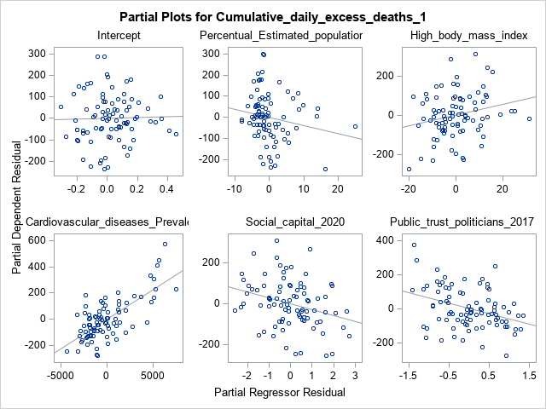
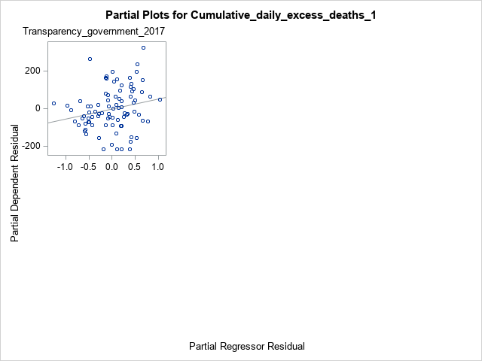
Figure 2: Partial Plots for daily and cumulative excess deaths due to COVID-19 per 100 thousand in 2021.

Parameter Estimates
Variable | Label | DF | Parameter  Estimate | Standard  Error | t Value | Pr > |t|
Intercept | Intercept | 1 | 70.34529 | 39.16024 | 1.80 | 0.0759
Percentual_Population_ages65_abo | Percentual_Population_ages65_above | 1 | 27.35987 | 2.90215 | 9.43 | <.0001
High_body_mass_index | High_body_mass_index | 1 | 5.68772 | 1.55840 | 3.65 | 0.0004
Equal_distribution_resources_ind | Equal_distribution_resources_index_2019 | 1 | -274.40121 | 69.22511 | -3.96 | 0.0001
Table 3: Multiple linear regression models for daily and cumulative excess deaths due to COVID-19 per 100 thousand, in 2022, by sociodemographic, vaccination, health, social cohesion and risk communication variables (n = 92).

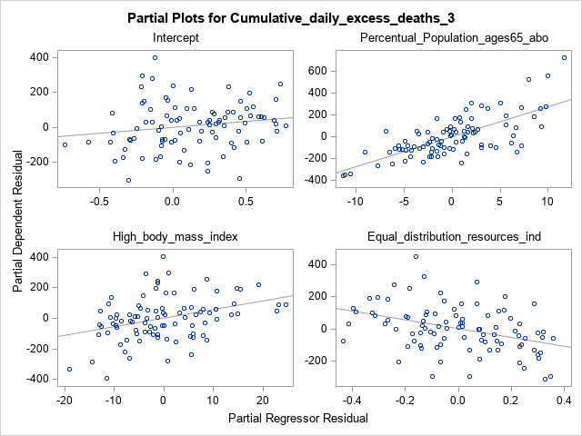
Figure 3: Partial Plots for daily and cumulative excess deaths due to COVID-19 per 100 thousand in 2022.

