Supplementary Figure 1. COVID-19 saturation rates.
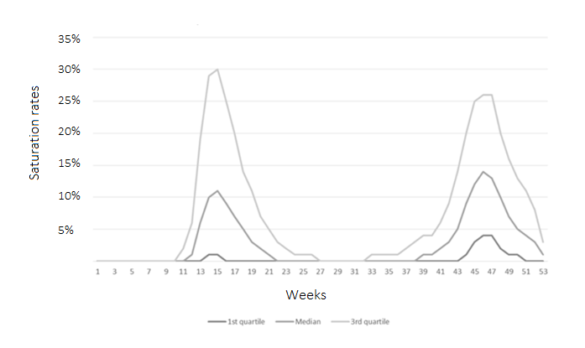

Supplementary Figure 2. Receiver Operating Characteristic (ROC) Curve and Area Under the Curve (AUC) for Logistic Model.
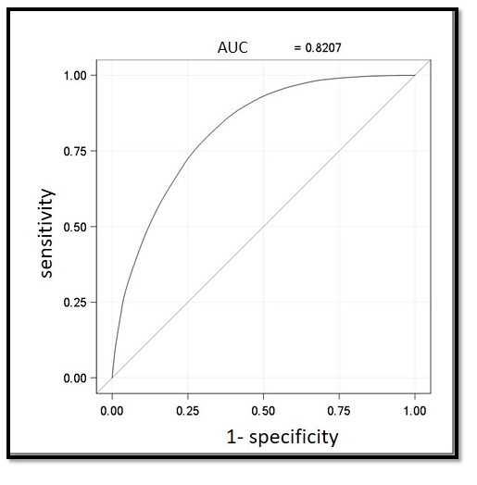

Supplementary Tables. Sensitivity analyses.
 | [5-15%[ (low) | [15-30%[ (moderate) | >30% (high)
Multivariate analysis was conducted, incorporating all covariates and replacing the Charlson Comorbidity Index with 17 indicator variables representing individual comorbidities (reference <5% (no)) | 1.050 [1.034-1.067] | 1.121 [1.098-1.145] | 1.255 [1.214-1.297]

 | Univariate OR  [95% CI] | P | Multivariate OR*  [95% CI] | P
Multivariate analysis was conducted including saturation rate as continuous numeric variable | 1,824 [1,721-1,933] | <.0001 | 1,677 [1,577-1,783] | p<.0001

 | [5-15%[ (low) | [15-30%[ (moderate) | >30% (high)
Multivariate analysis was conducted using Cox regression model with shared frailty model (reference <5% (no)) | 1.051  [1.036-1.066] | 1.136 [1.114-1.158] | 1.267 [1.230-1.304]

