Additional Figure 1 Forest plots of SA, SP, AS, and CS in PLWHA
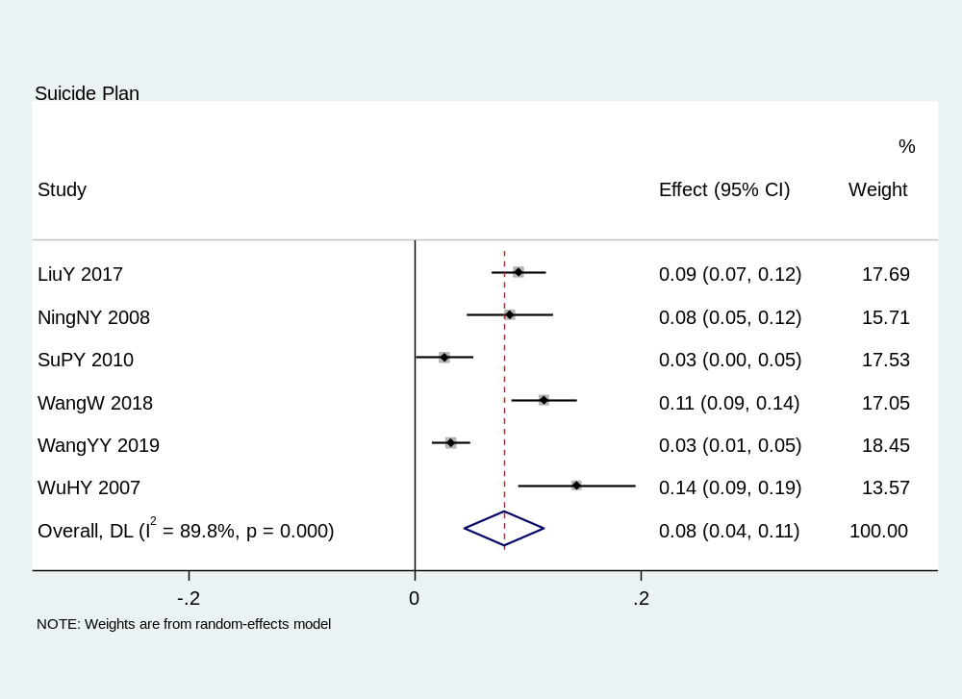
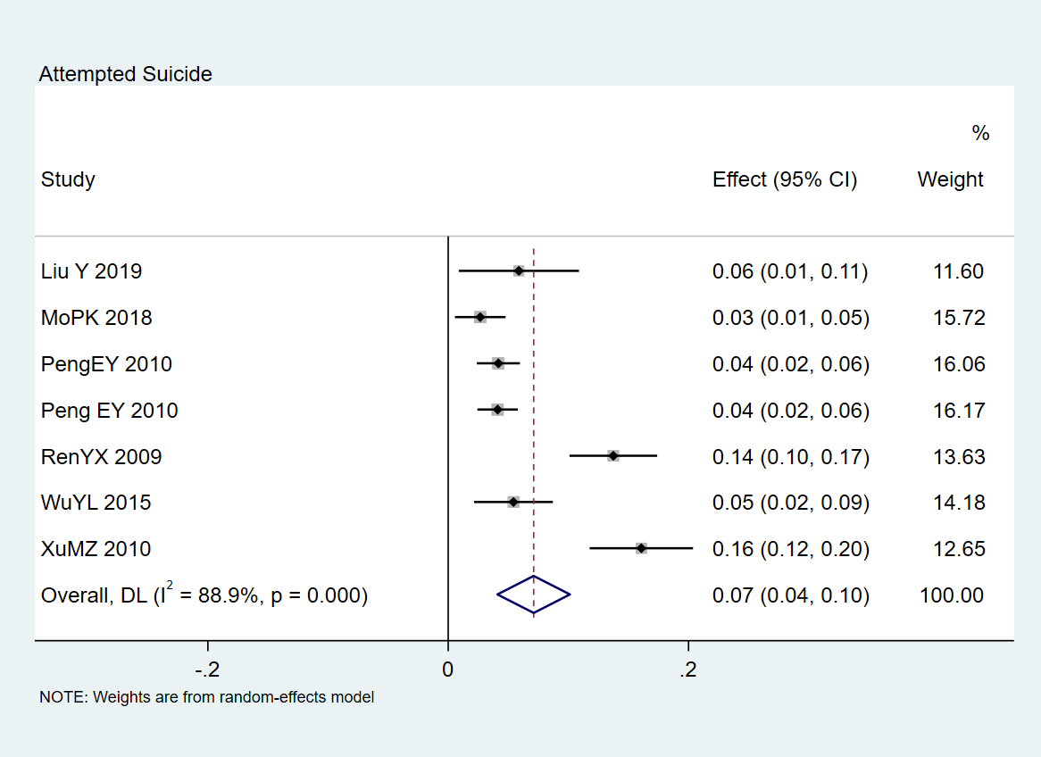
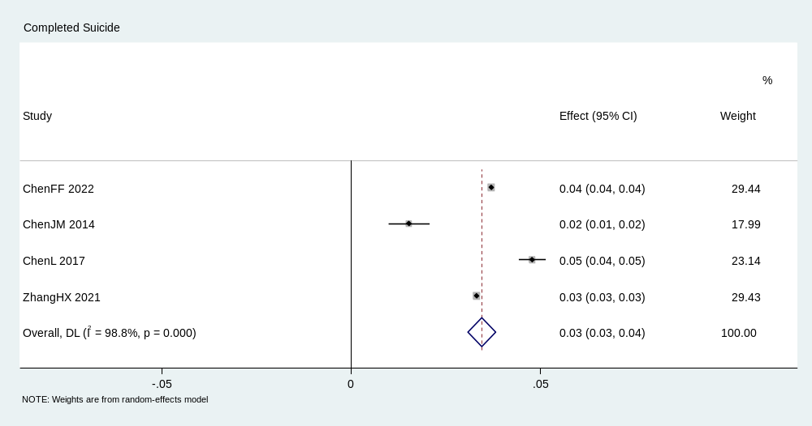

Additional Figure 2 Forest plots for subgroup analysis
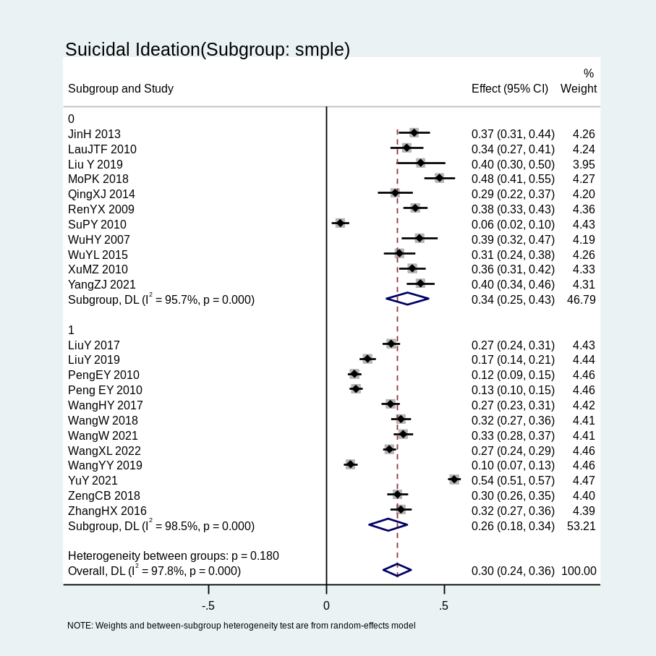
Note: 0, sample size < 400; 1, sample size ≥ 400
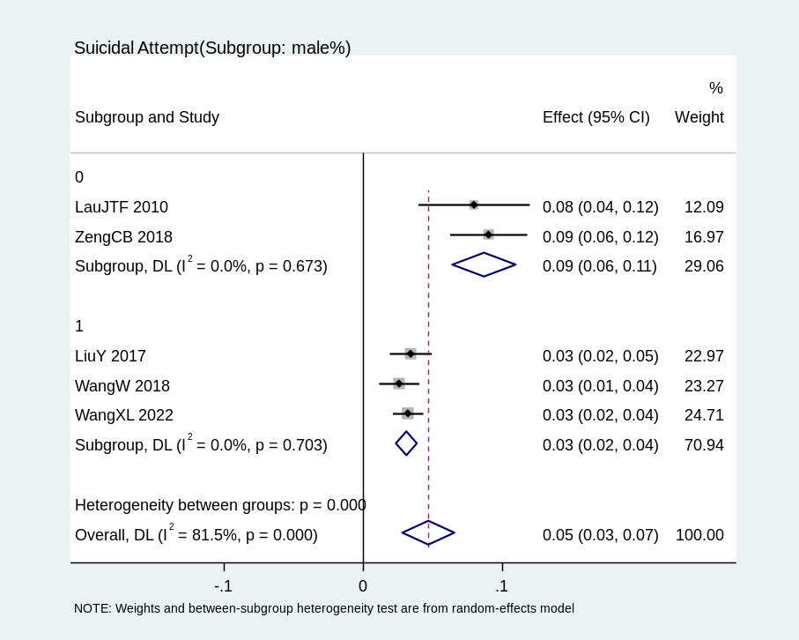
Note: 0, male proportion < 70%; 1, male proportion ≥ 70%
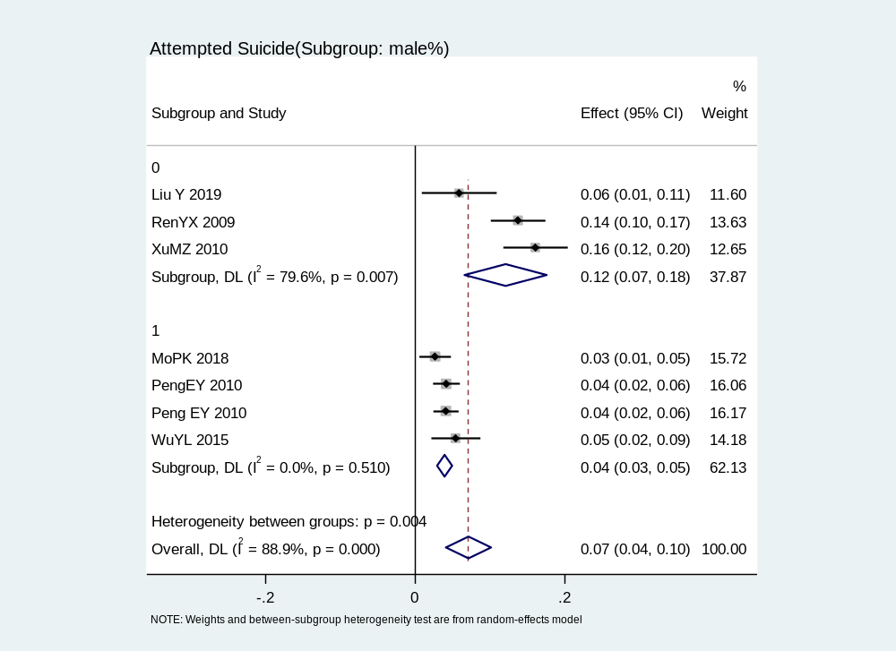
Note: 0, male proportion < 100%; 1, male proportion ≥ 100%
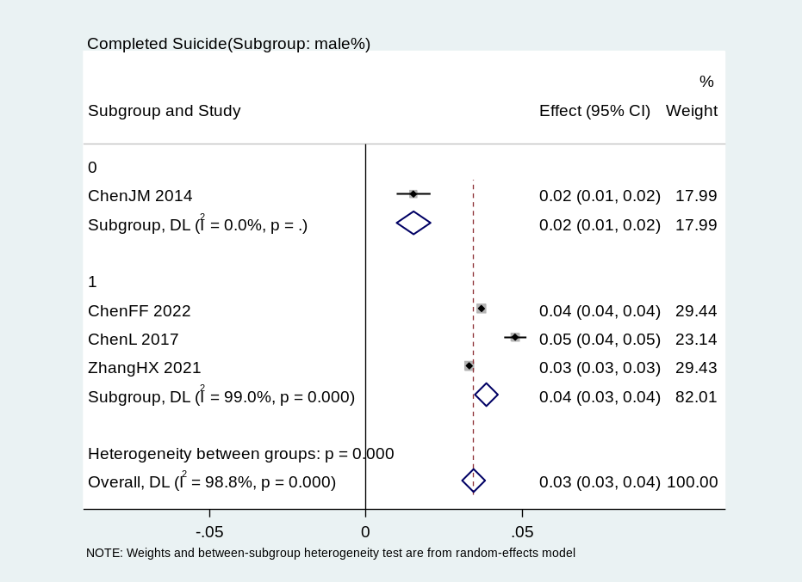
Note: 0, male proportion < 70%; 1, male proportion ≥ 70%
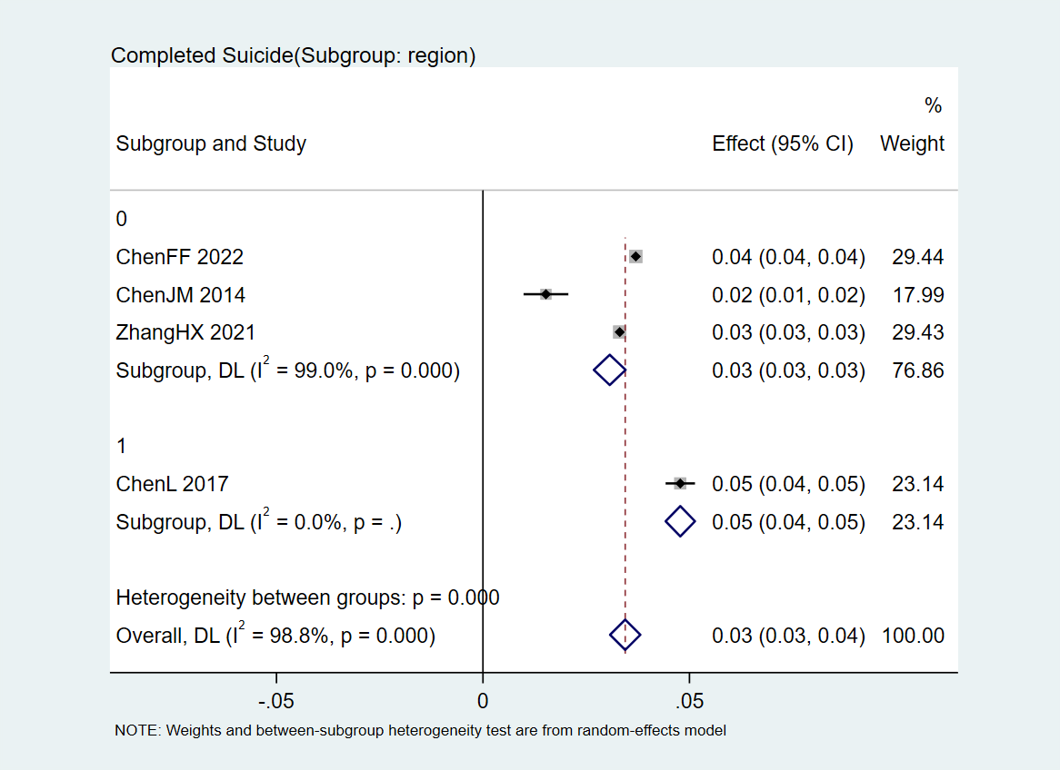
Note: 0, Non-coastal city; 1, Coastal city

Additional Figure 3 Sensitivity analysis of pooling prevalence of SI, SA, SP, and AS in PLWHA
Note: Sensitivity analysis of pooling prevalence of SI
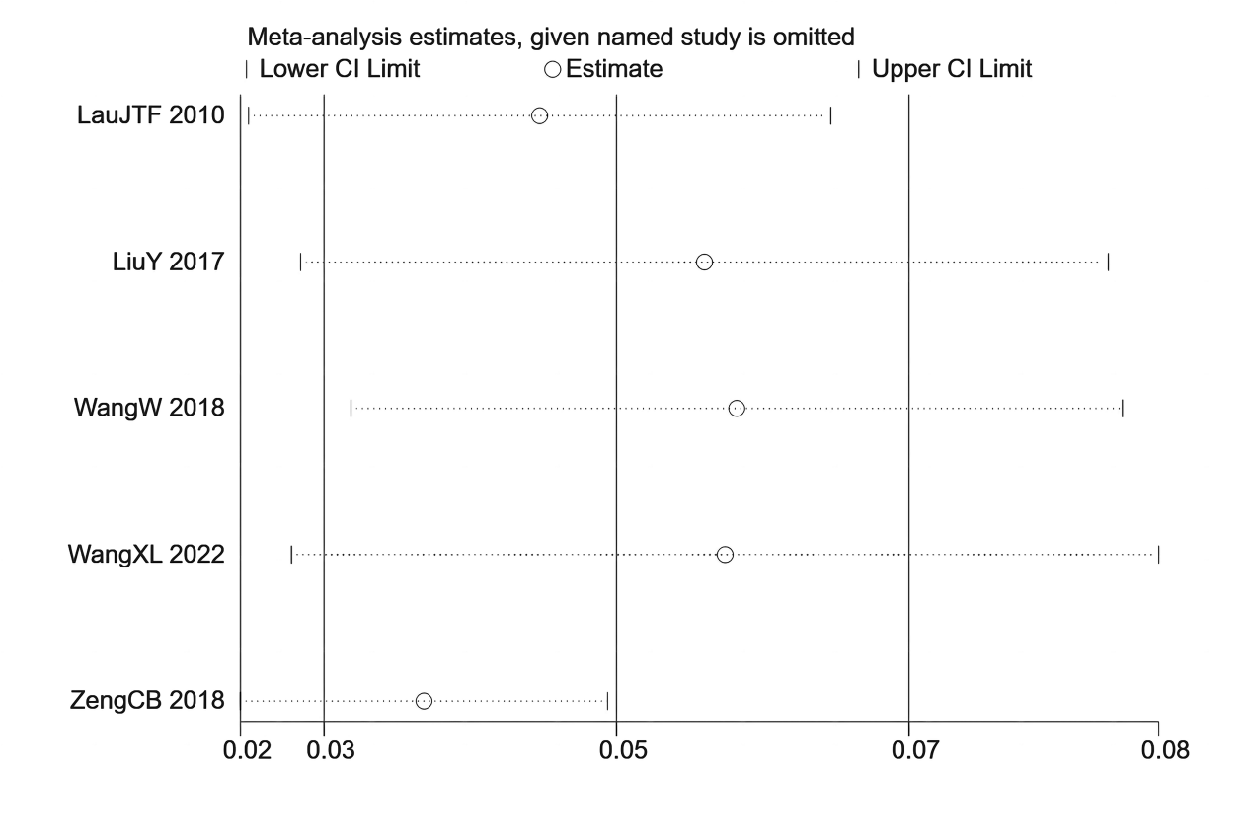
Note: Sensitivity analysis of pooling prevalence of SA

Note: Sensitivity analysis of pooling prevalence of SP
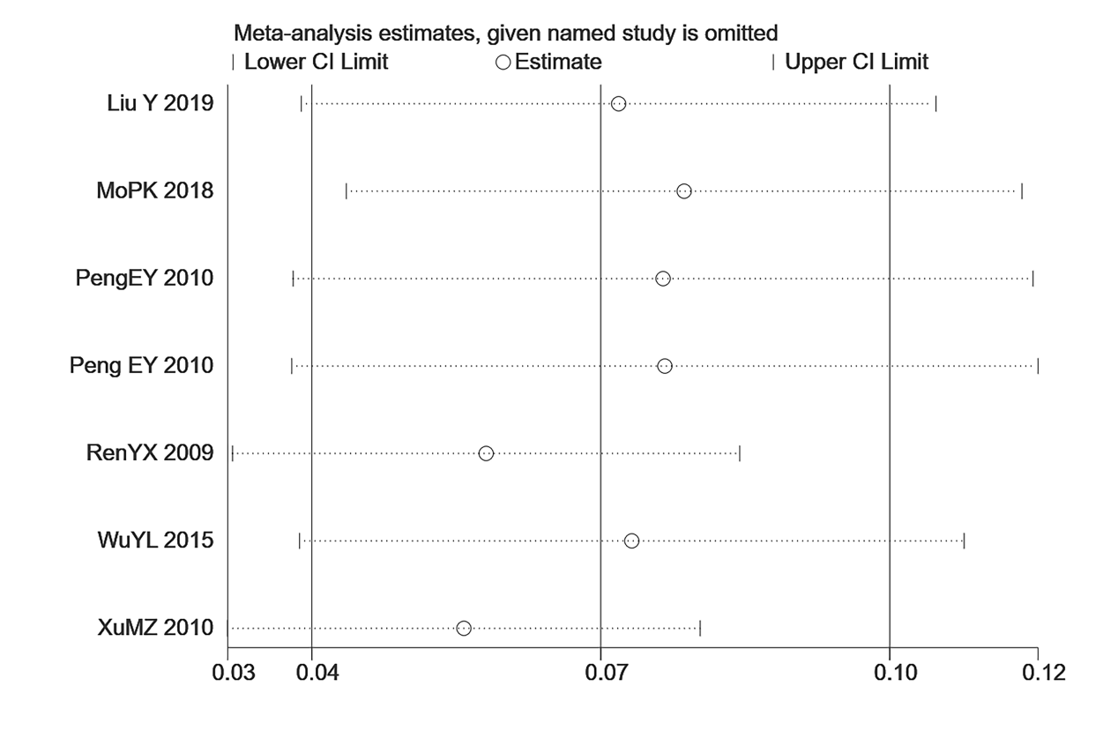
Note: Sensitivity analysis of pooling prevalence of AS

