Supplementary Material

Figure S1. Algorithm for participant selection in the NHANES (1999-2018).
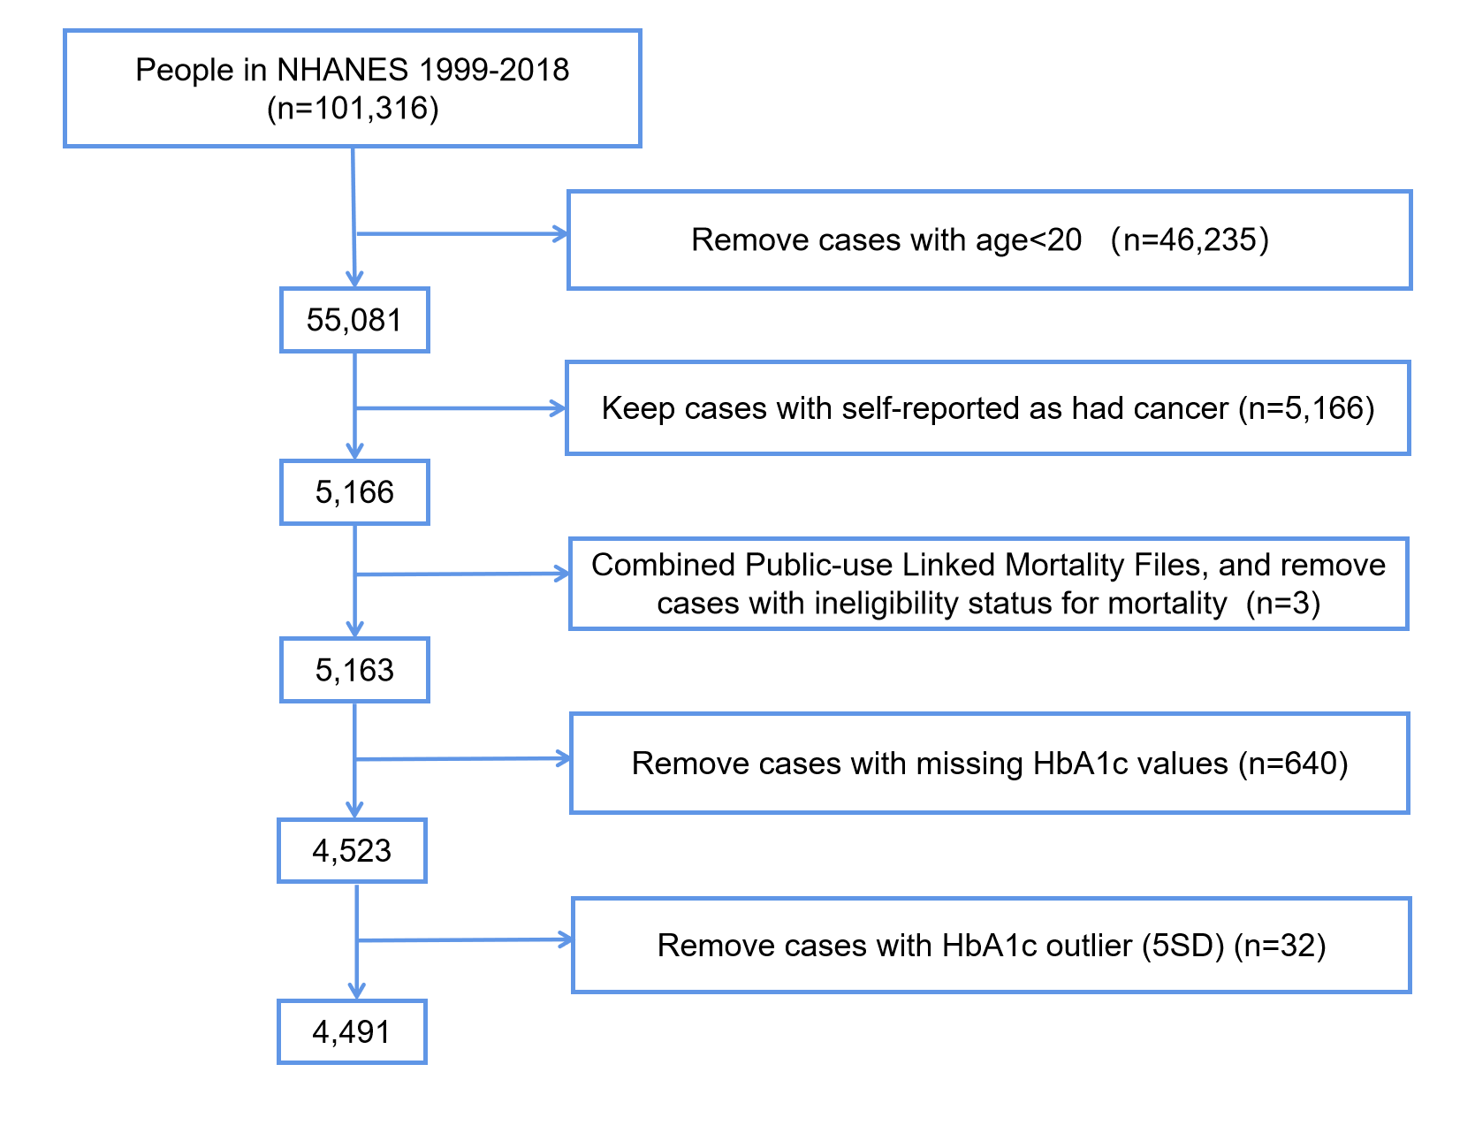
Note:
A cancer person was defined based on the question “Have you ever been told by a doctor or other health professional that you/s had cancer or a malignancy of any kind?”

Figure S2. Numerical distribution diagram before and after multiple interpolation.
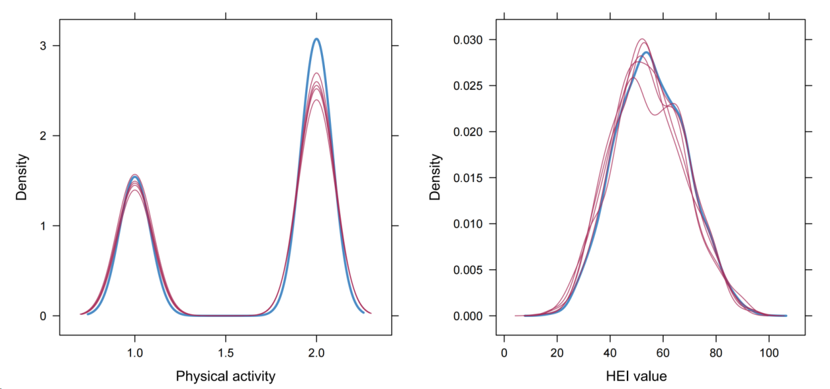
The blue line is the actual numerical distribution, and the red line is the numerical distribution after multiple interpolation.

Figure S3. Cumulative incidence function of CVD-related mortality categorized by different subgroups of HbA1c (A) and association between HbA1c and CVD-related mortality (B).
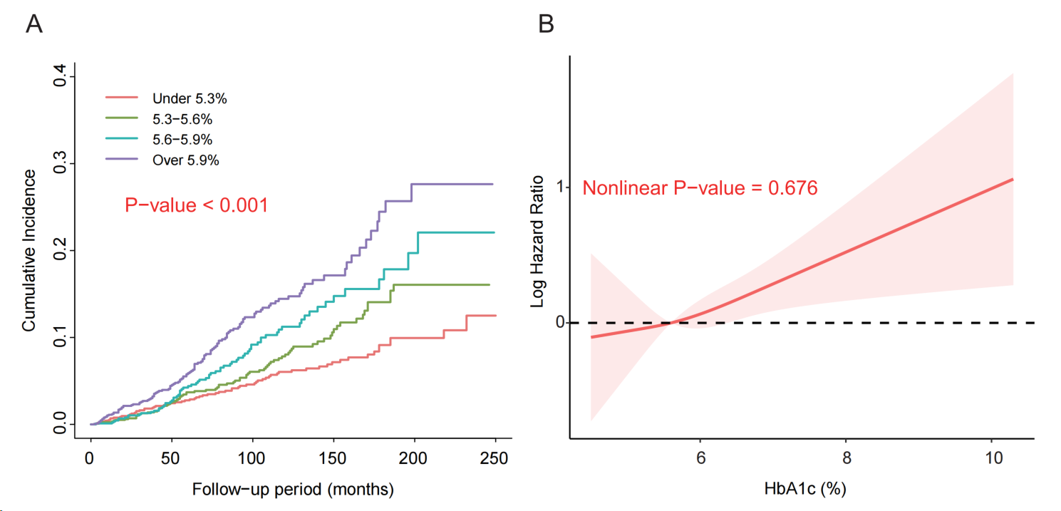

Note:
A restricted cubic spline model was calculated after adjusting for age, sex, race/ethnicity, BMI, education level, family income-poverty ratio, alcohol use, smoking status, ideal physical activity, HEI score, self-reported hypertension, hypercholesterolemia, CVD, years since first cancer diagnosis, use of prescription medications, and cancer sites.

Figure S4. Cumulative incidence function of Cancer-related mortality categorized by different subgroups of HbA1c (A) and association between HbA1c and Cancer-related mortality (B).
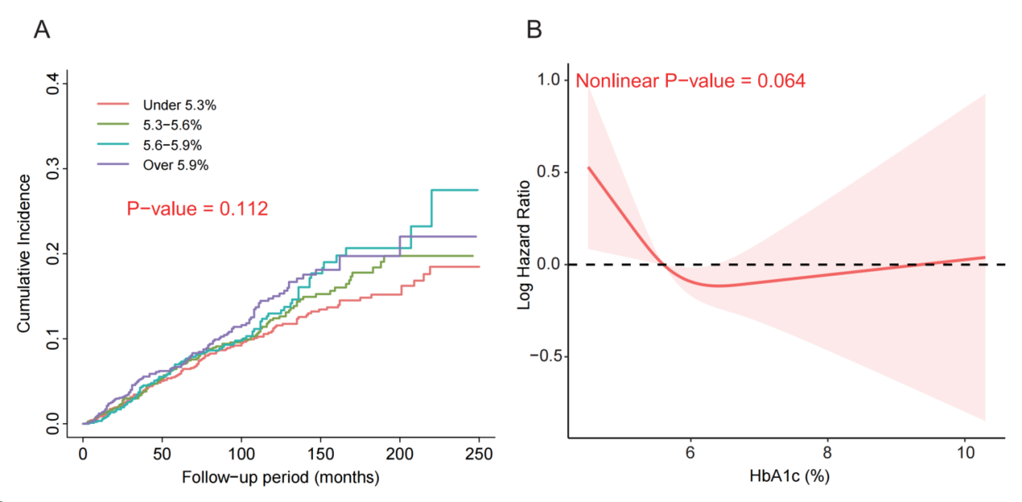

Note:
A restricted cubic spline model was calculated after adjusting for age, sex, race/ethnicity, BMI, education level, family income-poverty ratio, alcohol use, smoking status, ideal physical activity, HEI score, self-reported hypertension, hypercholesterolemia, CVD, years since first cancer diagnosis, use of prescription medications, and cancer sites.

Table S1. Missing value information of variables
Variable | N | Percent (%) | Total
Age | 0 | 0 | 4491
Gender | 0 | 0 | 4491
Race/ethnicity | 0 | 0 | 4491
BMI (kg/m²) | 118 | 2.627 | 4491
Alcohol user | 300 | 6.680 | 4491
Smoking | 4 | 0.089 | 4491
Education | 6 | 0.134 | 4491
Family income-poverty ratio | 382 | 8.506 | 4491
Physical activity | 1615 | 35.961 | 4491
HEI value | 537 | 11.957 | 4491
Hyperlipidemia | 0 | 0 | 4491
Hypertension | 0 | 0 | 4491
CVD | 0 | 0 | 4491
The years since cancer diagnosis | 28 | 0.623 | 4491
Use of prescription medications | 3 | 0.067 | 4491
Cancer sites | 0 | 0 | 4491

Table S2. Hazard ratios (95% CIs) for non-CVD and non-Cancer mortality among different HbA1c subgroups in NHANES 1999–2018.
 | HbA1c (per 0.2% increment) | Quartile 1  (≤5.3%) | Quartile 2  (5.3-5.6%) | Quartile 2  (5.6-5.9%) | Quartile 4  (>5.9%) | P trend
Non-CVD mortality
Model 1ª | 1.014 (0.997,1.032) 0.114 | 1.019 (0.855,1.215) 0.835 | 1.00 | 0.971 (0.8,1.179) 0.767 | 1.093 (0.907,1.316) 0.352 | 0.421
Model 2^{b} | 1.009 (0.99,1.028) 0.358 | 1.075 (0.901,1.283) 0.421 | 1.00 | 0.996 (0.823,1.205) 0.964 | 1.063 (0.882,1.281) 0.52 | 0.917
Model 3^{c} | 1.01 (0.992,1.029) 0.281 | 1.084 (0.903,1.3) 0.387 | 1.00 | 1.008 (0.829,1.225) 0.935 | 1.066 (0.883,1.286) 0.506 | 0.931
Non-Cancer mortality
Model 1ª | 1.041 (1.024,1.058) <0.001 | 0.982 (0.83,1.161) 0.832 | 1.00 | 1.041 (0.867,1.25) 0.667 | 1.406 (1.176,1.681) <0.001 | <0.001
Model 2^{b} | 1.035 (1.016,1.055) <0.001 | 1.02 (0.863,1.204) 0.819 | 1.00 | 1.071 (0.888,1.291) 0.474 | 1.361 (1.128,1.643) 0.001 | 0.002
Model 3^{c} | 1.032 (1.013,1.052) 0.001 | 1.028 (0.858,1.23) 0.767 | 1.00 | 1.086 (0.898,1.313) 0.397 | 1.311 (1.081,1.591) 0.006 | 0.009
Note:
a Model 1: adjusted for age;
b Model 2: further adjusted (from Model 1) for sex, race/ethnicity, BMI, education level, family income-poverty ratio, alcohol use, smoking status, ideal physical activity, and HEI score;
c Model 3: further adjusted (from Model 2) for self-reported hypertension, hypercholesterolemia, CVD, years since first cancer diagnosis, use of prescription medications, and cancer sites.

Table S3. Hazard ratios (95% CIs) for mortality among different HbA1c clinical threshold subgroups in NHANES 1999–2018.
 | HbA1c(per 0.2% increment) | <5.7% | 5.7-6.5% | ≥6.5% | P trend
All-cause mortality
Model 1ª | 1.025 (1.009,1.041) 0.002 | 1.00 | 1.045 (0.915,1.193) 0.513 | 1.391 (1.153,1.677) 0.001 | 0.001
Model 2^{b} | 1.018 (1,1.035) 0.044 | 1.00 | 1.034 (0.909,1.177) 0.608 | 1.265 (1.027,1.559) 0.027 | 0.029
Model 3^{c} | 1.018 (1.002,1.034) 0.031 | 1.00 | 1.028 (0.9,1.174) 0.681 | 1.262 (1.045,1.523) 0.016 | 0.018
CVD-related mortality
Model 1ª | 1.061 (1.035,1.088) <0.001 | 1.00 | 1.472 (1.115,1.945) 0.006 | 2.128 (1.527,2.964) <0.001 | <0.001
Model 2^{b} | 1.048 (1.014,1.083) 0.005 | 1.00 | 1.43 (1.074,1.903) 0.014 | 1.747 (1.149,2.656) 0.009 | 0.007
Model 3^{c} | 1.04 (1.008,1.074) 0.015 | 1.00 | 1.353 (1.02,1.795) 0.036 | 1.6 (1.087,2.354) 0.017 | 0.015
Cancer-related mortality
Model 1ª | 0.986 (0.951,1.022) 0.435 | 1.00 | 0.946 (0.724,1.237) 0.687 | 0.845 (0.57,1.255) 0.404 | 0.403
Model 2^{b} | 0.974 (0.939,1.01) 0.156 | 1.00 | 0.901 (0.701,1.159) 0.419 | 0.739 (0.498,1.097) 0.134 | 0.129
Model 3^{c} | 0.979 (0.944,1.015) 0.254 | 1.00 | 0.91 (0.695,1.191) 0.491 | 0.782 (0.532,1.149) 0.21 | 0.206
Note:
a Model 1: adjusted for age;
b Model 2: further adjusted (from Model 1) for sex, race/ethnicity, BMI, education level, family income-poverty ratio, alcohol use, smoking status, ideal physical activity, and HEI score;
c Model 3: further adjusted (from Model 2) for self-reported hypertension, hypercholesterolemia, CVD, years since first cancer diagnosis, use of prescription medications, and cancer sites.

Table S4. Hazard ratios (95% CIs) for non-CVD and non-Cancer mortality among different HbA1c clinical threshold subgroups in NHANES 1999–2018.
 | HbA1c(per 0.2% increment) | <5.7% | 5.7-6.5% | ≥6.5% | P trend
Non-CVD mortality
Model 1ª | 1.014 (0.997,1.032) 0.114 | 1.00 | 0.955 (0.828,1.102) 0.529 | 1.243 (1.01,1.529) 0.04 | 0.068
Model 2^{b} | 1.009 (0.99,1.028) 0.374 | 1.00 | 0.95 (0.824,1.096) 0.482 | 1.16 (0.927,1.452) 0.193 | 0.240
Model 3^{c} | 1.01 (0.992,1.030) 0.280 | 1.00 | 0.954 (0.822,1.107) 0.533 | 1.179 (0.947,1.468) 0.141 | 0.178
Non-Cancer mortality
Model 1ª | 1.041 (1.024,1.058) <0.001 | 1.00 | 1.097 (0.948,1.27) 0.213 | 1.691 (1.379,2.072) <0.001 | <0.001
Model 2^{b} | 1.035 (1.015,1.055) 0.001 | 1.00 | 1.103 (0.951,1.279) 0.196 | 1.561 (1.23,1.981) <0.001 | <0.001
Model 3^{c} | 1.032 (1.012,1.052) 0.001 | 1.00 | 1.092 (0.939,1.271) 0.253 | 1.514 (1.207,1.9) <0.001 | <0.001
Note:
a Model 1: adjusted for age;
b Model 2: further adjusted (from Model 1) for sex, race/ethnicity, BMI, education level, family income-poverty ratio, alcohol use, smoking status, ideal physical activity, and HEI score;
c Model 3: further adjusted (from Model 2) for self-reported hypertension, hypercholesterolemia, CVD, years since first cancer diagnosis, use of prescription medications, and cancer sites.

Table S5. Hazard ratios (95% CIs) of mortality among different fasting plasma glucose subgroups (n=2189ª)
 | Fasting plasma glucose (per 0.2 mmol/L increment) | Quartile 1  (≤5.2 mmol/L) | Quartile 2  (5.2-5.7 mmol/L) | Quartile 3  (5.7-6.3 mmol/L) | Quartile 4  (>6.3 mmol/L) | P trend
All-cause mortality
Model 1^{b} | 1.012 (1.002,1.021) 0.018 | 1.263 (0.993,1.605) 0.057 | 1.00 | 0.978 (0.792,1.206) 0.833 | 1.401 (1.123,1.746) 0.003 | 0.077
Model 2^{c} | 1.006 (0.995,1.017) 0.295 | 1.308 (1.033,1.655) 0.026 | 1.00 | 0.942 (0.738,1.202) 0.63 | 1.253 (0.991,1.584) 0.06 | 0.526
Model 3^{d} | 1.006 (0.994,1.018) 0.306 | 1.487 (1.141,1.937) 0.003 | 1.00 | 1.05 (0.82,1.343) 0.7 | 1.332 (1.04,1.706) 0.023 | 0.662
CVD-related mortality
Model 1^{b} | 1.032 (1.017,1.047) <0.001 | 0.849 (0.506,1.424) 0.535 | 1.00 | 0.811 (0.425,1.549) 0.526 | 1.813 (1.078,3.048) 0.025 | 0.002
Model 2^{c} | 1.021 (1.004,1.039) 0.014 | 0.873 (0.485,1.572) 0.65 | 1.00 | 0.711 (0.361,1.402) 0.325 | 1.442 (0.807,2.576) 0.217 | 0.042
Model 3^{d} | 1.018 (0.999,1.037) 0.059 | 1.152 (0.625,2.123) 0.65 | 1.00 | 0.893 (0.465,1.717) 0.735 | 1.533 (0.866,2.714) 0.143 | 0.107
Cancer-related mortality
Model 1^{b} | 1.003 (0.982,1.024) 0.795 | 1.472 (0.976,2.219) 0.065 | 1.00 | 1.405 (0.917,2.153) 0.119 | 1.515 (0.969,2.368) 0.068 | 0.449
Model 2^{c} | 0.999 (0.974,1.024) 0.922 | 1.495 (0.988,2.262) 0.057 | 1.00 | 1.355 (0.873,2.103) 0.176 | 1.404 (0.905,2.176) 0.13 | 0.731
Model 3^{d} | 1.002 (0.978,1.026) 0.882 | 1.492 (0.946,2.354) 0.085 | 1.00 | 1.386 (0.864,2.224) 0.176 | 1.448 (0.888,2.36) 0.137 | 0.631
Note:
a We included cancer survivors with fasting plasma glucose from NHANES 1990-2019, and the data cleaning algorithm was similar to the HbA1c;
b Model 1: adjusted for age;
c Model 2: further adjusted (from Model 1) for sex, race/ethnicity, BMI, education level, family income-poverty ratio, alcohol use, smoking status, ideal physical activity, and HEI score;
d Model 3: further adjusted (from Model 2) for self-reported hypertension, hypercholesterolemia, CVD, years since first cancer diagnosis, use of prescription medications, and cancer sites.

Table S6. Hazard ratios (95% CIs) for non-CVD and non-Cancer mortality among different fasting plasma glucose subgroups (n=2189)
 | Fasting plasma glucose (per 0.2 mmol/L increment) | Quartile 1  (≤5.2 mmol/L) | Quartile 2  (5.2-5.7 mmol/L) | Quartile 3  (5.7-6.3 mmol/L) | Quartile 4  (>6.3 mmol/L) | P trend
Non-CVD mortality
Model 1ª | 1.006 (0.994,1.018) 0.325 | 1.362 (1.046,1.775) 0.022 | 1.00 | 1.022 (0.805,1.299) 0.856 | 1.297 (1.031,1.631) 0.026 | 0.667
Model 2^{b} | 1.001 (0.988,1.014) 0.848 | 1.405 (1.101,1.794) 0.006 | 1.00 | 0.999 (0.771,1.294) 0.992 | 1.184 (0.944,1.485) 0.143 | 0.675
Model 3^{c} | 1.002 (0.989,1.016) 0.76 | 1.536 (1.168,2.021) 0.002 | 1.00 | 1.084 (0.824,1.427) 0.565 | 1.256 (0.978,1.612) 0.074 | 0.724
Non-Cancer mortality
Model 1ª | 1.016 (1.004,1.028) 0.008 | 1.188 (0.893,1.58) 0.238 | 1.00 | 0.824 (0.632,1.075) 0.154 | 1.365 (1.051,1.774) 0.02 | 0.104
Model 2^{b} | 1.009 (0.996,1.021) 0.17 | 1.253 (0.934,1.681) 0.132 | 1.00 | 0.789 (0.583,1.068) 0.125 | 1.189 (0.884,1.6) 0.252 | 0.676
Model 3^{c} | 1.008 (0.994,1.021) 0.251 | 1.518 (1.075,2.143) 0.018 | 1.00 | 0.924 (0.681,1.254) 0.614 | 1.296 (0.949,1.771) 0.103 | 0.859
Note:
a Model 1: adjusted for age;
b Model 2: further adjusted (from Model 1) for sex, race/ethnicity, BMI, education level, family income-poverty ratio, alcohol use, smoking status, ideal physical activity, and HEI score;
c Model 3: further adjusted (from Model 2) for self-reported hypertension, hypercholesterolemia, CVD, years since first cancer diagnosis, use of prescription medications, and cancer sites.

Table S7. Threshold effect analysis of fasting plasma glucose on all-cause mortality (n=2189)
 | Threshold value | < threshold value (per 0.2 mmol/L increment) | ≥ threshold value (per 0.2 mmol/L increment) | P for log likelihood ratio test†
All-cause mortality | 5.7 | 0.942 (0.888,0.998), 0.044 | 1.013 (1.001,1.024), 0.029 | 0.010~0.016
Note:
† The P value for 5 imputed datasets range from 0.010 to 0.016, and the P for log likelihood ratio test <0.05.
The two piecewise linear regression models were adjusted for age, sex, race/ethnicity, BMI, education level, family income-poverty ratio, alcohol use, smoking status, ideal physical activity, HEI score, self-reported hypertension, hypercholesterolemia, CVD, years since first cancer diagnosis, use of prescription medications, and cancer sites.

Table S8. Hazard ratios (95% CIs) of mortality among different HbA1c subgroups in breast cancer survivors (n=659ª)
 | Fasting plasma glucose (per 0.2 % increment) | Quartile 1  (≤5.3 %) | Quartile 2  (5.3-5.6 %) | Quartile 3  (5.6-5.9 %) | Quartile 4  (>5.9 %) | P trend
All-cause mortality
Model 1^{b} | 1.041 (1.008,1.075) 0.014 | 1.519 (1.003,2.301) 0.049 | 1.00 | 1.286 (0.898,1.841) 0.17 | 1.536 (1.046,2.257) 0.029 | 0.329
Model 2^{c} | 1.036 (1.001,1.071) 0.042 | 1.822 (1.157,2.869) 0.010 | 1.00 | 1.37 (0.892,2.104) 0.15 | 1.502 (0.955,2.363) 0.079 | 0.772
Model 3^{d} | 1.037 (1.003,1.073) 0.035 | 1.913 (1.176,3.114) 0.009 | 1.00 | 1.453 (0.951,2.22) 0.084 | 1.578 (0.971,2.564) 0.065 | 0.704
CVD-related mortality
Model 1^{b} | 1.081 (1.011,1.155) 0.023 | 1.296 (0.395,4.251) 0.669 | 1.00 | 1.349 (0.597,3.048) 0.471 | 1.875 (0.784,4.487) 0.158 | 0.244
Model 2^{c} | 1.068 (0.991,1.15) 0.083 | 1.507 (0.39,5.82) 0.552 | 1.00 | 1.367 (0.514,3.635) 0.531 | 1.642 (0.56,4.811) 0.366 | 0.58
Model 3^{d} | 1.067 (0.983,1.159) 0.123 | 1.598 (0.444,5.745) 0.473 | 1.00 | 1.595 (0.567,4.485) 0.376 | 2.004 (0.581,6.905) 0.271 | 0.394
Cancer-related mortality
Model 1^{b} | 1.065 (1.012,1.121) 0.015 | 1.451 (0.661,3.185) 0.353 | 1.00 | 1.494 (0.736,3.033) 0.267 | 1.598 (0.815,3.136) 0.173 | 0.403
Model 2^{c} | 1.05 (0.98,1.125) 0.166 | 1.899 (0.843,4.274) 0.122 | 1.00 | 1.383 (0.651,2.939) 0.399 | 1.313 (0.607,2.842) 0.489 | 0.796
Model 3^{d} | 1.06 (0.991,1.133) 0.088 | 1.855 (0.829,4.153) 0.133 | 1.00 | 1.4 (0.657,2.98) 0.383 | 1.384 (0.652,2.938) 0.397 | 0.955
Note:
a We selected breast cancer survivors based on the question “1st cancer - what kind was it?”, and the data cleaning algorithm was similar to the HbA1c;
b Model 1: adjusted for age;
c Model 2: further adjusted (from Model 1) for race/ethnicity, BMI, education level, family income-poverty ratio, alcohol use, smoking status, ideal physical activity, and HEI score;
d Model 3: further adjusted (from Model 2) for self-reported hypertension, hypercholesterolemia, CVD, years since first cancer diagnosis, use of prescription medications.

Table S9. Hazard ratios (95% CIs) of non-CVD and non-Cancer mortality among different HbA1c subgroups in breast cancer survivors (n=659)
 | Fasting plasma glucose (per 0.2 % increment) | Quartile 1  (≤5.3 %) | Quartile 2  (5.3-5.6 %) | Quartile 3  (5.6-5.9 %) | Quartile 4  (>5.9 %) | P trend
Non-CVD mortality
Model 1ª | 1.031 (0.994,1.07) 0.098 | 1.563 (1.014,2.41) 0.043 | 1.00 | 1.264 (0.816,1.959) 0.295 | 1.466 (0.947,2.271) 0.087 | 0.597
Model 2^{b} | 1.028 (0.986,1.071) 0.195 | 1.871 (1.177,2.975) 0.008 | 1.00 | 1.349 (0.833,2.185) 0.223 | 1.459 (0.869,2.45) 0.153 | 0.973
Model 3^{c} | 1.031 (0.991,1.074) 0.134 | 1.9 (1.152,3.133) 0.012 | 1.00 | 1.405 (0.872,2.265) 0.162 | 1.514 (0.888,2.58) 0.127 | 0.873
Non-Cancer mortality
Model 1ª | 1.027 (0.984,1.073) 0.226 | 1.556 (0.963,2.515) 0.071 | 1.00 | 1.2 (0.786,1.831) 0.398 | 1.518 (0.92,2.506) 0.103 | 0.515
Model 2^{b} | 1.027 (0.983,1.073) 0.231 | 1.817 (1.077,3.063) 0.025 | 1.00 | 1.374 (0.818,2.309) 0.23 | 1.659 (0.962,2.862) 0.069 | 0.538
Model 3^{c} | 1.027 (0.983,1.073) 0.229 | 1.948 (1.08,3.514) 0.027 | 1.00 | 1.461 (0.863,2.473) 0.158 | 1.753 (0.966,3.183) 0.065 | 0.528
Note:
a Model 1: adjusted for age;
b Model 2: further adjusted (from Model 1) for race/ethnicity, BMI, education level, family income-poverty ratio, alcohol use, smoking status, ideal physical activity, and HEI score;
c Model 3: further adjusted (from Model 2) for self-reported hypertension, hypercholesterolemia, CVD, years since first cancer diagnosis, use of prescription medications.

Table S10. Threshold effect analysis of HbA1c on all-cause mortality in breast cancer survivors (n=659)
 | Threshold value | < threshold value (per 0.2 mmol/L increment) | ≥ threshold value (per 0.2 mmol/L increment) | P for log likelihood ratio test†
All-cause mortality | 5.5 | 0.824 (0.669,1.016), 0.07 | 1.053 (1.018,1.089), 0.003 | 0.028~0.037
Note:
† The P value for 5 imputed datasets range from 0.028 to 0.037, and the P for log likelihood ratio test <0.05.
The two piecewise linear regression models were adjusted for age, race/ethnicity, BMI, education level, family income-poverty ratio, alcohol use, smoking status, ideal physical activity, HEI score, self-reported hypertension, hypercholesterolemia, CVD, years since first cancer diagnosis, use of prescription medications.

Table S11. Hazard ratios (95% CIs) of mortality among different HbA1c subgroups in prostate cancer survivors (n=673ª)
 | Fasting plasma glucose (per 0.2 % increment) | Quartile 1  (≤5.4 %) | Quartile 2  (5.4-5.7 %) | Quartile 3  (5.7-6.1 %) | Quartile 4  (>6.1 %) | P trend
All-cause mortality
Model 1^{b} | 1.047 (1.013,1.083) 0.006 | 0.838 (0.595,1.181) 0.314 | 1.00 | 1.295 (0.881,1.902) 0.188 | 1.318 (0.861,2.017) 0.204 | 0.024
Model 2^{c} | 1.038 (1.002,1.075) 0.036 | 0.895 (0.625,1.283) 0.547 | 1.00 | 1.272 (0.885,1.826) 0.193 | 1.285 (0.853,1.935) 0.231 | 0.057
Model 3^{d} | 1.045 (1.007,1.085) 0.019 | 0.867 (0.606,1.24) 0.434 | 1.00 | 1.255 (0.865,1.822) 0.231 | 1.32 (0.876,1.989) 0.184 | 0.033
CVD-related mortality
Model 1^{b} | 1.037 (0.958,1.123) 0.366 | 1.159 (0.586,2.293) 0.672 | 1.00 | 1.602 (0.747,3.436) 0.226 | 1.715 (0.737,3.992) 0.211 | 0.247
Model 2^{c} | 1.031 (0.953,1.115) 0.449 | 1.026 (0.474,2.222) 0.948 | 1.00 | 1.538 (0.692,3.422) 0.291 | 1.507 (0.654,3.469) 0.335 | 0.303
Model 3^{d} | 1.019 (0.939,1.106) 0.647 | 0.987 (0.459,2.12) 0.973 | 1.00 | 1.282 (0.581,2.826) 0.538 | 1.27 (0.518,3.109) 0.601 | 0.551
Cancer-related mortality
Model 1^{b} | 1.049 (0.998,1.103) 0.062 | 0.589 (0.282,1.23) 0.159 | 1.00 | 1.259 (0.592,2.675) 0.55 | 1.069 (0.492,2.324) 0.866 | 0.153
Model 2^{c} | 1.019 (0.966,1.076) 0.488 | 0.672 (0.323,1.4) 0.289 | 1.00 | 1.177 (0.576,2.405) 0.654 | 0.898 (0.435,1.851) 0.77 | 0.577
Model 3^{d} | 1.026 (0.968,1.088) 0.386 | 0.659 (0.32,1.356) 0.257 | 1.00 | 1.201 (0.588,2.455) 0.615 | 0.946 (0.451,1.982) 0.882 | 0.458
Note:
a We selected breast cancer survivors based on the question “1st cancer - what kind was it?”, and the data cleaning algorithm was similar to the HbA1c;
b Model 1: adjusted for age;
c Model 2: further adjusted (from Model 1) for race/ethnicity, BMI, education level, family income-poverty ratio, alcohol use, smoking status, ideal physical activity, and HEI score;
d Model 3: further adjusted (from Model 2) for self-reported hypertension, hypercholesterolemia, CVD, years since first cancer diagnosis, use of prescription medications.

Table S12. Hazard ratios (95% CIs) for non-CVD and non-Cancer mortality among different HbA1c subgroups in prostate cancer survivors (n=673)
 | Fasting plasma glucose (per 0.2 % increment) | Quartile 1  (≤5.4 %) | Quartile 2  (5.4-5.7 %) | Quartile 3  (5.7-6.1 %) | Quartile 4  (>6.1 %) | P trend
Non-CVD mortality
Model 1ª | 1.049 (1.012,1.089) 0.01 | 0.766 (0.5,1.174) 0.221 | 1.00 | 1.227 (0.79,1.905) 0.362 | 1.231 (0.761,1.99) 0.397 | 0.053
Model 2^{b} | 1.039 (0.999,1.08) 0.057 | 0.859 (0.548,1.347) 0.507 | 1.00 | 1.225 (0.817,1.835) 0.326 | 1.249 (0.787,1.983) 0.346 | 0.107
Model 3^{c} | 1.048 (1.005,1.092) 0.027 | 0.827 (0.528,1.294) 0.405 | 1.00 | 1.256 (0.825,1.913) 0.287 | 1.328 (0.847,2.082) 0.217 | 0.039
Non-Cancer mortality
Model 1ª | 1.046 (1.002,1.093) 0.042 | 0.98 (0.648,1.482) 0.924 | 1.00 | 1.328 (0.817,2.158) 0.252 | 1.491 (0.903,2.462) 0.119 | 0.051
Model 2^{b} | 1.05 (1.008,1.095) 0.021 | 1.006 (0.647,1.564) 0.98 | 1.00 | 1.309 (0.812,2.112) 0.269 | 1.572 (0.955,2.588) 0.075 | 0.037
Model 3^{c} | 1.057 (1.012,1.104) 0.012 | 0.99 (0.641,1.53) 0.966 | 1.00 | 1.305 (0.805,2.116) 0.281 | 1.61 (0.971,2.668) 0.065 | 0.035
Note:
a Model 1: adjusted for age;
b Model 2: further adjusted (from Model 1) for race/ethnicity, BMI, education level, family income-poverty ratio, alcohol use, smoking status, ideal physical activity, and HEI score;
c Model 3: further adjusted (from Model 2) for self-reported hypertension, hypercholesterolemia, CVD, years since first cancer diagnosis, use of prescription medications.

Table S13. Threshold effect analysis of HbA1c on all-cause mortality in prostate cancer survivors (n=673)
 | Threshold value | < threshold value (per 0.2 mmol/L increment) | ≥ threshold value (per 0.2 mmol/L increment) | P for log likelihood ratio test†
All-cause mortality | 5.3 | 0.819 (0.695,0.965), 0.017 | 1.059 (1.021,1.098), 0.002 | 0.037~0.050
Note:
† The P value for 5 imputed datasets range from 0.037 to 0.050, and the P for log likelihood ratio test ≤0.05.
The two piecewise linear regression models were adjusted for age, race/ethnicity, BMI, education level, family income-poverty ratio, alcohol use, smoking status, ideal physical activity, HEI score, self-reported hypertension, hypercholesterolemia, CVD, years since first cancer diagnosis, use of prescription medications.

Table S14. Hazard ratios (95% CIs) of mortality among different HbA1c subgroups in skin (non-melanoma) cancer survivors (n=698ª)
 | Fasting plasma glucose (per 0.2 % increment) | Quartile 1  (≤5.3 %) | Quartile 2  (5.3-5.5 %) | Quartile 3  (5.5-5.8 %) | Quartile 4  (>5.8 %) | P trend
All-cause mortality
Model 1^{b} | 1.057 (1.012,1.103) 0.012 | 0.787 (0.494,1.254) 0.314 | 1.00 | 0.877 (0.558,1.38) 0.57 | 1.071 (0.709,1.619) 0.744 | 0.178
Model 2^{c} | 1.051 (0.999,1.106) 0.055 | 0.896 (0.563,1.427) 0.645 | 1.00 | 0.898 (0.558,1.444) 0.658 | 1.041 (0.665,1.628) 0.861 | 0.565
Model 3^{d} | 1.053 (1,1.11) 0.051 | 0.838 (0.517,1.359) 0.475 | 1.00 | 0.858 (0.544,1.354) 0.511 | 0.982 (0.612,1.577) 0.941 | 0.596
CVD-related mortality
Model 1^{b} | 1.097 (1.03,1.168) 0.004 | 0.952 (0.403,2.244) 0.91 | 1.00 | 2.698 (1.154,6.307) 0.022 | 1.863 (0.815,4.258) 0.14 | 0.032
Model 2^{c} | 1.102 (1.025,1.185) 0.008 | 1.118 (0.42,2.976) 0.823 | 1.00 | 3.124 (1.198,8.15) 0.02 | 1.898 (0.787,4.577) 0.154 | 0.12
Model 3^{d} | 1.111 (1.028,1.2) 0.008 | 0.998 (0.374,2.659) 0.997 | 1.00 | 2.972 (1.105,7.994) 0.031 | 1.711 (0.681,4.303) 0.253 | 0.206
Cancer-related mortality
Model 1^{b} | 1.005 (0.919,1.1) 0.906 | 0.748 (0.29,1.928) 0.548 | 1.00 | 0.433 (0.182,1.029) 0.058 | 1.122 (0.491,2.563) 0.786 | 0.462
Model 2^{c} | 0.978 (0.869,1.101) 0.713 | 0.88 (0.327,2.362) 0.799 | 1.00 | 0.353 (0.14,0.894) 0.028 | 0.912 (0.394,2.113) 0.83 | 0.986
Model 3^{d} | 0.974 (0.863,1.098) 0.663 | 0.958 (0.333,2.754) 0.936 | 1.00 | 0.347 (0.138,0.871) 0.024 | 0.919 (0.386,2.184) 0.848 | 0.909
Note:
a We selected breast cancer survivors based on the question “1st cancer - what kind was it?”, and the data cleaning algorithm was similar to the HbA1c;
b Model 1: adjusted for age;
c Model 2: further adjusted (from Model 1) for race/ethnicity, BMI, education level, family income-poverty ratio, alcohol use, smoking status, ideal physical activity, and HEI score;
d Model 3: further adjusted (from Model 2) for self-reported hypertension, hypercholesterolemia, CVD, years since first cancer diagnosis, use of prescription medications.

Table S15. Hazard ratios (95% CIs) for non-CVD and non-Cancer mortality among different HbA1c subgroups in skin (non-melanoma) cancer survivors (n=698)
 | Fasting plasma glucose (per 0.2 % increment) | Quartile 1  (≤5.3 %) | Quartile 2  (5.3-5.5 %) | Quartile 3  (5.5-5.8 %) | Quartile 4  (>5.8 %) | P trend
Non-CVD mortality
Model 1ª | 1.04 (0.987,1.096) 0.141 | 0.759 (0.444,1.298) 0.313 | 1.00 | 0.558 (0.324,0.961) 0.035 | 0.934 (0.566,1.539) 0.788 | 0.62
Model 2^{b} | 1.031 (0.969,1.096) 0.332 | 0.874 (0.515,1.482) 0.616 | 1.00 | 0.551 (0.323,0.94) 0.029 | 0.902 (0.533,1.526) 0.7 | 0.92
Model 3^{c} | 1.032 (0.97,1.099) 0.319 | 0.84 (0.49,1.44) 0.526 | 1.00 | 0.537 (0.317,0.91) 0.021 | 0.869 (0.505,1.496) 0.613 | 0.906
Non-Cancer mortality
Model 1ª | 1.07 (1.02,1.123) 0.005 | 0.793 (0.473,1.329) 0.379 | 1.00 | 1.034 (0.614,1.743) 0.899 | 1.06 (0.684,1.641) 0.795 | 0.237
Model 2^{b} | 1.068 (1.012,1.128) 0.017 | 0.883 (0.529,1.474) 0.634 | 1.00 | 1.095 (0.634,1.891) 0.744 | 1.064 (0.662,1.71) 0.797 | 0.466
Model 3^{c} | 1.074 (1.013,1.138) 0.017 | 0.807 (0.482,1.35) 0.413 | 1.00 | 1.044 (0.624,1.746) 0.871 | 1.009 (0.612,1.663) 0.972 | 0.447
Note:
a Model 1: adjusted for age;
b Model 2: further adjusted (from Model 1) for race/ethnicity, BMI, education level, family income-poverty ratio, alcohol use, smoking status, ideal physical activity, and HEI score;
c Model 3: further adjusted (from Model 2) for self-reported hypertension, hypercholesterolemia, CVD, years since first cancer diagnosis, use of prescription medications.

Table S16. Threshold effect analysis of HbA1c on all-cause mortality in skin (non-melanoma) cancer survivors (n=698)
 | Threshold value | < threshold value (per 0.2 mmol/L increment) | ≥ threshold value (per 0.2 mmol/L increment) | P for log likelihood ratio test†
All-cause mortality | 6.0 | 0.95 (0.855,1.056), 0.341 | 1.094 (1.036,1.155), 0.001 | 0.045~0.058
Note:
† The P value for 5 imputed datasets range from 0.045 to 0.058.
The two piecewise linear regression models were adjusted for age, race/ethnicity, BMI, education level, family income-poverty ratio, alcohol use, smoking status, ideal physical activity, HEI score, self-reported hypertension, hypercholesterolemia, CVD, years since first cancer diagnosis, use of prescription medications.

Table S17. Hazard ratios (95% CIs) of mortality among different HbA1c subgroups after excluding participants who died within two years of follow-up (n=3995)
 | HbA1c (per 0.2% increment) | Quartile 1  (＜5.3%) | Quartile 2  (5.3-5.6%) | Quartile 2  (5.6-5.9%) | Quartile 4  (≥5.9%) | P trend
All-cause mortality
Model 1ª | 1.027 (1.01,1.043) 0.001 | 1.042 (0.877,1.236) 0.641 | 1.00 | 1.097 (0.923,1.305) 0.293 | 1.265 (1.069,1.498) 0.006 | 0.018
Model 2^{b} | 1.02 (1.001,1.039) 0.035 | 1.1 (0.927,1.304) 0.277 | 1.00 | 1.114 (0.939,1.323) 0.215 | 1.218 (1.025,1.446) 0.025 | 0.124
Model 3^{c} | 1.018 (1,1.036) 0.047 | 1.126 (0.94,1.349) 0.198 | 1.00 | 1.129 (0.945,1.35) 0.181 | 1.192 (1.005,1.414) 0.043 | 0.252
CVD-related mortality
Model 1ª | 1.062 (1.036,1.088) <0.001 | 0.964 (0.662,1.403) 0.849 | 1.00 | 1.443 (0.966,2.155) 0.073 | 1.824 (1.306,2.547) 0 | <0.001
Model 2^{b} | 1.047 (1.016,1.078) 0.003 | 1.018 (0.696,1.49) 0.925 | 1.00 | 1.415 (0.951,2.107) 0.087 | 1.59 (1.116,2.267) 0.01 | 0.009
Model 3^{c} | 1.039 (1.008,1.072) 0.013 | 1.06 (0.712,1.578) 0.775 | 1.00 | 1.408 (0.944,2.099) 0.093 | 1.48 (1.033,2.121) 0.033 | 0.036
Cancer-related mortality
Model 1ª | 0.977 (0.939,1.017) 0.262 | 1.239 (0.86,1.784) 0.25 | 1.00 | 1.231 (0.813,1.864) 0.326 | 0.837 (0.577,1.215) 0.349 | 0.097
Model 2^{b} | 0.968 (0.928,1.01) 0.135 | 1.345 (0.94,1.922) 0.105 | 1.00 | 1.22 (0.818,1.819) 0.329 | 0.807 (0.551,1.182) 0.272 | 0.024
Model 3^{c} | 0.967 (0.927,1.009) 0.118 | 1.392 (0.971,1.995) 0.072 | 1.00 | 1.21 (0.805,1.82) 0.36 | 0.799 (0.547,1.167) 0.245 | 0.017
Note:
a Model 1: adjusted for age;
b Model 2: further adjusted (from Model 1) for sex, race/ethnicity, BMI, education level, family income-poverty ratio, alcohol use, smoking status, ideal physical activity, and HEI score;
c Model 3: further adjusted (from Model 2) for self-reported hypertension, hypercholesterolemia, CVD, and years since first cancer diagnosis, use of prescription medications, and cancer sites.

Table S18. Hazard ratios (95% CIs) for non-CVD and non-Cancer mortality among different HbA1c subgroups after excluding participants who died within two years of follow-up (n=3995)
 | HbA1c (per 0.2% increment) | Quartile 1  (＜5.3%) | Quartile 2  (5.3-5.6%) | Quartile 2  (5.6-5.9%) | Quartile 4  (≥5.9%) | P trend
Non-CVD mortality
Model 1ª | 1.016 (0.997,1.036) 0.108 | 1.052 (0.867,1.277) 0.607 | 1.00 | 1.017 (0.834,1.24) 0.869 | 1.139 (0.943,1.376) 0.176 | 0.34
Model 2^{b} | 1.012 (0.991,1.034) 0.262 | 1.111 (0.917,1.345) 0.281 | 1.00 | 1.043 (0.859,1.267) 0.67 | 1.129 (0.932,1.368) 0.215 | 0.628
Model 3^{c} | 1.011 (0.99,1.033) 0.301 | 1.13 (0.924,1.383) 0.235 | 1.00 | 1.053 (0.859,1.29) 0.62 | 1.118 (0.921,1.357) 0.259 | 0.78
Non-Cancer mortality
Model 1ª | 1.043 (1.025,1.062) 0 | 0.954 (0.803,1.134) 0.592 | 1.00 | 1.046 (0.862,1.268) 0.651 | 1.444 (1.199,1.739) 0 | <0.001
Model 2^{b} | 1.037 (1.017,1.058) 0 | 0.999 (0.841,1.186) 0.988 | 1.00 | 1.072 (0.879,1.308) 0.49 | 1.388 (1.148,1.677) 0.001 | 0.001
Model 3^{c} | 1.035 (1.014,1.055) 0.001 | 1.017 (0.845,1.225) 0.856 | 1.00 | 1.097 (0.896,1.345) 0.37 | 1.354 (1.108,1.654) 0.003 | 0.003
Note:
a Model 1: adjusted for age;
b Model 2: further adjusted (from Model 1) for sex, race/ethnicity, BMI, education level, family income-poverty ratio, alcohol use, smoking status, ideal physical activity, and HEI score;
c Model 3: further adjusted (from Model 2) for self-reported hypertension, hypercholesterolemia, CVD, and years since first cancer diagnosis, use of prescription medications, and cancer sites.

Table S19. Threshold effect analysis of HbA1c on all-cause mortality after excluding participants who died within two years of follow-up (n=3995)
 | Threshold value | < threshold value | ≥ threshold value | P for log likelihood ratio test†
All-cause mortality | 5.4 | 0.946 (0.876,1.022), 0.160 | 1.024 (1.006,1.042), 0.010 | 0.080~0.125
Note:
† The P value for 5 imputed datasets range from 0.080 to 0.125.
The two piecewise linear regression models were adjusted for age, sex, race/ethnicity, BMI, education level, family income-poverty ratio, alcohol use, smoking status, ideal physical activity, HEI score, self-reported hypertension, hypercholesterolemia, CVD, years since first cancer diagnosis, use of prescription medications, and cancer sites.

Table S20. Stratified analyses of the associations (hazard ratios, 95% CIs) between different HbA1c subgroups and all-cause mortality
 | HbA1c (per 0.2% increment) | Quartile 1  (＜5.3%) | Quartile 2  (5.3-5.6%) | Quartile 2  (5.6-5.9%) | Quartile 4  (≥5.9%) | P trend | P Interaction
Age (years) |  |  |  |  |  |  | <0.001
≤ 70 (n=2399) | 1.02 (0.991,1.049) 0.176 | 1.069 (0.787,1.451) 0.671 | 1.00 | 1.133 (0.804,1.596) 0.475 | 1.029 (0.722,1.469) 0.873 | 1.003 (0.946,1.063) 0.914
>70 (n=2092) | 1.022 (1.005,1.039) 0.009 | 0.841 (0.675,1.047) 0.121 | 1.00 | 0.91 (0.742,1.116) 0.366 | 1.123 (0.902,1.398) 0.299 | 1.035 (1,1.07) 0.047
Gender |  |  |  |  |  |  | 0.544
Male (n=2372) | 1.02 (0.999,1.042) 0.064 | 0.793 (0.597,1.054) 0.11 | 1.00 | 0.918 (0.723,1.165) 0.482 | 1.061 (0.825,1.365) 0.644 | 1.025 (0.984,1.068) 0.235
Female (n=2119) | 1.02 (1,1.041) 0.045 | 1.055 (0.859,1.294) 0.611 | 1.00 | 1.12 (0.891,1.409) 0.332 | 1.132 (0.901,1.421) 0.286 | 1.019 (0.984,1.056) 0.282
Race/ethnicity |  |  |  |  |  |  | 0.793
White (n=3172) | 1.018 (0.999,1.038) 0.06 | 0.891 (0.738,1.075) 0.227 | 1.00 | 0.983 (0.802,1.205) 0.87 | 1.048 (0.856,1.284) 0.647 | 1.016 (0.984,1.05) 0.329
Non-White (n=1319) | 1.02 (0.996,1.046) 0.107 | 1.022 (0.578,1.808) 0.939 | 1.00 | 0.925 (0.569,1.502) 0.751 | 1.175 (0.721,1.914) 0.517 | 1.031 (0.964,1.102) 0.373
BMI, kg/m² |  |  |  |  |  |  | 0.961
≤ 30 (n=2910) | 1.023 (1.001,1.045) 0.044 | 0.934 (0.761,1.145) 0.51 | 1.00 | 1.026 (0.825,1.275) 0.819 | 1.118 (0.886,1.411) 0.345 | 1.024 (0.987,1.063) 0.206
>30 (n=1581) | 1.017 (0.991,1.043) 0.2 | 0.75 (0.483,1.162) 0.198 | 1.00 | 0.863 (0.585,1.275) 0.46 | 0.925 (0.657,1.304) 0.657 | 1.011 (0.961,1.063) 0.676
Note:
All the models adjusted for age, sex, race/ethnicity, BMI, education level, family income-poverty ratio, alcohol use, smoking status, ideal physical activity, HEI score, self-reported hypertension, hypercholesterolemia, CVD, years since first cancer diagnosis, use of prescription medications, and cancer sites.

Table S21. Stratified analyses of the associations (hazard ratios, 95% CIs) between different HbA1c subgroups and CVD-related mortality
 | HbA1c (per 0.2% increment) | Quartile 1  (＜5.3%) | Quartile 2  (5.3-5.6%) | Quartile 2  (5.6-5.9%) | Quartile 4  (≥5.9%) | P trend | P Interaction
Age (years) |  |  |  |  |  |  | 0.075
≤70 (n=2399) | 1.013 (0.94,1.091) 0.739 | 0.783 (0.358,1.711) 0.54 | 1.00 | 1.061 (0.368,3.06) 0.913 | 0.921 (0.374,2.267) 0.858 | 0.999 (0.86,1.16) 0.99
>70 (n=2092) | 1.056 (1.025,1.088) <0.001 | 0.846 (0.523,1.369) 0.496 | 1.00 | 1.181 (0.715,1.951) 0.515 | 1.57 (1.002,2.46) 0.049 | 1.104 (1.037,1.175) 0.002
Gender |  |  |  |  |  |  | 0.528
Male (n=2372) | 1.043 (0.998,1.09) 0.062 | 0.587 (0.302,1.142) 0.117 | 1.00 | 0.913 (0.472,1.766) 0.787 | 1.099 (0.608,1.985) 0.756 | 1.056 (0.958,1.164) 0.276
Female (n=2119) | 1.041 (0.998,1.087) 0.064 | 1.108 (0.716,1.713) 0.646 | 1.00 | 1.436 (0.882,2.339) 0.146 | 1.633 (0.986,2.704) 0.057 | 1.085 (1.007,1.169) 0.033
Race/ethnicity |  |  |  |  |  |  | 0.149
White (n=3172) | 1.048 (1.014,1.082) 0.005 | 0.814 (0.536,1.236) 0.334 | 1.00 | 1.24 (0.793,1.94) 0.345 | 1.441 (0.936,2.22) 0.097 | 1.087 (1.018,1.161) 0.013
Non-White (n=1319) | 0.994 (0.906,1.092) 0.907 | 0.637 (0.242,1.675) 0.361 | 1.00 | 0.296 (0.094,0.927) 0.037 | 0.526 (0.183,1.513) 0.234 | 0.925 (0.763,1.122) 0.429
BMI, kg/m² |  |  |  |  |  |  | 0.734
≤30 (n=2910) | 1.05 (1.014,1.087) 0.006 | 0.91 (0.573,1.445) 0.691 | 1.00 | 1.083 (0.648,1.807) 0.762 | 1.479 (0.902,2.425) 0.121 | 1.081 (1.002,1.167) 0.044
>30 (n=1581) | 1.031 (0.966,1.1) 0.36 | 0.574 (0.276,1.195) 0.139 | 1.00 | 1.196 (0.503,2.846) 0.686 | 1.029 (0.461,2.297) 0.945 | 1.042 (0.921,1.18) 0.513
Note:
All the models adjusted for age, sex, race/ethnicity, BMI, education level, family income-poverty ratio, alcohol use, smoking status, ideal physical activity, HEI score, self-reported hypertension, hypercholesterolemia, CVD, years since first cancer diagnosis, use of prescription medications, and cancer sites.

Table S22. Stratified analyses of the associations (hazard ratios, 95% CIs) between different HbA1c subgroups and non-CVD mortality
 | HbA1c (per 0.2% increment) | Quartile 1  (＜5.3%) | Quartile 2  (5.3-5.6%) | Quartile 2  (5.6-5.9%) | Quartile 4  (≥5.9%) | P trend | P Interaction
Age (years) |  |  |  |  |  |  | <0.001
≤70 (n=2399) | 1.02 (0.989,1.052) 0.206 | 1.125 (0.829,1.528) 0.449 | 1.00 | 1.152 (0.824,1.61) 0.408 | 1.032 (0.692,1.541) 0.877 | 1.002 (0.939,1.07) 0.951
>70 (n=2092) | 1.009 (0.986,1.032) 0.467 | 0.836 (0.661,1.058) 0.137 | 1.00 | 0.835 (0.66,1.057) 0.134 | 1.002 (0.778,1.29) 0.986 | 1.012 (0.972,1.054) 0.562
Gender |  |  |  |  |  |  | 0.255
Male (n=2372) | 1.012 (0.985,1.04) 0.371 | 0.847 (0.621,1.155) 0.294 | 1.00 | 0.905 (0.686,1.192) 0.477 | 1.036 (0.771,1.392) 0.814 | 1.016 (0.969,1.065) 0.52
Female (n=2119) | 1.015 (0.992,1.038) 0.214 | 1.051 (0.84,1.315) 0.664 | 1.00 | 1.047 (0.804,1.365) 0.732 | 1.025 (0.79,1.33) 0.853 | 1.002 (0.961,1.044) 0.941
Race/ethnicity |  |  |  |  |  |  | 0.535
White (n=3172) | 1.008 (0.985,1.032) 0.491 | 0.911 (0.745,1.114) 0.362 | 1.00 | 0.918 (0.727,1.159) 0.472 | 0.951 (0.758,1.195) 0.668 | 0.996 (0.96,1.034) 0.832
Non-White (n=1319) | 1.024 (0.998,1.051) 0.073 | 1.097 (0.593,2.03) 0.769 | 1.00 | 1.08 (0.634,1.84) 0.776 | 1.311 (0.767,2.239) 0.322 | 1.045 (0.973,1.122) 0.225
BMI, kg/m² |  |  |  |  |  |  | 0.956
≤30 (n=2910) | 1.015 (0.989,1.041) 0.261 | 0.945 (0.764,1.169) 0.601 | 1.00 | 1.011 (0.802,1.273) 0.929 | 1.033 (0.799,1.335) 0.805 | 1.009 (0.968,1.052) 0.669
>30 (n=1581) | 1.013 (0.984,1.043) 0.387 | 0.801 (0.479,1.338) 0.396 | 1.00 | 0.782 (0.489,1.251) 0.305 | 0.91 (0.597,1.385) 0.659 | 1.003 (0.944,1.066) 0.912
Note:
All the models adjusted for age, sex, race/ethnicity, BMI, education level, family income-poverty ratio, alcohol use, smoking status, ideal physical activity, HEI score, self-reported hypertension, hypercholesterolemia, CVD, years since first cancer diagnosis, use of prescription medications, and cancer sites.

Table S23. Stratified analyses of the associations (hazard ratios, 95% CIs) between different HbA1c subgroups and cancer-related mortality
 | HbA1c (per 0.2% increment) | Quartile 1  (＜5.3%) | Quartile 2  (5.3-5.6%) | Quartile 2  (5.6-5.9%) | Quartile 4  (≥5.9%) | P trend | P Interaction
Age (years) |  |  |  |  |  |  | 0.028
≤70 (n=2399) | 0.968 (0.916,1.023) 0.253 | 0.804 (0.52,1.244) 0.327 | 1.00 | 1.104 (0.682,1.786) 0.687 | 0.569 (0.339,0.954) 0.032 | 0.923 (0.851,1.002) 0.056
>70 (n=2092) | 0.99 (0.94,1.042) 0.696 | 0.817 (0.552,1.209) 0.312 | 1.00 | 0.719 (0.463,1.115) 0.141 | 0.77 (0.479,1.236) 0.279 | 0.964 (0.89,1.044) 0.364
Gender |  |  |  |  |  |  | 0.604
Male (n=2372) | 0.989 (0.934,1.047) 0.704 | 0.521 (0.304,0.892) 0.017 | 1.00 | 0.913 (0.58,1.437) 0.694 | 0.672 (0.387,1.168) 0.159 | 0.964 (0.877,1.059) 0.441
Female (n=2119) | 0.969 (0.927,1.014) 0.173 | 1.152 (0.79,1.679) 0.463 | 1.00 | 0.825 (0.514,1.325) 0.427 | 0.739 (0.487,1.121) 0.154 | 0.937 (0.878,1.001) 0.052
Race/ethnicity |  |  |  |  |  |  | 0.436
White (n=3172) | 0.971 (0.926,1.017) 0.213 | 0.8 (0.569,1.126) 0.201 | 1.00 | 0.808 (0.546,1.194) 0.284 | 0.636 (0.422,0.956) 0.03 | 0.933 (0.872,0.998) 0.045
Non-White (n=1319) | 1.002 (0.954,1.051) 0.947 | 0.734 (0.376,1.433) 0.365 | 1.00 | 1.152 (0.573,2.318) 0.691 | 0.839 (0.452,1.556) 0.577 | 0.985 (0.895,1.085) 0.762
BMI, kg/m² |  |  |  |  |  |  | 0.846
≤30 (n=2910) | 0.977 (0.927,1.03) 0.385 | 0.796 (0.543,1.169) 0.245 | 1.00 | 0.675 (0.439,1.038) 0.073 | 0.717 (0.466,1.102) 0.129 | 0.945 (0.878,1.017) 0.128
>30 (n=1581) | 0.988 (0.935,1.045) 0.672 | 0.68 (0.352,1.314) 0.251 | 1.00 | 1.167 (0.606,2.246) 0.644 | 0.665 (0.359,1.23) 0.193 | 0.951 (0.862,1.05) 0.322
Note:
All the models adjusted for age, sex, race/ethnicity, BMI, education level, family income-poverty ratio, alcohol use, smoking status, ideal physical activity, HEI score, self-reported hypertension, hypercholesterolemia, CVD, years since first cancer diagnosis, use of prescription medications, and cancer sites.

Table S24. Stratified analyses of the associations (hazard ratios, 95% CIs) between different HbA1c subgroups and non-Cancer mortality
 | HbA1c (per 0.2% increment) | Quartile 1  (＜5.3%) | Quartile 2  (5.3-5.6%) | Quartile 2  (5.6-5.9%) | Quartile 4  (≥5.9%) | P trend | P Interaction
Age (years) |  |  |  |  |  |  | <0.001
≤70 (n=2399) | 1.046 (1.013,1.08) 0.005 | 1.325 (0.882,1.991) 0.175 | 1.00 | 1.129 (0.706,1.806) 0.612 | 1.55 (1,2.401) 0.05 | 1.065 (0.99,1.145) 0.091
>70 (n=2092) | 1.033 (1.014,1.052) 0.001 | 0.844 (0.656,1.086) 0.188 | 1.00 | 0.996 (0.779,1.273) 0.972 | 1.277 (0.989,1.648) 0.06 | 1.06 (1.02,1.102) 0.003
Gender |  |  |  |  |  |  | 0.905
Male (n=2372) | 1.032 (1.008,1.056) 0.008 | 0.934 (0.691,1.261) 0.655 | 1.00 | 0.912 (0.675,1.232) 0.547 | 1.257 (0.944,1.675) 0.117 | 1.048 (0.999,1.099) 0.056
Female (n=2119) | 1.042 (1.017,1.068) 0.001 | 1.007 (0.784,1.293) 0.959 | 1.00 | 1.3 (1,1.689) 0.05 | 1.382 (1.035,1.844) 0.028 | 1.061 (1.016,1.107) 0.007
Race/ethnicity |  |  |  |  |  |  | 0.574
White (n=3172) | 1.035 (1.013,1.057) 0.002 | 0.944 (0.772,1.156) 0.578 | 1.00 | 1.085 (0.865,1.362) 0.48 | 1.286 (1.014,1.629) 0.038 | 1.052 (1.012,1.093) 0.01
Non-White (n=1319) | 1.031 (0.998,1.065) 0.062 | 1.245 (0.509,3.044) 0.632 | 1.00 | 0.731 (0.387,1.38) 0.333 | 1.403 (0.697,2.824) 0.343 | 1.055 (0.964,1.156) 0.244
BMI, kg/m² |  |  |  |  |  |  | 0.996
≤30 (n=2910) | 1.039 (1.014,1.066) 0.002 | 1.013 (0.816,1.258) 0.907 | 1.00 | 1.229 (0.957,1.578) 0.106 | 1.363 (1.047,1.775) 0.022 | 1.058 (1.014,1.105) 0.009
>30 (n=1581) | 1.03 (0.998,1.063) 0.067 | 0.784 (0.464,1.322) 0.361 | 1.00 | 0.706 (0.434,1.149) 0.162 | 1.066 (0.705,1.611) 0.763 | 1.043 (0.98,1.11) 0.186
Note:
All the models adjusted for age, sex, race/ethnicity, BMI, education level, family income-poverty ratio, alcohol use, smoking status, ideal physical activity, HEI score, self-reported hypertension, hypercholesterolemia, CVD, years since first cancer diagnosis, use of prescription medications, and cancer sites.

Table S25. Stratified analyses of the threshold effect analysis of HbA1c on all-cause mortality
 | Threshold value | < threshold value | ≥ threshold value | P for log likelihood ratio testt†
Age (years)
≤ 70 (n=2399) | 6.3 | 0.971 (0.914,1.032), 0.347 | 1.047 (1.007,1.089), 0.021 | 0.072~0.096
>70 (n=2092) | 5.5 | 0.909 (0.834,0.989), 0.027 | 1.034 (1.017,1.052), 0 | 0.003~0.009
Gender
Male (n=2372) | 5.4 | 0.928 (0.829,1.039), 0.193 | 1.029 (1.005,1.053), 0.019 | 0.08~0.168
Female (n=2119) | 5.2 | 0.863 (0.753,0.989), 0.034 | 1.027 (1.007,1.047), 0.009 | 0.029~0.042
Race/ethnicity
White (n=3172) | 5.3 | 0.888 (0.82,0.961), 0.003 | 1.027 (1.007,1.046), 0.007 | 0.01~0.023
Non-White (n=1319) | 5.6 | 0.948 (0.825,1.089), 0.45 | 1.028 (1.001,1.055), 0.042 | 0.194~0.244
BMI, kg/m²
≤ 30 (n=2910) | 5.2 | 0.866 (0.758,0.991), 0.036 | 1.03 (1.007,1.053), 0.011 | 0.014~0.044
>30 (n=1581) | 5.4 | 0.932 (0.835,1.042), 0.215 | 1.025 (0.997,1.053), 0.08 | 0.131~0.307
Note
† The P-value ranges for the 5 imputed datasets.
The two piecewise linear regression models were adjusted for age, sex, race/ethnicity, BMI, education level, family income-poverty ratio, alcohol use, smoking status, ideal physical activity, HEI score, self-reported hypertension, hypercholesterolemia, CVD, years since first cancer diagnosis, use of prescription medications, and cancer sites.

