Supplementary material

Identification and prediction of frailty among community-dwelling older Japanese adults based on Bayesian network analysis: a cross-sectional and longitudinal study

Contents:
Supplementary Table 1 Multivariate logistic regression model for frailty identification
Supplementary Table 2 Multivariate logistic regression model for frailty worsening
Supplementary Figure Validation for multivariate logistic regression models. A: ROC curve for frailty identification. B: Calibration plot for frailty identification. C: ROC curve for frailty worsening. D: Calibration plot for frailty worsening

Supplementary Table 1. Multivariate logistic regression model for frailty identification
Variable | OR | 95% CI | P
Age = 75 years or older (ref. 65–74 years) | 1.93 | 0.97–3.84 | 0.060
Function status = Dysfunction (ref. Normal) | 19.04 | 7.86–46.16 | <0.001
Polypharmacy = Having (ref. Not having) | 3.04 | 1.47–6.27 | 0.003
Dementia = Having (ref. Not having) | 25.54 | 2.22–293.81 | 0.009
Musculoskeletal disorders = Having (ref. Not having) | 5.07 | 2.23–11.52 | <0.001
Depression = Having (ref. Not having) | 4.93 | 2.46–9.90 | <0.001
Social relationships (Continuous) | 0.71 | 0.62–0.81 | <0.001
OR: odds ratio, CI: confidence interval.

Supplementary Table 2 Multivariate logistic regression model for frailty worsening
Variable | OR | 95% CI | P
Age = 75 years or older (ref. 65–74 years) | 2.05 | 1.17–3.58 | 0.012
Sex = Female (ref. Male) | 1.46 | 0.85–2.50 | 0.170
Physical activity = Active (ref. Inactive) | 0.74 | 0.43–1.28 | 0.283
Function status decline = Having (ref. Not having) | 5.84 | 2.52–13.56 | <0.001
Diabetes = Having (ref. Not having) | 2.65 | 1.28–5.47 | 0.009
Musculoskeletal disorders = Having (ref. Not having) | 1.90 | 0.76–4.72 | 0.168
Depression = Having (ref. Not having) | 1.87 | 0.94–3.75 | 0.076
Life satisfaction decline = Having (ref. Not having) | 1.76 | 0.88–3.50 | 0.107
Social relationships decline = Having (ref. Not having) | 1.54 | 0.88–2.71 | 0.133
OR: odds ratio, CI: confidence interval.

A.
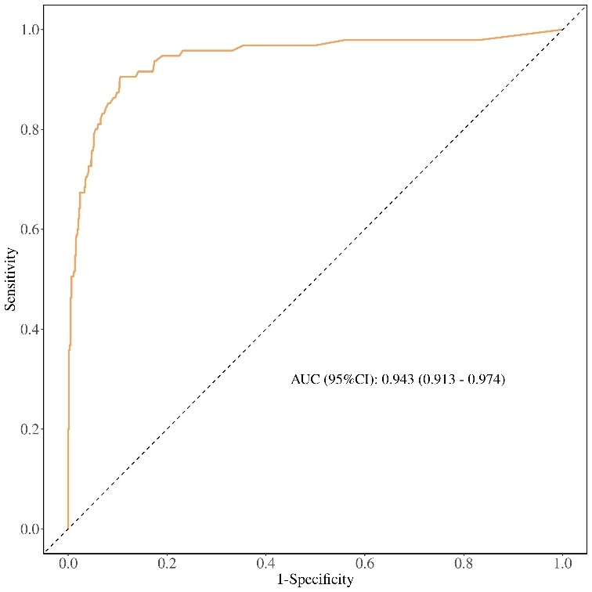

B.
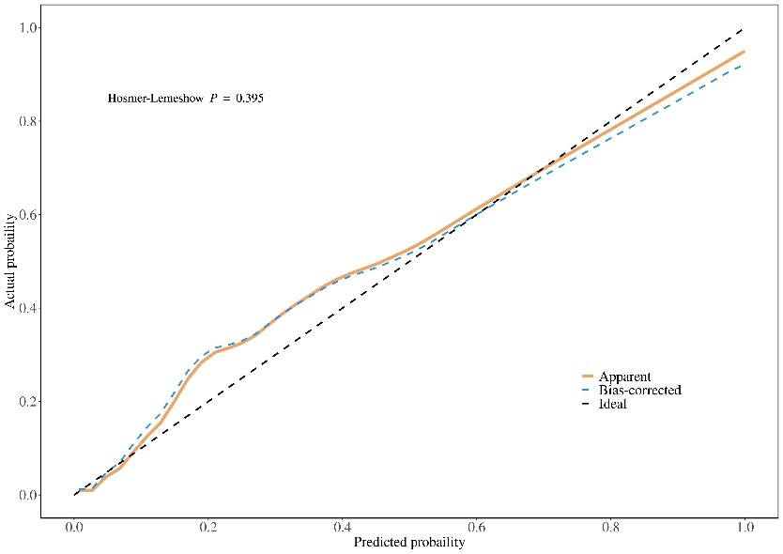

C.
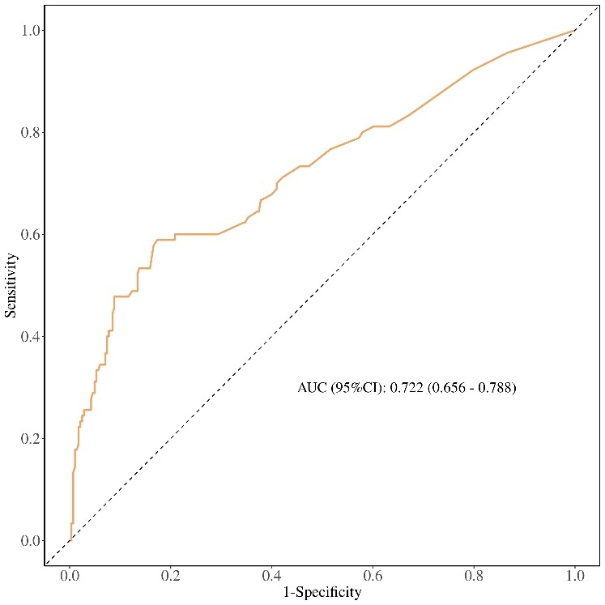

D.
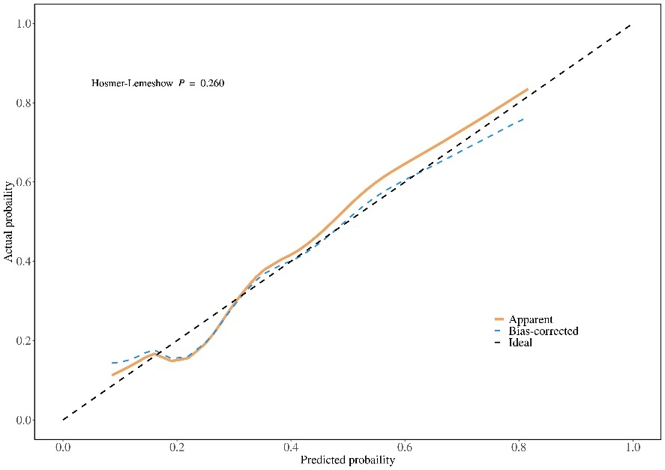
Supplementary Figure Validation for multivariate logistic regression models. A: ROC curve for frailty identification. B: Calibration plot for frailty identification. C: ROC curve for frailty worsening. D: Calibration plot for frailty worsening

