Appendix
Forecasting Informal Care Needs of the Urban-Rural Older Adults in China Based on Microsimulation Model

Contents
1 Microsimulation Model 1
1.1 Two-part model 1
1.2 Multinomial Logit model 1
1.3 Multi-state Markov model 2
1.4 The process of microsimulation 4
1.5 Statistical software 6
2 Supplementary Results 7
Table S1 Variables assignment 7
Table S2 Factors influencing receipt of informal care and informal care intensity for the older adults in 2018 7
Table S3 Factors influencing informal care source for the older adults in 2018 8
Table S4 Size of rural older adults by health status 10
from 2020 to 2040 (million) 10
Table S5 Size of urban older adults by health status 11
from 2020 to 2040 (million) 11
Table S6 Size of rural older adults receiving different informal care intensities from 2020 to 2040 (million) 11
Table S7 Size of urban older adults receiving different informal care intensities from 2020 to 2040 (million) 12
Table S8 The number of the rural older adults receiving different informal care sources from 2020 to 2040 (million) 13
Table S9 The number of the urban older adults receiving different informal care sources from 2020 to 2040 (million) 14
Table S10 The difference between the 2013 forecast and the survey data 15
Table S11 Size of the older adults receiving informal care under the "9073" policy (million) 15
Figure S1 Transition of health status in the older adults 16

1 Microsimulation Model

1.1 Two-part model
This study divides the informal care needs into two separate parts. This study divided the informal care needs into two separate parts and constructed a two-part model to examine the factors influencing the receipt of informal care and the intensity of informal care. The first part was a binomial Logit model, and the second part was a generalized linear mode.
The first part was a probabilistic model of whether or not there are positive observations with the expression:
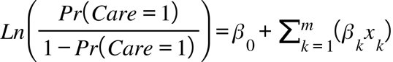 Equation (1)
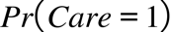 denoted the probability of receiving informal care, denoted the independency variable, 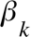 denoted the coefficient on the independency variable .
The second part was a generalized linear model for the positive observations with the expression:
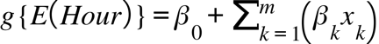 Equation (2)
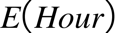 denoted the average number of hours per week that older adults received informal care under the condition of receiving informal care, 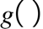 denoted the link function, denoted the independency variable, denoted the coefficient of the independency variable .

1.2 Multinomial Logit model
This study analyzed the factors influencing the source of informal care constructing a multinomial logit model with the expression:
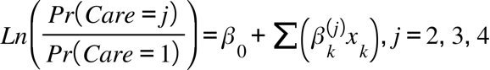 Equation (3)
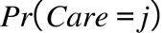 denotes the probability of receiving informal care from a specific source , denoted the explanatory variable，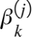 denoted the coefficient on the explanatory variable , in a specific source j. In this study, indicated that informal care from spouses only was set as the reference group.

1.3 Multi-state Markov model
The state development process of older adults' disability is characterized by time continuity and state countability, which was analyzed in this study using a multi-state Markov model with continuous time and discrete states. The Markov chain of continuous time has no posteriority, i.e., under the condition of knowing the present as well as the state in the past, the state at a certain moment in the future depends only on the state in the present and is independency of the past state. Therefore, this study utilized a Markov model with five states to represent the transfer process of each health state in older adults. In each wave, the health states of the older adults were one of the five states of independency, mild disability, moderate disability, severe disability, and death, which were recorded as 0, 1, 2, 3, and 4, respectively. Among them, death as an absorptive state could not be transferred to the other states, but independency, mild disability, moderate disability, and severe disability could be were realized as bi-directional transfers. Meanwhile, independency, mild disability, moderate disability, and severe disability could bidirectional transfer across intermediate stages, for example, older adults could directly change from independency to severe disability without experiencing mild disability and moderate disability. The multi-state Markov model transfer schematic is shown in Figure S1, with the circle indicating the state in which the individual is located and the arrows indicating the direction in which the state may be transferred.
As shown in Equation (4), 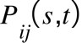 denoted the transfer probability function for an individual to transfer to state j after a time interval t under the condition that the individual is in state i at moments s. In continuous time homogeneous Markov process, the transfer probability was independent of the initial time s, but only related to the time interval t, denoted as 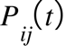. The transfer probability matrix of each health state was constructed according to Figure S1, where the rows of the matrix represented the beginning state and the columns of the matrix represented the end state after the time interval t. The transfer probability of each health state was calculated as follows. The element located on the diagonal of the matrix is the probability of maintaining the beginning state; the element above the diagonal indicates the probability of the health state changing from good to poor; the element below the diagonal indicates the probability of the health state changing from poor to good. Since individuals could not be transferred to other states after death, the last columns of the matrix 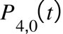、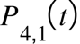、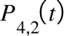、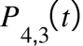 were all equal to 0, while 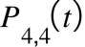 was equal to 1. Based on equations (4) and the 2015-2018 CHARLS data, the calculation leads to the three-year probability of health state transfer matrix P(3) for different genders and ages in urban and rural areas.
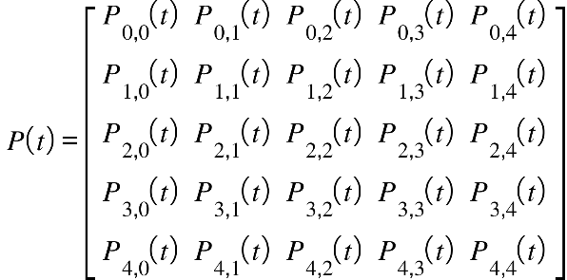 Equation (4)
In order to predict the number of people in different health states, this study measured the one-year health state transfer probability matrix P(1) using the three-year health state transfer probability matrix P(3) and the transfer intensity matrix Q. Firstly, the transfer intensity matrix was calculated. It was assumed that the individual was in state i at time t and its movement within the finite health state space was determined by the transfer intensity 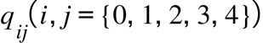. The transfer intensity 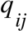 represented the instantaneous risk of moving from state i to state j, which satisfies Equation (5):
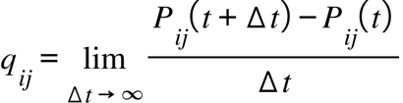 Equation (5)
Written in matrix form: 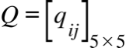, the relationship between P(t) and the transfer intensity matrix Q could be obtained based on the Chapman-Kolmogorov forward equation:
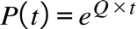 Equation (6)
The intensity transfer matrix Q was obtained by the inverse operation of the matrix exponential:
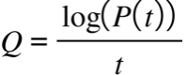 Equation (7)
The transfer intensity matrix Q was calculated from the three-year health state transfer probability matrix by Equation (7), and then the one-year health state transfer probability matrix P(1) could be calculated by using Equation (6).

1.4 The process of microsimulation
First, 2020 was clarified as the baseline to project the number of older adults in each health state stratified by urban and rural areas, gender and age in 2020. Based on P(1) obtained above and the number of older adults aged 60 years and above in CHARLS 2018, the number of older adults aged 62 years and above in each health state in CHARLS 2020 was simulated. It was important to note that the matrix of multiplied health transfer probabilities with age should correspond to the age group in which they were located. As an example, 68-year-old adults in 2018 should correspond to the health state transfer probability matrix for ages 60 to 69 in 2019, and for ages 70 to 79 in 2020. In addition, 58- and 59- year-old adults in CHARLS 2018 were simulated according to the current year's population mortality rate respectively until they reached the age of 60. The population mortality rate data used for 2011-2021 were obtained from the National Statistical Office, and the 2022 Population mortality rates for 2040 were obtained from World Population Prospects 2022. This study assumed that all 60-year-old adults entered the cohort with a health state of independency. On the basis of measuring the number of older people in each health state in CHARLS 2020, the number of older people in each health state in 2020, stratified by urban and rural areas, gender and age, could be obtained based on the population proportion method and the data from the Seventh National Population Census.
Based on the 2020 baseline data, the number of newly included 60-year-olds and the number of older adults aged 61 and above in each health status were simulated each year by applying the matrices of population mortality rates and one-year probabilities of health status transfers projected by World Population Prospects2022, then summed to obtain the number of older adults of different sexes and ages in urban and rural areas in each health status in the period of 2020-2040. The number of older adults in different genders and ages in urban and rural areas in2020-2040. Combined with Equation (2-1), the number of older adults of each health state by gender and age in urban and rural areas receiving informal care in 2020-2040 was calculated.
For the probability of informal care intensity and source of informal care for older adults in each health state under the condition of receiving informal care, this study assumed that there would be no change over time. Informal care intensity 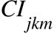, informal care source 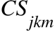, and informal care cost needs 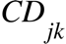 were calculated according to Equation (8), Equation (9), and Equation (10), respectively
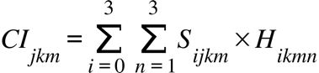 Equation (8)
i (i=0, 1, 2, 3) denoted the health state, corresponding to independency, mild disability, moderate disability, and severe disability; j (j=0, 1, 2, ..., 20) denoted the year, corresponding to 2020 to 2040; k (k=0, 1) corresponded to rural and urban households; m (m=0, 1) corresponded to male and female; n (n=1, 2, 3) denotes the informal care intensity, corresponding to 0-10 hr/wk, 10-30 hr/wk, and 30+ hr/wk. 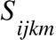 denoted the predicted number of older adults in year j for the health state i corresponding to household k and gender m; 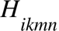 denoted the probability of informal care intensity n for the health state i corresponding to household k and gender m.
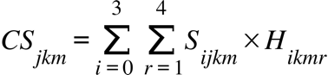 Equation (9)
i (i=0, 1, 2, 3) denoted the health state, corresponding to independency, mild disability, moderate disability, and severe disability; j (j=0, 1, 2, ..., 20) denoted the year, corresponding to 2020 to 2040; k (k=0, 1) corresponded to rural and urban households; m (m=0, 1) corresponded to male and female; r (r=1, 2, 3, 4) denoted the informal care source, corresponding to only from spouse, only from children, only from spouse and children, and others. denoted the predicted number of older adults in year j for the health state i corresponding to household k and gender m; 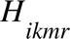 denoted the probability of informal care source r for the health state i corresponding to household k and gender m.
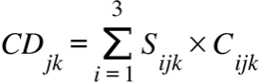 Equation (10)
i (i=1, 2, 3) denoted the disabled states, which were mild disability, moderate disability, and severe disability; j (j=0, 1, 2, ..., 20) denoted the year, corresponding to 2020 to 2040; and k (k=0, 1) corresponded to rural and urban households. 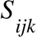 denoted the projected number of older adults in year j for health state i corresponding to household k; 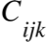 denoted the per capita cost of informal care for health state i corresponding to household k in year j.
For model fitting evaluation, the chi-square goodness-of-fit test was used to evaluate the predictive performance of the Microsimulation model. The hypothesis test level was two-sided α=0.05, when P>0.05, the data obtained from the model prediction was not significantly different from the actual data.

1.5 Statistical software
Data cleaning was performed in STATA. Before statistical analysis, missing values were multiply interpolated using the mice package in R because the mice algorithm has the advantage of rapid convergence and small number of iterations. The two-part model, multinomial Logit model, and multi-state Markov model were performed in R. Differences were considered statistically significant at P<0.05.

2 Supplementary Results

Table S1 Variables assignment
Variables |  | Assignment
Informal care needs | Receipt of informal care | 0=No; 1=Yes
 | Care source | 0=No; 1=Only from spouse; 2=Only from children; 3=Only from spouse and children; 4=Others
 | Care intensity | 0=0-10 hr/wk; 1=10-30 hr/wk; 2=30+ hr/wk
Predisposing factors | Age | 0=60-69; 1=70-79; 2=80+
 | Sex | 0=Male; 1=Female
 | Hukou | 0=Rural; 1=Urban
 | Education | 0=Incomplete primary school; 1=Graduate from elementary or middle school; 2=Graduate form high school or above
 | Marital status | 0=Alone; 1=Married
 | Living arrangement | 0=Alone; 1=Cohabit
Enabling factors | Household income | 0=¥0-6,000 per year; 1=¥6,000-20,000 per year; 2=¥20,000+ per year
 | Financial support from children | 0=¥0-500 per month; 1=¥500-1,000 per month; 2=¥1,000+ per month
 | Toilet type | 0=Outdoor toilet; 1=Indoor squat toilet; 2=Indoor sit-down toilet
 | Tap water | 0=No; 1=Yes
Need factors | Health status* | 0=Independency; 1=Mild disability; 2=Moderate disability; 3=Severe disability
 | Chronic diseases | 0=0; 1=1-2; 2=2+
 | Depression | 0=No; 1=Yes
*Note: In the CHARLS questionnaire, there were four options, including (1) No, I don’t have any difficulty, (2) I have difficulty but can still do it, (3) Yes, I have difficulty and need help, (4) I cannot do it, respectively. This study defined options 1 and 2 as independent, and defined options 3 and 4 as need help.

Table S2 Demographic and socioeconomic characteristics of the older adults by gender in 2018
 | Total | Male | Female | P-Value
Age (years)
60~69 | 6,264 (0.59) | 3,045 (0.59) | 3,219 (0.60) | 0.4
70~79 | 3,187 (0.30) | 1,593 (0.31) | 1,594 (0.30)
80+ | 1,113 (0.11) | 535 (0.10) | 578 (0.10)
Hukou
Rural | 8,035 (0.76) | 3,816 (0.74) | 4,219 (0.78) | < 0.01
Urban | 2,529 (0.24) | 1,357 (0.26) | 1,172 (0.22)
Education
Incomplete primary school | 5,723 (0.54) | 1,962 (0.38) | 3,761 (0.70) | < 0.01
Graduate from elementary or middle school | 3,846 (0.37) | 2,525 (0.49) | 1,321 (0.24)
Graduate form high school or above | 995 (0.09) | 686 (0.13) | 309 (0.06)
Marital status
Alone | 2,286 (0.22) | 703 (0.14) | 1,583 (0.29) | < 0.01
Married | 8,278 (0.78) | 4,470 (0.86) | 3,808 (0.71)
Living arrangement
Alone | 2,623 (0.25) | 897 (0.17) | 1,726 (0.32) | < 0.01
Cohabit | 7,941 (0.75) | 4,276 (0.83) | 3,665 (0.68)
Household income (per year)
0~6,000 | 9,680 (0.92) | 4,481 (0.86) | 5,199 (0.97) | < 0.01
6,000~20,000 | 471 (0.04) | 346 (0.07) | 125 (0.02)
20,000+ | 413 (0.04) | 346 (0.07) | 67 (0.01)
Financial support from children (per month)
0~500 | 7,693 (0.73) | 3,745 (0.72) | 3,968 (0.74) | 0.59
500~1,000 | 1,644 (0.16) | 810 (0.16) | 824 (0.15)
1,000+ | 1,227 (0.12) | 618 (0.12) | 599 (0.11)
Toilet type
Outdoor toilet | 2,228 (0.21) | 1,087 (0.21) | 1,141 (0.21) | 0.42
Indoor squat toilet | 5,244 (0.50) | 2,600 (0.50) | 2,644 (0.49)
Indoor sit-down toilet | 3,092 (0.29) | 1,486 (0.29) | 1,606 (0.30)
Tap water
No | 2,042 (0.19) | 1,001 (0.19) | 1,041 (0.19) | 0.98
Yes | 8,522 (0.81) | 4,172 (0.81) | 4,350 (0.81)
Health status
Independency | 7,960 (0.75) | 4,129 (0.80) | 3,831 (0.71) | < 0.01
Mild disability | 1,519 (0.14) | 574 (0.11) | 945 (0.17)
Moderate disability | 601 (0.06) | 238 (0.05) | 363 (0.07)
Severe disability | 484 (0.05) | 232 (0.04) | 252 (0.05)
Chronic diseases
0 | 1,460 (0.14) | 830 (0.16) | 630 (0.12) | < 0.01
1~2 | 4,459 (0.42) | 2,254 (0.44) | 2,205 (0.41)
2+ | 4,645 (0.44) | 2,089 (0.40) | 2,556 (0.47)
Depression
No | 6,191 (0.59) | 3,475 (0.67) | 2,716 (0.50) | < 0.01
Yes | 4,373 (0.41) | 1,698 (0.33) | 2,675 (0.50)
Receipt of informal care
No | 7,614 (0.72) | 4,030 (0.78) | 3,584 (0.66) | < 0.01
Yes | 2,950 (0.28) | 1,143 (0.22) | 1,807 (0.34)
Care source
Only from spouse | 1,152 (0.39) | 562 (0.49) | 590 (0.33) | < 0.01
Only from children | 1,037 (0.35) | 268 (0.24) | 769 (0.43)
Only from spouse and children | 462 (0.16) | 206 (0.18) | 256 (0.14)
Others | 299 (0.10) | 107 (0.09) | 192 (0.10)
Care intensity(hours/one week)
0~10 | 1,246 (0.42) | 449 (0.39) | 797 (0.44) | <0.05
10~30 | 680 (0.23) | 287 (0.25) | 393 (0.22)
30+ | 1,024 (0.35) | 407 (0.36) | 617 (0.34)

Table S3 Factors influencing receipt of informal care and informal care intensity for the older adults in 2018
Variables | Two-part model (N=10,564)
Variables | Receipt of informal care | Informal care intensity
Predisposing factors
Age (years) (ref=60-69)
70-79 | 0.64***(0.08) | 0.24***(0.06)
80+ | 0.05(0.06) | 0.08(0.05)
Sex (ref=Male)
Female | 0.33***(0.08) | 0.06(0.07)
Hukou (ref=Rural)
Urban | -0.07(0.07) | 0.19*(0.08)
Education (ref=Incomplete primary school)
Graduate from elementary or middle school | -0.31**(0.10) | 0.15(0.09)
Graduate form high school or above | -0.20**(0.07) | 0.03(0.07)
Marital status (ref=Alone)
Married | 0.19(0.22) | 0.09(0.27)
Living arrangement (ref=Alone)
Cohabit | 0.27(0.21) | -0.12(0.27)
Enabling factors
Household income (per year)
(ref=¥0-6,000)
¥6,000-20,000 | -0.61**(0.20) | -0.29(0.34)
¥20,000+ | 0.13(0.21) | -0.38(0.30)
Financial support from children (per month)
(ref=¥0-499)
¥500-1,000 | 0.01(0.08) | 0.14*(0.07)
¥1,000+ | -0.02(0.08) | 0.02(0.08)
Toilet type (ref=Outdoor toilet)
Indoor squat toilet | -0.21*(0.09) | -0.01(0.08)
Indoor sit-down toilet | 0.06(0.10) | 0.10(0.09)
Tap water (ref=No)
Yes | -0.23**(0.08) | 0.01(0.08)
Need factors
Health status (ref=Independency)
Mild disability | 3.61***(0.17) | 0.81***(0.08)
Moderate disability | 0.75***(0.14) | 0.06(0.07)
Severe disability | 1.29***(0.10) | 0.25***(0.06)
Chronic diseases (ref=0)
1-2 | 0.34***(0.08) | 0.05(0.10)
2+ | 0.13*(0.06) | 0.12(0.08)
Depression (ref=No)
Yes | 0.45***(0.07) | 0.09(0.07)
Note: Robust standard errors of z-tests are shown in parentheses; *: P<0.05; **: P<0.01; ***: P<0.001.

Table S4 Factors influencing informal care source for the older adults in 2018
Variables | Multinomial Logit model (ref=Only from spouse) (N=2,950)
Variables | Only from children | Only from spouse and children | Others
Predisposing factors
Age (years) (ref=60-69)
70-79 | 0.95***(0.13) | 0.18(0.13) | 0.54***(0.16)
80+ | 0.29**(0.11) | 0.34**(0.11) | 0.25(0.13)
Sex (ref=Male)
Female | 0.75***(0.13) | 0.13(0.12) | 0.20(0.17)
Hukou (ref=Rural)
Urban | -0.14(0.17) | 0.09(0.16) | 0.18(0.22)
Education (ref=Incomplete primary school)
Graduate from elementary or middle school | -0.59*(0.26) | -0.08(0.18) | -0.40(0.29)
Graduate form high school or above | -0.21(0.17) | 0.29*(0.13) | 0.06(0.20)
Marital status (ref=Alone)
Married | -2.90***(0.71) | 12.50***(0.36) | -2.90***(0.75)
Living arrangement (ref=Alone)
Cohabit | -3.20***(0.51) | -0.75(0.68) | -2.99***(0.56)
Enabling factors
Household income (per year)
(ref=¥0-6,000)
¥6,000-20,000 | -1.04(0.79) | -0.17(0.37) | -1.20(0.95)
¥20,000+ | 0.13(0.67) | 0.14(0.45) | -1.08(0.69)
Financial support from children (per month)
(ref=¥0-499)
¥500-1,000 | -0.55***(0.16) | -0.17(0.13) | -0.04(0.18)
¥1,000+ | -0.08(0.15) | -0.01(0.14) | -0.10(0.18)
Toilet type (ref=Outdoor toilet)
Indoor squat toilet | -0.07(0.14) | -0.01(0.14) | -0.01(0.18)
Indoor sit-down toilet | -0.34(0.18) | 0.12(0.17) | -0.26(0.23)
Tap water (ref=No)
Yes | 0.09(0.14) | 0.21(0.14) | 0.22(0.18)
Need factors
Health status (ref=Independency)
Mild disability | -0.51***(0.15) | 0.18(0.13) | -0.84***(0.18)
Moderate disability | 0.05(0.14) | 0.22(0.12) | 0.51**(0.17)
Severe disability | -0.17(0.13) | -0.30**(0.11) | -0.05(0.17)
Chronic diseases (ref=0)
1-2 | -0.12(0.17) | 0.16(0.17) | -0.20(0.20)
2+ | -0.21(0.12) | 0.30*(0.13) | 0.01(0.15)
Depression (ref=No)
Yes | -0.19(0.13) | -0.08(0.12) | 0.04(0.16)
Note: Robust standard errors of z-tests are shown in parentheses; *: P<0.05; **: P<0.01; ***: P<0.001.

Table S5 Size of rural older adults by health status from 2020 to 2040 (million)
 | Rural female |  |  |  | Rural male
Year | Independency | Mild disability | Moderate disability | Severe disability | Independency | Mild disability | Moderate disability | Severe disability
2020 | 38.03 | 9.11 | 4.41 | 2.50 | 42.31 | 5.81 | 2.66 | 2.04
2021 | 38.47 | 9.19 | 4.50 | 2.57 | 42.14 | 5.77 | 2.65 | 2.03
2022 | 40.53 | 9.36 | 4.64 | 2.67 | 43.86 | 5.79 | 2.67 | 2.04
2023 | 43.27 | 9.62 | 4.78 | 2.76 | 46.42 | 5.86 | 2.70 | 2.05
2024 | 45.08 | 10.01 | 4.98 | 2.88 | 47.99 | 6.02 | 2.77 | 2.09
2025 | 46.81 | 10.42 | 5.21 | 3.01 | 49.58 | 6.19 | 2.85 | 2.14
2026 | 48.50 | 10.85 | 5.44 | 3.14 | 51.19 | 6.38 | 2.94 | 2.20
2027 | 49.54 | 11.28 | 5.68 | 3.28 | 52.06 | 6.58 | 3.03 | 2.26
2028 | 51.24 | 11.68 | 5.91 | 3.42 | 53.62 | 6.76 | 3.11 | 2.32
2029 | 52.34 | 12.08 | 6.14 | 3.54 | 54.61 | 6.95 | 3.20 | 2.39
2030 | 53.59 | 12.47 | 6.35 | 3.65 | 55.74 | 7.11 | 3.27 | 2.44
2031 | 54.35 | 12.84 | 6.54 | 3.75 | 56.48 | 7.27 | 3.34 | 2.49
2032 | 54.86 | 13.17 | 6.71 | 3.83 | 56.97 | 7.40 | 3.40 | 2.53
2033 | 55.24 | 13.42 | 6.84 | 3.89 | 57.43 | 7.50 | 3.44 | 2.55
2034 | 54.88 | 13.72 | 7.04 | 4.02 | 57.01 | 7.65 | 3.51 | 2.61
2035 | 54.23 | 13.91 | 7.19 | 4.13 | 56.38 | 7.74 | 3.55 | 2.65
2036 | 53.40 | 14.03 | 7.31 | 4.22 | 55.58 | 7.80 | 3.59 | 2.68
2037 | 52.20 | 14.06 | 7.41 | 4.30 | 54.38 | 7.82 | 3.61 | 2.71
2038 | 51.09 | 14.02 | 7.47 | 4.37 | 53.26 | 7.80 | 3.61 | 2.73
2039 | 50.00 | 13.92 | 7.50 | 4.42 | 52.19 | 7.76 | 3.61 | 2.74
2040 | 48.77 | 13.76 | 7.51 | 4.47 | 50.89 | 7.69 | 3.59 | 2.75

Table S6 Size of urban older adults by health status from 2020 to 2040 (million)
 | Urban female |  |  |  | Urban male
Year | Independency | Mild disability | Moderate disability | Severe disability | Independency | Mild disability | Moderate disability | Severe disability
2020 | 52.53 | 8.06 | 3.87 | 1.88 | 52.40 | 4.29 | 2.77 | 1.48
2021 | 53.60 | 8.49 | 4.07 | 2.01 | 53.19 | 4.48 | 2.90 | 1.54
2022 | 56.94 | 8.93 | 4.31 | 2.18 | 56.38 | 4.74 | 3.05 | 1.61
2023 | 62.00 | 9.42 | 4.56 | 2.36 | 61.37 | 5.07 | 3.21 | 1.68
2024 | 65.57 | 10.01 | 4.88 | 2.55 | 64.85 | 5.49 | 3.42 | 1.78
2025 | 68.90 | 10.62 | 5.21 | 2.76 | 68.18 | 5.92 | 3.65 | 1.89
2026 | 72.04 | 11.23 | 5.54 | 2.98 | 71.34 | 6.33 | 3.89 | 2.02
2027 | 74.24 | 11.86 | 5.88 | 3.20 | 73.55 | 6.74 | 4.13 | 2.14
2028 | 77.89 | 12.45 | 6.21 | 3.42 | 77.24 | 7.12 | 4.36 | 2.27
2029 | 80.92 | 13.08 | 6.55 | 3.64 | 80.35 | 7.51 | 4.59 | 2.40
2030 | 84.26 | 13.72 | 6.88 | 3.86 | 83.82 | 7.88 | 4.82 | 2.53
2031 | 87.03 | 14.38 | 7.23 | 4.08 | 86.84 | 8.25 | 5.05 | 2.67
2032 | 89.47 | 15.03 | 7.56 | 4.30 | 89.55 | 8.58 | 5.26 | 2.81
2033 | 91.82 | 15.59 | 7.85 | 4.51 | 92.23 | 8.95 | 5.44 | 2.92
2034 | 93.15 | 16.28 | 8.23 | 4.80 | 93.73 | 9.37 | 5.69 | 3.06
2035 | 94.04 | 16.86 | 8.55 | 5.07 | 94.88 | 9.77 | 5.91 | 3.19
2036 | 94.72 | 17.36 | 8.86 | 5.33 | 95.81 | 10.14 | 6.12 | 3.30
2037 | 94.83 | 17.76 | 9.13 | 5.56 | 96.09 | 10.46 | 6.32 | 3.41
2038 | 95.15 | 18.11 | 9.36 | 5.77 | 96.58 | 10.74 | 6.49 | 3.51
2039 | 95.70 | 18.36 | 9.56 | 5.97 | 97.24 | 11.00 | 6.65 | 3.60
2040 | 95.81 | 18.48 | 9.73 | 6.11 | 97.27 | 11.22 | 6.81 | 3.67

Table S7 Size of rural older adults receiving different informal care intensities from 2020 to 2040 (million)
 | Older female |  |  | Older male
Year | Low-intensity care | Middle-intensity care | High-intensity care | Low-intensity care | Middle-intensity care | High-intensity care | Total
2020 | 8.99 | 4.18 | 5.94 | 4.84 | 2.92 | 3.89 | 30.76
2021 | 9.11 | 4.24 | 6.04 | 4.82 | 2.91 | 3.87 | 30.98
2022 | 9.44 | 4.36 | 6.22 | 4.90 | 2.94 | 3.90 | 31.78
2023 | 9.87 | 4.53 | 6.45 | 5.05 | 3.00 | 3.96 | 32.87
2024 | 10.28 | 4.71 | 6.71 | 5.20 | 3.08 | 4.06 | 34.05
2025 | 10.70 | 4.91 | 7.00 | 5.36 | 3.17 | 4.17 | 35.32
2026 | 11.13 | 5.11 | 7.30 | 5.52 | 3.27 | 4.30 | 36.63
2027 | 11.49 | 5.30 | 7.58 | 5.66 | 3.36 | 4.42 | 37.83
2028 | 11.90 | 5.50 | 7.87 | 5.82 | 3.46 | 4.55 | 39.10
2029 | 12.26 | 5.68 | 8.14 | 5.96 | 3.54 | 4.67 | 40.25
2030 | 12.61 | 5.86 | 8.39 | 6.10 | 3.63 | 4.77 | 41.35
2031 | 12.90 | 6.01 | 8.61 | 6.21 | 3.70 | 4.87 | 42.30
2032 | 13.14 | 6.15 | 8.81 | 6.29 | 3.76 | 4.95 | 43.09
2033 | 13.32 | 6.24 | 8.95 | 6.36 | 3.80 | 5.00 | 43.67
2034 | 13.48 | 6.37 | 9.16 | 6.42 | 3.85 | 5.09 | 44.37
2035 | 13.55 | 6.45 | 9.30 | 6.44 | 3.89 | 5.15 | 44.76
2036 | 13.56 | 6.50 | 9.40 | 6.44 | 3.90 | 5.18 | 44.98
2037 | 13.50 | 6.51 | 9.46 | 6.40 | 3.90 | 5.20 | 44.98
2038 | 13.41 | 6.51 | 9.48 | 6.35 | 3.89 | 5.19 | 44.83
2039 | 13.28 | 6.48 | 9.47 | 6.29 | 3.86 | 5.18 | 44.57
2040 | 13.11 | 6.43 | 9.43 | 6.21 | 3.83 | 5.14 | 44.15

Table S8 Size of urban older adults receiving different informal care intensities from 2020 to 2040 (million)
 | Older female |  |  | Older male
Year | Low-intensity care | Middle-intensity care | High-intensity care | Low-intensity care | Middle-intensity care | High-intensity care | Total
2020 | 5.14 | 2.83 | 7.11 | 3.53 | 2.51 | 3.88 | 25.00
2021 | 5.35 | 2.96 | 7.48 | 3.65 | 2.61 | 4.03 | 26.08
2022 | 5.65 | 3.13 | 7.94 | 3.86 | 2.76 | 4.25 | 27.59
2023 | 6.03 | 3.33 | 8.47 | 4.13 | 2.93 | 4.51 | 29.41
2024 | 6.41 | 3.55 | 9.05 | 4.41 | 3.14 | 4.83 | 31.38
2025 | 6.79 | 3.77 | 9.65 | 4.70 | 3.35 | 5.16 | 33.41
2026 | 7.16 | 3.99 | 10.25 | 4.98 | 3.56 | 5.49 | 35.44
2027 | 7.51 | 4.21 | 10.85 | 5.24 | 3.77 | 5.81 | 37.38
2028 | 7.89 | 4.43 | 11.45 | 5.52 | 3.98 | 6.13 | 39.40
2029 | 8.27 | 4.66 | 12.06 | 5.80 | 4.19 | 6.46 | 41.42
2030 | 8.66 | 4.88 | 12.68 | 6.07 | 4.39 | 6.78 | 43.47
2031 | 9.03 | 5.11 | 13.30 | 6.33 | 4.59 | 7.10 | 45.48
2032 | 9.39 | 5.33 | 13.90 | 6.57 | 4.78 | 7.40 | 47.38
2033 | 9.72 | 5.53 | 14.45 | 6.81 | 4.96 | 7.68 | 49.15
2034 | 10.06 | 5.76 | 15.13 | 7.06 | 5.17 | 8.01 | 51.19
2035 | 10.35 | 5.96 | 15.72 | 7.28 | 5.36 | 8.31 | 52.98
2036 | 10.60 | 6.13 | 16.25 | 7.48 | 5.53 | 8.59 | 54.59
2037 | 10.80 | 6.27 | 16.71 | 7.65 | 5.69 | 8.83 | 55.95
2038 | 10.97 | 6.40 | 17.12 | 7.80 | 5.82 | 9.05 | 57.17
2039 | 11.12 | 6.51 | 17.47 | 7.95 | 5.95 | 9.25 | 58.25
2040 | 11.21 | 6.58 | 17.70 | 8.07 | 6.06 | 9.42 | 59.03

Table S9 The number of the rural older adults receiving different informal care sources from 2020 to 2040 (million)
 | Older female |  |  |  | Older male
Year | Only from spouse | Only from children | Only from spouse and children | Others | Only from spouse | Only from children | Only from spouse and children | Others | Total
2020 | 6.31 | 8.06 | 2.72 | 2.02 | 5.63 | 2.89 | 1.96 | 1.17 | 30.76
2021 | 6.40 | 8.18 | 2.77 | 2.04 | 5.60 | 2.88 | 1.95 | 1.16 | 30.98
2022 | 6.60 | 8.45 | 2.86 | 2.12 | 5.67 | 2.92 | 1.98 | 1.19 | 31.78
2023 | 6.86 | 8.79 | 2.98 | 2.22 | 5.79 | 2.99 | 2.02 | 1.22 | 32.87
2024 | 7.14 | 9.16 | 3.10 | 2.32 | 5.94 | 3.07 | 2.07 | 1.25 | 34.05
2025 | 7.43 | 9.54 | 3.23 | 2.41 | 6.12 | 3.16 | 2.13 | 1.29 | 35.32
2026 | 7.74 | 9.93 | 3.36 | 2.51 | 6.30 | 3.26 | 2.19 | 1.33 | 36.63
2027 | 8.02 | 10.29 | 3.48 | 2.59 | 6.48 | 3.35 | 2.25 | 1.37 | 37.83
2028 | 8.31 | 10.67 | 3.61 | 2.68 | 6.66 | 3.44 | 2.32 | 1.41 | 39.10
2029 | 8.58 | 11.01 | 3.72 | 2.76 | 6.83 | 3.53 | 2.38 | 1.44 | 40.25
2030 | 8.84 | 11.34 | 3.83 | 2.84 | 6.98 | 3.61 | 2.43 | 1.47 | 41.35
2031 | 9.07 | 11.63 | 3.93 | 2.90 | 7.12 | 3.68 | 2.48 | 1.50 | 42.30
2032 | 9.26 | 11.87 | 4.01 | 2.95 | 7.23 | 3.73 | 2.52 | 1.52 | 43.09
2033 | 9.41 | 12.05 | 4.07 | 2.99 | 7.31 | 3.77 | 2.54 | 1.53 | 43.67
2034 | 9.58 | 12.27 | 4.14 | 3.02 | 7.42 | 3.82 | 2.58 | 1.55 | 44.37
2035 | 9.68 | 12.40 | 4.18 | 3.04 | 7.47 | 3.84 | 2.60 | 1.56 | 44.77
2036 | 9.74 | 12.48 | 4.20 | 3.04 | 7.50 | 3.85 | 2.62 | 1.56 | 44.98
2037 | 9.75 | 12.50 | 4.20 | 3.02 | 7.50 | 3.84 | 2.62 | 1.55 | 44.98
2038 | 9.73 | 12.47 | 4.19 | 3.00 | 7.47 | 3.82 | 2.61 | 1.54 | 44.83
2039 | 9.68 | 12.42 | 4.16 | 2.98 | 7.42 | 3.79 | 2.60 | 1.52 | 44.57
2040 | 9.59 | 12.31 | 4.12 | 2.94 | 7.35 | 3.75 | 2.58 | 1.50 | 44.15

Table S10 The number of the urban older adults receiving different informal care sources from 2020 to 2040 (million)
 | Older female |  |  |  | Older male
Year | Only from spouse | Only from children | Only from spouse and children | Others | Only from spouse | Only from children | Only from spouse and children | Others | Total
2020 | 4.40 | 6.86 | 2.09 | 1.72 | 5.14 | 1.87 | 2.18 | 0.73 | 25.00
2021 | 4.61 | 7.18 | 2.18 | 1.81 | 5.33 | 1.95 | 2.26 | 0.76 | 26.08
2022 | 4.88 | 7.61 | 2.32 | 1.92 | 5.63 | 2.05 | 2.38 | 0.80 | 27.59
2023 | 5.19 | 8.12 | 2.48 | 2.05 | 6.01 | 2.18 | 2.54 | 0.86 | 29.41
2024 | 5.53 | 8.65 | 2.64 | 2.19 | 6.42 | 2.33 | 2.71 | 0.92 | 31.38
2025 | 5.87 | 9.19 | 2.81 | 2.33 | 6.85 | 2.49 | 2.89 | 0.98 | 33.41
2026 | 6.21 | 9.74 | 2.98 | 2.47 | 7.28 | 2.65 | 3.07 | 1.04 | 35.44
2027 | 6.54 | 10.26 | 3.14 | 2.61 | 7.67 | 2.81 | 3.23 | 1.09 | 37.38
2028 | 6.89 | 10.81 | 3.31 | 2.76 | 8.10 | 2.97 | 3.41 | 1.15 | 39.40
2029 | 7.23 | 11.36 | 3.48 | 2.90 | 8.51 | 3.13 | 3.59 | 1.21 | 41.42
2030 | 7.59 | 11.92 | 3.66 | 3.05 | 8.93 | 3.28 | 3.76 | 1.27 | 43.47
2031 | 7.94 | 12.48 | 3.83 | 3.20 | 9.33 | 3.43 | 3.94 | 1.33 | 45.48
2032 | 8.28 | 13.01 | 3.99 | 3.34 | 9.70 | 3.58 | 4.09 | 1.38 | 47.38
2033 | 8.59 | 13.50 | 4.14 | 3.48 | 10.07 | 3.71 | 4.25 | 1.43 | 49.15
2034 | 8.94 | 14.06 | 4.31 | 3.64 | 10.46 | 3.88 | 4.42 | 1.49 | 51.19
2035 | 9.24 | 14.55 | 4.46 | 3.77 | 10.82 | 4.02 | 4.57 | 1.54 | 52.98
2036 | 9.51 | 14.98 | 4.60 | 3.90 | 11.15 | 4.16 | 4.71 | 1.58 | 54.59
2037 | 9.73 | 15.34 | 4.71 | 4.00 | 11.44 | 4.28 | 4.83 | 1.62 | 55.95
2038 | 9.92 | 15.66 | 4.81 | 4.10 | 11.69 | 4.39 | 4.94 | 1.66 | 57.17
2039 | 10.08 | 15.93 | 4.90 | 4.18 | 11.93 | 4.49 | 5.04 | 1.69 | 58.25
2040 | 10.18 | 16.10 | 4.96 | 4.23 | 12.13 | 4.57 | 5.13 | 1.72 | 59.03

Table S11 The difference between the 2013 forecast and the survey data
Group | Independency | Mild disability | Moderate disability | Severe disability | P
Survey result | 76.35% | 14.38% | 5.19% | 4.08% | P>0.05
Forecast result | 76.87% | 13.96% | 4.95% | 4.22% | P>0.05

Table S12 Size of the older adults receiving informal care under the "9073" policy (million)
Policy simulation | 2020 | 2030 | 2040
Not fully implemented | 55.75 | 84.82 | 103.18
Full implemented | 54.08 | 82.27 | 100.08

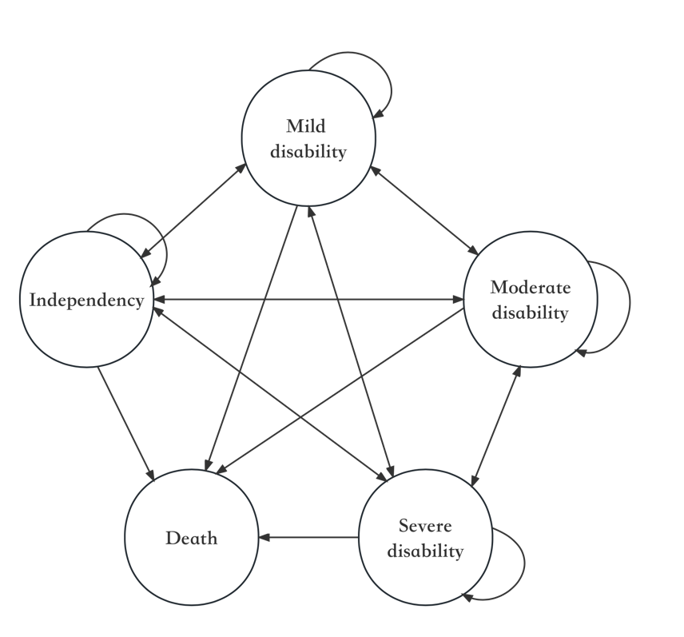

Figure S1 Transition of health status in the older adults

