Supplementary material
Index
Figure S1. Plots showing categories of measures related to “Public Events” in place during the observation period (March-December 2020) and SARS-Cov-2 incidence per 100,000, in 32 countries from the European region. Secondary Axis: “0” corresponds to periods when no measure was in place for all NPIs, while 1, 2 and 3, correspond to periods where increasing categories of each NPIs were in place. 3
Figure S2. Plots showing categories of measures related to “Public Spaces” in place during the observation period (March-December 2020) and SARS-Cov-2 incidence per 100,000, in 32 countries from the European region. Secondary Axis: “0” corresponds to periods when no measure was in place for all NPIs, while 1, 2 and 3, correspond to periods where increasing categories of each NPIs were in place. 4
Figure S3. Plots showing categories of measures related to “Public Institutions” in place during the observation period (March-December 2020) and SARS-Cov-2 incidence per 100,000, in 32 countries from the European region. Secondary Axis: “0” corresponds to periods when no measure was in place for all NPIs, while 1, 2 and 3, correspond to periods where increasing categories of each NPIs were in place. 5
Figure S4. Plots showing categories of measures related to “Public transport” in place during the observation period (March-December 2020) and SARS-Cov-2 incidence per 100,000, in 32 countries from the European region. Secondary Axis: “0” corresponds to periods when no measure was in place for all NPIs, while 1, 2 and 3, correspond to periods where increasing categories of each NPIs were in place. 6
Figure S5. Plots showing categories of measures related to “Movement/mobility” in place during the observation period (March-December 2020) and SARS-Cov-2 incidence per 100,000, in 32 countries from the European region. Secondary Axis: “0” corresponds to periods when no measure was in place for all NPIs, while 1, 2 and 3, correspond to periods where increasing categories of each NPIs were in place. 7
Figure S8. Plots showing measures aiming at “Masks” recommendation/enforcement during the observation period (March-December 2020) and SARS-Cov-2 incidence per 100.000, in 32 countries from the European region. Secondary Axis: “0” corresponds to periods when no measure was in place for all NPIs, while 1, 2 and 3, correspond to periods where increasing categories of each NPIs were in place. 10
Figure S9. Scree plots from PCA conducted over selected non-pharmaceutical interventions (NPIs) for Wave 1 (calendar weeks 5-25, February to June) and Wave 2 (calendar weeks 35-52 end of August to December) during 2020. 10
Panel S1. Categorization of non-pharmaceutical interventions variables for analysis 11
Table S1. Variation observed in the eight non-pharmaceutical interventions (NPIs) used, categories described in Panel S1, and the three component scores, across the 32 countries analysed, by wave. 12
Figure S10. Plots showing Component 1 (from COV-PPM) and SARS-Cov-2 Cases per 100.000 (secondary axis), in 32 countries from the European region during wave 1 (March-July 2020). 14
Figure S11. Plots showing Component 2 (from COV-PPM) and SARS-Cov-2 Cases per 100.000 (secondary axis), in 32 countries from the European region during wave 1 (March-July 2020). 15
Figure S12. Plots showing Component 3 (from COV-PPM) and SARS-Cov-2 Cases per 100.000 (secondary axis), in 32 countries from the European region during wave 1 (March-July 2020). 16
Figure S13. Plots showing Component 4 (from COV-PPM) and SARS-Cov-2 Cases per 100.000 (secondary axis), in 32 countries from the European region during wave 2 (August-December 2020). 17
Figure S14. Plots showing Component 5 (from COV-PPM) and SARS-Cov-2 Cases per 100.000 (secondary axis), in 32 countries from the European region during wave 2 (August-December 2020). 18
Figure S15. Plots showing Component 6 (from COV-PPM) and SARS-Cov-2 Cases per 100.000 (secondary axis), in 32 countries from the European region during wave 2 (August-December 2020). 19
Table S2. Test of model specifications 19
Table S3. Incidence Rate Ratios (IRR) – cases - for the lagged-effects obtained for the three extracted components from PCA of NPIs (pc1 – pc3), considering a 7, 14, 21, 28 and 35 days-lag across all countries – Wave 1 (weeks 5-25 or end of February-June, 2020). 21
Table S4. Incidence Rate Ratios (IRR) – cases - for the lagged-effects obtained for the three extracted components from PCA of NPIs (pc4 – pc6), considering a 7, 14, 21, 28 and 35 days-lag across all countries – Wave 2 (weeks 35-52 or end of August-December, 2020). 22
Table S5. Incidence Rate Ratios (IRR) -deaths- for the lagged-effects obtained for the three extracted components from PCA of NPIs (pc1 – pc3), considering a 21, 28, 35, 42 and 49 days-lag across all countries – Wave 1 (weeks 5-25 or end of February-June, 2020). 23
Table S6. Incidence Rate Ratios (IRR) -deaths- for the lagged-effects obtained for the three extracted components from PCA of NPIs (pc4 – pc6), considering a 21, 28, 35, 42 and 49 days-lag across all countries – Wave 2 (weeks 35-52 or end of August-December, 2020). 24
Figure S16. Incidence Rate Ratios (IRR) and 95% CI for the lagged-effects (7, 14, 21, 28 and 35 days) on SARS-CoV2 incidence of the three principal component (PCA) scores of NPIs (using OxCGRT data) in 32 countries during the first and second waves of infections (March-December 2020), by region 25
Figure S17. Incidence Rate Ratios (IRR) and 95% CI for the lagged-effects (21, 28, 35, 42 and 49 days) on SARS-CoV2 deaths of the three principal component (PCA) scores of NPIs (using OxCGRT data) in 32 countries during the first and second waves of infections (March-December 2020), by region 26

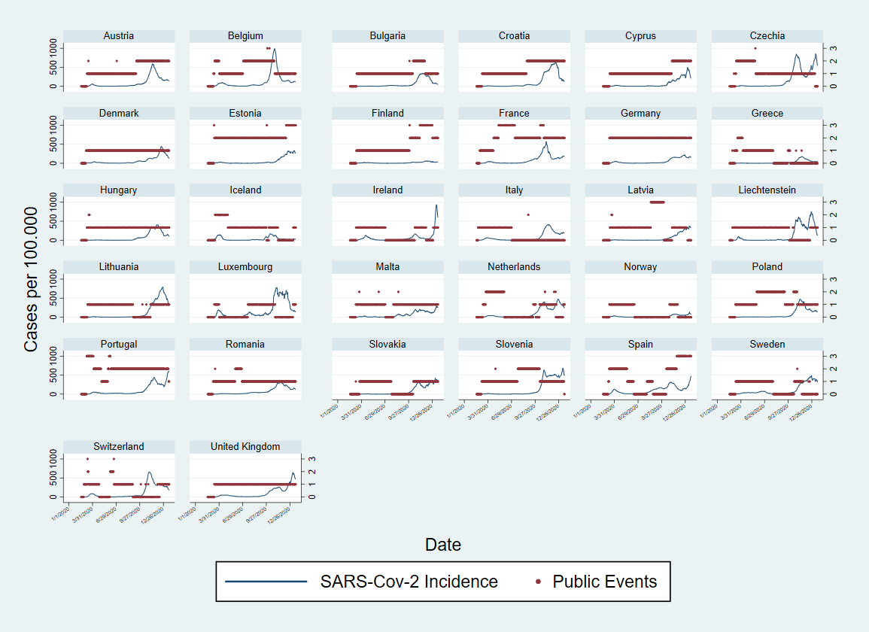

Figure S1. Plots showing categories of measures related to “Public Events” in place during the observation period (March-December 2020) and SARS-Cov-2 incidence per 100,000, in 32 countries from the European region. Secondary Axis: “0” corresponds to periods when no measure was in place for all NPIs, while 1, 2 and 3, correspond to periods where increasing categories of each NPIs were in place.

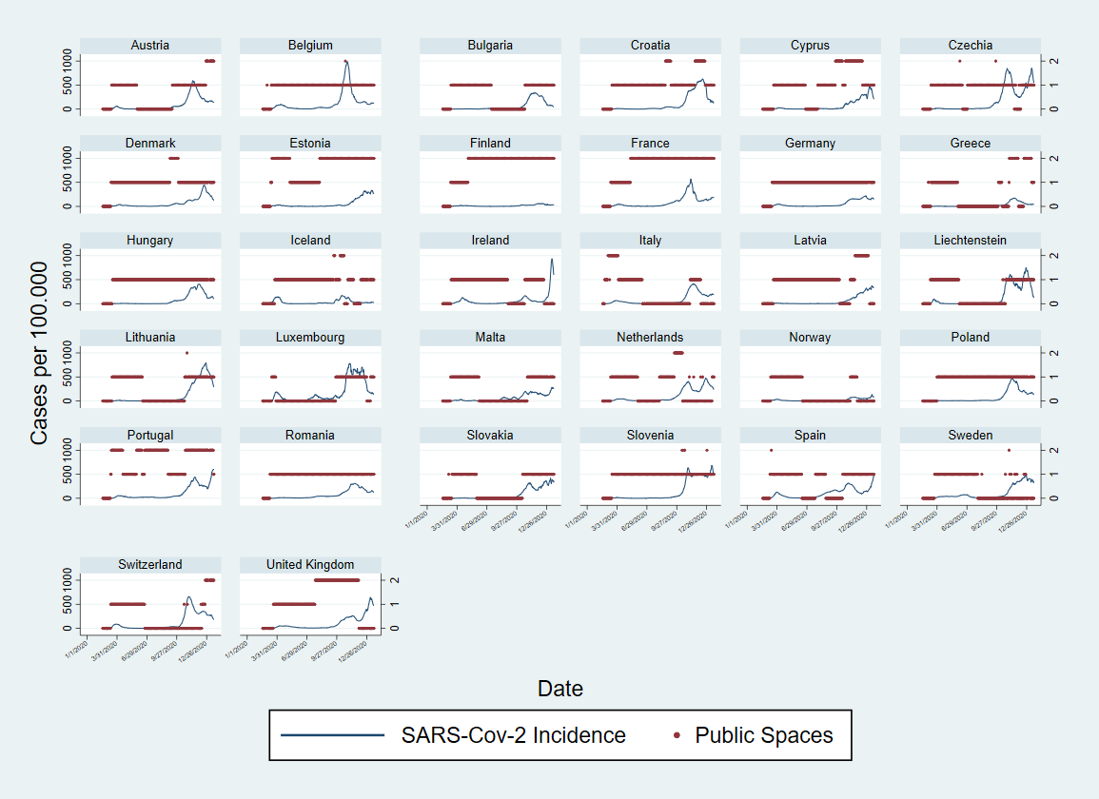

Figure S2. Plots showing categories of measures related to “Public Spaces” in place during the observation period (March-December 2020) and SARS-Cov-2 incidence per 100,000, in 32 countries from the European region. Secondary Axis: “0” corresponds to periods when no measure was in place for all NPIs, while 1, 2 and 3, correspond to periods where increasing categories of each NPIs were in place.

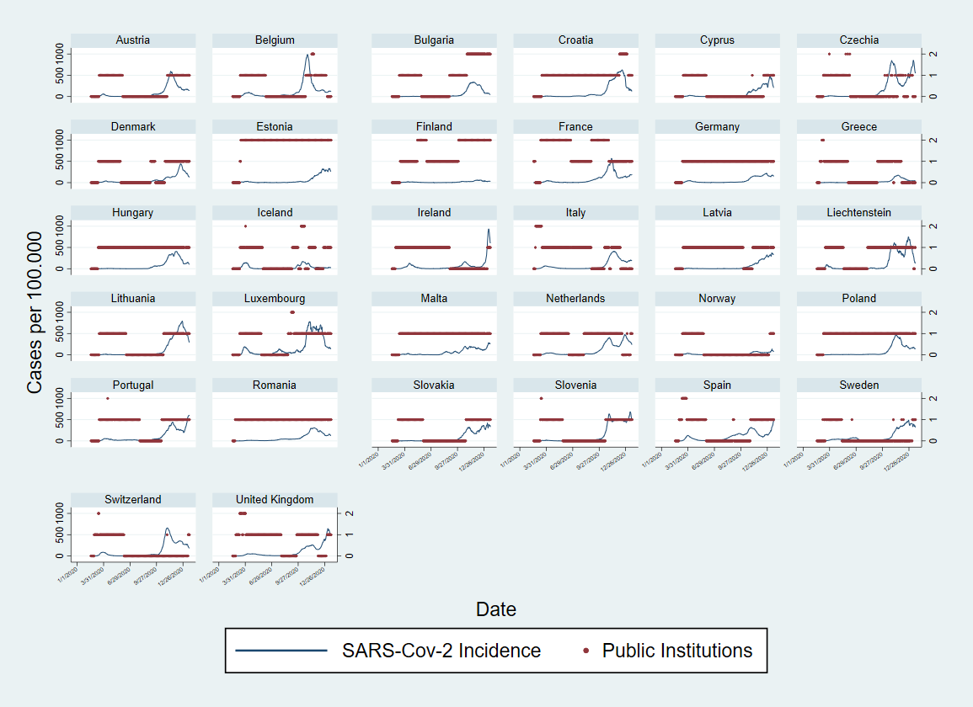

Figure S3. Plots showing categories of measures related to “Public Institutions” in place during the observation period (March-December 2020) and SARS-Cov-2 incidence per 100,000, in 32 countries from the European region. Secondary Axis: “0” corresponds to periods when no measure was in place for all NPIs, while 1, 2 and 3, correspond to periods where increasing categories of each NPIs were in place.

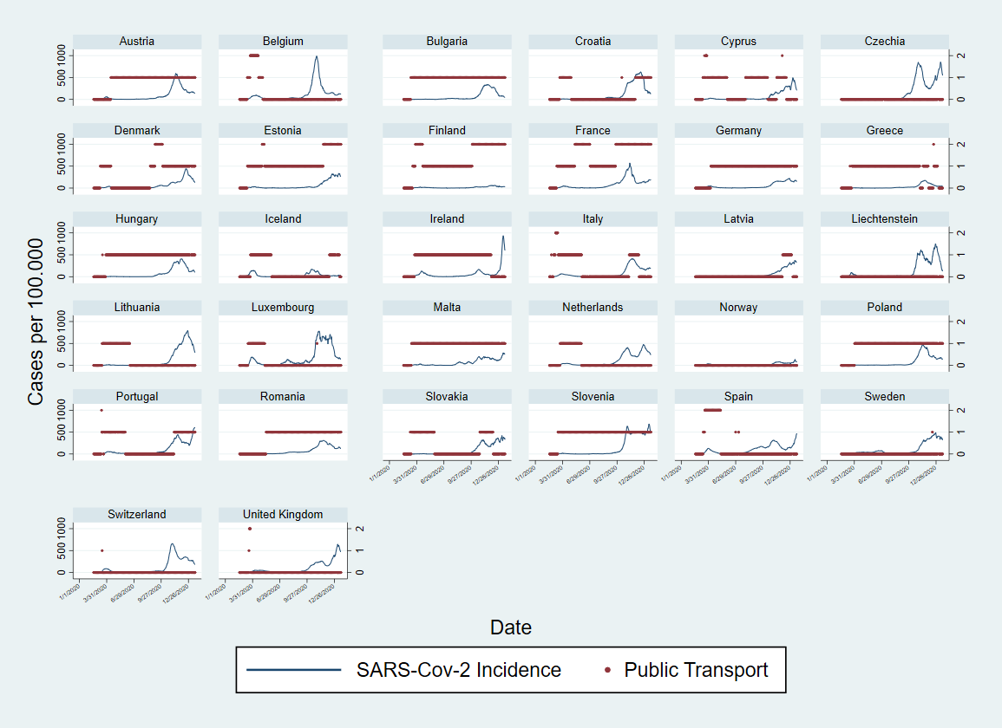

Figure S4. Plots showing categories of measures related to “Public transport” in place during the observation period (March-December 2020) and SARS-Cov-2 incidence per 100,000, in 32 countries from the European region. Secondary Axis: “0” corresponds to periods when no measure was in place for all NPIs, while 1, 2 and 3, correspond to periods where increasing categories of each NPIs were in place.

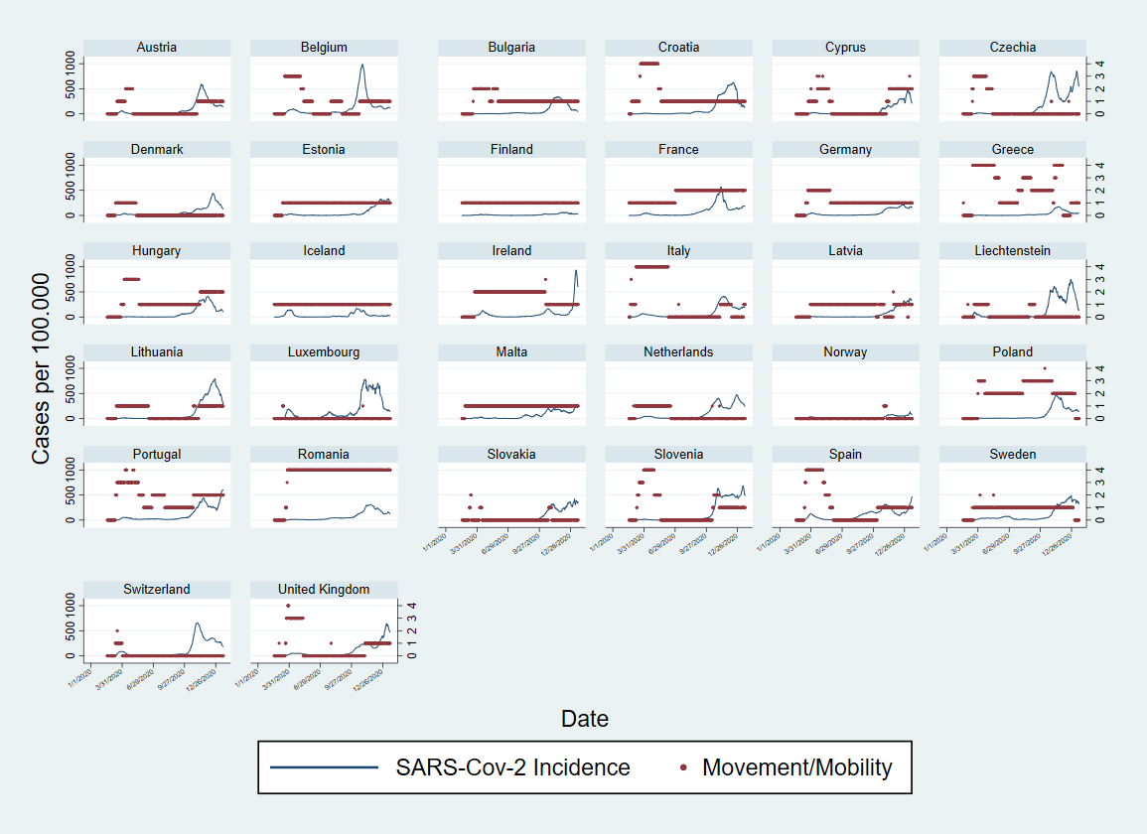

Figure S5. Plots showing categories of measures related to “Movement/mobility” in place during the observation period (March-December 2020) and SARS-Cov-2 incidence per 100,000, in 32 countries from the European region. Secondary Axis: “0” corresponds to periods when no measure was in place for all NPIs, while 1, 2 and 3, correspond to periods where increasing categories of each NPIs were in place.

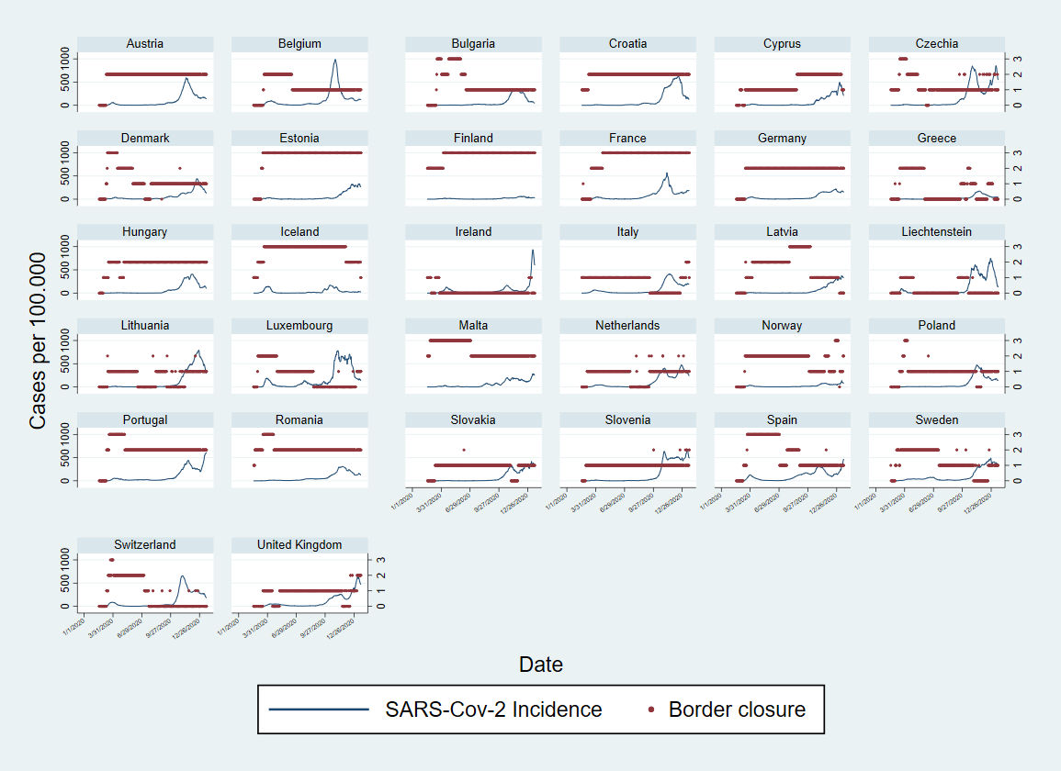Figure S6. Plots showing categories of measures related to “Border closure” in place during the observation period (March-December 2020) and SARS-Cov-2 incidence per 100,000, in 32 countries from the European region. Secondary Axis: “0” corresponds to periods when no measure was in place for all NPIs, while 1, 2 and 3, correspond to periods where increasing categories of each NPIs were in place.

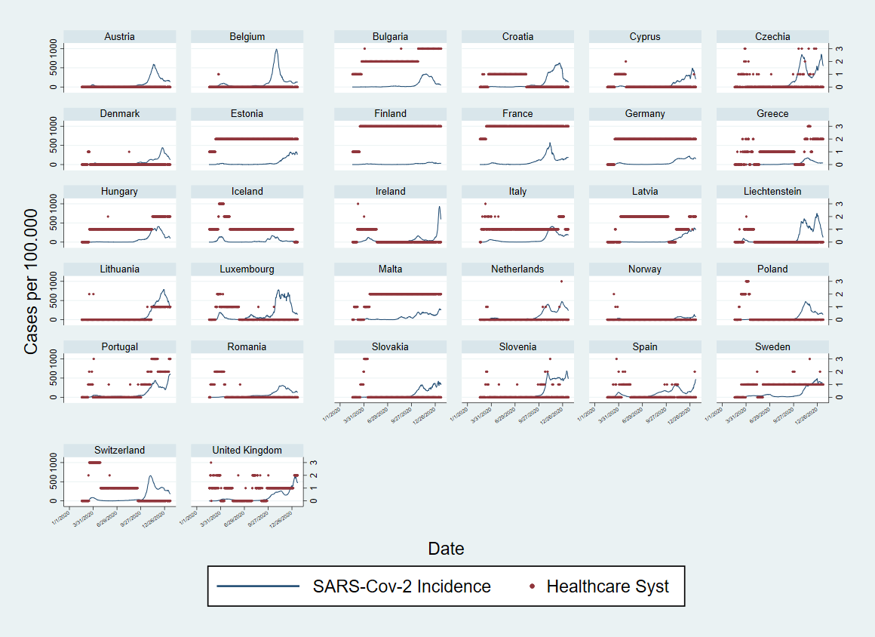Figure S7. Plots showing categories of measures related to “Improvement to the healthcare system” in place during the observation period (March-December 2020) and SARS-Cov-2 incidence per 100,000, in 32 countries from the European region. Secondary Axis: “0” corresponds to periods when no measure was in place for all NPIs, while 1, 2 and 3, correspond to periods where increasing categories of each NPIs were in place.

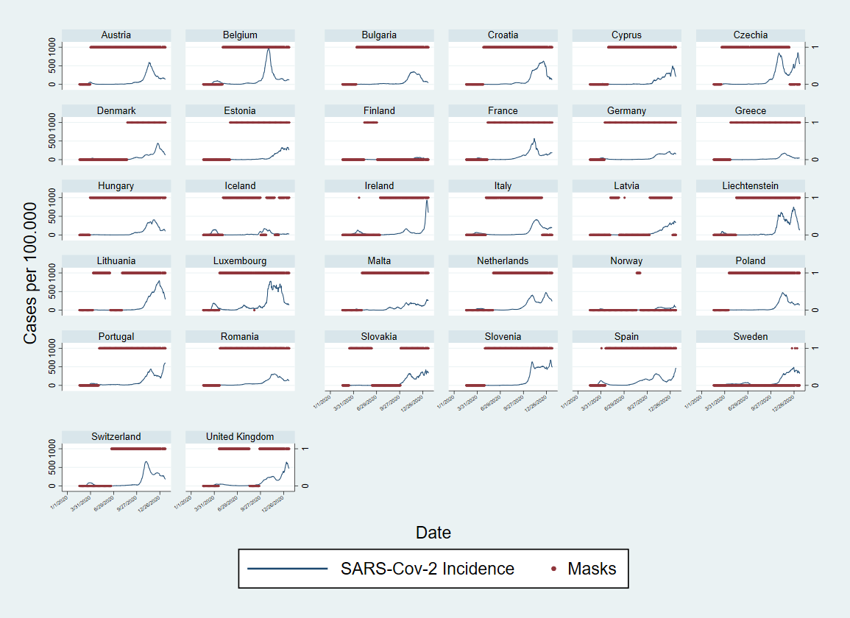

Figure S8. Plots showing measures aiming at “Masks” recommendation/enforcement during the observation period (March-December 2020) and SARS-Cov-2 incidence per 100.000, in 32 countries from the European region. Secondary Axis: “0” corresponds to periods when no measure was in place for all NPIs, while 1, 2 and 3, correspond to periods where increasing categories of each NPIs were in place.

Wave 1 | Wave 2
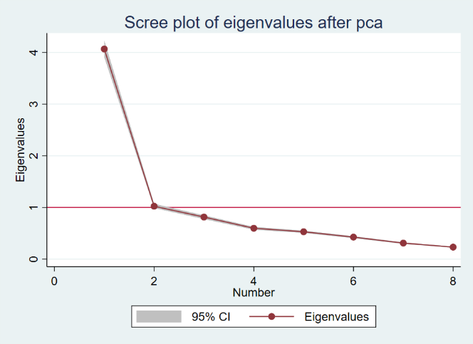 | 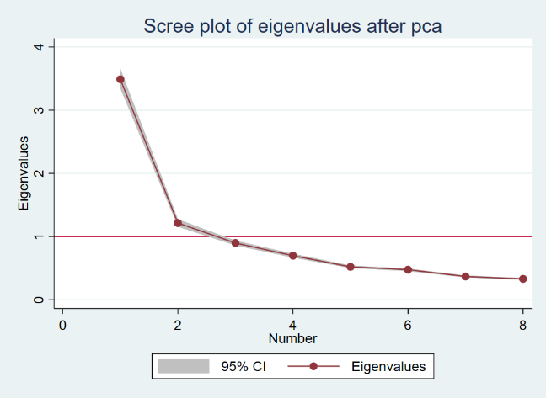

Figure S9. Scree plots from PCA conducted over selected non-pharmaceutical interventions (NPIs) for Wave 1 (calendar weeks 5-25, February to June) and Wave 2 (calendar weeks 35-52 end of August to December) during 2020.

Panel S1. Categorization of non-pharmaceutical interventions variables for analysis
a) Public events: coded as 0 if no measure was in place; coded as 1 if at least one of the categories “not-specified”, “more than 1000 persons”, “less than 1000 persons”, “More than 50 persons”, “any type/number” was present; coded as 2 if at least two of these categories were simultaneously present; coded as 3 if three or four of these categories (unless not mutually exclusive) were simultaneously present.
b) Public institutions: coded as 0 if no measure was in place; coded as 1 if at least one of the categories “not-specified”, “single cities”, “state level” or “national”, was present; coded as 2 if two or more these categories were simultaneously present;
c) Public spaces: coded as 0 if no measure was in place; coded as 1 if at least one of the categories “not-specified”, “single cities”, “state level” or “national”, was present; coded as 2 if two or more these categories were simultaneously present;
d) Public transports: coded as 0 if no measure was in place; coded as 1 if at least one of the categories “not-specified”, “single cities”, “state level” or “national”, was present; coded as 2 if two or more these categories were simultaneously present;
e) Movement/mobility: coded as 0 if no measure was in place; coded as 1 if at least one of the categories “not specified”, “pedestrians”, “private cars”, “aviation national travel”, or “other (Ships, trains, etc)”, was present; coded as 2 if two of these categories were simultaneously present; coded as 3 if three of these categories were simultaneously present; code as 4 if four or more of these categories were simultaneously present;
f) Travelling or border closure: coded as 0 if no measure was in place; coded as 1 if at least one of the categories “not specified”, “for non-nationals from high-risk regions”, “for all non-nationals”, or “for all incoming travellers” was present; coded as 2 if two of these categories were simultaneously present; coded as 3 if three of more of these categories were simultaneously present;
g) Measures to improve the healthcare system: coded as 0 if no measure was in place; coded as 1 if at least one of the categories “not specified”, “HR reinforcement or redistribution”, “technical reinforcement or redistribution”, “material infrastructural reinforcement or redistribution” was present; coded as 2 if two of these categories were simultaneously present; coded as 3 if three or more of these categories were simultaneously present.
h) Masks: coded as 0 if no measure was in place; coded as 1 if any measure for nose and mouth protection recommendation or mandatory requirement, was in place.

Table S1. Variation observed in the eight non-pharmaceutical interventions (NPIs) used, categories described in Panel S1, and the three component scores, across the 32 countries analysed, by wave.
Wave 1 |  |  |  |  |  |  |  | Wave 2
Variable |  | Mean | Std. Dev. | Min | Max | Observations |  | Mean | Std. Dev. | Min | Max | Observations
Public events | overall | 0.8471514 | 0.7085490 | 0 | 3 | N = 4704 |  | 1.077538 | 0.819334 | 0 | 3 | N = 4256
 | between |  | 0.2894207 | 0.1292517 | 1.47619 | n = 32 |  |  | 0.666409 | 0.015038 | 2.180451 | n = 32
 | within |  | 0.6487509 | -0.6290391 | 3.19409 | T = 147 |  |  | 0.4909 | -0.4563 | 3.0625 | T = 133
Public spaces | overall | 0.6940901 | 0.5845112 | 0 | 2 |  |  | 0.7434211 | 0.6192782 | 0 | 2
 | between |  | 0.2315859 | 0.4013605 | 1.489796 |  |  |  | 0.4840963 | 0.0075188 | 2
 | within |  | 0.5382251 | -0.7957058 | 2.156675 |  |  |  | 0.3955077 | -0.7077068 | 2.156955
Public institutions | overall | 0.6753827 | 0.5627363 | 0 | 2 |  |  | 0.9309211 | 0.6937171 | 0 | 2
 | between |  | 0.1853622 | 0.0884354 | 1.061224 |  |  |  | 0.5169163 | 0.0827068 | 2
 | within |  | 0.5323342 | -0.3858418 | 2.022321 |  |  |  | 0.471519 | -0.5878759 | 2.848214
Public transport | overall | 0.4491922 | 0.5669802 | 0 | 2 |  |  | 0.5596805 | 0.6110693 | 0 | 2
 | between |  | 0.2805871 | 0 | 0.9795918 |  |  |  | 0.5497136 | 0 | 1.774436
 | within |  | 0.495158 | -0.5303997 | 2.374362 |  |  |  | 0.2838928 | -0.2222744 | 1.93562
Movement/mobility | overall | 1.017857 | 1.235634 | 0 | 4 |  |  | 0.8858083 | 0.9433424 | 0 | 4
 | between |  | 0.673215 | 0 | 2.687075 |  |  |  | 0.8560943 | 0 | 4
 | within |  | 1.042901 | -1.669218 | 3.963435 |  |  |  | 0.4239501 | -1.06156 | 2.93844
Border closure | overall | 1.344175 | 1.044592 | 0 | 3 |  |  | 1.345395 | 0.9350556 | 0 | 3
 | between |  | 0.6281309 | 0.2040816 | 2.802721 |  |  |  | 0.8853125 | 0.0300752 | 3
 | within |  | 0.8419451 | -0.7034439 | 3.487032 |  |  |  | 0.3389178 | -0.2786654 | 2.841635
Healthcare system improvement | overall | 0.7055697 | 0.9230682 | 0 | 3 |  |  | 0.7882989 | 1.012989 | 0 | 3
 | between |  | 0.6744655 | 0 | 2.693878 |  |  |  | 0.951732 | 0 | 3
 | within |  | 0.6413058 | -0.9270833 | 3.542304 |  |  |  | 0.3852965 | -0.6101974 | 3.743186
Masks | overall | 0.329932 | 0.4702381 | 0 | 1 |  |  | 0.8601974 | 0.3468229 | 0 | 1
 | between |  | 0.1832463 | 0 | 0.6462585 |  |  |  | 0.2920201 | 0 | 1
 | within |  | 0.4342662 | -0.3163265 | 1.323129 |  |  |  | 0.1940511 | -0.1322838 | 1.84516
Component 1 (4 for wave 2) | overall | 50 | 16.96749 | 24.32622 | 95.29994 |  |  | 50 | 16.62913 | 21.62831 | 93.31548
 | between |  | 6.786782 | 35.64553 | 63.18238 |  |  |  | 15.1712 | 27.99734 | 84.95831
 | within |  | 15.59696 | 14.25135 | 86.26042 |  |  |  | 7.314572 | 21.897 | 72.01978
Component 2 (5 for wave 2) | overall | 50 | 14.1044 | 30.54177 | 92.62379 |  |  | 50 | 12.7371 | 29.41809 | 86.60291
 | between |  | 8.569364 | 40.56193 | 75.04967 |  |  |  | 11.75188 | 34.91665 | 77.89664
 | within |  | 11.30397 | 15.0046 | 84.77342 |  |  |  | 5.330221 | 26.34875 | 73.42411
Component 3 (6 for wave 2) | overall | 50 | 10.62755 | 36.12392 | 72.27434 |  |  | 50 | 11.01743 | 16.23185 | 62.31834
 | between |  | 3.703322 | 41.66169 | 57.89436 |  |  |  | 9.61353 | 20.07576 | 60.33374
 | within |  | 9.982789 | 32.7591 | 76.43093 |  |  |  | 5.64189 | 16.20047 | 75.6832

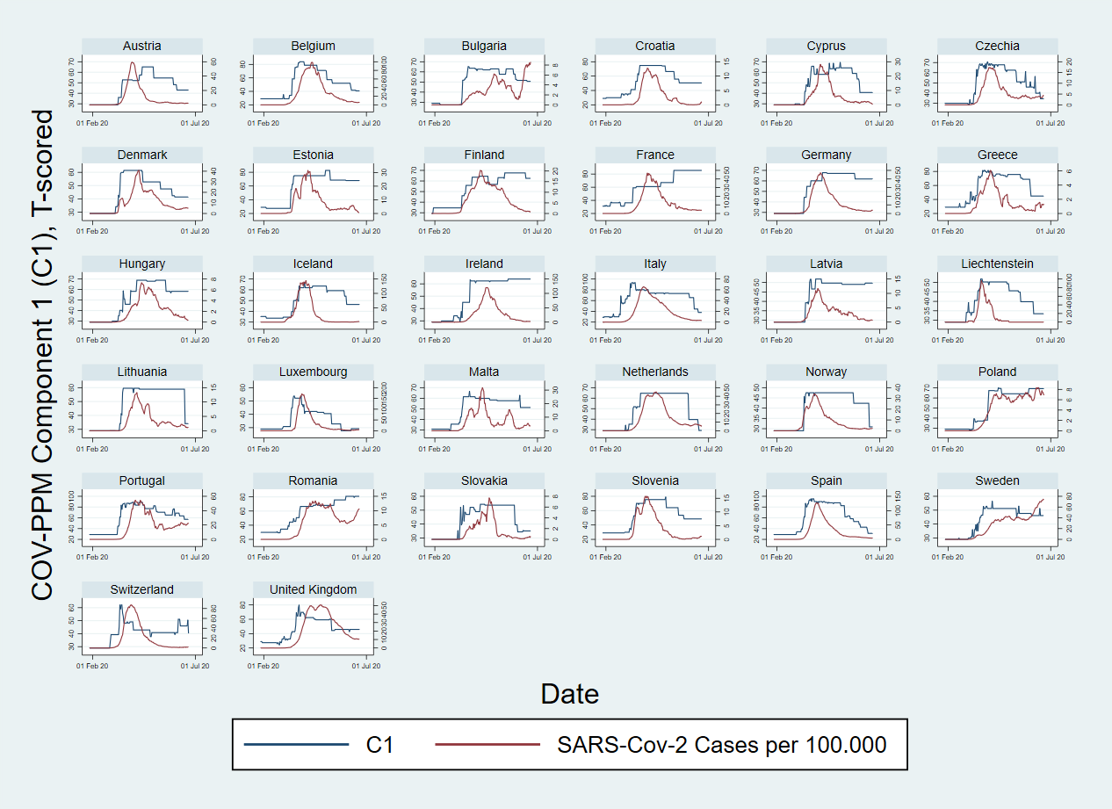

Figure S10. Plots showing Component 1 (from COV-PPM) and SARS-Cov-2 Cases per 100.000 (secondary axis), in 32 countries from the European region during wave 1 (March-July 2020).

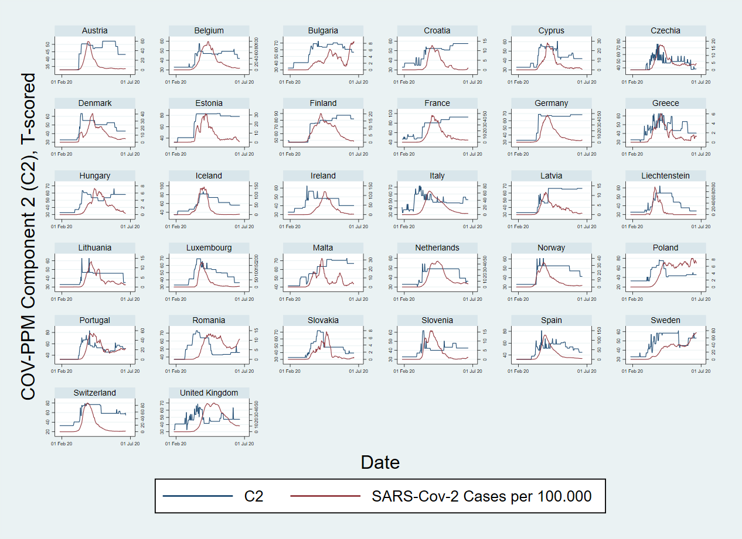

Figure S11. Plots showing Component 2 (from COV-PPM) and SARS-Cov-2 Cases per 100.000 (secondary axis), in 32 countries from the European region during wave 1 (March-July 2020).

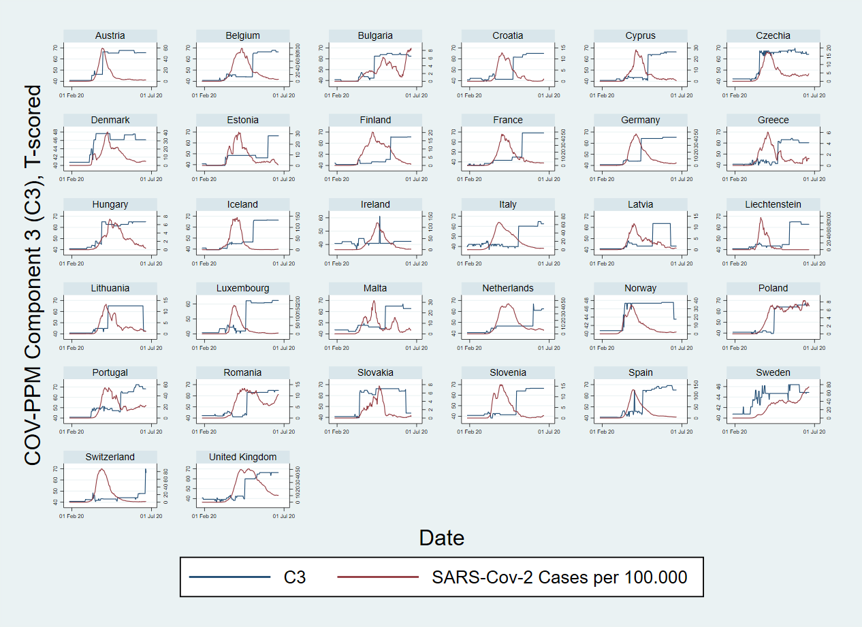

Figure S12. Plots showing Component 3 (from COV-PPM) and SARS-Cov-2 Cases per 100.000 (secondary axis), in 32 countries from the European region during wave 1 (March-July 2020).

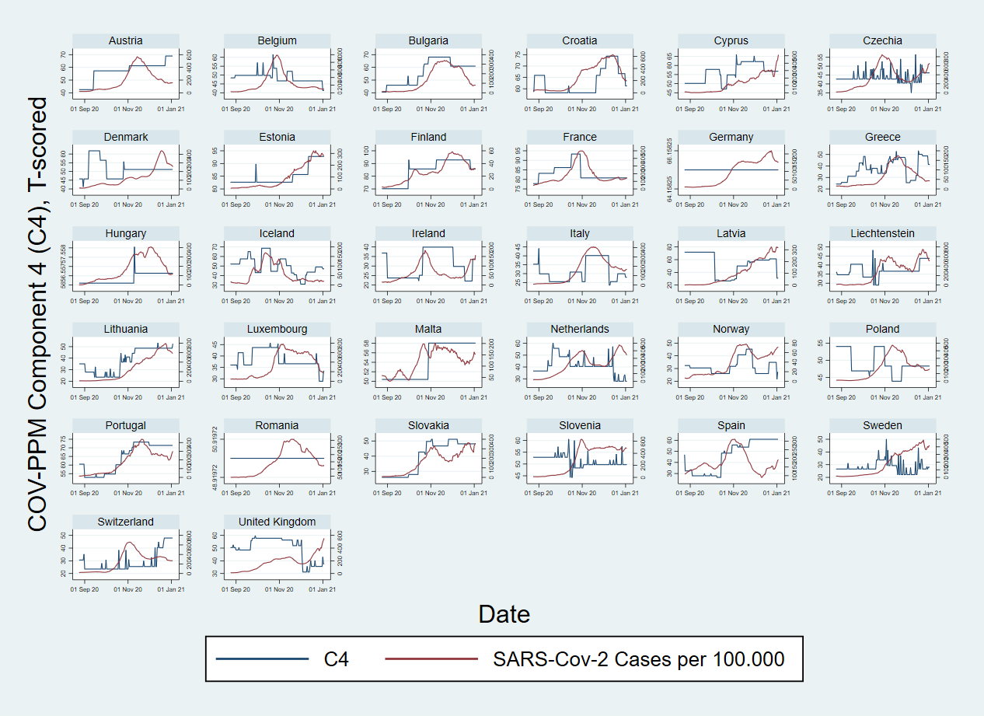

Figure S13. Plots showing Component 4 (from COV-PPM) and SARS-Cov-2 Cases per 100.000 (secondary axis), in 32 countries from the European region during wave 2 (August-December 2020).

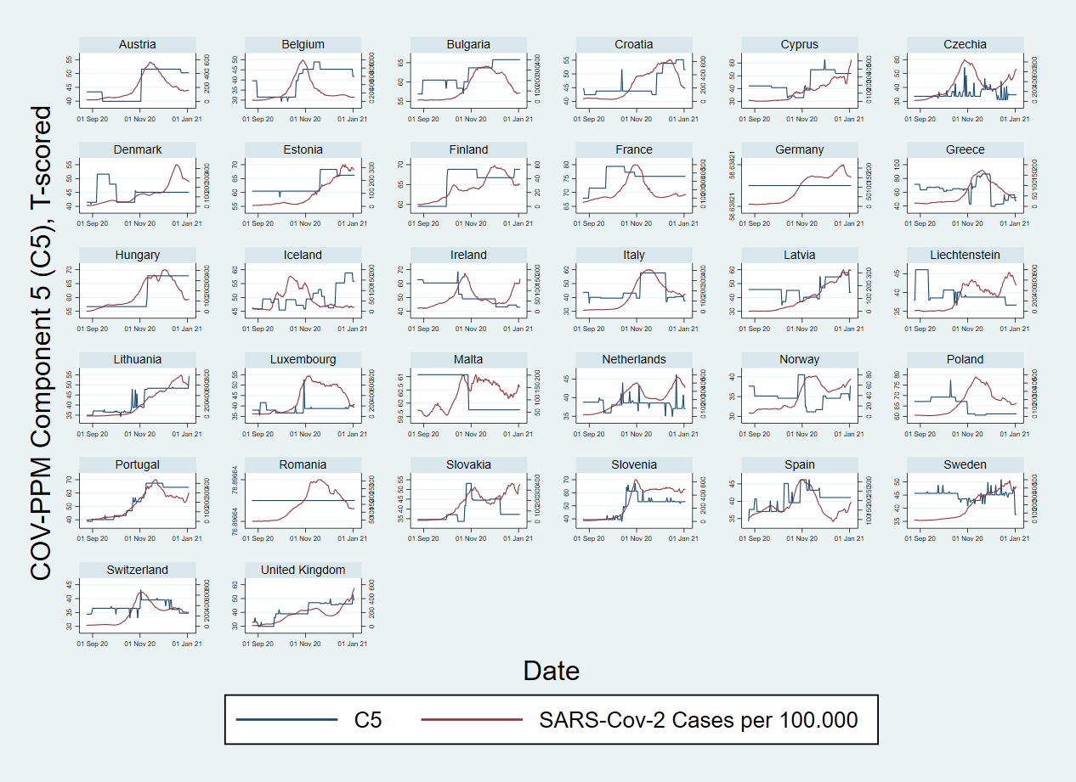

Figure S14. Plots showing Component 5 (from COV-PPM) and SARS-Cov-2 Cases per 100.000 (secondary axis), in 32 countries from the European region during wave 2 (August-December 2020).

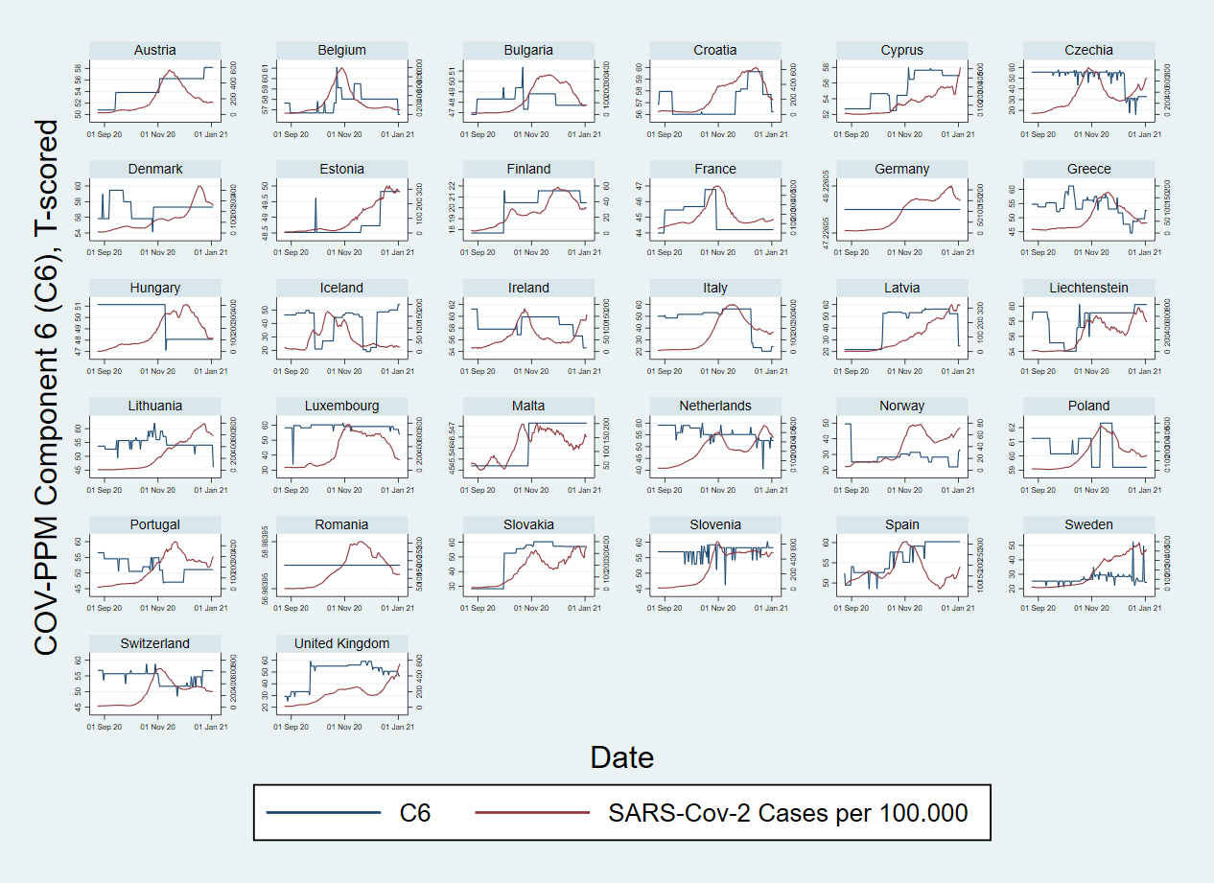

Figure S15. Plots showing Component 6 (from COV-PPM) and SARS-Cov-2 Cases per 100.000 (secondary axis), in 32 countries from the European region during wave 2 (August-December 2020).

Table S2. Test of model specifications
First, models were adjusted for a variable of day-count and the natural logarithm of the population size as offset. Second, models were tested with the three component scores and finally with the 7-day incidence rate change variable. Negative binomial, Poisson and gamma distributions were tested, considering country as a random or fixed effects factor in the case of negative binomial link.
Wave 1
Model (observations, n=4704, weeks 5-25, 2020) | Family | LL(model) | df | AIC | BIC
Cases_ms7~Day + offset || (country as random) | nbinomial | -30326.06 | 4 | 60660.11 | 60685.94
Cases_ms7~Day + offset + Country (as fixed) | nbinomial | -30251.74 | 34 | 60571.47 | 60790.98
Cases_ms7~Day + offset + Country (as fixed) | poisson | -6731096 | 33 | 1.35e+07 | 1.35e+07
Cases_ms7~Day + offset + Country (as fixed) | gamma | -1.78e+14 | 33 | 3.55e+14 | 3.55e+14
Cases_ms7~Day + C1+C2+C3 + offset || (country as random) | nbinomial | -28611.36 | 7 | 57236.72 | 57281.91
Cases_ms7~Day + C1+C2+C3 + offset + Country (as fixed) | nbinomial | -28519.36 | 37 | 57112.72 | 57351.60
Cases_ms7~Day + C1+C2+C3 + offset + Country (as fixed) | poisson | -3361023 | 36 | 6722118 | 6722350
Cases_ms7~Day + C1+C2+C3 + offset + Country (as fixed) | gamma | -28441.62 | 36 | 56955.23 | 57187.66
Cases_ms7~Day + C1+C2+C3 + rate_change + offset || (country as random) | nbinomial | -28479.72 | 8 | 56975.44 | 57027.09
Cases_ms7~Day + C1+C2+C3 + rate_change + offset + Country (as fixed) | nbinomial | -28386.80 | 38 | 56849.59 | 57094.93
Cases_ms7~Day + C1+C2+C3 + rate_change + offset + Country (as fixed) | poisson | -3165739 | 37 | 6331552 | 6331791
Cases_ms7~Day + C1+C2+C3 + rate_change + offset + Country (as fixed) | gamma | -28029.40 | 37 | 56132.79 | 56371.67

Wave 2
Model (observations, n=4256 weeks 35-52, 2020) | Family | LL(model) | df | AIC | BIC
Cases_ms7~Day + offset || (country as random) | nbinomial | -41313.40 | 4 | 82634.79 | 82660.22
Cases_ms7~Day + offset + Country (as fixed) | nbinomial | -41221.70 | 34 | 82511.40 | 82727.50
Cases_ms7~Day + offset + Country (as fixed) | poisson | -2.15e+07 | 33 | 4.29e+07 | 4.29e+07
Cases_ms7~Day + offset + Country (as fixed) | gamma | -1.17e+15 | 33 | 2.35e+15 | 2.35e+15
Cases_ms7~Day + C4+C5+C6 + offset || (country as random) | nbinomial | -41154.49 | 7 | 82322.98 | 82367.47
Cases_ms7~Day + C4+C5+C6 + offset + Country (as fixed) | nbinomial | -41059.32 | 37 | 82192.64 | 82427.81
Cases_ms7~Day + C4+C5+C6 + offset + Country (as fixed) | poisson | -1.95e+07 | 36 | 3.90e+07 | 3.90e+07
Cases_ms7~Day + C4+C5+C6 + offset + Country (as fixed) | gamma | -41802.66 | 36 | 83677.33 | 83906.15
Cases_ms7~Day + C4+C5+C6 + rate_change + offset || (country as random) | nbinomial | -41016.29 | 8 | 82048.59 | 82099.44
Cases_ms7~Day + C4+C5+C6 + rate_change + offset + Country (as fixed) | nbinomial | -40910.82 | 38 | 81915.65 | 82157.18
Cases_ms7~Day + C4+C5+C6 + rate_change + offset + Country (as fixed) | poisson | -1.90e+07 | 37 | 3.81e+07 | 3.81e+07
Cases_ms7~Day + C4+C5+C6 + rate_change + offset + Country (as fixed) | gamma | -41746.21 | 37 | 83566.42 | 83801.59

Table S3. Incidence Rate Ratios (IRR) – cases - for the lagged-effects obtained for the three extracted components from PCA of NPIs (pc1 – pc3), considering a 7, 14, 21, 28 and 35 days-lag across all countries – Wave 1 (weeks 5-25 or end of February-June, 2020).
Cases - Wave 1 (32 countries)
VARIABLES | IRR (95%CI) | IRR (95%CI) | IRR (95%CI) | IRR (95%CI) | IRR (95%CI) | IRR (95%CI)
ID_day | 1.027***(1.025 - 1.029) | 1.026***(1.023 - 1.028) | 1.022***(1.020 - 1.025) | 1.018***(1.015 - 1.020) | 1.012***(1.009 - 1.014) | 1.003**(1.001 - 1.005)
Tpc1nolagw1 | 1.111***(1.106 - 1.115) | 1.090***(1.082 - 1.098) | 1.093***(1.088 - 1.099) | 1.092***(1.087 - 1.097) | 1.086***(1.082 - 1.091) | 1.073***(1.069 - 1.077)
Tpc2nolagw1 | 1.051***(1.045 - 1.057) | 1.041***(1.034 - 1.049) | 1.045***(1.039 - 1.051) | 1.042***(1.037 - 1.048) | 1.034***(1.029 - 1.039) | 1.026***(1.021 - 1.031)
Tpc3nolagw1 | 0.962***(0.955 - 0.969) | 0.985***(0.976 - 0.995) | 0.982***(0.974 - 0.990) | 0.981***(0.974 - 0.988) | 0.983***(0.977 - 0.989) | 0.987***(0.982 - 0.993)
Tpc1_7lagw1 |  | 1.017***(1.010 - 1.024)
Tpc2_7lagw1 |  | 1.011***(1.003 - 1.018)
Tpc3_7lagw1 |  | 0.968***(0.959 - 0.978)
Tpc1_14lagw1 |  |  | 1.008***(1.002 - 1.013)
Tpc2_14lagw1 |  |  | 1.002(0.996 - 1.008)
Tpc3_14lagw1 |  |  | 0.968***(0.961 - 0.976)
Tpc1_21lagw1 |  |  |  | 1.002(0.997 - 1.006)
Tpc2_21lagw1 |  |  |  | 0.993***(0.987 - 0.998)
Tpc3_21lagw1 |  |  |  | 0.975***(0.968 - 0.981)
Tpc1_28lagw1 |  |  |  |  | 0.995**(0.992 - 0.999)
Tpc2_28lagw1 |  |  |  |  | 0.987***(0.982 - 0.992)
Tpc3_28lagw1 |  |  |  |  | 0.988***(0.982 - 0.994)
Tpc1_35lagw1 |  |  |  |  |  | 0.994***(0.990 - 0.997)
Tpc2_35lagw1 |  |  |  |  |  | 0.984***(0.979 - 0.988)
Tpc3_35lagw1 |  |  |  |  |  | 1.001(0.996 - 1.007)
ratechange | 1.100***(1.084 - 1.117) | 1.100***(1.083 - 1.117) | 1.066***(1.051 - 1.081) | 1.031***(1.021 - 1.042) | 1.005(0.998 - 1.013) | 0.987***(0.982 - 0.992)
lnalpha | 1.726***(1.656 - 1.800) | 1.643***(1.576 - 1.713) | 1.548***(1.484 - 1.615) | 1.398***(1.340 - 1.459) | 1.177***(1.127 - 1.228) | 0.891***(0.853 - 0.931)
var(_cons[Country_code]) | 4.707***(2.189 - 10.125) | 4.521***(2.144 - 9.536) | 4.166***(2.056 - 8.439) | 3.766***(1.953 - 7.262) | 3.389***(1.851 - 6.202) | 3.068***(1.761 - 5.343)
Observations | 4.704 | 4.576 | 4.352 | 4.128 | 3.904 | 3.680
95% CI – Confidence Intervals in parentheses
*** p<0.01, ** p<0.05, * p<0.1

Table S4. Incidence Rate Ratios (IRR) – cases - for the lagged-effects obtained for the three extracted components from PCA of NPIs (pc4 – pc6), considering a 7, 14, 21, 28 and 35 days-lag across all countries – Wave 2 (weeks 35-52 or end of August-December, 2020).
Cases - Wave 2 (32 countries)
VARIABLES | IRR (95%CI) | IRR (95%CI) | IRR (95%CI) | IRR (95%CI) | IRR (95%CI) | IRR (95%CI)
ID_day | 1.025***(1.024 - 1.025) | 1.024***(1.024 - 1.025) | 1.025***(1.024 - 1.025) | 1.025***(1.024 - 1.026) | 1.025***(1.025 - 1.026) | 1.026***(1.025 - 1.026)
Tpc4nolagw2 | 1.004**(1.001 - 1.007) | 1.004**(1.001 - 1.008) | 1.004***(1.001 - 1.008) | 1.004**(1.001 - 1.007) | 1.004**(1.001 - 1.007) | 1.004***(1.001 - 1.007)
Tpc5nolagw2 | 1.022***(1.018 - 1.026) | 1.019***(1.014 - 1.024) | 1.022***(1.018 - 1.026) | 1.023***(1.019 - 1.027) | 1.025***(1.021 - 1.028) | 1.023***(1.020 - 1.027)
Tpc6nolagw2 | 1.023***(1.019 - 1.026) | 1.015***(1.009 - 1.020) | 1.018***(1.014 - 1.022) | 1.018***(1.014 - 1.022) | 1.017***(1.013 - 1.021) | 1.018***(1.014 - 1.021)
Tpc4_7lagw2 |  | 1.000(0.996 - 1.003)
Tpc5_7lagw2 |  | 1.003(0.998 - 1.008)
Tpc6_7lagw2 |  | 1.012***(1.007 - 1.017)
Tpc4_14lagw2 |  |  | 0.998(0.995 - 1.002)
Tpc5_14lagw2 |  |  | 0.997(0.993 - 1.002)
Tpc6_14lagw2 |  |  | 1.010***(1.006 - 1.014)
Tpc4_21lagw2 |  |  |  | 0.999(0.996 - 1.002)
Tpc5_21lagw2 |  |  |  | 0.990***(0.986 - 0.994)
Tpc6_21lagw2 |  |  |  | 1.011***(1.007 - 1.015)
Tpc4_28lagw2 |  |  |  |  | 1.000(0.997 - 1.003)
Tpc5_28lagw2 |  |  |  |  | 0.980***(0.976 - 0.984)
Tpc6_28lagw2 |  |  |  |  | 1.011***(1.007 - 1.014)
Tpc4_35lagw2 |  |  |  |  |  | 0.999(0.996 - 1.002)
Tpc5_35lagw2 |  |  |  |  |  | 0.975***(0.971 - 0.979)
Tpc6_35lagw2 |  |  |  |  |  | 1.008***(1.005 - 1.012)
ratechange | 1.494***(1.421 - 1.571) | 1.508***(1.434 - 1.586) | 1.492***(1.418 - 1.569) | 1.475***(1.403 - 1.551) | 1.466***(1.395 - 1.540) | 1.474***(1.403 - 1.548)
lnalpha | 0.389***(0.374 - 0.406) | 0.387***(0.372 - 0.403) | 0.387***(0.372 - 0.403) | 0.386***(0.370 - 0.402) | 0.381***(0.365 - 0.396) | 0.377***(0.362 - 0.393)
var(_cons[Country_code]) | 1.545***(1.241 - 1.923) | 1.542***(1.239 - 1.919) | 1.476***(1.210 - 1.799) | 1.374***(1.168 - 1.616) | 1.296***(1.136 - 1.479) | 1.267***(1.125 - 1.427)
Observations | 4.256 | 4.256 | 4.256 | 4.256 | 4.256 | 4.256
95% CI – Confidence Intervals in parentheses
*** p<0.01, ** p<0.05, * p<0.1

Table S5. Incidence Rate Ratios (IRR) -deaths- for the lagged-effects obtained for the three extracted components from PCA of NPIs (pc1 – pc3), considering a 21, 28, 35, 42 and 49 days-lag across all countries – Wave 1 (weeks 5-25 or end of February-June, 2020).
Deaths - Wave 1 (32 countries)
VARIABLES | IRR (95%CI) |  | IRR (95%CI) |  | IRR (95%CI) |  | IRR (95%CI) |  | IRR (95%CI) |  | IRR (95%CI)
ID_day | 1.027***(1.025 - 1.029) |  | 1.011***(1.008 - 1.013) |  | 1.010***(1.007 - 1.013) |  | 1.007***(1.004 - 1.010) |  | 0.997*(0.995 - 1.000) |  | 0.992***(0.989 - 0.995)
Tpc1nolagw1 | 1.124***(1.119 - 1.129) |  | 1.086***(1.081 - 1.090) |  | 1.092***(1.088 - 1.097) |  | 1.088***(1.083 - 1.092) |  | 1.064***(1.059 - 1.069) |  | 1.042***(1.038 - 1.046)
Tpc2nolagw1 | 1.060***(1.053 - 1.067) |  | 1.053***(1.046 - 1.059) |  | 1.048***(1.042 - 1.055) |  | 1.034***(1.028 - 1.041) |  | 1.015***(1.009 - 1.021) |  | 0.996(0.990 - 1.002)
Tpc3nolagw1 | 0.986***(0.980 - 0.993) |  | 0.987***(0.981 - 0.993) |  | 0.989***(0.983 - 0.995) |  | 0.992**(0.986 - 0.999) |  | 0.993**(0.988 - 0.999) |  | 0.994**(0.989 - 0.999)
Tpc1_21lagw1 |  |  | 1.037***(1.033 - 1.040)
Tpc2_21lagw1 |  |  | 1.014***(1.009 - 1.018)
Tpc3_21lagw1 |  |  | 0.986***(0.980 - 0.992)
Tpc1_28lagw1 |  |  |  |  | 1.019***(1.015 - 1.022)
Tpc2_28lagw1 |  |  |  |  | 1.007***(1.002 - 1.012)
Tpc3_28lagw1 |  |  |  |  | 0.987***(0.981 - 0.993)
Tpc1_35lagw1 |  |  |  |  |  |  | 1.008***(1.004 - 1.011)
Tpc2_35lagw1 |  |  |  |  |  |  | 1.003(0.998 - 1.008)
Tpc3_35lagw1 |  |  |  |  |  |  | 0.992***(0.987 - 0.998)
Tpc1_42lagw1 |  |  |  |  |  |  |  |  | 1.000(0.997 - 1.004)
Tpc2_42lagw1 |  |  |  |  |  |  |  |  | 0.996*(0.991 - 1.001)
Tpc3_42lagw1 |  |  |  |  |  |  |  |  | 0.997(0.993 - 1.002)
Tpc1_49lagw1 |  |  |  |  |  |  |  |  |  |  | 0.994***(0.991 - 0.997)
Tpc2_49lagw1 |  |  |  |  |  |  |  |  |  |  | 0.990***(0.986 - 0.995)
Tpc3_49lagw1 |  |  |  |  |  |  |  |  |  |  | 1.000(0.996 - 1.004)
ratechange | 0.952***(0.942 - 0.962) |  | 0.953***(0.944 - 0.962) |  | 0.929***(0.920 - 0.939) |  | 0.905***(0.895 - 0.914) |  | 0.761***(0.744 - 0.779) |  | 0.707***(0.688 - 0.727)
lnalpha | 1.219***(1.157 - 1.284) |  | 0.932**(0.882 - 0.984) |  | 0.985(0.933 - 1.040) |  | 0.928***(0.879 - 0.981) |  | 0.689***(0.649 - 0.732) |  | 0.533***(0.500 - 0.568)
var(_cons[Country_code]) | 13.632***(3.751 - 49.537) |  | 12.643***(3.612 - 44.255) |  | 9.808***(3.173 - 30.315) |  | 7.622***(2.794 - 20.796) |  | 5.411***(2.351 - 12.455) |  | 4.665***(2.181 - 9.979)
Observations | 4.704 |  | 4.128 |  | 3.904 |  | 3.680 |  | 3.456 |  | 3.232
95% CI – Confidence Intervals in parentheses
*** p<0.01, ** p<0.05, * p<0.1

Table S6. Incidence Rate Ratios (IRR) -deaths- for the lagged-effects obtained for the three extracted components from PCA of NPIs (pc4 – pc6), considering a 21, 28, 35, 42 and 49 days-lag across all countries – Wave 2 (weeks 35-52 or end of August-December, 2020).
Deaths - Wave 2 (32 countries)
VARIABLES | IRR (95%CI) | IRR (95%CI) | IRR (95%CI) | IRR (95%CI) | IRR (95%CI) | IRR (95%CI)
ID_day | 1.034***(1.033 - 1.035) | 1.033***(1.033 - 1.034) | 1.034***(1.033 - 1.034) | 1.034***(1.034 - 1.035) | 1.035***(1.034 - 1.035) | 1.034***(1.034 - 1.035)
Tpc4nolagw2 | 0.994***(0.991 - 0.998) | 0.994***(0.991 - 0.997) | 0.995***(0.991 - 0.998) | 0.995***(0.992 - 0.998) | 0.995***(0.992 - 0.998) | 0.994***(0.991 - 0.997)
Tpc5nolagw2 | 1.027***(1.023 - 1.031) | 1.027***(1.023 - 1.031) | 1.028***(1.024 - 1.032) | 1.028***(1.024 - 1.032) | 1.027***(1.023 - 1.031) | 1.026***(1.022 - 1.030)
Tpc6nolagw2 | 1.024***(1.020 - 1.028) | 1.019***(1.015 - 1.024) | 1.021***(1.017 - 1.025) | 1.020***(1.016 - 1.025) | 1.021***(1.017 - 1.025) | 1.023***(1.019 - 1.027)
Tpc4_7lagw2 |  | 1.001(0.998 - 1.005)
Tpc5_7lagw2 |  | 0.999(0.995 - 1.003)
Tpc6_7lagw2 |  | 1.015***(1.011 - 1.020)
Tpc4_14lagw2 |  |  | 1.004**(1.001 - 1.007)
Tpc5_14lagw2 |  |  | 0.993***(0.989 - 0.997)
Tpc6_14lagw2 |  |  | 1.011***(1.007 - 1.016)
Tpc4_21lagw2 |  |  |  | 1.001(0.997 - 1.004)
Tpc5_21lagw2 |  |  |  | 0.988***(0.984 - 0.992)
Tpc6_21lagw2 |  |  |  | 1.008***(1.004 - 1.012)
Tpc4_28lagw2 |  |  |  |  | 0.998(0.995 - 1.001)
Tpc5_28lagw2 |  |  |  |  | 0.986***(0.982 - 0.990)
Tpc6_28lagw2 |  |  |  |  | 1.007***(1.003 - 1.011)
Tpc4_35lagw2 |  |  |  |  |  | 0.998(0.994 - 1.001)
Tpc5_35lagw2 |  |  |  |  |  | 0.988***(0.983 - 0.992)
Tpc6_35lagw2 |  |  |  |  |  | 1.006***(1.001 - 1.010)
ratechange | 0.650***(0.615 - 0.687) | 0.662***(0.626 - 0.700) | 0.651***(0.616 - 0.688) | 0.646***(0.612 - 0.683) | 0.649***(0.615 - 0.686) | 0.651***(0.616 - 0.688)
lnalpha | 0.328***(0.312 - 0.344) | 0.323***(0.308 - 0.339) | 0.324***(0.308 - 0.340) | 0.323***(0.307 - 0.339) | 0.322***(0.306 - 0.338) | 0.323***(0.308 - 0.339)
var(_cons[Country_code]) | 2.257***(1.509 - 3.377) | 2.106***(1.456 - 3.047) | 2.104***(1.455 - 3.044) | 2.082***(1.448 - 2.995) | 2.082***(1.448 - 2.992) | 2.079***(1.447 - 2.987)
Observations | 4.256 | 4.256 | 4.256 | 4.256 | 4.256 | 4.256
95% CI – Confidence Intervals in parentheses
*** p<0.01, ** p<0.05, * p<0.1

Figure S16. Incidence Rate Ratios (IRR) and 95% CI for the lagged-effects (7, 14, 21, 28 and 35 days) on SARS-CoV2 incidence of the three principal component (PCA) scores of NPIs (using OxCGRT data) in 32 countries during the first and second waves of infections (March-December 2020), by region
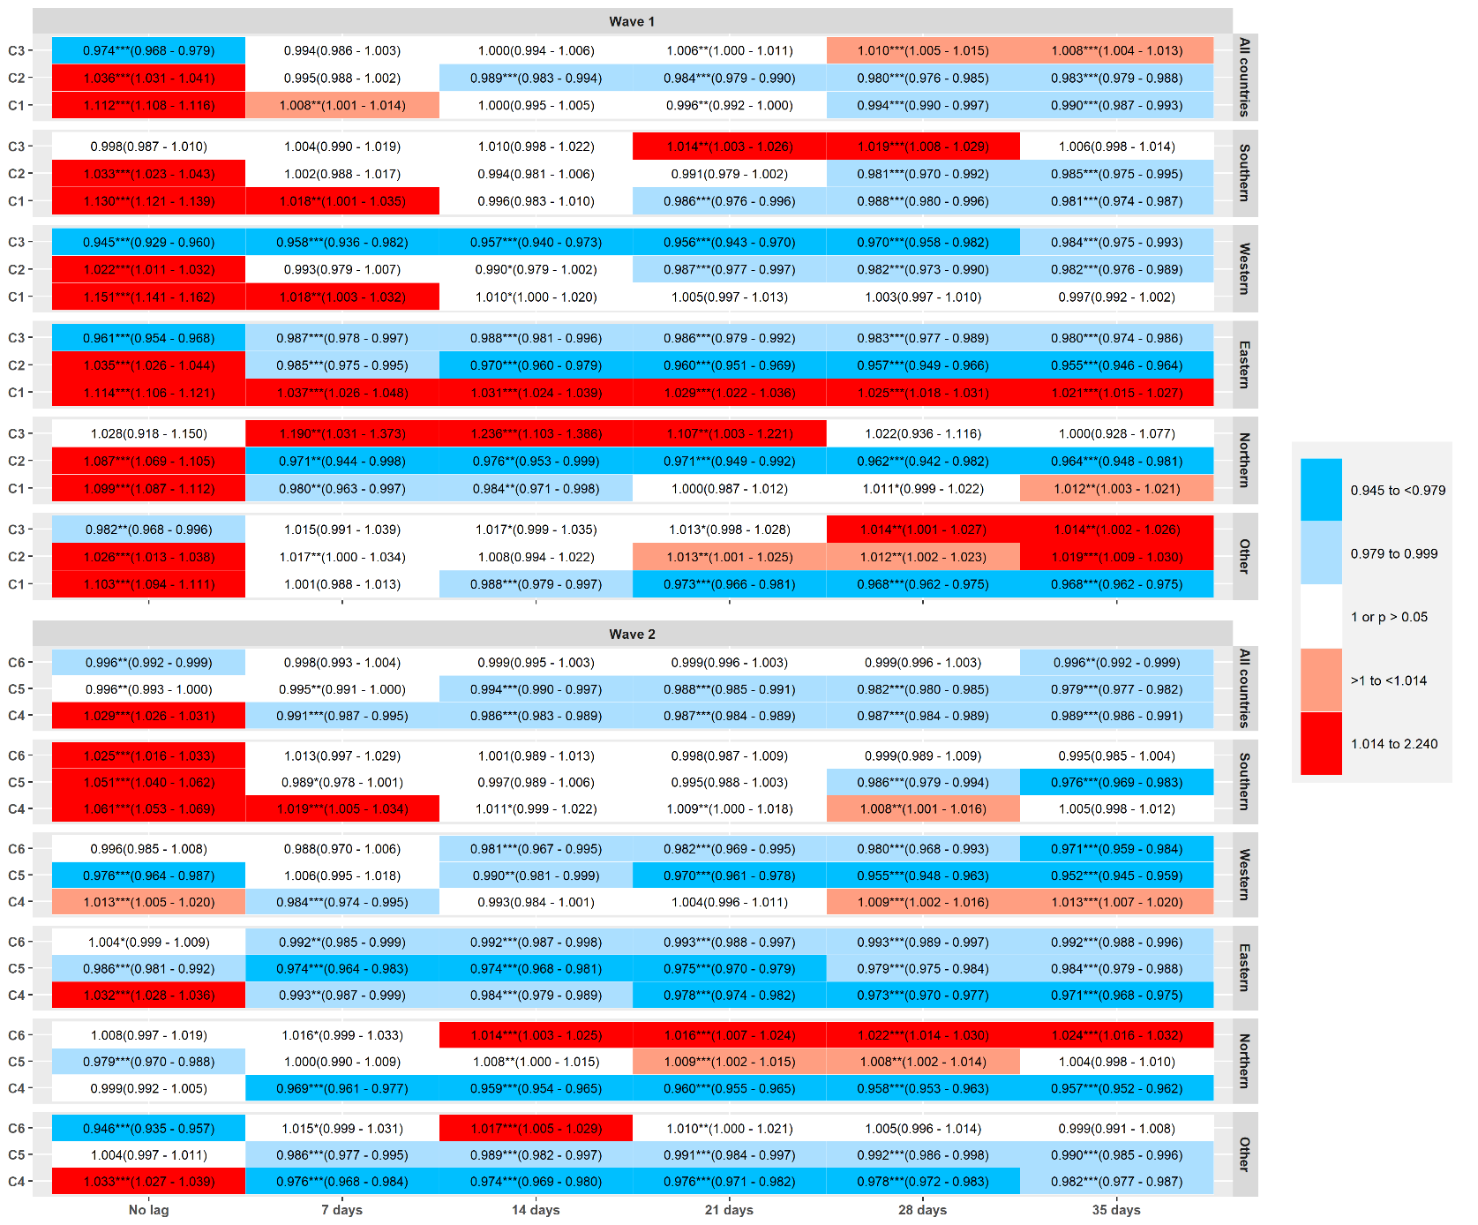
All countries: includes all countries; Southern: Portugal, Spain, Italy, Greece and Cyprus; Western: Belgium, Netherlands, France, Germany, Ireland, United Kingdom and Austria; Eastern: Czech Republic, Slovakia, Slovenia, Poland, Romania, Hungary and Bulgaria; Northern: Norway, Sweden, Finland and Denmark; Other: Croatia, Estonia, Iceland, Latvia, Lithuania, Luxembourg, Malta, Switzerland and Liechtenstein.

Figure S17. Incidence Rate Ratios (IRR) and 95% CI for the lagged-effects (21, 28, 35, 42 and 49 days) on SARS-CoV2 deaths of the three principal component (PCA) scores of NPIs (using OxCGRT data) in 32 countries during the first and second waves of infections (March-December 2020), by region
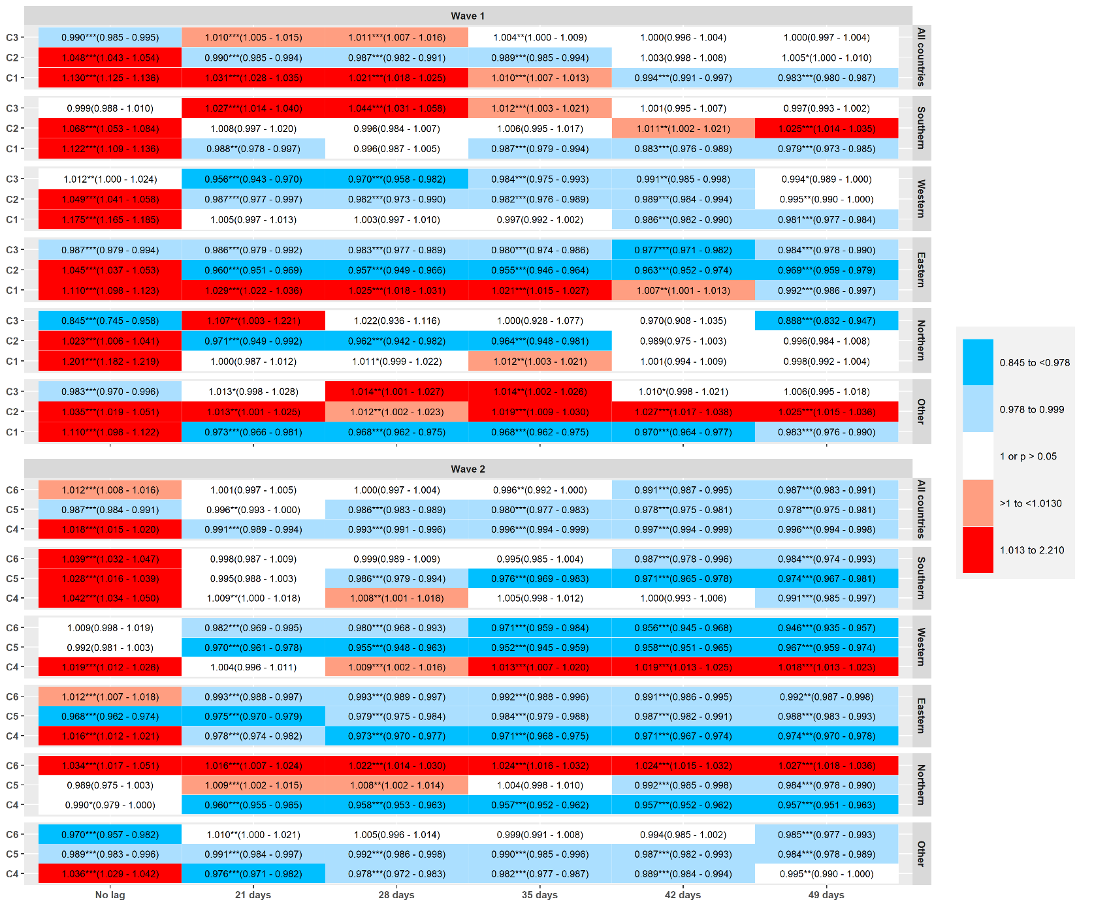

*** p<0.01, ** p<0.05, * p<0.1
All countries: includes all countries; Southern: Portugal, Spain, Italy, Greece and Cyprus; Western: Belgium, Netherlands, France, Germany, Ireland, United Kingdom and Austria; Eastern: Czech Republic, Slovakia, Slovenia, Poland, Romania, Hungary and Bulgaria; Northern: Norway, Sweden, Finland and Denmark; Other: Croatia, Estonia, Iceland, Latvia, Lithuania, Luxembourg, Malta, Switzerland and Liechtenstein.

