Table S1
Demographic characteristics of the study population in different trimesters.
Characteristics |  | Mean ± SD or No. (%) |  |  |  | P
Characteristics |  | 2nd trimester |  | 3rd trimester |  | P
Characteristics |  | (n=554) |  | (n=463) |  | P
Maternal
Age at recruitment (years) |  | 28.9±3.2 |  | 28.9±3.2 |  | 0.478
< 25 |  | 37(6.7) |  | 24(5.2)
25–30 |  | 282(50.9) |  | 253(54.6)
≥30 |  | 235(42.4) |  | 186(40.2)
Pre-pregnancy BMI (kg/m2） |  | 21.5±3.0 |  | 21.3±3.0 |  | 0.225
< 18.5 |  | 67(12.1) |  | 65(14.0)
18.5–23.9 |  | 390(70.4) |  | 316(68.3)
≥24.0 |  | 97(17.5) |  | 82(17.7)
Gravidity |  |  |  |  |  | 0.75
Primigravida |  | 284(51.3) |  | 242(52.3)
Multigravida |  | 270(48.7) |  | 221(47.7)
Parity |  |  |  |  |  | 0.691
Nulliparous |  | 394(71.1) |  | 324(70.0)
Multiparous |  | 160(28.9) |  | 139(30.0)
Mode of delivery |  |  |  |  |  | 0.475
Spontaneous delivery |  | 324(58.5) |  | 281(60.7)
Cesarean delivery |  | 230(41.5) |  | 182(39.3)
GDM |  | 108(19.5) |  | 93(20.1) |  | 0.813
Alcohol use in gestation |  | 65(11.7) |  | 55(11.9) |  | 0.951
Passive smoking in gestation |  | 78(14.1) |  | 72(15.6) |  | 0.51
Often drinking caffeinated beverages in gestation |  | 133(24.0) |  | 120(25.9) |  | 0.493
Often drinking tea in gestation |  | 174(31.4) |  | 155(33.5) |  | 0.495
Education |  |  |  |  |  | 0.818
Less than junior high school |  | 49 (8.8) |  | 36(7.8)
Junior high school or equivalent |  | 251(45.3) |  | 210(45.4)
College and above |  | 254(45.8) |  | 217(46.9)
Gestational age (weeks) |  | 39.0±1.3 |  | 39.1±1.1 |  | 0.135
Neonatal
Gender
Female |  | 299(54.0) |  | 243(52.5) |  | 0.659
Male |  | 255(46.0) |  | 220(47.5)
SGA |  | 23(4.2) |  | 23(5.0) |  | 0.548

Table S2
Relationship between maternal arsenic levels in the 3rd trimester and infants’ weight up to one year of age according to subgroups.
Weight |  | 0 month |  |  | 6 month |  |  | 12 month
Weight |  | β(95%CI) | P_{interaction} |  | β(95%CI) | P_{interaction} |  | β(95%CI) | P_{interaction}
Pre-pregnancy BMI
18.5-23.9 |  | -0.066(-0.154,0.023) | 0.901 |  | -0.195(-0.426,0.037) | 0.99 |  | -0.198(-0.457,0.061) | 0.909
<18.5 or >24.0 |  | 0.006(-0.126,0.138) | 0.901 |  | 0.049(-0.330,0.428) | 0.99 |  | -0.036(-0.464,0.392) | 0.909
GWG
AWG |  | -0.052(-0.162,0.058) | 0.138 |  | -0.177(-0.455,0.100) | 0.072 |  | -0.137(-0.501,0.227) | 0.193
EGWG or IWG |  | -0.044(-0.143,0.055) | 0.138 |  | -0.192(-0.471,0.088) | 0.072 |  | -0.247(-0.535,0.041) | 0.193
Gender
male |  | -0.061(-0.180,0.057) | 0.681 |  | -0.380(-0.710,-0.051) | 0.042* |  | -0.440(-0.812,-0.069) | 0.078
female |  | -0.037(-0.127,0.054) | 0.681 |  | 0.040(-0.194, 0.274) | 0.042* |  | -0.040(-0.311,0.231) | 0.078
GWG: gestational weight gain, EGWG:Excessive gestational weight gain, AWG:adequate weight gain, IWG:insufficient weight gain

Table S3
Relationship between maternal arsenic levels in the 3rd trimester and infants’ length up to one year of age according to subgroups.
Length |  | 0 month |  |  | 6 month |  |  | 12 month
Length |  | β(95%CI) | P_{interaction} |  | β(95%CI) | P_{interaction} |  | β(95%CI) | P_{interaction}
Pre-pregnancy BMI
18.5-23.9 |  | -0.194(-0.440,0.051) | 0.555 |  | -0.450(-0.998,0.098) | 0.524 |  | -0.068(-0.952,0.816) | 0.952
<18.5 or >24.0 |  | -0.067(-0.388,0.254) | 0.555 |  | 0.042(-1.347,1.431) | 0.524 |  | -0.044(-0.932,0.845) | 0.952
GWG
AWG |  | -0.294(-0.555,0.033) | 0.976 |  | -0.129(-0.800,0.542) | 0.936 |  | -0.304(-1.071,0.462) | 0.957
EGWG or IWG |  | -0.099(-0.385,0.187) | 0.976 |  | -0.677(-0.047,0.238) | 0.936 |  | -0.024(-1.025,0.977) | 0.957
Gender
male |  | -0.260(-0.560,0.039) | 0.416 |  | -0.975(-1.762,-0.188) | 0.055 |  | -1.229(-2.033,-0.426) | 0.002**
female |  | -0.108(-0.366,0.150) | 0.416 |  | 0.075(-0.761,0.912) | 0.055 |  | 0.889(-0.106,1.885) | 0.002**

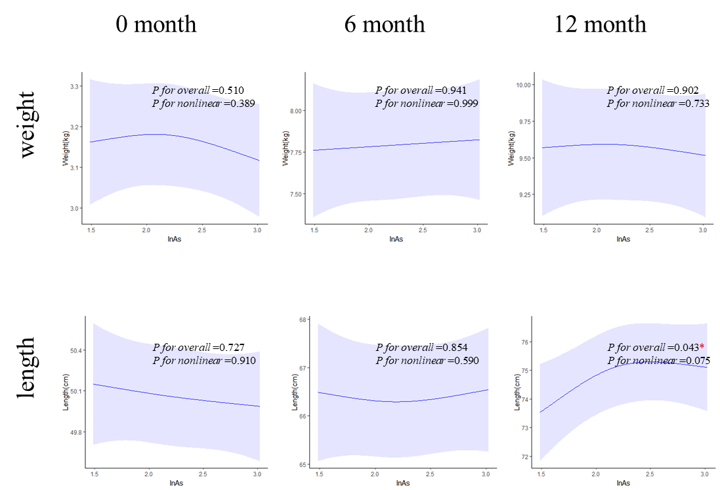
Fig S1. Dose–response correlation between maternal arsenic levels in the third trimester and physical development of 0-12 months girls, using three-node RCS functions. Models were adjusted for maternal age, parity, gravidity, GDM, pre-pregnancy BMI, gestational weeks, education levels, alcohol use, passive smoking, caffeinated beverages intake, and tea intake in gestation.

