Supplementary appendix 2

Results
Table of Content

- Baseline characteristics of study participants stratified by osteoarthritis.
- The associations between exposures and all-cause mortality using a restricted cubic spline (RCS) regression
- Estimated event rates of serum calcium, vitamin D and CRP
- Subgroup analyses for exposure and all-cause mortality based on calcium or vitamin D supplementation history and CKD history
- Subgroup analyses for exposure and all-cause mortality based on baseline age and sex
- Sensitivity analysis 1: baseline missing data imputation (pooled results)
- Sensitivity analysis 2: serum calcium-reference Interval values using 99% reference interval values
- Sensitivity analysis 3: The association between serum calcium and the outcomes using age and sex-specific values
- Sensitivity analysis 4: Multivariable analyses before the onset of COVID-19 pandemic
Baseline characteristics of study participants stratified by osteoarthritis. Values are numbers (percentages) unless stated otherwise.
Characteristics | Overall  (n= 499,773) | OA  (n=49,082) | P values
Age (mean (SD), years) | 56.51 (8.09) | 60.69 (6.54) | <0.001
Female (%) | 272337 (54.5) | 28827 (58.7) | <0.001
White (%) | 451856 (90.4) | 45537 (92.8) | <0.001
Nmiss (%) | 2680 (0.5) | 266 (0.5)
Household income (£, %) |  |  | <0.001
<18 000 | 96311 (19.3) | 14909 (30.4)
18 000-30 999 | 107586 (21.5) | 11543 (23.5)
31 000-51 999 | 110368 (22.1) | 7849 (16.0)
52 000-100 000 | 86022 (17.2) | 4192 (8.5)
>100 000 | 22879 (4.6) | 731 (1.5)
Nmiss (%) | 76607 (15.3) | 9858 (20.1)
TDI (median [range]) | -2.14 [-6.26, 11.00] | -1.88 [-6.26, 10.56] | <0.001
Nmiss (%) | 623 (0.1) | 58 (0.1)
BMI (mean (SD), kg/m²) | 27.43 (4.78) | 29.51 (5.41) | <0.001
Nmiss (%) | 9970 (2.0) | 1470 (3.0)
Smoking status (%) |  |  | <0.001
Never | 272552 (54.5) | 23665 (48.2)
Former | 171917 (34.4) | 19921 (40.6)
Current | 52395 (10.5) | 5114 (10.4)
Nmiss (%) | 2909 (0.6) | 382 (0.8)
Alcohol consumption (times/week, %) |  |  | <0.001
Never | 40278 (8.1) | 5468 (11.1)
1-2 | 241901 (48.4) | 25064 (51.1)
3-4 | 114965 (23.0) | 9624 (19.6)
≥5 | 101154 (20.2) | 8772 (17.9)
Nmiss (%) | 1475 (0.3) | 154 (0.3)
IPAQ activity group (%) |  |  | <0.001
Low | 75584 (15.1) | 8181 (16.7)
Moderate | 163227 (32.7) | 13981 (28.5)
High | 161472 (32.3) | 14577 (29.7)
Nmiss (%) | 99490 (19.9) | 12343 (25.1)
Sleep status (%)
<7 h/day or >9 h/day | 131650 (26.3) | 16515 (33.6) | <0.001
Nmiss (%) | 4148 (0.8) | 612 (1.2)
CCI (median [range]) | 0.00 [0.00, 14.00] | 0.0 [0.00, 14.00] | <0.001
> 0 (%) | 96432 (19.3) | 16420 (33.5) | <0.001
Chronic kidney disease (%) | 32309 (6.5) | 4660 (9.5) | <0.001
Nmiss (%) | 4756 (1.0) | 488 (1.0)
Hypertension (%) | 279234 (55.9) | 33118 (67.5) | <0.001
Calcium (mean (SD), mmol/L) | 2.38 (0.09) | 2.38 (0.10) | <0.001
Nmiss (%) | 69839 (14.0) | 6819 (13.9)
Albumin adjusted calcium (mean (SD), mmol/L) | 2.38 (0.08) | 2.39 (0.08) | <0.001
Moderate (2.19-2.56 mmol/L, %) | 417658 (83.6) | 40718 (83.0) | <0.001
Low (<2.19 mmol/L, %) | 2529 (0.5) | 219 (0.4)
High (>2.56 mmol/L ,%) | 9570 (1.9) | 1304 (2.7)
Nmiss (%) | 70016 (14.0) | 6841 (13.9)
Calcium supplementation (%) | 34662 (6.9) | 4437 (9.0) | <0.001
Nmiss (%) | 4664 (0.9) | 453 (0.9)
Vitamin D (median [range], nmol/L) | 46.80 (10.00, 340.00) | 48.10 (10.00, 291.00) | <0.001
Insufficient (<50 nmol/L, %) | 247710 (49.6) | 23271 (47.4) | <0.001
Nmiss (%) | 52161 (10.4) | 5218 (10.6)
Vitamin D supplementation (%) | 19885 (4.0) | 2432 (5.0) | <0.001
Nmiss (%) | 4663 (0.9) | 453 (0.9)
hs-CRP (median [range], mg/L) | 1.33 (0.08, 79.96) | 1.90 (0.08, 78.81) | <0.001
high (≥ 3 mg/L,%) | 105461 (21.1) | 15282 (31.1) | <0.001
Nmiss (%) | 32360 (6.5) | 3146 (6.4)
Cholesterol (mean (SD), mmol/L) | 5.69 (1.14) | 5.64 (1.20) | <0.001
Nmiss (%) | 31395 (6.3) | 3050 (6.2)

- Abbreviation: SD: standard deviation; Nmiss: number of missing; TDI: Townsend Deprivation Index; BMI: body mass index; CCI: Charlson comorbidity index. Prevalent hypertension was defined as a self-reported history of hypertension, the use of antihypertensive drugs, a systolic blood pressure of 140 mm Hg or higher, or a diastolic blood pressure of 90 mm Hg or higher.

The associations between exposures and all-cause mortality using a restricted cubic spline (RCS) regression
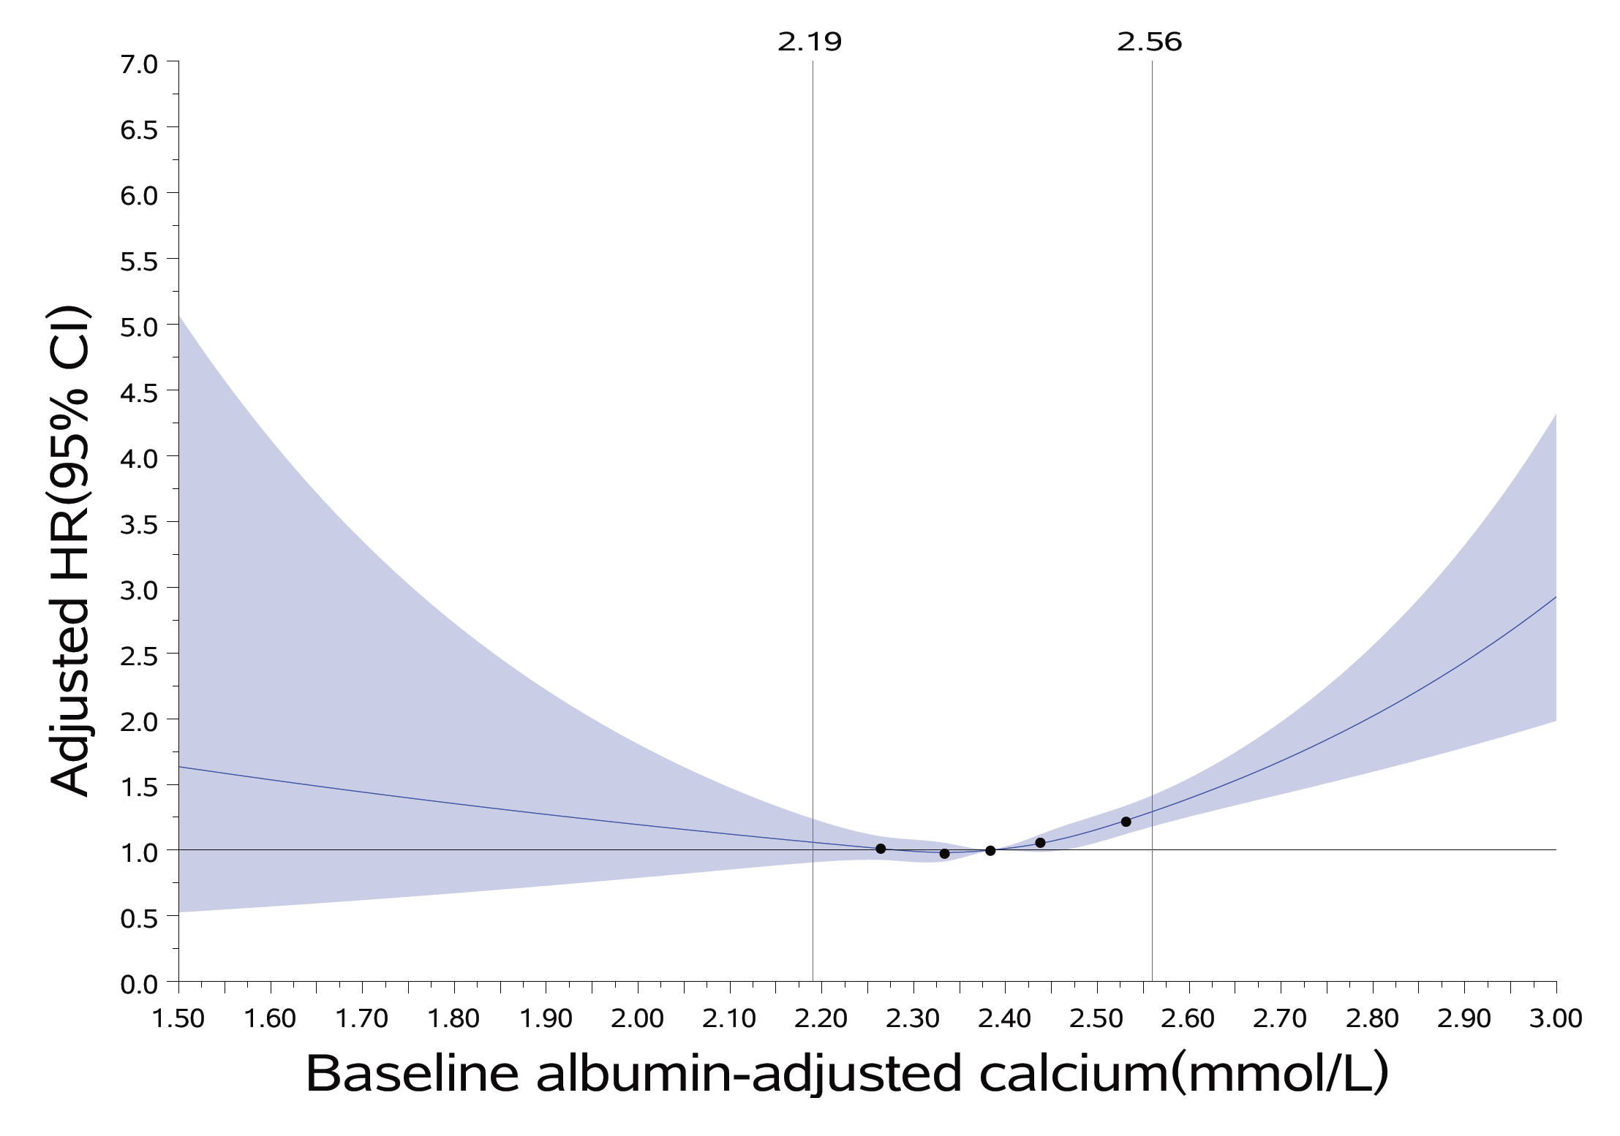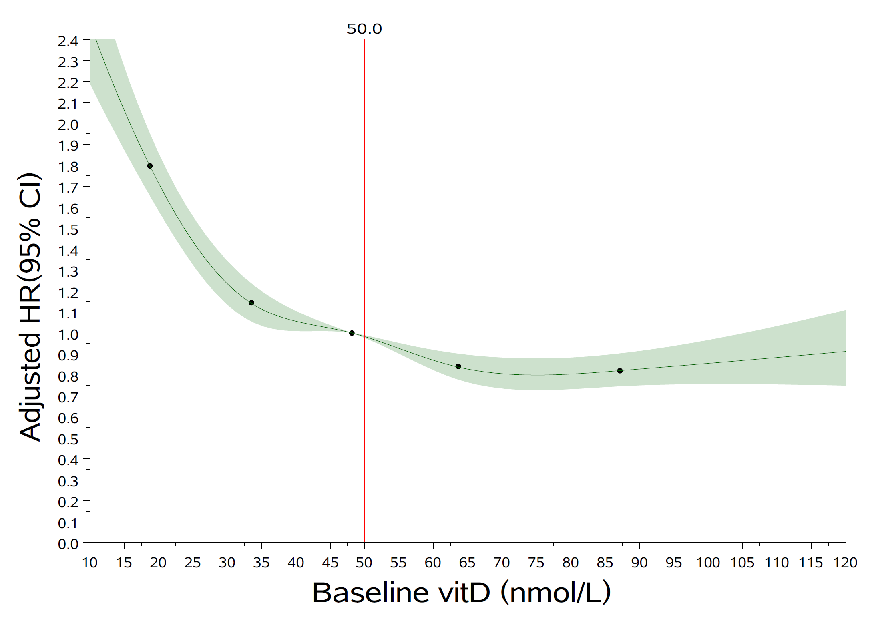
* RCS models fitted for Cox proportional hazards models with five knots (5th, 25th, 50th, 75th and 95th percentiles) were used, adjusted for baseline age and sex. Reference red line were the cut-offs of medical reference range in UK population.

Estimated event rates of serum calcium, vitamin D and CRP

Events in OA | Estimated event rate  (events/1000 person years)
Events in OA | Albumin-adjusted serum calcium |  |  | Vitamin D |  | CRP
Events in OA | Medium  (n=40,718) | Low  (n=219) | High  (n=1,304) | ≥ 50 nmol/L  (n=20,593) | Insufficient: <50 nmol/L  (n=23,271) | <3mg/L  (n=30,654) | High: ≥3 mg/L  (n=15,282)
CVD-related deaths | 1.86  (1.74, 1.99) | 4.26  (2.36, 7.69) | 2.73  (2.02, 3.69) | 1.52  (1.37, 1.68) | 2.23  (2.06, 2.41) | 1.51  (1.39, 1.64) | 2.62  (2.39, 2.87)
Cancer-related deaths | 4.01  (3.84, 4.19) | 5.81  (3.50, 9.64) | 4.30  (3.38, 5.47) | 3.78  (3.55, 4.03) | 4.27  (4.03, 4.52) | 3.64  (3.45, 3.84) | 4.86  (4.55, 5.19)
Other deaths | 3.33  (3.17, 3.50) | 3.49  (1.82, 6.71) | 4.88  (3.89, 6.12) | 2.63  (2.44, 2.84) | 4.06  (3.83, 4.30) | 2.78  (2.62, 2.96) | 4.63  (4.33, 4.95)
All-cause mortality | 9.21  (8.94, 9.48) | 13.56  (9.74, 18.89) | 11.91  (10.3, 13.77) | 7.94  (7.60, 8.30) | 10.56  (10.18, 10.95) | 7.93  (7.65, 8.22) | 12.11  (11.61, 12.63)

Subgroup analyses for exposure and all-cause mortality based on calcium or vitamin D supplementation history and CKD history

Exposures | Baseline calcium supplemental history |  |  | Baseline vitamin D supplemental history |  |  | Baseline CKD
Exposures | Yes (n=2,593) | No (n=26,551) | P for interaction # | Yes (n=1423) | No (n=27,721) | P for interaction # | Yes (n=2,660) | No (n=26,485) | P for interaction #
Low calcium | 2.28(0.71,7.26) | 1.19(0.77,1.86) | 0.476 | — | 1.33(0.88,2.01) | 0.990 | 1.84(0.87,3.90) | 1.16(0.71,1.90) | 0.544
High calcium | 1.47(0.96,2.24) | 1.28(1.04,1.57) | 0.476 | 1.35(0.65,2.79) | 1.33(1.10,1.61) | 0.990 | 1.42(1.01,2.01) | 1.28(1.03,1.58) | 0.544
Vitamin D | 1.20(0.93,1.54) | 1.22(1.12,1.32) | 0.777 | 1.12(0.77,1.63) | 1.19(1.10,1.28) | 0.725 | 1.24(1.03,1.49) | 1.18(1.09,1.28) | 0.835
CRP | 1.50(1.18,1.92) | 1.29(1.19,1.40) | 0.487 | 1.30(0.89,1.89) | 1.30(1.21,1.41) | 0.874 | 1.44(1.21,1.71) | 1.28(1.17,1.39) | 0.667

Adjusted by the MSAS: age, BMI, CCI, CKD, sleep duration, IPAQ, alcohol consumption, ethnicity, gender, hypertension, smoking, TDI, serum cholesterol and other serum markers.
#Interaction between subgroup stratified factors and exposures.
Statistical significance was determined if 95%CI for difference if 95%CI for HRs did not overlap with 1.

Subgroup analyses for exposure and all-cause mortality based on baseline age and sex

Exposures | Baseline age below 60 years |  | Baseline age equal or higher than 60 years
Exposures | Females (n=10,013) | Males (n=6,949) | Females (n=18,814) | Males (n=13,306)
Low calcium | 1.39 (0.34, 5.65) | 0.79 (0.20, 3.20) | 1.85 (0.76, 4.45) | 1.26 (0.74, 2.14)
High calcium | 2.08 (1.21, 3.58) | 1.11 (0.45, 2.71) | 1.12 (0.86, 1.45) | 1.59 (1.17, 2.17)
Vitamin D | 1.53 (1.15, 2.03) | 1.23 (0.95, 1.58) | 1.17 (1.03, 1.32) | 1.16 (1.04, 1.29)
CRP | 1.37 (1.04, 1.81) | 1.45 (1.13, 1.86) | 1.15 (1.02, 1.31) | 1.39 (1.25, 1.56)

Adjusted for baseline age (continuous), BMI, CCI, CKD, sleep duration, IPAQ, alcohol consumption, ethnicity, hypertension, smoking, TDI, serum cholesterol, and other serum markers.
Statistical significance was established when the 95% confidence interval (CI) for the hazard ratios (HRs) did not include 1.

Sensitivity analysis 1: The association between serum markers and the outcomes after 20 imputations for missing covariates at baseline (pooled results)

Events in OA | Adjusted HR (95%CI) for albumin-adjusted calcium |  | Adjusted HR (95%CI) for Vitamin D insufficiency | Adjusted HR (95%CI) for high CRP
Events in OA | Low vs medium | High vs medium | Adjusted HR (95%CI) for Vitamin D insufficiency | Adjusted HR (95%CI) for high CRP
CVD-related deaths | 1.81(1.00,3.28) | 1.38(1.01,1.88) | 1.26 (1.11, 1.44) | 1.33 (1.17, 1.50)
Cancer-related deaths | 1.35(0.81,2.24) | 1.01(0.79,1.29) | 1.06 (0.98, 1.16) | 1.19 (1.09, 1.30)
Other deaths | 0.91(0.47,1.75) | 1.33(1.05,1.68) | 1.34 (1.21, 1.47) | 1.33 (1.22, 1.46)
All-cause mortality | 1.28(0.93,1.77) | 1.20(1.03,1.40) | 1.19 (1.13, 1.27) | 1.27 (1.20, 1.34)

The effect (adjusted HRs) for exposures were calculated by Cox-PH-based model (albumin-adjusted serum calcium, n = 42,241) and IPTW-based Cox regression models (vitamin D, n=43,864; CRP, n=45,936).
For each model, covariates in MSAS (age, BMI, CCI, CKD, sleep duration, IPAQ, alcohol consumption, ethnicity, gender, hypertension, smoking, TDI, serum cholesterol and other serum markers) were adjusted or balanced according to their weights.
Results were pooled from 20 imputed datasets, according to Rubin’s rule, statistical significance was determined if 95%CI for difference if 95%CI for HRs did not overlap with 1.

Sensitivity analysis 2: The association between serum calcium levels and the outcomes using 99% reference interval values

Events in OA | FPSM-based adjusted HR (95%CI) ^{ab} |  | Cox-PH-based adjusted HR (95%CI) ª |  | IPTW-based adjusted HR (95%CI) ª
Events in OA | Low vs. Medium | High vs. Medium | Low vs. Medium | High vs. Medium | Low vs. Medium | High vs. Medium
CVD-related deaths | 2.07  (0.99,3.85) | 1.84  (1.18,2.72) | 2.06  (1.02,4.14) | 1.84  (1.20,2.83) | 1.99  (0.97, 4.05) | 2.00  (1.29, 3.11)
Cancer-related deaths | 1.45  (0.75,2.49) | 1.08  (0.74,1.51) | 1.45  (0.80,2.63) | 1.08  (0.75,1.55) | 1.52  (0.83, 2.78) | 1.14  (0.78, 1.64)
Other deaths | 0.62  (0.19,1.44) | 1.97  (1.44, 2.61) | 0.62  (0.23,1.66) | 1.96  (1.44,2.65) | 0.58  (0.22, 1.56) | 1.94  (1.42, 2.64)
All-cause mortality | 1.28  (0.83,1.88) | 1.54  (1.25, 1.87) | 1.28  (0.85,1.93) | 1.54  (1.25,1.89) | 1.27 (0.84, 1.92) | 1.60  (1.30, 1.97)

Reference interval values (lower limit: 2.19, higher limit: 2.58) were calculated in 42,241 participants with albumin-adjusted serum calcium, using ‘referenceIntervals’ package
a Results were adjusted or IPTW for MSAS (baseline age, BMI, CCI, CKD, sleep duration, IPAQ, alcohol consumption, ethnicity, gender, hypertension, smoking, TDI, serum cholesterol, serum vitamin D and CRP levels).
b FPSM were selected using BIC, including the baseline log-cumulative hazard with 4 degrees of freedom and time-varying coefficients of attend age and CCI.
Statistical significance was determined if 95%CI for difference if 95%CI for HRs did not overlap with 1.

Sensitivity analysis 3：The association between serum calcium and the outcomes using age and sex-specific values

Events in OA | FPSM-based adjusted HR (95%CI) ª |  | Cox-PH-based adjusted HR (95%CI) ª |  | IPTW-based adjusted HR (95%CI) ª
Events in OA | Low vs. Medium | High vs. Medium | Low vs. Medium | High vs. Medium | Low vs. Medium | High vs. Medium
CVD-related deaths | 2.02  (0.97,3.63) | 1.62  (1.06,2.34) | 2.00  (1.04,3.88) | 1.62  (1.08,2.42) | 2.02  (1.03, 3.93) | 1.70  (1.13, 2.56)
Cancer-related deaths | 1.41  (0.77,2.31) | 1.08  (0.76,1.47) | 1.40  (0.81,2.42) | 1.07  (0.77,1.50) | 1.42  (0.82, 2.46) | 1.10  (0.79, 1.54)
Other deaths | 0.78  (0.31,1.57) | 1.79  (1.33, 2.34) | 0.78  (0.35,1.73) | 1.78  (1.33,2.37) | 0.71  (0.31, 1.60) | 1.70  (1.27, 2.27)
All-cause mortality | 1.30  (0.88,1.84) | 1.44  (1.19, 1.73) | 1.30  (0.90,1.89) | 1.44  (1.19,1.74) | 1.27  (0.87, 1.85) | 1.44  (1.19, 1.75)

The cut-off values of abnormal albumin-adjusted calcium by age and sex (lower limit: age<55 and women 2.211, age<55 and men 2.195,age≥55 and women:2.192, age≥55 and men:2.210; higher limit: age<55 and women:2.552, age<55 and men 2.565,age≥55 and women:2.549, age≥55 and men:2.586) were extracted from a preceding study based on UK Biobank data.
a Results were adjusted or IPTW for MSAS (baseline age, BMI, CCI, CKD, sleep duration, IPAQ, alcohol consumption, ethnicity, gender, hypertension, smoking, TDI, serum cholesterol, serum vitamin D and CRP levels).
b FPSM were selected using BIC, including the baseline log-cumulative hazard with 4 degrees of freedom and time-varying coefficients of attend age, BMI and CCI.
Statistical significance was determined if 95%CI for difference if 95%CI for HRs did not overlap with 1.

Sensitivity analysis 4: Multivariable analyses before the onset of COVID-19 pandemic

Events in OA | Albumin-adjusted calcium |  | Vitamin D insufficiency | Elevated CRP
Events in OA | Low vs. Medium* | High vs. Medium | Vitamin D insufficiency | Elevated CRP
CVD-related deaths | 1.72(0.71,4.16) | 1.81(1.18,2.80) | 1.54 (1.24, 1.91) | 1.37 (1.11, 1.70)
Cancer-related deaths | 1.34(0.88,2.04) | 1.13(0.85,1.50) | 1.14 (0.99, 1.31) | 1.27 (1.10, 1.46)
Other deaths | 0.94(0.35,2.35) | 1.29(0.88,1.90) | 1.28 (1.07, 1.53) | 1.31 (1.09, 1.57)
All-cause mortality | 1.38(0.87,2.19) | 1.32(1.06,1.64) | 1.26 (1.14, 1.38) | 1.30 (1.18, 1.44)

- Up to 31 January 2020: the date of the first recorded UK COVID-19 case.
- The effect (adjusted HR) for exposures were calculated by Cox-PH-based model (serum calcium) and IPTW-based Cox regression models (vitamin D and CRP).
- For each model, covariates in MSAS (age, BMI, CCI, CKD, sleep duration, IPAQ, alcohol consumption, ethnicity, gender, hypertension, smoking, TDI, cholesterol and other serum markers) were adjusted or balanced according to their weights; Statistical significance was determined if 95% CI for difference if 95%CI for HRs did not overlap with 1.
* Low serum calcium levels were associated with CVD-related death but this association became non-significant, likely due to the limited data on low serum calcium.

