Sex Differences in Association of Healthy Eating Pattern with All-cause Mortality and Cardiovascular Mortality
SUPPLEMENTARY MATERIAL

Table S1. HEI-2015 Components and Score Standards
Table S2. Gender differences in dietary components in HEI-2015
Table S3. Baseline characteristics of the lowest and extreme quartiles of HEI-2015 after propensity score matching
Table S4. Multivariable-adjusted analysis of HEI-2015 associated with all-cause mortality and CVD mortality after propensity score matching
Table S5. Association of HEI-2015 with Prevalent Hypertension by Sex.
Table S6. Association of HEI-2015 with Prevalent Obesity by Sex.
Table S7. Association of HEI-2015 with Prevalent Cancer by Sex.
Table S8. Association of HEI-2015 with Prevalent CVD by Sex.
Table S9. Association of HEI-2015 with Prevalent Diabetes by Sex.
Table S10. HR(95%CI) of all-cause mortality and CVD mortality according to quartiles of HEI-2015 after excluding participants who died within 2 years of follow-up in NHANES 2003-2018
Table S11. HR(95%CI) of all-cause mortality and CVD mortality according to quartiles of HEI-2015 after excluding participants who self-reported CVD at baseline in NHANES 2003-2018
Table S12. HR(95%CI) of all-cause mortality and CVD mortality according to quartiles of HEI-2015 after excluding participants who had diabetes at baseline in NHANES 2003-2018
Table S13. HR(95%CI) of all-cause mortality and CVD mortality according to quartiles of HEI-2015 after excluding participants who had cancer at baseline in NHANES 2003-2018
Figure S1. Flow Chart of Participants Recruitment.
Figure S2. Directed Acyclic Graph.
Figure S3. Differences in HEI-2015 distribution between different genders.
Figure S4. Variables balance between participants with HEI-2015≤40.4 and those with HEI-2015>57.1 before and after the propensity score matching.

Table S1. HEI-2015 Components and Score Standards
Component | Dietary Constituents | Standard for Minimum | Min Score | Standard for Max | Max Score
Adequacy
Total Fruits | Total Fruit | No | 0 | ≥0.8 cup eq. per 1000Kcal | 5
Whole Fruits | Citrus, Melons, Berries + Other Intact Fruits | No | 0 | ≥0.4 cup eq. per 1000Kcal | 5
Total Vegetables | Total Vegetables + Legumes (Beans and Peas) in cup equivalents | No | 0 | ≥1.1 cup eq. per 1000Kcal | 5
Greens and Beans | Dark Green Vegetables + Legumes | No | 0 | ≥0.2 cup eq.per 1000Kcal | 5
Whole Grains | Whole Grains | No | 0 | ≥1.5 oz eq.per 1000Kcal | 10
Dairy | Total Dairy | No | 0 | ≥1.3 oz eq.per 1000Kcal | 10
Total Protein Foods | (Beans and Peas) in cup equivalents | No | 0 | ≥2.5 oz eq. per 1000Kcal | 5
Seafood and Plant Proteins | Seafood (high in n-3) + Seafood (low in n-3) + Soy + Nuts and Seeds + Legumes (Beans and Peas) in oz equivalents | No | 0 | ≥0.8 oz eq. per 1000Kcal | 5
Fatty Acids | (Total Monounsaturated Fatty Acids + Total Polyunsaturated Fatty Acids) /Total Saturated Fatty Acids | ≤1.2 | 0 | ≥2.5 | 10
Moderation
Refined Grains | Refined Grains | ≥4.3 oz eq. per 1,000 kcal | 0 | ≤1.8 oz eq. per 1000 kcal | 10
Sodium | Sodium | ≥2.0 g per 1000Kcal | 0 | ≤1.1 g per 1000Kcal | 10
Added Sugars | Added Sugars | ≥26% of energy | 0 | ≤6.5% of energy | 10
Saturated Fats | Total Saturated Fatty Acids | ≥16% of energy | 0 | ≤8% of energy | 10
HEI-2015 consists of adequacy components and moderation components. Each component is recommended to have a minimum score of 0 and a maximum score of 5 or 10. If the intake is between the minimum and maximum, the score is calculated using a linear interpolation formula.
Table S2. Gender differences in dietary components in HEI-2015
Componentª | Overall | Males | Females | P value
Total Fruits | 2.08 (0.20, 4.72) | 1.66 (0.09, 4.10) | 2.49 (0.42, 5.00) | <0.001
Whole Fruits | 0.00 (0.00, 1.60) | 0.00 (0.00, 0.98) | 0.00 (0.00, 2.18) | <0.001
Total Vegetables | 3.12 (1.90, 4.77) | 2.85 (1.73, 4.30) | 3.43 (2.08, 5.00) | <0.001
Greens and Beans | 0.61 (0.00, 4.75) | 0.19 (0.00, 4.18) | 1.03 (0.00, 5.00) | <0.001
Whole Grains | 1.53 (0.00, 4.34) | 1.29 (0.00, 3.97) | 1.78 (0.00, 4.64) | <0.001
Dairy | 5.12 (2.79, 7.90) | 4.91 (2.61, 7.58) | 5.33 (2.96, 8.18) | <0.001
Total Protein Foods | 5.00 (4.25, 5.00) | 5.00 (4.47, 5.00) | 5.00 (4.10, 5.00) | <0.001
Seafood and Plant Proteins | 3.08 (0.16, 5.00) | 2.93 (0.09, 5.00) | 3.20 (0.25, 5.00) | <0.001
Fatty Acids | 4.59 (2.07, 7.74) | 4.49 (2.04, 7.53) | 4.67 (2.11, 7.97) | 0.005
Refined Grains | 4.96 (1.81, 7.98) | 4.99 (1.85, 7.98) | 4.94 (1.78, 7.98) | 0.7
Sodium | 3.99 (0.87, 6.73) | 3.93 (0.85, 6.72) | 4.04 (0.88, 6.74) | 0.3
Added Sugars | 6.24 (2.46, 9.05) | 6.26 (2.44, 9.17) | 6.22 (2.49, 8.96) | 0.2
Saturated Fats | 6.21 (3.47, 8.81) | 6.15 (3.45, 8.72) | 6.27 (3.48, 8.89) | 0.11
HEI-2015 | 48.41 (40.30, 57.25) | 47.15 (39.35, 55.95) | 49.51 (41.26, 58.52) | <0.001
ª Data are presented as medians (interquartile ranges).
Abbreviations: HEI, health eating index.

Table S3. Baseline characteristics of the lowest and extreme quartiles of HEI-2015 after propensity score matching
Variable | Overall | Lowest & highest quartiles of HEI |  | P value
Variable | Overall | HEI-2015≤40.4 | HEI-2015＞57.1 | P value
Total no. | 12558 | 6279 | 6279
Age, years | 47 (33.0, 60.0) | 47(33.0, 60.0) | 48 (33.0, 61.0) | 0.1
Race and ethnicity,n(%) |  |  |  | 0.8
Non-Hispanic White | 5,341 (67.4%) | 2,688(66.0%) | 2,653 (68.8%)
Non-Hispanic Black | 2,644(10.7%) | 1,322 (11.1%) | 1,322 (10.2%)
Mexican American | 2,175 (9.1%) | 1,093 (9.7%) | 1,082 (8.5%)
Others | 2,398(12.8%) | 1,176 (13.2%) | 1,222 (12.4%)
Education level ,n(%) |  |  |  | 0.8
Less than high | 3,442 (16.9%) | 1,737 (17.3%) | 1,705 (16.5%)
High school grad or equivalent | 2,664 (21.5%) | 1,342 (22.3%) | 1,322(20.7%)
College or above | 6,452 (61.6%) | 3,200(60.4%) | 3,252(62.8%)
Family income-poverty ratio,n(%) |  |  |  | 0.4
≤1.30 | 3,763 (21.0%) | 1,903 (20.9%) | 1,860 (21.1%)
1.3-3.5 | 4,899 (35.2%) | 2,483 (35.7%) | 2,416 (34.7%)
>3.5 | 3,896 (43.8%) | 1,893 (43.5%) | 2,003 (44.2%)
BMI, Kg/m² |  |  |  | 0.7
< 25.0 | 3,558(29.8%) | 1,775 (27.9%) | 1,783 (31.7%)
25.0-29.9 | 4,060 (32.4%) | 2,001 (31.4%) | 2,059 (33.4%)
≥30 | 4,940 (37.8%) | 2,503 (40.7%) | 2,437 (34.9%)
Smoking status ,n(%) |  |  |  | 0.8
Never | 7,474 (59.3%) | 3,739 (60.6%) | 3,735 (58.0%)
former smoker | 3,273 (26.1%) | 1,616(24.9%) | 1,657 (27.4%)
Current smoker | 1,811 (14.6%) | 924 (14.6%) | 887 (14.6%)
Drinking status ,n(%) |  |  |  | 0.6
Never | 9,346(70.2%) | 4,707 (71.6%) | 4,639 (68.9%)
Moder | 1,871 (16.8%) | 931 (16.4%) | 940(17.1%)
Heavy | 1,341 (13.0%) | 641 (12.0%) | 700 (14.0%)
Hypertension ,n(%) |  |  |  | 0.7
No | 7,262 (62.4%) | 3,648 (61.5%) | 3,614 (63.2%)
Yes | 5,296 (37.6%) | 2,631(38.5%) | 2,665 (36.8%)
Diabetes ,n(%) |  |  |  | 0.9
No | 10,328 (86.5%) | 5,159(86.1%) | 5,169 (86.9%)
Yes | 2,230 (13.5%) | 1,120 (13.9%) | 1,110 (13.1%)
TG (mg/dL) |  |  |  | >0.9
Quartile 1 | 3,043 (23.5%) | 1,511 (21.8%) | 1,532 (25.2%)
Quartile 2 | 3,082(25.0%) | 1,538 (25.4%) | 1,544 (24.7%)
Quartile 3 | 3,175 (25.3%) | 1,608 (25.9%) | 1,567 (24.8%)
Quartile 4 | 3,258 (26.1%) | 1,622 (26.9%) | 1,636 (25.3%)
HDL-Cholesterol (mg/dL) |  |  |  | 0.7
Quartile 1 | 3,439 (25.8%) | 1,760 (27.3%) | 1,679 (24.3%)
Quartile 2 | 3,221(25.4%) | 1,601 (26.3%) | 1,620 (24.5%)
Quartile 3 | 3,061 (24.4%) | 1,526 (24.3%) | 1,535 (24.6%)
Quartile 4 | 2,837(24.4%) | 1,392(22.1%) | 1,445 (26.6%)
TC(mg/dL) |  |  |  | >0.9
Quartile 1 | 3,211(24.1%) | 1,591 (23.5%) | 1,620 (24.7%)
Quartile 2 | 3,044 (23.4%) | 1,542 (24.3%) | 1,502(22.5%)
Quartile 3 | 3,165(26.3%) | 1,588 (26.3%) | 1,577 (26.2%)
Quartile 4 | 3,138 (26.2%) | 1,558 (25.9%) | 1,580 (26.6%)
eGFR(mL/min/1.73m²) |  |  |  | 0.6
≥60 | 11,406(93.2%) | 5,694 (93.1%) | 5,712 (93.4%)
＜60 | 1,152 (6.8%) | 585(6.9%) | 567 (6.6%)
ª Data are presented as number (%) or Median (interquartile). Analyses of percent values were conducted using the adjustment of weights, primary sampling units, and strata.
Abbreviations: BMI, body mass index; TG, triglycerides; TC, total cholesterol.

Table S4. Multivariable-adjusted analysis of HEI-2015 associated with all-cause mortality and CVD mortality after propensity score matching
All-cause Mortality | Females |  | Males
All-cause Mortality | HR (95% CI) | P | HR (95% CI) | P
HEI-2015
Q1 | Referent | - | Referent | -
Q4 | 0.73 (0.59- 0.89) | 0.002 | 0.87(0.72-1.04) | 0.136
CVD Mortality | Females |  | Males
CVD Mortality | HR (95% CI) | P | HR (95% CI) | P
HEI-2015
Q1 | Referent | - | Referent | -
Q4 | 0.71(0.50-1.01) | 0.05 | 0.85(0.61-1.19) | 0.336
Data are weighted hazard ratio (95% confidence interval).
HRs were adjusted for age, race/ethnicity, education, family income-to-poverty ratios, smoking status, drinking status, BMI, hypertension, diabetes, HDL cholesterol(in quartiles), TG(in quartiles), TC(in quartiles), eGFR(>60 or ≥60).

Table S5. Association of HEI-2015 with Prevalent Hypertension by Sex.
HEI-2015 | Overall |  | Males |  | Females
HEI-2015 | OR (95%CI) | P | OR (95%CI) | P | OR (95%CI) | P
Q1 | Ref. | - | Ref. | - | Ref. | -
Q2 | 0.88(0.8-0.96) | 0.005 | 0.88(0.77-1) | 0.047 | 0.88(0.77-1.01) | 0.075
Q3 | 0.84(0.76-0.92) | <0.001 | 0.93(0.81-1.08) | 0.335 | 0.73(0.64-0.83) | <0.001
Q4 | 0.73(0.66-0.81) | <0.001 | 0.84(0.74-0.96) | 0.008 | 0.64(0.55-0.75) | <0.001
P to trend | ＜0.001 |  | 0.029 |  | ＜0.001
Data are weighted OR (95% CI). Adjusted for age, sex (for all participants only), race/ethnicity, education, family income-to-poverty ratios, smoking status, drinking status, BMI, diabetes, HDL cholesterol, TG, TC, eGFR, energy intake, protein intake, and fat intake.
Abbreviations: OR, odds ratio; CI, confidence interval.

Table S6. Association of HEI-2015 with Prevalent Obesity by Sex.
HEI-2015 | Overall |  | Males |  | Females
HEI-2015 | OR(95%CI) | P | OR(95%CI) | P | OR(95%CI) | P
Q1 | Ref. | - | Ref. | - | Ref. | -
Q2 | 0.89(0.81-0.98) | 0.017 | 0.83(0.74-0.94) | 0.003 | 0.88(0.78-0.98) | 0.022
Q3 | 0.77(0.7-0.84) | <0.001 | 0.81(0.71-0.92) | 0.002 | 0.76(0.67-0.86) | <0.001
Q4 | 0.56(0.52-0.62) | <0.001 | 0.56(0.49-0.65) | <0.001 | 0.55(0.49-0.62) | <0.001
P to trend | ＜0.001 |  | ＜0.001 |  | ＜0.001
Data are weighted OR (95% CI). Adjusted for age, sex (for all participants only), race/ethnicity, education, family income-to-poverty ratios, smoking status, drinking status, hypertension, diabetes, HDL cholesterol, TG, TC, eGFR, energy intake, protein intake, and fat intake.
Abbreviations: OR, odds ratio; CI, confidence interval.

Table S7. Association of HEI-2015 with Prevalent Cancer by Sex.
HEI-2015 | Overall |  | Males |  | Females
HEI-2015 | OR (95%CI) | P | OR (95%CI) | P | OR (95%CI) | P
Q1 | Ref. | - | Ref. | - | Ref. | -
Q2 | 0.88(0.75-1.02) | 0.09 | 0.97(0.78-1.2) | 0.769 | 0.87(0.72-1.06) | 0.178
Q3 | 0.83(0.72-0.96) | 0.012 | 0.79(0.62-1.01) | 0.063 | 0.87(0.72-1.05) | 0.136
Q4 | 0.83(0.72-0.94) | 0.005 | 0.84(0.68-1.04) | 0.116 | 0.81(0.68-0.96) | 0.017
P to trend | 0.007 |  | 0.074 |  | 0.021
Data are weighted OR (95% CI). Adjusted for age, sex (for all participants only), race/ethnicity, education, family income-to-poverty ratios, smoking status, drinking status, BMI, hypertension, diabetes, HDL cholesterol, TG, TC, eGFR, energy intake, protein intake, and fat intake.
Abbreviations: OR, odds ratio; CI, confidence interval.

Table S8. Association of HEI-2015 with Prevalent CVD by Sex.
HEI-2015 | Overall |  | Males |  | Females
HEI-2015 | OR(95%CI) | P | OR(95%CI) | P | OR(95%CI) | P
Q1 | Ref. | - | Ref. | - | Ref. | -
Q2 | 0.85(0.73-0.98) | 0.028 | 0.91(0.72-1.15) | 0.423 | 0.96(0.78-1.17) | 0.652
Q3 | 0.8(0.7-0.93) | 0.003 | 0.81(0.66-1) | 0.056 | 0.73(0.6-0.88) | 0.001
Q4 | 0.68(0.58-0.78) | <0.001 | 0.89(0.72-1.09) | 0.252 | 0.56(0.47-0.67) | <0.001
P to trend | ＜0.001 |  | 0.229 |  | ＜0.001
Data are weighted OR (95% CI). Adjusted for age, sex (for all participants only), race/ethnicity, education, family income-to-poverty ratios, smoking status, drinking status, BMI, hypertension, diabetes, HDL cholesterol, TG, TC, eGFR, energy intake, protein intake, and fat intake.
Abbreviations: OR, odds ratio; CI, confidence interval.

Table S9. Association of HEI-2015 with Prevalent Diabetes by Sex.
HEI-2015 | Overall |  | Males |  | Females
HEI-2015 | OR(95%CI) | P | OR(95%CI) | P | OR(95%CI) | P
Q1 | Ref. | - | Ref. | - | Ref. | -
Q2 | 1.01(0.89-1.15) | 0.845 | 0.84(0.7-1) | 0.055 | 1.24(1.06-1.46) | 0.009
Q3 | 0.95(0.85-1.07) | 0.402 | 0.83(0.7-0.98) | 0.025 | 1.08(0.91-1.27) | 0.377
Q4 | 0.86(0.76-0.97) | 0.013 | 0.85(0.71-1.02) | 0.078 | 0.88(0.74-1.04) | 0.127
P to trend | 0.004 |  | 0.107 |  | 0.017
Data are weighted OR (95% CI). Adjusted for age, sex (for all participants only), race/ethnicity, education, family income-to-poverty ratios, smoking status, drinking status, BMI, hypertension, HDL cholesterol, TG, TC, eGFR, energy intake, protein intake, and fat intake.
Abbreviations: OR, odds ratio; CI, confidence interval.

Table S10. HR(95%CI) of all-cause mortality and CVD mortality according to quartiles of HEI-2015 after excluding participants who died within 2 years of follow-up in NHANES 2003-2018
All-cause Mortality | Overall |  | Males |  | Females
All-cause Mortality | HR(95%CI) | P | HR(95%CI) | P | HR(95%CI) | P
Q1 | Ref. | - | Ref. | - | Ref. | -
Q2 | 0.92(0.81-1.06) | 0.262 | 0.92(0.73-1.15) | 0.458 | 0.81(0.67-0.98) | 0.033
Q3 | 0.87(0.75-1.02) | 0.081 | 0.97(0.74-1.27) | 0.841 | 0.73(0.61-0.88) | 0.001
Q4 | 0.79(0.69-0.91) | 0.001 | 0.87(0.71-1.07) | 0.186 | 0.65(0.53-0.8) | <0.001
P to trend | <0.001 |  | 0.25 |  | <0.001
CVD Mortality | Overall |  | Males |  | Females
CVD Mortality | HR(95%CI) | P | HR(95%CI) | P | HR(95%CI) | P
Q1 | Ref. | - | Ref. | - | Ref. | -
Q2 | 0.81(0.61-1.07) | 0.133 | 0.75(0.53-1.07) | 0.11 | 0.66(0.46-0.94) | 0.02
Q3 | 0.75(0.59-0.97) | 0.027 | 0.81(0.57-1.14) | 0.22 | 0.62(0.43-0.9) | 0.012
Q4 | 0.62(0.46-0.83) | 0.001 | 0.64(0.44-0.93) | 0.018 | 0.56(0.37-0.86) | 0.007
P to trend | 0.001 |  | 0.034 |  | 0.017
Data are weighted hazard ratio (95% confidence interval).
HRs were adjusted for age, sex (for all participants only), race/ethnicity, education, family income-to-poverty ratios, smoking status, drinking status, BMI, hypertension, diabetes, HDL cholesterol, TG, TC, eGFR, energy intake, protein intake, and fat intake.

Table S11. HR(95%CI) of all-cause mortality and CVD mortality according to quartiles of HEI-2015 after excluding participants who self-reported CVD at baseline in NHANES 2003-2018
All-cause Mortality | Overall |  | Males |  | Females
All-cause Mortality | HR(95%CI) | P | HR(95%CI) | P | HR(95%CI) | P
Q1 | Ref. | - | Ref. | - | Ref. | -
Q2 | 1.02(0.89-1.18) | 0.765 | 1.08(0.88-1.32) | 0.479 | 0.79(0.66-0.95) | 0.014
Q3 | 0.8(0.69-0.93) | 0.003 | 0.93(0.74-1.16) | 0.504 | 0.64(0.54-0.77) | <0.001
Q4 | 0.73(0.64-0.85) | <0.001 | 0.82(0.67-0.99) | 0.039 | 0.6(0.48-0.74) | <0.001
P to trend | <0.001 |  | 0.008 |  | <0.001
CVD Mortality | Overall |  | Males |  | Females
CVD Mortality | HR(95%CI) | P | HR(95%CI) | P | HR(95%CI) | P
Q1 | Ref. | - | Ref. | - | Ref. | -
Q2 | 1.03(0.8-1.33) | 0.809 | 1(0.69-1.47) | 0.983 | 0.74(0.53-1.03) | 0.077
Q3 | 0.78(0.6-1.02) | 0.074 | 0.89(0.59-1.34) | 0.578 | 0.57(0.4-0.81) | 0.002
Q4 | 0.63(0.47-0.83) | 0.001 | 0.69(0.46-1.01) | 0.058 | 0.53(0.36-0.77) | 0.001
P to trend | <0.001 |  | 0.035 |  | 0.002
Data are weighted hazard ratio (95% confidence interval).
HRs were adjusted for age, sex (for all participants only), race/ethnicity, education, family income-to-poverty ratios, smoking status, drinking status, BMI, hypertension, diabetes, HDL cholesterol, TG, TC, eGFR, energy intake, protein intake, and fat intake.

Table S12. HR(95%CI) of all-cause mortality and CVD mortality according to quartiles of HEI-2015 after excluding participants who had diabetes at baseline in NHANES 2003-2018
All-cause Mortality | Overall |  | Males |  | Females
All-cause Mortality | HR(95%CI) | P | HR(95%CI) | P | HR(95%CI) | P
Q1 | Ref. | - | Ref. | - | Ref. | -
Q2 | 0.92(0.83-1.11) | 0.591 | 0.97(0.8-1.18) | 0.771 | 0.84(0.69-1.02) | 0.082
Q3 | 0.83(0.71-0.97) | 0.021 | 1.01(0.81-1.27) | 0.915 | 0.66(0.55-0.81) | <0.001
Q4 | 0.75(0.66-0.86) | <0.001 | 0.84(0.69-1.02) | 0.082 | 0.63(0.51-0.79) | <0.001
P to trend | <0.001 |  | 0.099 |  | <0.001
CVD Mortality | Overall |  | Males |  | Females
CVD Mortality | HR(95%CI) | P | HR(95%CI) | P | HR(95%CI) | P
Q1 | Ref. | - | Ref. | - | Ref. | -
Q2 | 0.96(0.74-1.25) | 0.772 | 1.07(0.76-1.52) | 0.688 | 0.73(0.53-1.02) | 0.064
Q3 | 0.89(0.69-1.15) | 0.359 | 1.17(0.82-1.68) | 0.374 | 0.63(0.44-0.91) | 0.014
Q4 | 0.68(0.51-0.91) | 0.008 | 0.85(0.59-1.22) | 0.379 | 0.56(0.36-0.86) | 0.008
P to trend | 0.004 |  | 0.308 |  | 0.006
Data are weighted hazard ratio (95% confidence interval).
HRs were adjusted for age, sex (for all participants only), race/ethnicity, education, family income-to-poverty ratios, smoking status, drinking status, BMI, hypertension, HDL cholesterol, TG, TC, eGFR, energy intake, protein intake, and fat intake.

Table S13. HR(95%CI) of all-cause mortality and CVD mortality according to quartiles of HEI-2015 after excluding participants who had cancer at baseline in NHANES 2003-2018
All-cause Mortality | Overall |  | Males |  | Females
All-cause Mortality | HR(95%CI) | P | HR(95%CI) | P | HR(95%CI) | P
Q1 | Ref. | - | Ref. | - | Ref. | -
Q2 | 0.99(0.88-1.11) | 0.831 | 1.03(0.86-1.25) | 0.72 | 0.88(0.75-1.02) | 0.097
Q3 | 0.83(0.72-0.96) | 0.01 | 0.91(0.73-1.14) | 0.425 | 0.74(0.62-0.88) | 0.001
Q4 | 0.76(0.66-0.87) | <0.001 | 0.8(0.67-0.96) | 0.018 | 0.68(0.55-0.84) | <0.001
P to trend | <0.001 |  | 0.007 |  | <0.001
CVD Mortality | Overall |  | Males |  | Females
CVD Mortality | HR(95%CI) | P | HR(95%CI) | P | HR(95%CI) | P
Q1 | Ref. | - | Ref. | - | Ref. | -
Q2 | 0.99(0.77-1.27) | 0.94 | 1.02(0.73-1.43) | 0.891 | 0.81(0.58-1.15) | 0.244
Q3 | 0.78(0.61-0.99) | 0.041 | 0.88(0.63-1.23) | 0.446 | 0.62(0.44-0.87) | 0.006
Q4 | 0.63(0.48-0.83) | 0.001 | 0.63(0.45-0.88) | 0.006 | 0.61(0.41-0.91) | 0.015
P to trend | <0.001 |  | 0.002 |  | 0.014
Data are weighted hazard ratio (95% confidence interval).
HRs were adjusted for age, sex (for all participants only), race/ethnicity, education, family income-to-poverty ratios, smoking status, drinking status, BMI, hypertension, diabetes, HDL cholesterol, TG, TC, eGFR, energy intake, protein intake, and fat intake.

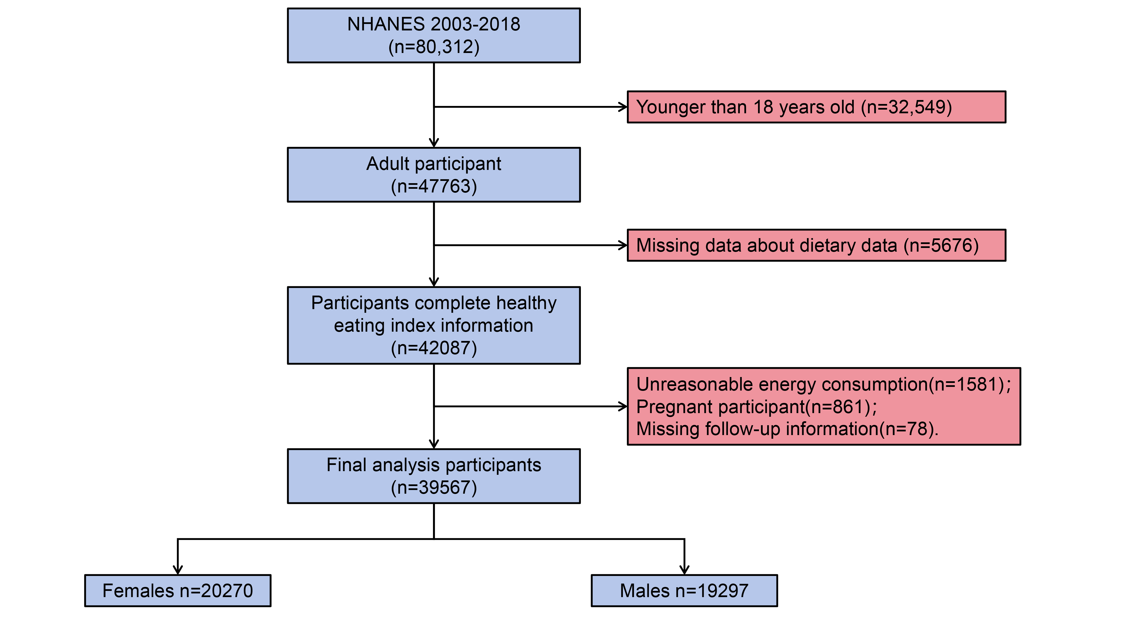
Figure S1. Flow Chart of Participants Recruitment.

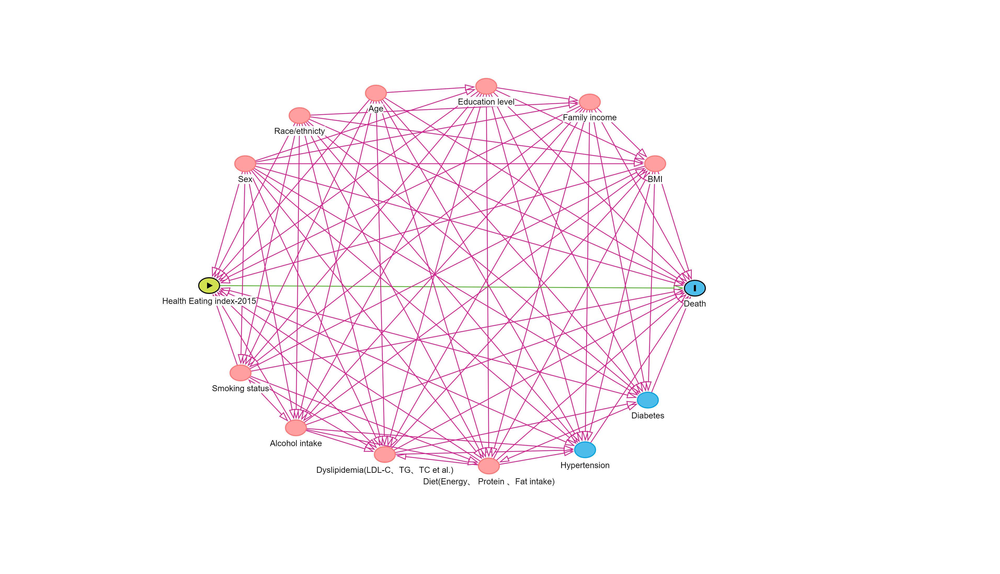
Figure S2. Directed Acyclic Graph. A directed acyclic graph represents the associations between covariates, main exposures, and outcomes. Variables in blue are the antecedents of the outcome variable; and those in red are antecedents of the outcome and exposure variables

Figure S3. Differences in HEI-2015 distribution between different genders. A, B: Distribution for males and females.

Figure S4. Variables balance between participants with HEI-2015≤40.4 and those with HEI-2015>57.1 before and after the propensity score matching. The absolute standardized mean difference of less than 0.1 was considered to indicate a negligible imbalance between the two groups(HEI-2015 ≤ 40.4 & HEI-2015 > 57.1).
Abbreviations: BMI, body mass index; TG, triglycerides; HDL-C, HDL cholesterol; triglycerides; TC, total cholesterol.

