Supplemental

Files
Figure S1. Flow diagram of study participant selection

Table S1. Exposures, outcomes and confounders’ definitions and descriptions
Covariate | Categorizations | UK Biobank Code | Descriptions
Social isolation | No (composite score < 2),  Yes (composite score ≥ 2) | 709, 1031, 6160 | Touchscreen questionnaire:  (i) “Including yourself, how many people are living together in your household?” (1 point if living alone);  (ii) “How often do you visit friends or family or have them visit you?” (1 point if friends/ family visits less than once a month);  (iii) “Which of the following [leisure/social activities] do you engage in once a week or more often?” (1 point if no activities selected).
Loneliness | No(composite score < 2),  Yes(composite score = 2) | 2020, 2110 | Touchscreen question:  (i) “Do you often feel lonely?”(1point if yes);  (ii) “How often are you able to confide in someone close to you?”(1 point if less than once every few months).
Age, years | Age at baseline | 34 | Year of birth of participant, which was used to calculate the participant's age at baseline.
Sex | Male, Female | 31 | NHS derived and/or touchscreen questionnaire.
Ethnicity | White, Mixed,  Asian or Asian British,  Black or Black British,  Chinese, Other ethnic group | 21000 | Touchscreen questionnaire“What is your ethnic group?”
Townsend deprivation index | Quartiles | 22189 | Townsend deprivation index calculated immediately prior to participant joining UK Biobank. Based on the preceding national census output areas. Each participant is assigned a score corresponding to the output area in which their postcode is located.  Townsend et al. defined the concept of deprivation as a “state of observable and demonstrable disadvantage relative to the local community or the wider society to which an indi- vidual, family or group belongs.” The Townsend deprivation index is a composite score based on 4 key variables: unemployment, overcrowded household, non-car ownership, and non-home ownership. This index has been validated and used in UK-based population studies, with higher scores representing higher levels of deprivation.
Education | With university or college degree,  Without / below university degree | 6138 | Touchscreen question “Which of the following qualifications do you have? (You can select more than one)”
BMI, kg/m² | Underweight<18.5,  Normal (18.5-25),  Overweight (25-30),  Obese≥30 | 21001 | BMI value here is constructed from height and weight measured during the initial Assessment Centre visit.
Month of assessment | January, February, March, April, May, June, July, August,  September, October, November,  December | 53 | Month when a participant attended a UK Biobank assessment centre.
Depression | No, Yes | 53, 130894, 130896 | Date of the first occurrence of any code mapped to 3-character ICD10 F32-33.
Alcohol intake frequency | Never, Special occasions only, One to three times a month,  Once or twice a week,  Three or four times a week,  Daily or almost daily | 1558 | Touchscreen question “About how often do you drink alcohol?”
Smoking status | Never, Current, Previous | 20116 | This field summarises the current/past smoking status of the participant.
Regular physical activity | No, Yes | 22038, 22039 | Touchscreen questionnaire:  (i) Metabolic Equivalent Task (MET) minutes per week for moderate activity (yes if ≥150 minutes);  (ii) Metabolic Equivalent Task (MET) minutes per week for vigorous activity (yes if ≥ 75minutes).
Sleep duration | hours of sleep <7, 7-8, >8 | 1160 | Touchscreen question “About how many hours sleep do you get in every 24 hours? (please include naps)”
Diet | Regular meat-eaters,  Low meat-eaters,  Fish-eaters,  Vegetarians | 1289, 1299, 1309, 1329, 1339, 1359, 1369, 1379 ,1389 | Regular meat-eaters were defined as a participant who consumed red or poultry ≥5 times a week. Low meat-eaters were defined as consumed red or poultry <5 times per week. Fish-eaters were defined as do not consume red or poultry but consumed fish. Vegetarians were defined as do not consume any meat or fish.
Salt added to food | Never/rarely, Sometimes, Usually, Always | 1478 | Touchscreen question “Do you add salt to your food? (Do not include salt used in cooking)”
Family history of stroke | No, Yes | 20107, 20110,  20111 | Touchscreen questionnaire:  (i) “Has/did your father ever suffer from? ”(yes if has);  (ii) “Has/did your mother ever suffer from? ”(yes if has);  (iii) “Have any of your brothers or sisters suffered from any of the following diseases? ”(yes if has).
Family history of heart disease | No, Yes | 20107, 20110,  20111 | Touchscreen questionnaire:  (i) “Has/did your father ever suffer from? ”(yes if has);  (ii) “Has/did your mother ever suffer from? ”(yes if has);  (iii) “Have any of your brothers or sisters suffered from any of the following diseases? ”(yes if has).
Diabetes | No, Yes | 53, 2443, 41270,  41280, 130706,  130708, 130710,  130712, 130714 | Diabetes was defined as ICD-10 code E10-E14 or diagnosed by doctor which participant select 'yes'.
Hypertension | No, Yes | 53, 41270, 41280,  131286, 131294 | Hypertension was defined as ICD-10 code I10 and I15.
Use of insulin | No, Yes | 6153, 6177 | Touchscreen question “Do you regularly take any of the following medications?”
Use of blood pressure medication | No, Yes | 6153, 6177 | Touchscreen question “Do you regularly take any of the following medications?”
Use of cholesterol lowering medication | No, Yes | 6153, 6177 | Touchscreen question “Do you regularly take any of the following medications?”

Figure S2. Forest plot of confounders associated with CVD
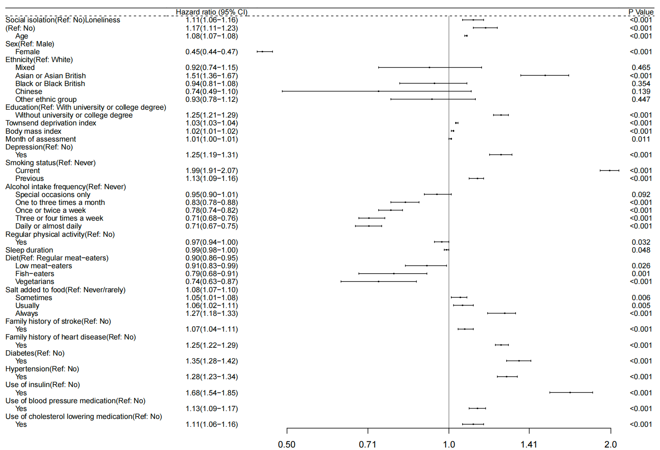

Figure S3. Forest plot of confounders associated with stroke
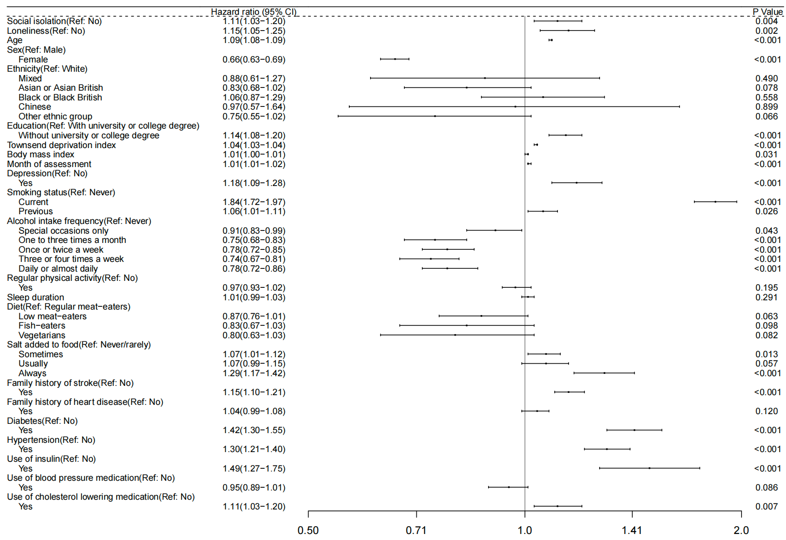
Figure S4. Forest plot of confounders associated with myocardial infarction
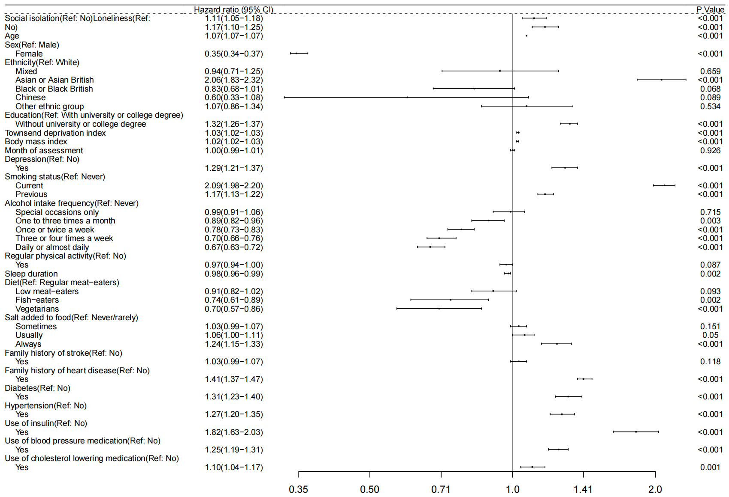

Table S2. Association of social isolation and loneliness with incident cardiovascular disease only including participants with cardiovascular disease diagnosed at least two years after baseline
 | Hazard ratio (95% CI)
 | Non-adjusted model | Model 1 | Model 2 | Model 3 | Model 4
Social isolation
CVD | 1.30(1.24-1.36) | 1.21(1.15-1.26) | 1.17(1.11-1.22) | 1.12(1.07-1.17) | 1.12(1.07-1.17)
Stroke | 1.27(1.18-1.37) | 1.19(1.11-1.29) | 1.16(1.08-1.26) | 1.14(1.05-1.23) | 1.13(1.05-1.22)
Myocardial infarction | 1.32(1.25-1.40) | 1.22(1.15-1.29) | 1.17(1.10-1.24) | 1.11(1.05-1.17) | 1.11(1.05-1.18)
Loneliness
CVD | 1.31(1.25-1.38) | 1.29(1.22-1.36) | 1.23(1.16-1.29) | 1.20(1.14-1.27) | 1.17(1.11-1.24)
Stroke | 1.23(1.13-1.35) | 1.25(1.14-1.36) | 1.20(1.09-1.31) | 1.19(1.08-1.30) | 1.17(1.07-1.28)
Myocardial infarction | 1.36(1.28-1.45) | 1.31(1.23-1.40) | 1.24(1.16-1.33) | 1.21(1.13-1.29) | 1.18(1.10-1.26)
Model 1 was adjusted for age, sex, ethnicity, education, Townsend deprivation index, BMI and month of assessment. Model 2 was adjusted for model 1 criteria plus depression, loneliness or social isolation. Model 3 was adjusted for model 2 criteria plus smoking status, frequency of alcohol consumption, physical activity, sleep duration, diet and salt. Model 4 was adjusted for model 3 criteria plus family history of stroke, family history of heart disease, diabetes, hypertension, use of diabetes medication, use of hypertension medication and use of hyperlipidemia medication.

Table S3. Association of social isolation and loneliness with incident cardiovascular disease only including participants with cardiovascular disease diagnosed at least five years after baseline
 | Hazard ratio (95% CI)
 | Non-adjusted model | Model 1 | Model 2 | Model 3 | Model 4
Social isolation
CVD | 1.28(1.22-1.34) | 1.19(1.13-1.25) | 1.17(1.12-1.23) | 1.12(1.07-1.18) | 1.12(1.06-1.17)
Stroke | 1.22(1.12-1.33) | 1.15(1.06-1.26) | 1.15(1.05-1.25) | 1.12(1.03-1.22) | 1.11(1.02-1.21)
Myocardial infarction | 1.30(1.23-1.38) | 1.20(1.14-1.28) | 1.19(1.12-1.26) | 1.12(1.06-1.19) | 1.12(1.06-1.19)
Loneliness
CVD | 1.31(1.24-1.39) | 1.29(1.22-1.36) | 1.23(1.16-1.30) | 1.20(1.14-1.27) | 1.18(1.11-1.25)
Stroke | 1.25(1.13-1.38) | 1.27(1.15-1.40) | 1.23(1.11-1.36) | 1.22(1.10-1.35) | 1.20(1.08-1.33)
Myocardial infarction | 1.35(1.26-1.44) | 1.30(1.22-1.39) | 1.23(1.15-1.32) | 1.20(1.12-1.28) | 1.17(1.09-1.25)
Model 1 was adjusted for age, sex, ethnicity, education, Townsend deprivation index, BMI and month of assessment. Model 2 was adjusted for model 1 criteria plus depression, loneliness or social isolation. Model 3 was adjusted for model 2 criteria plus smoking status, frequency of alcohol consumption, physical activity, sleep duration, diet and salt. Model 4 was adjusted for model 3 criteria plus family history of stroke, family history of heart disease, diabetes, hypertension, use of diabetes medication, use of hypertension medication and use of hyperlipidemia medication.

Table S4. Association of social isolation and loneliness with incident cardiovascular disease using competing risk analysis considering death as a competing event
 | Hazard ratio (95% CI)
 | Non-adjusted model | Model 1 | Model 2 | Model 3 | Model 4
Social isolation
CVD | 1.26(1.21-1.32) | 1.16(1.11-1.21) | 1.12(1.07-1.17) | 1.08(1.03-1.13) | 1.07(1.02-1.12)
Stroke | 1.24(1.16-1.33) | 1.15(1.07-1.24) | 1.13(1.05-1.21) | 1.10(1.02-1.19) | 1.09(1.01-1.17)
Myocardial infarction | 1.27(1.20-1.35) | 1.16(1.10-1.23) | 1.12(1.06-1.19) | 1.06(1.00-1.12) | 1.06(1.00-1.13)
Loneliness
CVD | 1.29(1.23-1.36) | 1.26(1.20-1.33) | 1.21(1.14-1.27) | 1.18(1.12-1.25) | 1.16(1.10-1.22)
Stroke | 1.21(1.12-1.32) | 1.22(1.12-1.33) | 1.17(1.08-1.28) | 1.16(1.07-1.27) | 1.14(1.05-1.25)
Myocardial infarction | 1.34(1.25-1.43) | 1.29(1.21-1.37) | 1.23(1.15-1.31) | 1.19(1.11-1.27) | 1.16(1.09-1.24)
Model 1 was adjusted for age, sex, ethnicity, education, Townsend deprivation index, BMI and month of assessment. Model 2 was adjusted for model 1 criteria plus depression, loneliness or social isolation. Model 3 was adjusted for model 2 criteria plus smoking status, frequency of alcohol consumption, physical activity, sleep duration, diet and salt. Model 4 was adjusted for model 3 criteria plus family history of stroke, family history of heart disease, diabetes, hypertension, use of diabetes medication, use of hypertension medication and use of hyperlipidemia medication.

Table S5. Association of social isolation and loneliness with incident cardiovascular disease in all participants, females and males
 | Hazard ratio (95% CI)
 | Stroke | Myocardial infarction | CVD
Social isolation
People without social isolation | 1.00 | 1.00 | 1.00
People with social isolation | 1.13(1.05-1.21) | 1.13(1.07-1.20) | 1.13(1.08-1.18)
Male | 1.05(0.95-1.16) | 1.10(1.03-1.18) | 1.09(1.02-1.15)
Female | 1.22(1.10-1.35) | 1.18(1.07-1.30) | 1.19(1.11-1.28)
Loneliness
People without loneliness | 1.00 | 1.00 | 1.00
People with loneliness | 1.15(1.05-1.25) | 1.17(1.10-1.25) | 1.17(1.11-1.23)
Male | 1.14(1.01-1.29) | 1.16(1.07-1.26) | 1.16(1.08-1.24)
Female | 1.16(1.02-1.31) | 1.20(1.07-1.34) | 1.18(1.09-1.29)
All HRs were adjusted for age, sex, ethnicity, education, Townsend deprivation index, BMI, month of assessment, depression, smoking status, frequency of alcohol consumption, physical activity, sleep duration, diet, salt, family history of stroke, family history of heart disease, diabetes, hypertension, use of diabetes medication, use of hypertension medication and use of hyperlipidemia medication.

Table S6. Association of social isolation and loneliness with incident cardiovascular disease in all participants and different age
 | Hazard ratio (95% CI)
 | Stroke | Myocardial infarction | CVD
Social isolation
People without social isolation | 1.00 | 1.00 | 1.00
People with social isolation | 1.13(1.05-1.21) | 1.13(1.07-1.20) | 1.13(1.08-1.18)
≥ 38 to < 50 | 1.13(0.87-1.47) | 0.95(0.79-1.16) | 1.01(0.86-1.18)
≥ 50 to < 60 | 1.04(0.89-1.21) | 1.09(0.98-1.21) | 1.07(0.98-1.17)
≥ 60 to < 70 | 1.16(1.06-1.28) | 1.13(1.05-1.22) | 1.14(1.08-1.21)
≥ 70 to ≤ 73 | 0.89(0.62-1.26) | 1.39(1.05-1.84) | 1.16(0.93-1.45)
Loneliness
People without loneliness | 1.00 | 1.00 | 1.00
People with loneliness | 1.15(1.05-1.25) | 1.17(1.10-1.25) | 1.17(1.11-1.23)
≥ 38 to < 50 | 0.99(0.73-1.33) | 1.31(1.10-1.58) | 1.21(1.04-1.41)
≥ 50 to < 60 | 1.08(0.91-1.29) | 1.06(0.94-1.20) | 1.06(0.96-1.18)
≥ 60 to < 70 | 1.15(1.03-1.29) | 1.18(1.08-1.29) | 1.17(1.09-1.26)
≥ 70 to ≤ 73 | 1.80(1.25-2.59) | 1.26(0.86-1.86) | 1.50(1.15-1.95)
All HRs were adjusted for age, sex, ethnicity, education, Townsend deprivation index, BMI, month of assessment, depression, smoking status, frequency of alcohol consumption, physical activity, sleep duration, diet, salt, family history of stroke, family history of heart disease, diabetes, hypertension, use of diabetes medication, use of hypertension medication and use of hyperlipidemia medication.

Table S7. Association of social isolation and loneliness with incident cardiovascular disease in all participants and different education
 | Hazard ratio (95% CI)
 | Stroke | Myocardial infarction | CVD
Social isolation
People without social isolation | 1.00 | 1.00 | 1.00
People with social isolation | 1.13(1.05-1.21) | 1.13(1.07-1.20) | 1.13(1.08-1.18)
With university or college degree | 1.07(0.92-1.25) | 0.94(0.83-1.07) | 0.99(0.90-1.10)
Without / below university degree | 1.13(1.04-1.22) | 1.16(1.09-1.24) | 1.15(1.09-1.21)
Loneliness
People without loneliness | 1.00 | 1.00 | 1.00
People with loneliness | 1.15(1.05-1.25) | 1.17(1.10-1.25) | 1.17(1.11-1.23)
With university or college degree | 1.13(0.93-1.37) | 1.12(0.96-1.31) | 1.13(1.00-1.27)
Without / below university degree | 1.15(1.04-1.27) | 1.18(1.09-1.27) | 1.17(1.10-1.24)
All HRs were adjusted for age, sex, ethnicity, education, Townsend deprivation index, BMI, month of assessment, depression, smoking status, frequency of alcohol consumption, physical activity, sleep duration, diet, salt, family history of stroke, family history of heart disease, diabetes, hypertension, use of diabetes medication, use of hypertension medication and use of hyperlipidemia medication.

Table S8. Association of social isolation and loneliness with incident cardiovascular disease in all participants and different Townsend deprivation index
 | Hazard ratio (95% CI)
 | Stroke | Myocardial infarction | CVD
Social isolation
People without social isolation | 1.00 | 1.00 | 1.00
People with social isolation | 1.13(1.05-1.21) | 1.13(1.07-1.20) | 1.13(1.08-1.18)
Q1 | 1.07(0.87-1.31) | 0.98(0.84-1.15) | 1.01(0.89-1.15)
Q2 | 1.05(0.88-1.25) | 1.24(1.08-1.42) | 1.16(1.05-1.30)
Q3 | 1.12(0.96-1.30) | 1.17(1.04-1.32) | 1.15(1.05-1.26)
Q4 | 1.17(1.05-1.31) | 1.07(0.98-1.17) | 1.11(1.03-1.18)
Loneliness
People without loneliness | 1.00 | 1.00 | 1.00
People with loneliness | 1.15(1.05-1.25) | 1.17(1.10-1.25) | 1.17(1.11-1.23)
Q1 | 1.31(1.07-1.61) | 1.18(1.00-1.39) | 1.23(1.09-1.40)
Q2 | 0.97(0.79-1.19) | 1.14(0.98-1.33) | 1.08(0.95-1.22)
Q3 | 1.20(1.00-1.43) | 1.13(0.98-1.29) | 1.15(1.03-1.28)
Q4 | 1.15(1.00-1.32) | 1.20(1.09-1.33) | 1.18(1.09-1.29)
All HRs were adjusted for age, sex, ethnicity, education, Townsend deprivation index, BMI, month of assessment, depression, smoking status, frequency of alcohol consumption, physical activity, sleep duration, diet, salt, family history of stroke, family history of heart disease, diabetes, hypertension, use of diabetes medication, use of hypertension medication and use of hyperlipidemia medication.

Table S9. Association of social isolation and loneliness with incident cardiovascular disease in all participants and different depression status
 | Hazard ratio (95% CI)
 | Stroke | Myocardial infarction | CVD
Social isolation
People without social isolation | 1.00 | 1.00 | 1.00
People with social isolation | 1.13(1.05-1.21) | 1.13(1.07-1.20) | 1.13(1.08-1.18)
With depression | 1.28(1.05-1.56) | 1.13(0.97-1.33) | 1.19(1.05-1.34)
Without depression | 1.09(1.00-1.18) | 1.11(1.04-1.18) | 1.12(1.06-1.17)
Loneliness
People without loneliness | 1.00 | 1.00 | 1.00
People with loneliness | 1.15(1.05-1.25) | 1.17(1.10-1.25) | 1.17(1.11-1.23)
With depression | 1.01(0.82-1.25) | 1.05(0.90-1.23) | 1.04(0.92-1.18)
Without depression | 1.18(1.07-1.30) | 1.20(1.12-1.29) | 1.19(1.13-1.26)
All HRs were adjusted for age, sex, ethnicity, education, Townsend deprivation index, BMI, month of assessment, depression, smoking status, frequency of alcohol consumption, physical activity, sleep duration, diet, salt, family history of stroke, family history of heart disease, diabetes, hypertension, use of diabetes medication, use of hypertension medication and use of hyperlipidemia medication.

Table S10. Association of social isolation and loneliness with incident cardiovascular disease in all participants and different alcohol consumption
 | Hazard ratio (95% CI)
 | Stroke | Myocardial infarction | CVD
Social isolation
People without social isolation | 1.00 | 1.00 | 1.00
People with social isolation | 1.13(1.05-1.21) | 1.13(1.07-1.20) | 1.13(1.08-1.18)
Never / Special occasions only | 1.08(0.95-1.23) | 1.10(1.00-1.22) | 1.09(1.01-1.18)
One to three times a month / Once or twice a week | 1.21(1.07-1.38) | 1.19(1.09-1.32) | 1.20(1.11-1.30)
Three or four times a week / Daily or almost daily | 1.08(0.95-1.23) | 1.10(0.99-1.22) | 1.09(1.00-1.18)
Loneliness
People without loneliness | 1.00 | 1.00 | 1.00
People with loneliness | 1.15(1.05-1.25) | 1.17(1.10-1.25) | 1.17(1.11-1.23)
Never / Special occasions only | 1.08(0.92-1.27) | 1.20(1.07-1.35) | 1.16(1.05-1.27)
One to three times a month / Once or twice a week | 1.16(1.00-1.34) | 1.15(1.03-1.28) | 1.15(1.05-1.26)
Three or four times a week / Daily or almost daily | 1.19(1.03-1.38) | 1.17(1.04-1.31) | 1.18(1.08-1.29)
All HRs were adjusted for age, sex, ethnicity, education, Townsend deprivation index, BMI, month of assessment, depression, smoking status, frequency of alcohol consumption, physical activity, sleep duration, diet, salt, family history of stroke, family history of heart disease, diabetes, hypertension, use of diabetes medication, use of hypertension medication and use of hyperlipidemia medication.

Table S11. Association of social isolation and loneliness with incident cardiovascular disease in all participants and different smoking status
 | Hazard ratio (95% CI)
 | Stroke | Myocardial infarction | CVD
Social isolation
People without social isolation | 1.00 | 1.00 | 1.00
People with social isolation | 1.13(1.05-1.21) | 1.13(1.07-1.20) | 1.13(1.08-1.18)
Never | 1.01(0.90-1.14) | 0.99(0.90-1.09) | 1.00(0.93-1.07)
Current | 1.09(0.94-1.27) | 1.19(1.07-1.33) | 1.16(1.06-1.27)
Previous | 1.12(0.99-1.27) | 1.04(0.94-1.15) | 1.07(0.99-1.16)
Loneliness
People without loneliness | 1.00 | 1.00 | 1.00
People with loneliness | 1.15(1.05-1.25) | 1.17(1.10-1.25) | 1.17(1.11-1.23)
Never | 1.08(0.94-1.24) | 1.12(1.01-1.25) | 1.11(1.02-1.21)
Current | 1.04(0.86-1.26) | 1.20(1.05-1.36) | 1.15(1.03-1.28)
Previous | 1.22(1.06-1.41) | 1.11(1.00-1.24) | 1.15(1.06-1.26)
All HRs were adjusted for age, sex, ethnicity, education, Townsend deprivation index, BMI, month of assessment, depression, smoking status, frequency of alcohol consumption, physical activity, sleep duration, diet, salt, family history of stroke, family history of heart disease, diabetes, hypertension, use of diabetes medication, use of hypertension medication and use of hyperlipidemia medication.

Table S12. Association of social isolation and loneliness with incident cardiovascular disease in all participants and regular physical activity
 | Hazard ratio (95% CI)
 | Stroke | Myocardial infarction | CVD
Social isolation
People without social isolation | 1.00 | 1.00 | 1.00
People with social isolation | 1.13(1.05-1.21) | 1.13(1.07-1.20) | 1.13(1.08-1.18)
Yes | 1.09(0.98-1.21) | 1.17(1.08-1.27) | 1.13(1.06-1.21)
No | 1.14(1.02-1.26) | 1.06(0.97-1.15) | 1.09(1.02-1.16)
Loneliness
People without loneliness | 1.00 | 1.00 | 1.00
People with loneliness | 1.15(1.05-1.25) | 1.17(1.10-1.25) | 1.17(1.11-1.23)
Yes | 1.13(1.00-1.27) | 1.14(1.04-1.25) | 1.14(1.06-1.22)
No | 1.17(1.03-1.33) | 1.21(1.10-1.33) | 1.20(1.11-1.29)
All HRs were adjusted for age, sex, ethnicity, education, Townsend deprivation index, BMI, month of assessment, depression, smoking status, frequency of alcohol consumption, physical activity, sleep duration, diet, salt, family history of stroke, family history of heart disease, diabetes, hypertension, use of diabetes medication, use of hypertension medication and use of hyperlipidemia medication.

Table S13. Association of social isolation and loneliness with incident cardiovascular disease in all participants and sleep duration
 | Hazard ratio (95% CI)
 | Stroke | Myocardial infarction | CVD
Social isolation
People without social isolation | 1.00 | 1.00 | 1.00
People with social isolation | 1.13(1.05-1.21) | 1.13(1.07-1.20) | 1.13(1.08-1.18)
< 7 hours | 1.14(1.00-1.29) | 1.12(1.01-1.23) | 1.12(1.04-1.21)
7 - 8 hours | 1.08(0.98-1.19) | 1.09(1.01-1.18) | 1.08(1.02-1.15)
> 8 hours | 1.17(0.94-1.46) | 1.16(0.97-1.38) | 1.17(1.02-1.32)
Loneliness
People without loneliness | 1.00 | 1.00 | 1.00
People with loneliness | 1.15(1.05-1.25) | 1.17(1.10-1.25) | 1.17(1.11-1.23)
< 7 hours | 1.24(1.08-1.43) | 1.18(1.06-1.31) | 1.20(1.10-1.31)
7 - 8 hours | 1.09(0.96-1.23) | 1.14(1.04-1.25) | 1.12(1.04-1.21)
> 8 hours | 1.05(0.80-1.39) | 1.17(0.95-1.43) | 1.12(0.95-1.32)
All HRs were adjusted for age, sex, ethnicity, education, Townsend deprivation index, BMI, month of assessment, depression, smoking status, frequency of alcohol consumption, physical activity, sleep duration, diet, salt, family history of stroke, family history of heart disease, diabetes, hypertension, use of diabetes medication, use of hypertension medication and use of hyperlipidemia medication.

Figure S5. The association between social isolation, loneliness and cardiovascular disease by depression status

Figure S6. The association between social isolation, loneliness and cardiovascular disease by smoking status

Figure S7. The association between social isolation, loneliness and cardiovascular disease by diabetes status

Figure S8. The association between social isolation, loneliness and cardiovascular disease by hypertension status

Table S14. Interaction analyses between social isolation/loneliness and risk factors regarding the risk of incident CVD
Interaction term | Multiplicative interaction
 | HR (95% CI) | P value
Interaction analyses between social isolation and depression
(Without social isolation and depression as reference term)
Social isolation & Depression | 1.11(0.98-1.26) | 0.11
Interaction analyses between social isolation and smoking status
(Without social isolation and never smoking as reference term)
Social isolation & Current smoking | 1.23(1.10-1.38) | <0.01
Social isolation & Previous smoking | 1.08(0.97-1.19) | 0.17
Interaction analyses between social isolation and diabetes
(Without social isolation and diabetes as reference term)
Social isolation & Diabetes | 1.05(0.92-1.19) | 0.48
Interaction analyses between social isolation and hypertension
(Without social isolation and hypertension as reference term)
Social isolation & Hypertension | 0.94(0.86-1.02) | 0.14
Interaction analyses between loneliness and depression
(Without loneliness and depression as reference term)
Loneliness & Depression | 0.91(0.79-1.04) | 0.16
Interaction analyses between loneliness and smoking status
(Without loneliness and never smoking as reference term)
Loneliness & Current smoking | 1.10(0.96-1.25) | 0.17
Loneliness & Previous smoking | 1.02(0.91-1.15) | 0.71
Interaction analyses between loneliness and diabetes
(Without loneliness and diabetes as reference term)
Loneliness & Diabetes | 1.08(0.94-1.24) | 0.29
Interaction analyses between loneliness and hypertension
(Without loneliness and hypertension as reference term)
Loneliness & Hypertension | 1.07(0.96-1.18) | 0.23

Table S15. Interaction analyses between social isolation/loneliness and risk factors regarding the risk of incident stroke
Interaction term | Multiplicative interaction
 | HR (95% CI) | P value
Interaction analyses between social isolation and depression
(Without social isolation and depression as reference term)
Social isolation & Depression | 1.11(0.98-1.26) | 0.11
Interaction analyses between social isolation and smoking status
(Without social isolation and never smoking as reference term)
Social isolation & Current smoking | 1.12(0.93-1.35) | 0.23
Social isolation & Previous smoking | 1.12(0.95-1.32) | 0.18
Interaction analyses between social isolation and diabetes
(Without social isolation and diabetes as reference term)
Social isolation & Diabetes | 1.10(0.90-1.35) | 0.36
Interaction analyses between social isolation and hypertension
(Without social isolation and hypertension as reference term)
Social isolation & Hypertension | 0.90(0.78-1.04) | 0.16
Interaction analyses between loneliness and depression
(Without loneliness and depression as reference term)
Loneliness & Depression | 0.90(0.72-1.13) | 0.38
Interaction analyses between loneliness and smoking status
(Without loneliness and never smoking as reference term)
Loneliness & Current smoking | 0.99(0.79-1.25) | 0.95
Loneliness & Previous smoking | 1.12(0.93-1.36) | 0.24
Interaction analyses between loneliness and diabetes
(Without loneliness and diabetes as reference term)
Loneliness & Diabetes | 1.18(0.93-1.49) | 0.17
Interaction analyses between loneliness and hypertension
(Without loneliness and hypertension as reference term)
Loneliness & Hypertension | 1.15(0.97-1.36) | 0.11

Table S16. Interaction analyses between social isolation/loneliness and risk factors regarding the risk of incident myocardial infarction
Interaction term | Multiplicative interaction
 | HR (95% CI) | P value
Interaction analyses between social isolation and depression
(Without social isolation and depression as reference term)
Social isolation & Depression | 1.11(0.98-1.26) | 0.11
Interaction analyses between social isolation and smoking status
(Without social isolation and never smoking as reference term)
Social isolation & Current smoking | 1.30(1.13-1.50) | <0.01
Social isolation & Previous smoking | 1.05(0.92-1.20) | 0.49
Interaction analyses between social isolation and diabetes
(Without social isolation and diabetes as reference term)
Social isolation & Diabetes | 1.02(0.87-1.20) | 0.78
Interaction analyses between social isolation and hypertension
(Without social isolation and hypertension as reference term)
Social isolation & Hypertension | 0.95(0.85-1.06) | 0.35
Interaction analyses between loneliness and depression
(Without loneliness and depression as reference term)
Loneliness & Depression | 0.90(0.76-1.07) | 0.23
Interaction analyses between loneliness and smoking status
(Without loneliness and never smoking as reference term)
Loneliness & Current smoking | 1.15(0.97-1.35) | 0.10
Loneliness & Previous smoking | 0.97(0.83-1.13) | 0.70
Interaction analyses between loneliness and diabetes
(Without loneliness and diabetes as reference term)
Loneliness & Diabetes | 1.03(0.86-1.22) | 0.77
Interaction analyses between loneliness and hypertension
(Without loneliness and hypertension as reference term)
Loneliness & Hypertension | 1.01(0.89-1.15) | 0.85

Figure S9. Log cumulative hazard plot for CVD according to social isolation
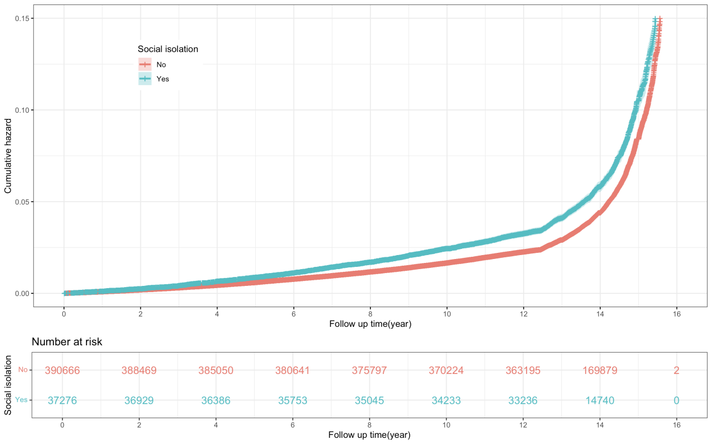
Figure S10. Log cumulative hazard plot for CVD according to loneliness
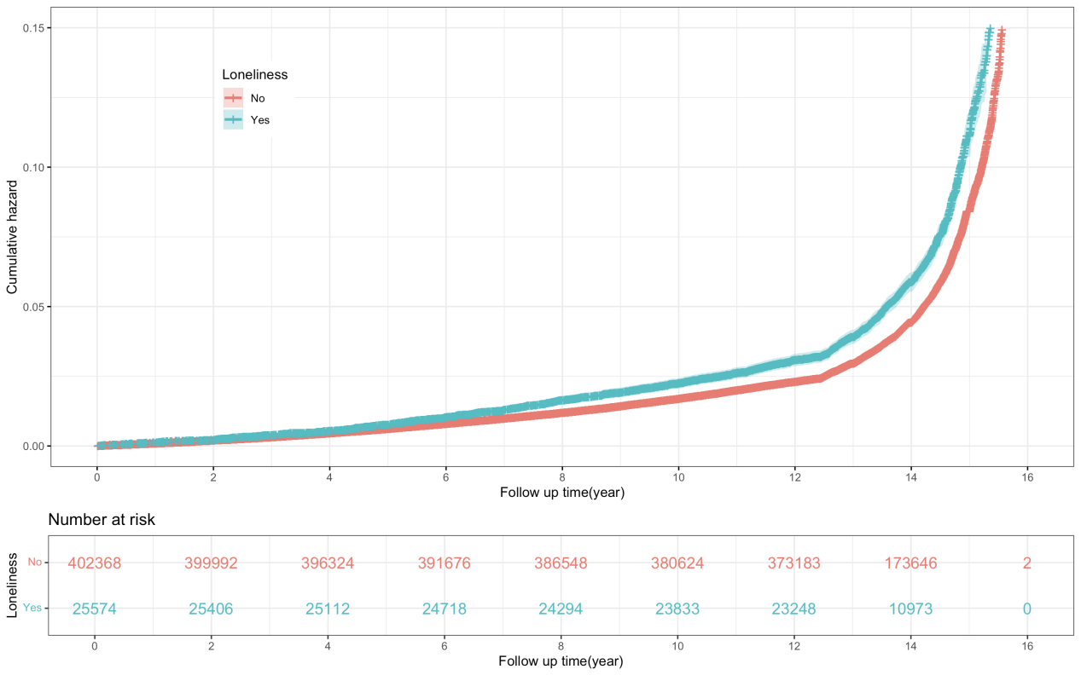

Figure S11. Log cumulative hazard plot for stroke according to social isolation
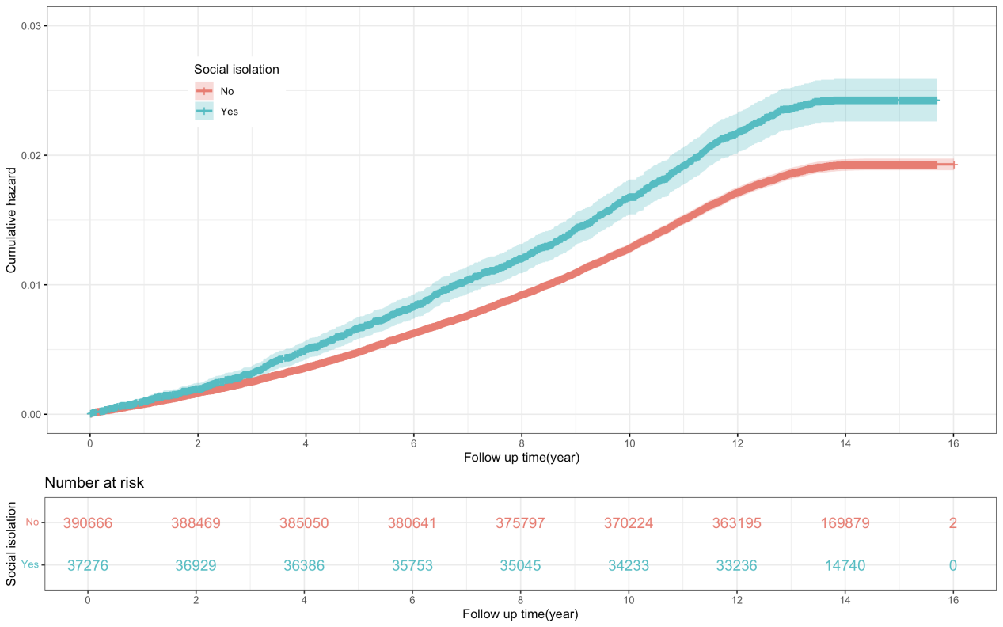
Figure S12. Log cumulative hazard plot for stroke according to loneliness
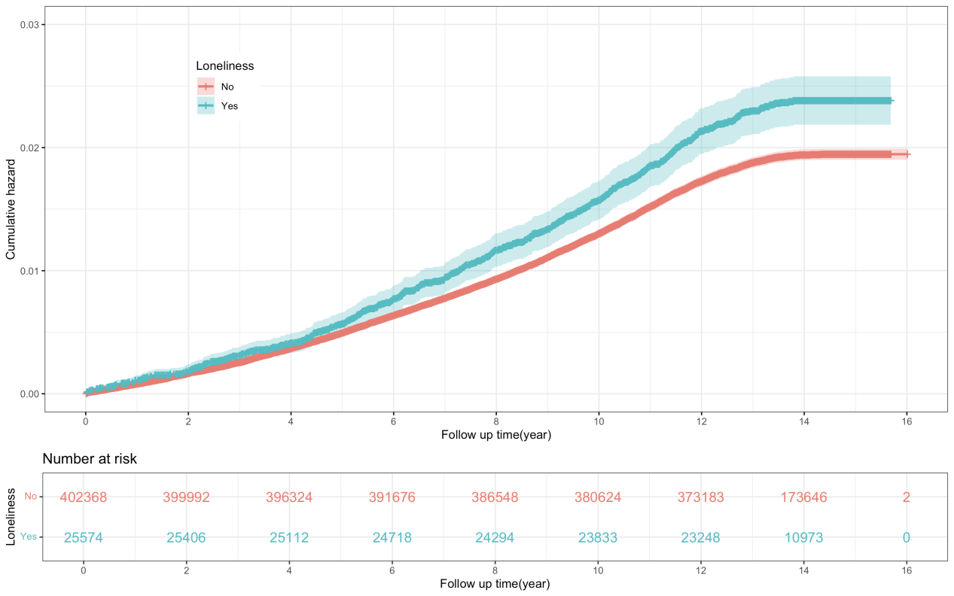

Figure S13. Log cumulative hazard plot for myocardial infarction according to social isolation
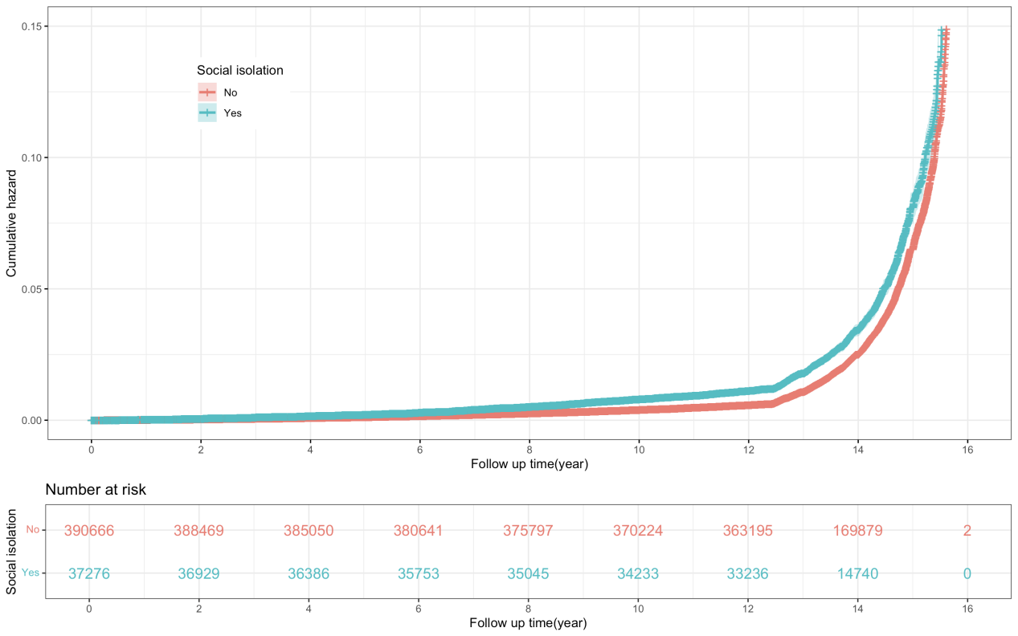
Figure S14. Log cumulative hazard plot for myocardial infarction according to loneliness
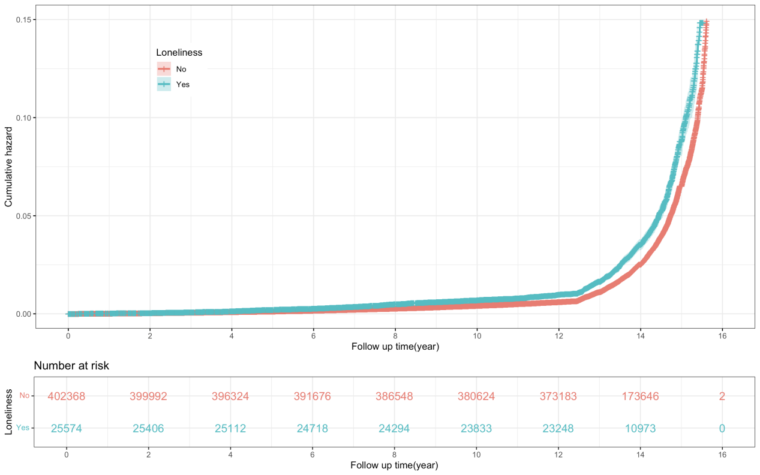

Figure S15. Kaplan-Meier curves for CVD risk stratified by social isolation status
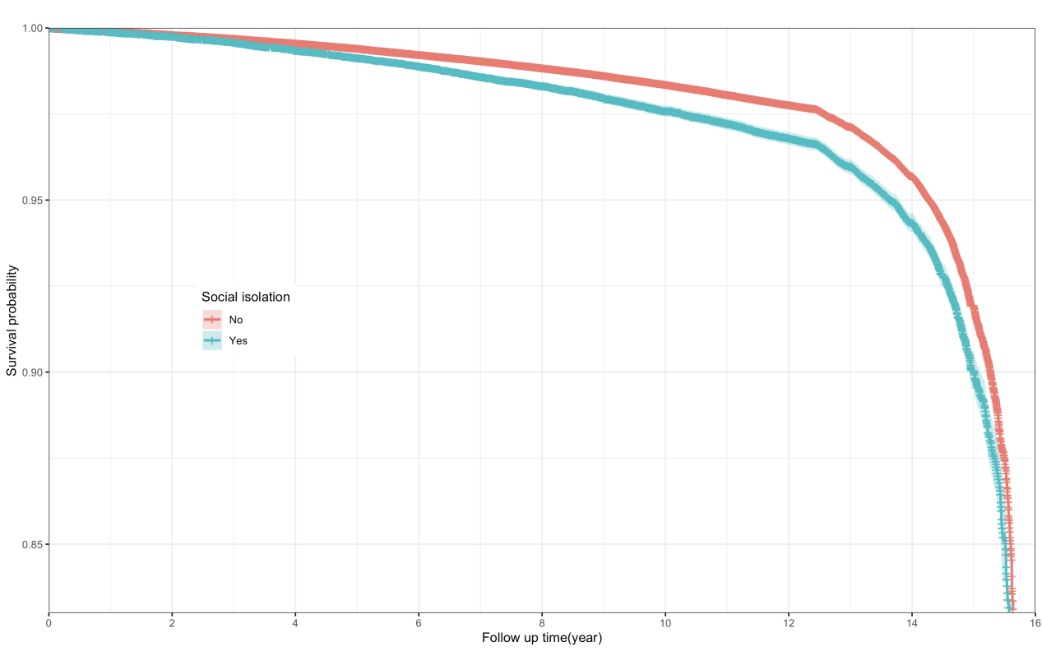

Figure S16. Kaplan-Meier curves for CVD risk stratified by loneliness status
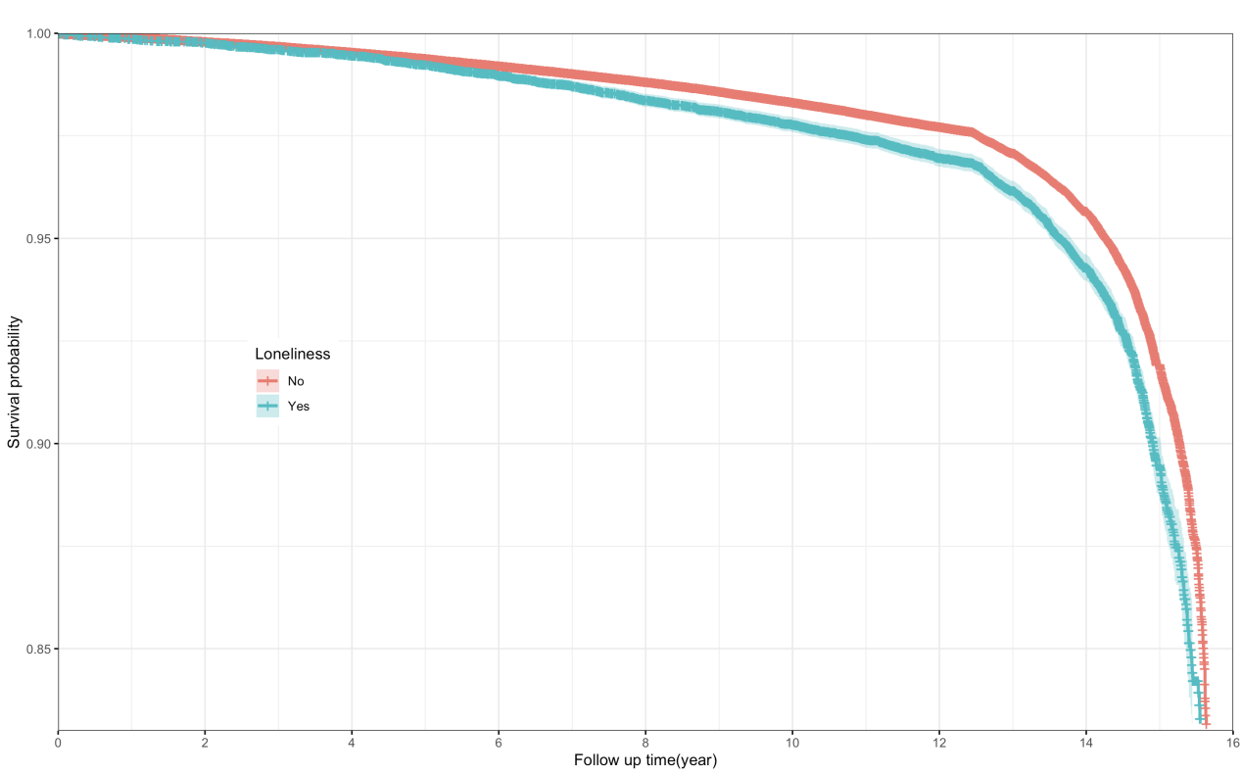

Figure S17. Kaplan-Meier curves for stroke risk stratified by social isolation status
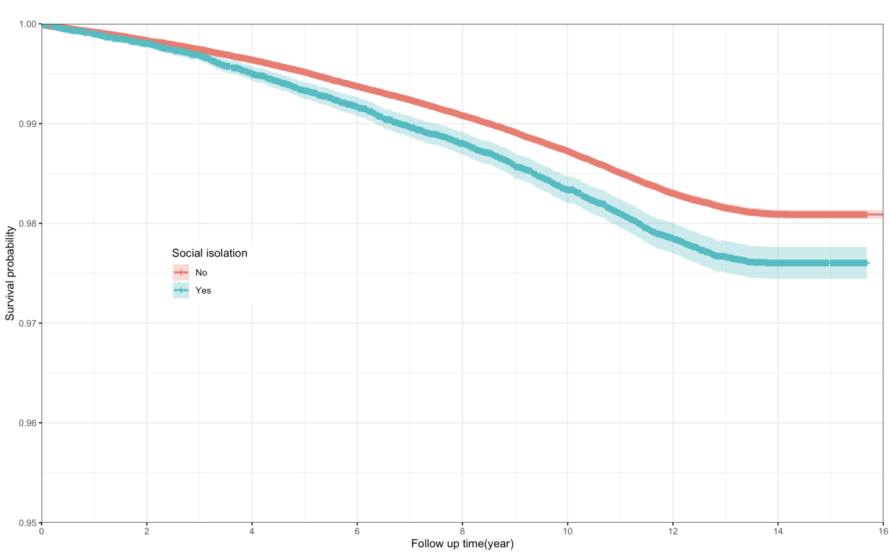

Figure S18. Kaplan-Meier curves for stroke risk stratified by loneliness status
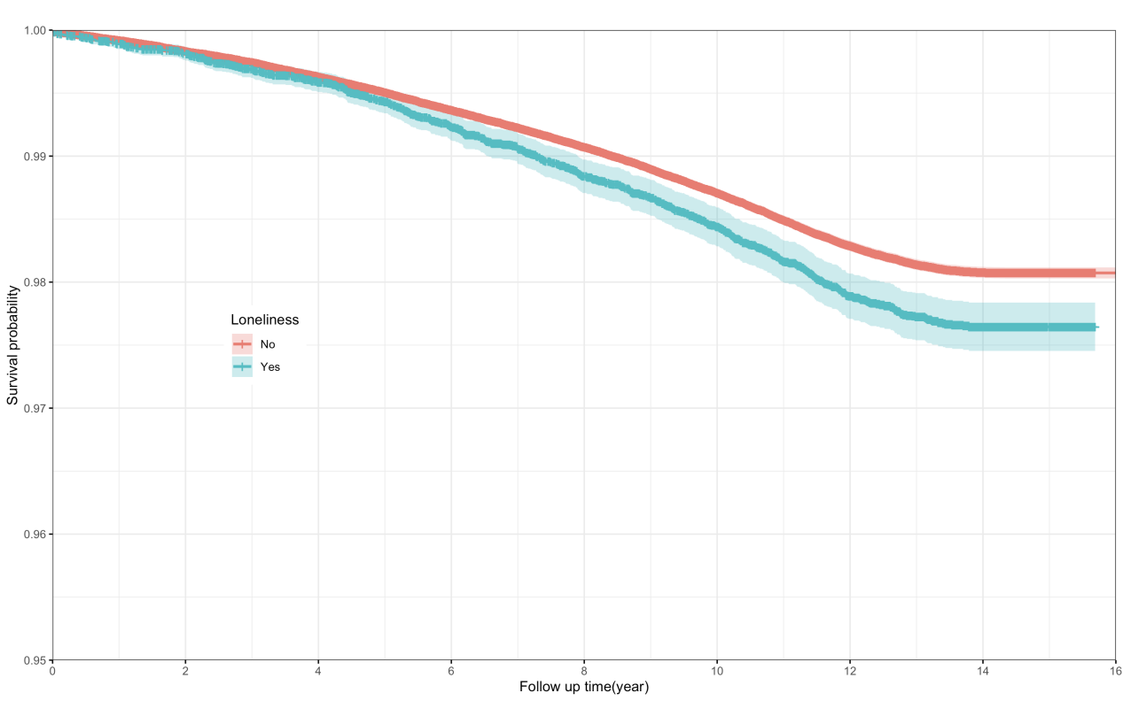

Figure S19. Kaplan-Meier curves for myocardial infarction risk stratified by social isolation status
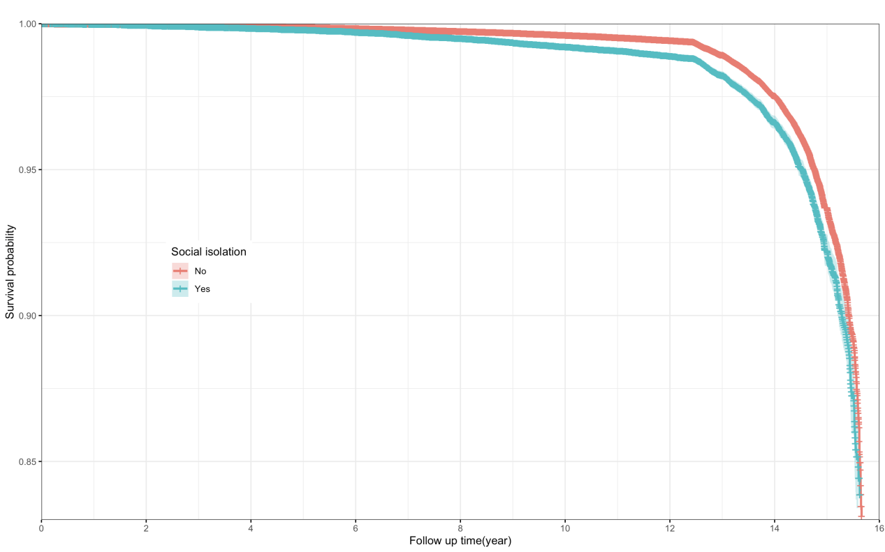

Figure S20. Kaplan-Meier curves for myocardial infarction risk stratified by loneliness status
