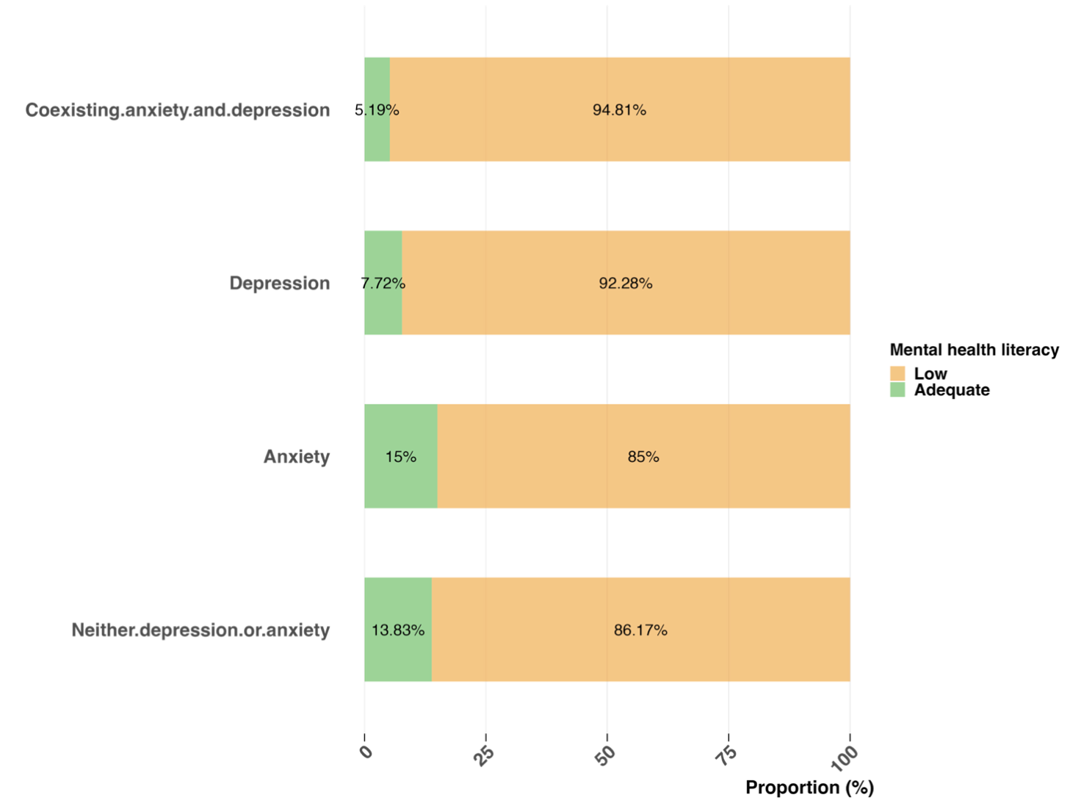
Supplemental figure 1. Proportions of low mental health literacy across different type of psychological distress categories among young adults
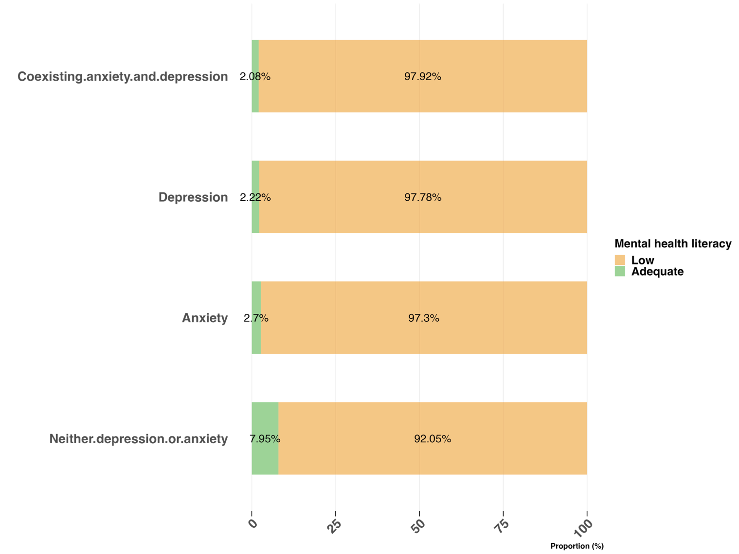
Supplemental figure 2. Proportions of low mental health literacy across different type of psychological distress categories among middle-aged adults
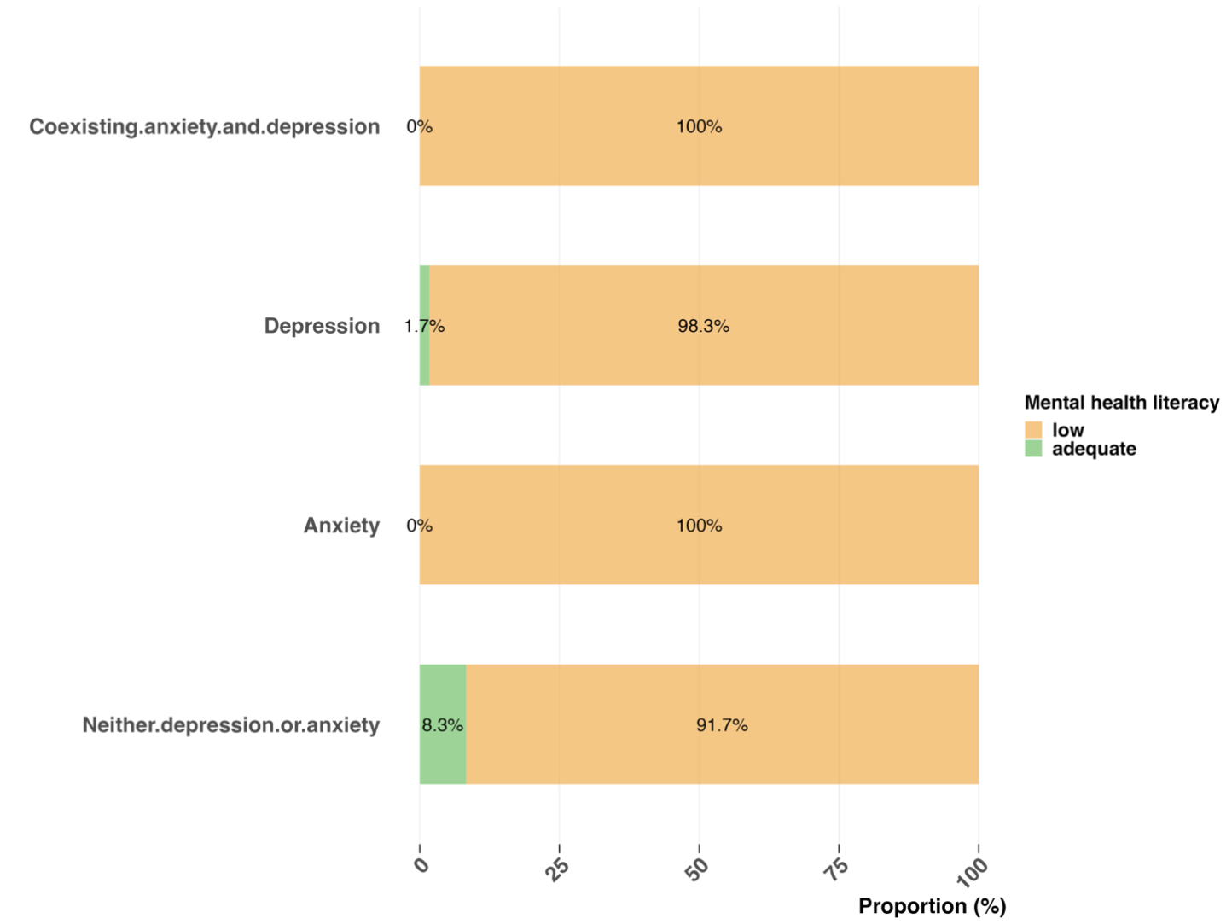
Supplemental figure 3. Proportions of low mental health literacy across different type of psychological distress categories among older adults

Supplemental table 1. Measurements for Variables
Variables | Description
Current smoking | Do you have a smoking habit? (At least one cigarette per day for six months or more)
Current alcohol use | Do you often drink alcoholic beverages? (At least once a week)
History of chronic diseases | Have you been clinically diagnosed with any of the following chronic diseases in the past year? (e.g., hypertension, diabetes, etc.)
Previous help-seeking behaviour | Did you seek help for mental or psychological issues in the past?
Napping frequency | How many times per week do you take a nap on average?
Sleep duration | How many hours do you actually sleep each night?

Supplemental Table 2. Comparison of characteristics between participants with low and adequate mental health literacy among adults with different age groups

 | Subgroup of young adults |  |  |  | Subgroup of middle-aged adults |  |  |  | Subgroup of older adults
Variables, % | Low MHL  (N=6414) | Adequate MHL  (N=997) | N  (N=7411) | P | Low MHL  (N=4932) | Adequate MHL  (N=415) | N  (N=5347) | P | Low MHL  (N=3638) | Adequate MHL  (N=319) | N  (N=3957) | P
Education level |  |  |  | < 0.001 |  |  |  | < 0.001 |  |  |  | 0.005
Low | 191 (3.0%) | 6 (0.6%) | 197 (2.7%) |  | 1024 (20.8%) | 67 (16.1%) | 1091 (20.4%) |  | 2001 (55.0%) | 146 (45.8%) | 2147 (54.3%)
Intermediate | 2633 (41.1%) | 208 (20.9%) | 2841 (38.3%) |  | 3205 (65.0%) | 240 (57.8%) | 3445 (64.4%) |  | 1473 (40.5%) | 153 (48.0%) | 1626 (41.1%)
High | 3590 (56.0%) | 783 (78.5%) | 4373 (59.0%) |  | 703 (14.3%) | 108 (26.0%) | 811 (15.2%) |  | 164 (4.5%) | 20 (6.3%) | 184 (4.6%)
Sex |  |  |  | < 0.001 |  |  |  | 0.066 |  |  |  | 0.978
Female | 3043 (47.4%) | 367 (36.8%) | 3410 (46.0%) |  | 2312 (46.9%) | 214 (51.6%) | 2526 (47.2%) |  | 1799 (49.5%) | 158 (49.5%) | 1957 (49.5%)
Male | 3371 (52.6%) | 630 (63.2%) | 4001 (54.0%) |  | 2620 (53.1%) | 201 (48.4%) | 2821 (52.8%) |  | 1839 (50.5%) | 161 (50.5%) | 2000 (50.5%)
Marital status |  |  |  | 0.698 |  |  |  | 0.14 |  |  |  | 0.024
Married | 4561 (71.1%) | 703 (70.5%) | 5264 (71.0%) |  | 4575 (92.8%) | 393 (94.7%) | 4968 (92.9%) |  | 2811 (77.3%) | 264 (82.8%) | 3075 (77.7%)
Single | 1853 (28.9%) | 294 (29.5%) | 2147 (29.0%) |  | 357 (7.2%) | 22 (5.3%) | 379 (7.1%) |  | 827 (22.7%) | 55 (17.2%) | 882 (22.3%)
Residence |  |  |  | < 0.001 |  |  |  | 0.003 |  |  |  | 0.175
Rural | 2195 (34.2%) | 277 (27.8%) | 2472 (33.4%) |  | 2120 (43.0%) | 147 (35.4%) | 2267 (42.4%) |  | 1534 (42.2%) | 147 (46.1%) | 1681 (42.5%)
Urban | 4219 (65.8%) | 720 (72.2%) | 4939 (66.6%) |  | 2812 (57.0%) | 268 (64.6%) | 3080 (57.6%) |  | 2104 (57.8%) | 172 (53.9%) | 2276 (57.5%)
Income |  |  |  | < 0.001 |  |  |  | < 0.001 |  |  |  | 0.07
<¥3,500 | 2255 (35.2%) | 431 (43.2%) | 2686 (36.2%) |  | 905 (18.3%) | 123 (29.6%) | 1028 (19.2%) |  | 2200 (60.5%) | 173 (54.2%) | 2373 (60.0%)
¥3,500 to ¥6,000 | 1846 (28.8%) | 225 (22.6%) | 2071 (27.9%) |  | 2679 (54.3%) | 159 (38.3%) | 2838 (53.1%) |  | 899 (24.7%) | 87 (27.3%) | 986 (24.9%)
>¥6,000 | 2313 (36.1%) | 341 (34.2%) | 2654 (35.8%) |  | 1348 (27.3%) | 133 (32.0%) | 1481 (27.7%) |  | 539 (14.8%) | 59 (18.5%) | 598 (15.1%)
Smoking |  |  |  | < 0.001 |  |  |  | 0.926 |  |  |  | 0.434
Yes | 1292 (20.1%) | 106 (10.6%) | 1398 (18.9%) |  | 1214 (24.6%) | 103 (24.8%) | 1317 (24.6%) |  | 775 (21.3%) | 62 (19.4%) | 837 (21.2%)
No | 5122 (79.9%) | 891 (89.4%) | 6013 (81.1%) |  | 3718 (75.4%) | 312 (75.2%) | 4030 (75.4%) |  | 2863 (78.7%) | 257 (80.6%) | 3120 (78.8%)
Alcohol use |  |  |  | < 0.001 |  |  |  | 0.413 |  |  |  | 0.004
Yes | 5795 (90.3%) | 953 (95.6%) | 6748 (91.1%) |  | 4380 (88.8%) | 374 (90.1%) | 4754 (88.9%) |  | 318 (8.7%) | 13 (4.1%) | 331 (8.4%)
No | 619 (9.7%) | 44 (4.4%) | 663 (8.9%) |  | 552 (11.2%) | 41 (9.9%) | 593 (11.1%) |  | 3320 (91.3%) | 306 (95.9%) | 3626 (91.6%)
Chronic disease |  |  |  | 0.356 |  |  |  | 0.009 |  |  |  | < 0.001
Yes | 5223 (81.4%) | 824 (82.6%) | 6047 (81.6%) |  | 2849 (57.8%) | 267 (64.3%) | 3116 (58.3%) |  | 1170 (32.2%) | 144 (45.1%) | 1314 (33.2%)
No | 1191 (18.6%) | 173 (17.4%) | 1364 (18.4%) |  | 2083 (42.2%) | 148 (35.7%) | 2231 (41.7%) |  | 2468 (67.8%) | 175 (54.9%) | 2643 (66.8%)
Previous help-seeking behavior |  |  |  | < 0.001 |  |  |  | 0.71 |  |  |  | 0.985
No | 5078 (79.2%) | 733 (73.5%) | 5811 (78.4%) |  | 4228 (85.7%) | 353 (85.1%) | 4581 (85.7%) |  | 3112 (85.5%) | 273 (85.6%) | 3385 (85.5%)
Yes | 1336 (20.8%) | 264 (26.5%) | 1600 (21.6%) |  | 704 (14.3%) | 62 (14.9%) | 766 (14.3%) |  | 526 (14.5%) | 46 (14.4%) | 572 (14.5%)
Napping frequency, per week |  |  |  | < 0.001 |  |  |  | < 0.001 |  |  |  | 0.011
0 | 2891 (45.1%) | 525 (52.7%) | 3416 (46.1%) |  | 2204 (44.7%) | 230 (55.4%) | 2434 (45.5%) |  | 588 (16.2%) | 45 (14.1%) | 633 (16.0%)
1-2 | 993 (15.5%) | 96 (9.6%) | 1089 (14.7%) |  | 867 (17.6%) | 59 (14.2%) | 926 (17.3%) |  | 506 (13.9%) | 34 (10.7%) | 540 (13.6%)
3-4 | 1246 (19.4%) | 159 (15.9%) | 1405 (19.0%) |  | 940 (19.1%) | 55 (13.3%) | 995 (18.6%) |  | 500 (13.7%) | 31 (9.7%) | 531 (13.4%)
5+ | 1284 (20.0%) | 217 (21.8%) | 1501 (20.3%) |  | 921 (18.7%) | 71 (17.1%) | 992 (18.6%) |  | 2044 (56.2%) | 209 (65.5%) | 2253 (56.9%)
Sleep duration, hours |  |  |  | 0.664 |  |  |  | 0.765 |  |  |  | 0.016
<7 | 2407 (37.5%) | 362 (36.3%) | 2769 (37.4%) |  | 1656 (33.6%) | 141 (34.0%) | 1797 (33.6%) |  | 1227 (33.7%) | 87 (27.3%) | 1314 (33.2%)
7-8 | 1621 (25.3%) | 250 (25.1%) | 1871 (25.2%) |  | 1424 (28.9%) | 113 (27.2%) | 1537 (28.7%) |  | 1088 (29.9%) | 92 (28.8%) | 1180 (29.8%)
>8 | 2386 (37.2%) | 385 (38.6%) | 2771 (37.4%) |  | 1852 (37.6%) | 161 (38.8%) | 2013 (37.6%) |  | 1323 (36.4%) | 140 (43.9%) | 1463 (37.0%)
Depression |  |  |  | < 0.001 |  |  |  | 0.013 |  |  |  | 0.014
No | 6029 (94.0%) | 969 (97.2%) | 6998 (94.4%) |  | 4797 (97.3%) | 412 (99.3%) | 5209 (97.4%) |  | 3548 (97.5%) | 318 (99.7%) | 3866 (97.7%)
Yes | 385 (6.0%) | 28 (2.8%) | 413 (5.6%) |  | 135 (2.7%) | 3 (0.7%) | 138 (2.6%) |  | 90 (2.5%) | 1 (0.3%) | 91 (2.3%)
Anxiety |  |  |  | 0.025 |  |  |  | 0.06 |  |  |  | 0.03
No | 6200 (96.7%) | 977 (98.0%) | 7177 (96.8%) |  | 4849 (98.3%) | 413 (99.5%) | 5262 (98.4%) |  | 3585 (98.5%) | 319 (100.0%) | 3904 (98.7%)
Yes | 214 (3.3%) | 20 (2.0%) | 234 (3.2%) |  | 83 (1.7%) | 2 (0.5%) | 85 (1.6%) |  | 53 (1.5%) | 0 (0.0%) | 53 (1.3%)
Note: MHL: mental health literacy.

Supplemental table 3. Unadjusted and adjusted odds ratio of depression among young adults

Variables, % |  | Without depression | Depression | OR (univariable) | aOR (multivariable)
Education level | Low | 184 (93.4) | 13 (6.6) | - | -
 | Intermediate | 2718 (95.7) | 123 (4.3) | 0.64 (0.37-1.21, p=0.139) | 0.87 (0.48-1.71, p=0.669)
 | High | 4096 (93.7) | 277 (6.3) | 0.96 (0.56-1.79, p=0.882) | 1.17 (0.64-2.31, p=0.621)
Sex | Adequate | 3242 (95.1) | 168 (4.9) | - | -
 | Male | 3756 (93.9) | 245 (6.1) | 1.26 (1.03-1.54, p=0.025) | 1.52 (1.19-1.96, p=0.001)
Marital status | Married | 5046 (95.9) | 218 (4.1) | - | -
 | Single | 1952 (90.9) | 195 (9.1) | 2.31 (1.89-2.82, p<0.001) | 2.37 (1.91-2.94, p<0.001)
Residence | Rural | 2356 (95.3) | 116 (4.7) | - | -
 | Urban | 4642 (94.0) | 297 (6.0) | 1.30 (1.05-1.63, p=0.020) | 1.13 (0.88-1.44, p=0.343)
Income | >¥6,000 | 2542 (94.6) | 144 (5.4) | - | -
 | <¥3,500 | 1943 (93.8) | 128 (6.2) | 1.16 (0.91-1.49, p=0.228) | 1.30 (0.99-1.72, p=0.059)
 | ¥3,500 to ¥6,000 | 2513 (94.7) | 141 (5.3) | 0.99 (0.78-1.26, p=0.937) | 1.03 (0.80-1.33, p=0.823)
Smoking | No | 5680 (94.5) | 333 (5.5) | - | -
 | Yes | 1318 (94.3) | 80 (5.7) | 1.04 (0.80-1.32, p=0.787) | 1.10 (0.79-1.52, p=0.587)
Alcohol use | No | 6387 (94.7) | 361 (5.3) | - | -
 | Yes | 611 (92.2) | 52 (7.8) | 1.51 (1.10-2.02, p=0.008) | 1.50 (1.04-2.14, p=0.026)
Chronic disease | No | 5802 (95.9) | 245 (4.1) | - | -
 | Yes | 1196 (87.7) | 168 (12.3) | 3.33 (2.70-4.08, p<0.001) | 2.41 (1.92-3.01, p<0.001)
Previous help-seeking behavior | No | 5565 (95.8) | 246 (4.2) | - | -
 | Yes | 1433 (89.6) | 167 (10.4) | 2.64 (2.15-3.23, p<0.001) | 1.89 (1.51-2.36, p<0.001)
Napping frequency, per week | 5+ | 3263 (95.5) | 153 (4.5) | - | -
 | 0 | 1023 (93.9) | 66 (6.1) | 1.38 (1.02-1.84, p=0.035) | 1.36 (0.99-1.86, p=0.057)
 | 1-2 | 1310 (93.2) | 95 (6.8) | 1.55 (1.18-2.01, p=0.001) | 1.44 (1.08-1.89, p=0.011)
 | 3-4 | 1402 (93.4) | 99 (6.6) | 1.51 (1.16-1.95, p=0.002) | 1.35 (1.03-1.78, p=0.030)
Sleep duration, hours | >8 | 2700 (97.5) | 69 (2.5) | - | -
 | <7 | 1630 (87.1) | 241 (12.9) | 5.79 (4.42-7.67, p<0.001) | 4.44 (3.36-5.94, p<0.001)
 | 7-8 | 2668 (96.3) | 103 (3.7) | 1.51 (1.11-2.07, p=0.009) | 1.35 (0.99-1.86, p=0.061)
Mental health literacy | Adequate | 969 (97.2) | 28 (2.8) | - | -
 | Low | 6029 (94.0) | 385 (6.0) | 2.21 (1.53-3.34, p<0.001) | 2.47 (1.68-3.78, p<0.001)

Supplemental table 4. Unadjusted and adjusted odds ratio of anxiety among young adults
Variables, % |  | Without anxiety | Anxiety | OR (univariable) | aOR (multivariable)
Education level | Low | 194 (98.5) | 3 (1.5) | - | -
 | Intermediate | 2774 (97.6) | 67 (2.4) | 1.56 (0.57-6.43, p=0.453) | 2.25 (0.79-9.48, p=0.185)
 | High | 4209 (96.2) | 164 (3.8) | 2.52 (0.95-10.26, p=0.115) | 3.17 (1.12-13.35, p=0.060)
Sex | Adequate | 3325 (97.5) | 85 (2.5) | - | -
 | Male | 3852 (96.3) | 149 (3.7) | 1.51 (1.16-1.99, p=0.003) | 1.66 (1.20-2.33, p=0.002)
Marital status | Married | 5124 (97.3) | 140 (2.7) | - | -
 | Single | 2053 (95.6) | 94 (4.4) | 1.68 (1.28-2.18, p<0.001) | 1.66 (1.25-2.21, p<0.001)
Residence | Rural | 2405 (97.3) | 67 (2.7) | - | -
 | Urban | 4772 (96.6) | 167 (3.4) | 1.26 (0.95-1.69, p=0.120) | 0.98 (0.71-1.34, p=0.879)
Income | >¥6,000 | 2589 (96.4) | 97 (3.6) | - | -
 | <¥3,500 | 2012 (97.2) | 59 (2.8) | 0.78 (0.56-1.08, p=0.144) | 0.88 (0.61-1.27, p=0.501)
 | ¥3,500 to ¥6,000 | 2576 (97.1) | 78 (2.9) | 0.81 (0.60-1.09, p=0.168) | 0.86 (0.63-1.19, p=0.365)
Smoking | No | 5817 (96.7) | 196 (3.3) | - | -
 | Yes | 1360 (97.3) | 38 (2.7) | 0.83 (0.57-1.17, p=0.298) | 0.88 (0.56-1.37, p=0.580)
Alcohol use | No | 6547 (97.0) | 201 (3.0) | - | -
 | Yes | 630 (95.0) | 33 (5.0) | 1.71 (1.15-2.45, p=0.005) | 1.95 (1.23-3.03, p=0.004)
Chronic disease | No | 5911 (97.8) | 136 (2.2) | - | -
 | Yes | 1266 (92.8) | 98 (7.2) | 3.36 (2.57-4.39, p<0.001) | 2.18 (1.63-2.90, p<0.001)
previous help-seeking behavior | No | 5687 (97.9) | 124 (2.1) | - | -
 | Yes | 1490 (93.1) | 110 (6.9) | 3.39 (2.60-4.40, p<0.001) | 2.42 (1.82-3.20, p<0.001)
Napping frequency, per week | 5+ | 3343 (97.9) | 73 (2.1) | - | -
 | 0 | 1051 (96.5) | 38 (3.5) | 1.66 (1.10-2.45, p=0.013) | 1.77 (1.15-2.67, p=0.008)
 | 1-2 | 1335 (95.0) | 70 (5.0) | 2.40 (1.72-3.35, p<0.001) | 2.27 (1.60-3.21, p<0.001)
 | 3-4 | 1448 (96.5) | 53 (3.5) | 1.68 (1.17-2.39, p=0.005) | 1.47 (1.01-2.12, p=0.043)
Sleep duration, hours | >8 | 2737 (98.8) | 32 (1.2) | - | -
 | <7 | 1731 (92.5) | 140 (7.5) | 6.92 (4.75-10.37, p<0.001) | 5.11 (3.47-7.73, p<0.001)
 | 7-8 | 2709 (97.8) | 62 (2.2) | 1.96 (1.28-3.04, p=0.002) | 1.76 (1.15-2.74, p=0.011)
Mental health literacy | Adequate | 977 (98.0) | 20 (2.0) | - | -
 | Low | 6200 (96.7) | 214 (3.3) | 1.69 (1.09-2.76, p=0.027) | 1.93 (1.22-3.21, p=0.007)

Supplemental table 5. Unadjusted and adjusted odds ratio of depression among middle-aged adults
Variables, % |  | Without depression | Depression | OR (univariable) | aOR (multivariable)
Education level | Low | 1066 (97.7) | 25 (2.3) | - | -
 | Intermediate | 3360 (97.5) | 85 (2.5) | 1.08 (0.70-1.73, p=0.742) | 0.96 (0.60-1.58, p=0.863)
 | High | 783 (96.5) | 28 (3.5) | 1.52 (0.88-2.65, p=0.131) | 1.43 (0.75-2.75, p=0.278)
Sex | Male | 2464 (97.5) | 62 (2.5) | - | -
 | Female | 2745 (97.3) | 76 (2.7) | 1.10 (0.78-1.55, p=0.581) | 1.00 (0.64-1.58, p=0.998)
Marital status | Married | 4854 (97.7) | 114 (2.3) | - | -
 | Single | 355 (93.7) | 24 (6.3) | 2.88 (1.79-4.45, p<0.001) | 2.04 (1.24-3.23, p=0.003)
Residence | Rural | 2230 (98.4) | 37 (1.6) | - | -
 | Urban | 2979 (96.7) | 101 (3.3) | 2.04 (1.41-3.03, p<0.001) | 1.78 (1.18-2.73, p=0.007)
Income | >¥6,000 | 1003 (97.6) | 25 (2.4) | - | -
 | <¥3,500 | 2763 (97.4) | 75 (2.6) | 1.09 (0.70-1.75, p=0.715) | 1.37 (0.82-2.35, p=0.238)
 | ¥3,500 to ¥6,000 | 1443 (97.4) | 38 (2.6) | 1.06 (0.64-1.78, p=0.833) | 1.14 (0.67-1.97, p=0.625)
Smoking | No | 3927 (97.4) | 103 (2.6) | - | -
 | Yes | 1282 (97.3) | 35 (2.7) | 1.04 (0.70-1.52, p=0.840) | 1.33 (0.80-2.22, p=0.275)
Alcohol use | No | 4628 (97.3) | 126 (2.7) | - | -
 | Yes | 581 (98.0) | 12 (2.0) | 0.76 (0.40-1.32, p=0.366) | 0.69 (0.34-1.29, p=0.274)
Chronic disease | No | 3079 (98.8) | 37 (1.2) | - | -
 | Yes | 2130 (95.5) | 101 (4.5) | 3.95 (2.72-5.84, p<0.001) | 3.06 (2.09-4.56, p<0.001)
previous help-seeking behavior | No | 4485 (97.9) | 96 (2.1) | - | -
 | Yes | 724 (94.5) | 42 (5.5) | 2.71 (1.85-3.90, p<0.001) | 2.24 (1.51-3.26, p<0.001)
Napping frequency, per week | 5+ | 2388 (98.1) | 46 (1.9) | - | -
 | 0 | 899 (97.1) | 27 (2.9) | 1.56 (0.95-2.50, p=0.071) | 1.51 (0.91-2.46, p=0.105)
 | 1-2 | 969 (97.4) | 26 (2.6) | 1.39 (0.85-2.25, p=0.182) | 1.23 (0.74-2.02, p=0.410)
 | 3-4 | 953 (96.1) | 39 (3.9) | 2.12 (1.37-3.27, p=0.001) | 2.01 (1.29-3.14, p=0.002)
Sleep duration, hours | >8 | 1766 (98.3) | 31 (1.7) | - | -
 | <7 | 1463 (95.2) | 74 (4.8) | 2.88 (1.90-4.47, p<0.001) | 2.34 (1.53-3.67, p<0.001)
 | 7-8 | 1980 (98.4) | 33 (1.6) | 0.95 (0.58-1.56, p=0.837) | 0.92 (0.56-1.52, p=0.743)
Mental health literacy | Adequate | 412 (99.3) | 3 (0.7) | - | -
 | Low | 4797 (97.3) | 135 (2.7) | 3.86 (1.46-15.72, p=0.021) | 3.68 (1.37-15.09, p=0.028)

Supplemental table 6. Unadjusted and adjusted odds ratio of anxiety among middle-aged adults
Variables, % |  | Without anxiety | Anxiety | OR (univariable)
Education level | Low | 1071 (98.2) | 20 (1.8) | -
 | Intermediate | 3399 (98.7) | 46 (1.3) | 0.72 (0.43-1.26, p=0.233)
 | High | 792 (97.7) | 19 (2.3) | 1.28 (0.68-2.43, p=0.439)
Sex | Male | 2485 (98.4) | 41 (1.6) | -
 | Female | 2777 (98.4) | 44 (1.6) | 0.96 (0.63-1.48, p=0.853)
Marital status | Married | 4895 (98.5) | 73 (1.5) | -
 | Single | 367 (96.8) | 12 (3.2) | 2.19 (1.12-3.92, p=0.013)
Residence | Rural | 2239 (98.8) | 28 (1.2) | -
 | Urban | 3023 (98.1) | 57 (1.9) | 1.51 (0.97-2.41, p=0.077)
Income | >¥6,000 | 1009 (98.2) | 19 (1.8) | -
 | <¥3,500 | 2791 (98.3) | 47 (1.7) | 0.89 (0.53-1.57, p=0.684)
 | ¥3,500 to ¥6,000 | 1462 (98.7) | 19 (1.3) | 0.69 (0.36-1.32, p=0.257)
Smoking | No | 3965 (98.4) | 65 (1.6) | -
 | Yes | 1297 (98.5) | 20 (1.5) | 0.94 (0.55-1.53, p=0.812)
Alcohol use | No | 4683 (98.5) | 71 (1.5) | -
 | Yes | 579 (97.6) | 14 (2.4) | 1.59 (0.86-2.76, p=0.114)
Chronic disease | No | 3087 (99.1) | 29 (0.9) | -
 | Yes | 2175 (97.5) | 56 (2.5) | 2.74 (1.76-4.36, p<0.001)
previous help-seeking behavior | No | 4524 (98.8) | 57 (1.2) | -
 | Yes | 738 (96.3) | 28 (3.7) | 3.01 (1.88-4.72, p<0.001)
Napping frequency, per week | 5+ | 2401 (98.6) | 33 (1.4) | -
 | 0 | 908 (98.1) | 18 (1.9) | 1.44 (0.79-2.54, p=0.215)
 | 1-2 | 978 (98.3) | 17 (1.7) | 1.26 (0.69-2.25, p=0.435)
 | 3-4 | 975 (98.3) | 17 (1.7) | 1.27 (0.69-2.26, p=0.429)
Sleep duration, hours | >8 | 1783 (99.2) | 14 (0.8) | -
 | <7 | 1493 (97.1) | 44 (2.9) | 3.75 (2.10-7.13, p<0.001)
 | 7-8 | 1986 (98.7) | 27 (1.3) | 1.73 (0.92-3.41, p=0.097)
Mental health literacy | Adequate | 413 (99.5) | 2 (0.5) | -
 | Low | 4849 (98.3) | 83 (1.7) | 3.53 (1.11-21.52, p=0.078)

Supplemental table 7. Unadjusted and adjusted odds ratio of depression among older adults
Variables, % |  | Without depression | Depression | OR (univariable) | aOR (multivariable)
Education level | Low | 2094 (97.5) | 53 (2.5) | - | -
 | Intermediate | 1592 (97.9) | 34 (2.1) | 0.84 (0.54-1.30, p=0.445) | 1.14 (0.69-1.85, p=0.604)
 | High | 180 (97.8) | 4 (2.2) | 0.88 (0.26-2.17, p=0.804) | 1.36 (0.38-3.81, p=0.591)
Sex | Male | 1959 (98.0) | 41 (2.0) | - | -
 | Female | 1907 (97.4) | 50 (2.6) | 1.25 (0.83-1.91, p=0.290) | 0.93 (0.54-1.64, p=0.808)
Marital status | Married | 3018 (98.1) | 57 (1.9) | - | -
 | Single | 848 (96.1) | 34 (3.9) | 2.12 (1.37-3.25, p=0.001) | 1.90 (1.17-3.04, p=0.008)
Residence | Rural | 1638 (97.4) | 43 (2.6) | - | -
 | Urban | 2228 (97.9) | 48 (2.1) | 0.82 (0.54-1.25, p=0.352) | 0.72 (0.45-1.14, p=0.163)
Income | >¥6,000 | 585 (97.8) | 13 (2.2) | - | -
 | <¥3,500 | 2311 (97.4) | 62 (2.6) | 1.21 (0.68-2.31, p=0.542) | 1.04 (0.56-2.09, p=0.905)
 | ¥3,500 to ¥6,000 | 970 (98.4) | 16 (1.6) | 0.74 (0.35-1.58, p=0.429) | 0.72 (0.34-1.57, p=0.399)
Smoking | No | 3049 (97.7) | 71 (2.3) | - | -
 | Yes | 817 (97.6) | 20 (2.4) | 1.05 (0.62-1.70, p=0.845) | 1.37 (0.73-2.52, p=0.321)
Alcohol use | No | 3540 (97.6) | 86 (2.4) | - | -
 | Yes | 326 (98.5) | 5 (1.5) | 0.63 (0.22-1.42, p=0.321) | 0.68 (0.23-1.63, p=0.437)
Chronic disease | No | 1303 (99.2) | 11 (0.8) | - | -
 | Yes | 2563 (97.0) | 80 (3.0) | 3.70 (2.05-7.37, p<0.001) | 3.07 (1.68-6.18, p=0.001)
previous help-seeking behavior | No | 3330 (98.4) | 55 (1.6) | - | -
 | Yes | 536 (93.7) | 36 (6.3) | 4.07 (2.63-6.22, p<0.001) | 4.06 (2.59-6.29, p<0.001)
Napping frequency, per week | 5+ | 2213 (98.2) | 40 (1.8) | - | -
 | 0 | 613 (96.8) | 20 (3.2) | 1.81 (1.03-3.07, p=0.033) | 2.02 (1.13-3.50, p=0.014)
 | 1-2 | 524 (97.0) | 16 (3.0) | 1.69 (0.91-2.98, p=0.080) | 1.47 (0.78-2.65, p=0.208)
 | 3-4 | 516 (97.2) | 15 (2.8) | 1.61 (0.85-2.87, p=0.121) | 1.62 (0.85-2.94, p=0.124)
Sleep duration, hours | >8 | 1438 (98.3) | 25 (1.7) | - | -
 | <7 | 1262 (96.0) | 52 (4.0) | 2.37 (1.48-3.90, p<0.001) | 2.05 (1.27-3.42, p=0.004)
 | 7-8 | 1166 (98.8) | 14 (1.2) | 0.69 (0.35-1.32, p=0.271) | 0.71 (0.36-1.37, p=0.319)
Mental health literacy | Adequate | 318 (99.7) | 1 (0.3) | - | -
 | Low | 3548 (97.5) | 90 (2.5) | 8.07 (1.79-142.42, p=0.038) | 6.89 (1.50-122.21, p=0.056)

