Appendix Figures and Tables
Figure A1: Flow diagram depicting the sample selection process for early marriage and early motherhood in India 2019-21.
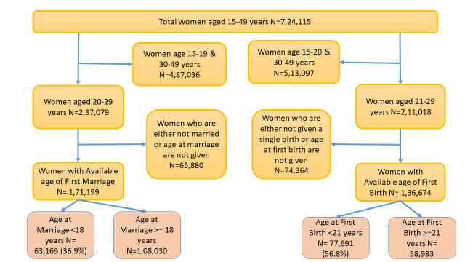

Table A1: Clustering of Early Marriage and Early Motherhood at state, district and PSU level in India 2019-21.
Level | Early Marriage
Level | ICC (95% CI) Model 1 | ICC (95% CI) Model 2 | ICC (95% CI) Model 3 | ICC (95% CI) Model 4
State | 0.09 [0.05 0.14] | 0.06 [0.04 0.1] | 0.05 [0.03 0.07] | 0.03 [0.02 0.06]
District | 0.13 [0.1 0.18] | 0.1 [0.07 0.13] | 0.08 [0.06 0.1] | 0.07 [0.05 0.08]
PSU | 0.19 [0.15 0.23] | 0.14 [0.12 0.17] | 0.12 [0.1 0.14] | 0.11 [0.09 0.13]
 | Early Motherhood
 | ICC (95% CI) Model 1 | ICC (95% CI) Model 2 | ICC (95% CI) Model 3 | ICC (95% CI) Model 4
State | 0.06 [0.03 0.09] | 0.04 [0.02 0.06] | 0.03 [0.02 0.05] | 0.03 [0.02 0.04]
District | 0.09 [0.07 0.12] | 0.06 [0.04 0.08] | 0.05 [0.04 0.07] | 0.05 [0.04 0.06]
PSU | 0.13 [0.1 0.16] | 0.08 [0.07 0.1] | 0.08 [0.06 0.09] | 0.07 [0.06 0.09]
Notes: ICC: intra-cluster correlation coefficient, CI: confidence interval, PSU: primary sampling unit

Figure A2: Percentage distribution of early marriage/cohabitation and motherhood in district of India. 2019-21.
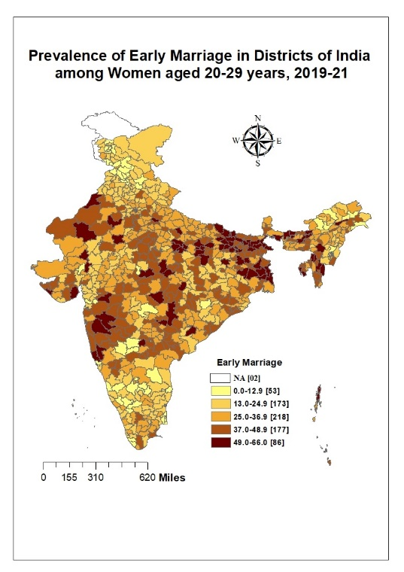 | 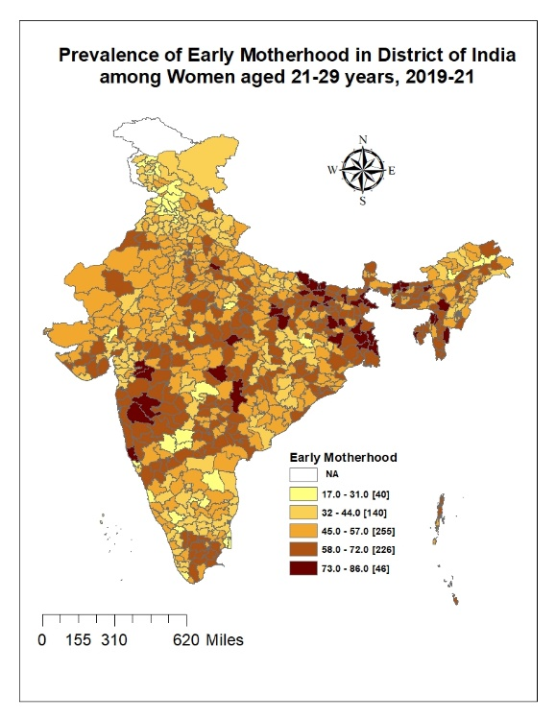

Table A2: Univariate and Bivariate Moran's I Statistics showing the spatial dependence for the district level prevalence of Early Marriage in India, 2019-21
District level Percentage of Meso scale Indicators/Variables | Early Marriage (Univariate) |  | Early Marriage (Bivariate) |  | Early Marriage (Emp Bayes Bivariate)
District level Percentage of Meso scale Indicators/Variables | Moran's I values | Z value | Moran's I values | Z value | Moran's I values | Z value
Early Marriage | 0.511 | 19.68 | Early Marriage
Rural | 0.181 | 6.99 | 0.141 | 6.99 | 0.076 | 3.71
No Education | 0.418 | 16.66 | 0.344 | 16.20 | 0.329 | 12.85
OBC | 0.506 | 20.06 | 0.14 | 7.25 | 0.306 | 14.44
Hindu | 0.531 | 19.83 | 0.174 | 8.96 | 0.138 | 5.78
Poorest | 0.484 | 18.87 | 0.322 | 15.05 | 0.269 | 9.83
No Prior Relationship | 0.575 | 21.73 | 0.07 | 3.64 | 0.467 | 18.32
Low Mass Media | 0.49 | 19.23 | 0.297 | 14.02 | 0.399 | 15.67

Table A3: Univariate and Bivariate Moran's I Statistics showing the spatial dependence for the district level prevalence of Early Motherhood in India, 2019-21
District level Percentage of Meso scale Indicators/Variables | Early Motherhood (Univariate) |  | Early Motherhood (Bivariate) |  | Early Motherhood (Emp Bayes Bivariate)
District level Percentage of Meso scale Indicators/Variables | Moran's I values | Z value | Moran's I values | Z value | Moran's I values | Z value
Early Motherhood | 0.481 | 19.07 | Early Motherhood
Rural | 0.181 | 7.02 | 0.126 | 6.35 | 0.080 | 4.24
No Education | 0.427 | 17.08 | 0.268 | 13.11 | 0.380 | 14.66
OBC | 0.505 | 19.99 | 0.098 | 5.13 | 0.292 | 12.99
Hindu | 0.533 | 19.88 | 0.138 | 7.26 | 0.116 | 4.61
Poorest | 0.485 | 18.93 | 0.306 | 14.34 | 0.274 | 9.96
No Prior Relationship | 0.576 | 21.68 | 0.079 | 4.07 | 0.425 | 16.76
Low Mass Media | 0.491 | 19.25 | 0.265 | 12.89 | 0.363 | 14.45

Table A4: Result of regression analysis (OLS) showing the adjusted coefficients of the correlates for early Marriage and early Motherhood in India, 2019-21
District-level meso scale correlates | Early Marriage |  | Early Motherhood
District-level meso scale correlates | Coef. (SE) | P Value | Coef. (SE) | P Value
Rural | -0.005 [0.021] | 0.808 | 0.017 [0.022] | 0.452
No Education | 0.475 [0.048] | 0.000 | 0.265 [0.049] | 0.000
OBC | 0.056 [0.021] | 0.009 | 0.028 [0.023] | 0.214
Hindu | 0.053 [0.016] | 0.001 | 0.028 [0.017] | 0.097
Poorest | 0.15 [0.03] | 0.000 | 0.169 [0.032] | 0.000
No Prior Relationship | -0.045 [0.037] | 0.223 | -0.084 [0.039] | 0.033
Low Mass Media | 0.172 [0.031] | 0.000 | 0.171 [0.032] | 0.000
AIC value | 5274.56 |  | 5360.55
Log Likelihood | -2629.28 |  | -2672.27
Adjusted R Square Value | 0.46 |  | 0.344
No of District | 707 |  | 707

Table A5: Result of regression analysis (Spatial Lag Model) showing the adjusted coefficients of the correlates for early Marriage and early Motherhood in India, 2019-21
District-level meso scale correlates | Early Marriage |  | Early Motherhood
District-level meso scale correlates | Coef. (SE) | P Value | Coef. (SE) | P Value
Rural | 0.014 [0.019] | 0.471 | 0.032 [0.02] | 0.117
No Education | 0.364 [0.044] | 0.000 | 0.199 [0.045] | 0.000
OBC | 0.031 [0.019] | 0.106 | 0.012 [0.021] | 0.576
Hindu | 0.038 [0.014] | 0.009 | 0.018 [0.016] | 0.236
Poorest | 0.098 [0.027] | 0.000 | 0.119 [0.029] | 0.000
No Prior Relationship | -0.076 [0.033] | 0.022 | -0.114 [0.036] | 0.001
Low Mass Media | 0.148 [0.028] | 0.000 | 0.155 [0.03] | 0.000
Rho Value (Lag coefficient) | 0.374 |  | 0.34263
AIC value | 5158.72 |  | 5256.55
Log Likelihood | -2570.36 |  | -2619.28
Pseudo R Square | 0.563 |  | 0.456
No of District | 707 |  | 707

