Additional Information Web Appendix

Supplementary Material 1. Diagnostic Criteria for Scarlet Fever Issued by Ministry of Health, People’s Republic of China released on February 28, 2008 (WS 282-2008)
1 Scope
This standard specifies the diagnostic basis, diagnostic principles, diagnosis and differential diagnosis for scarlet fever.
This standard applies to nationwide medical institutions and their staff to diagnose and report scarlet fever.
2 Terms and definitions
The following terms and definitions apply to this standard.
2.1 White strawberry tongue
The tongue has a white coating on it, while the papillae of the tongue are swollen and reddened, standing out on the white coating, making the tongue resemble a strawberry.
2.2 Red strawberry tongue
White strawberry tongue following the desquamating process, or the shedding of the tissue which created the white coating) the whiteness disappears while the red and enlarged papillae give it the "red strawberry" appearance.
2.3 Pastia's lines
Lines of petechiae which appear as pink/red areas located in arm pits and elbow pits.
2.4 Circumoral pallor
Obvious facial hyperemia compared to hyperemia of the nose and mouth, appearing to be white.
3 Diagnostic basis
3.1 Epidemiology history
Local occurrence and prevalence of the disease, with exposure to scarlet fever patients or to tonsillitis, angina, otitis media, erysipelas or other streptococcal infected patients.
3.2 Clinical manifestations
3.2.1 Common scarlet fever
Abrupt onset with fever, angina, and rash. Rash is observed on the second day of fever; the skin has disseminated hyperemia and flushing, among which congestive rash as small as a needle’s point can be seen that fades with pressing, accompanied by itching. A small number of patients can have a rash with yellow-white pustules, which do not break easily. Pastia’s lines may form on skin creases. Facial hyperemia emerges without rash, accompanied by “circumoral pallor”. In early onset of the disease, “white strawberry tongue” is seen and is more severe toward the edge of the tongue. After 2-3 days the white coating begins to fall off, forming a “red strawberry tongue”. After 2-5 days the rash subsides, after which the skin has desquamation or furfur.
3.2.2 Mild scarlet fever
Fever, angina and rash are mild and short of duration; desquamation is also mild.
3.2.3 Toxic type
The main clinical manifestation is toxemia, with obvious poisoning symptoms, like fever, headache, vomiting, hemorrhagic rash, confusion, etc. Angina is not severe. Toxic myocarditis, toxic hepatitis and septic shock can occur.
3.2.4 Sepsis type
Pharyngeal swelling with exudation of pus or even ulcers, causing cervical lymphadenitis, acute otitis media, acute sinusitis, etc. Can also cause sepsis.
3.2.5 Surgical and obstetric type
Pathogenic bacteria invade from the wound or birth canal. Local rash at first, which extends to the whole body with no pharyngitis. Systemic symptoms are mostly mild.
3.3 Laboratory testing
3.3.1 The total number of leukocytes and neutrophils increases, with possible toxic granulation for severe patients.
3.3.2 Group A Streptococcus by rapid antigen detection is positive.
3.3.3 The result of bacteria identification is the β hemolytic streptococcus by bacterial culture and by microscopy.
3.3.4 The result of a bacitracin-sensitive test is positive.
3.3.5 The result of biochemical identification is Streptococcus pyogenes.
3.3.6 Throat swab or other focal secretion is identified as Group A β hemolytic streptococcus by bacteria serotyping.
4 Diagnostic principles
Comprehensive diagnosis should be based on epidemiological data, clinical manifestations and laboratory tests. Confirmation must be based on
etiological examination.
5 Diagnosis
5.1 Probable cases
Satisfying clinical manifestations in 3.2 and 3.3.1.
5.2 Clinical diagnosis of cases
Meeting any of the following for diagnosis:
5.2.1 Probable cases satisfying 3.1.
5.2.2 Probable cases satisfying at least one of 3.3.2, 3.3.3, 3.3.4, or 3.3.5.
5.3 Confirmed cases
Clinical diagnosis of cases satisfying 3.3.6.

Supplementary Material 2. Changes in the average yearly incidences (per 100,000 people) of scarlet fever during the four stages in Chongqing.
Pre-upsurge period vs. post-upsurge period |  |  |  | Post-upsurge period vs. dynamic zero-COVID period |  |  |  | Pre-upsurge period vs. dynamic zero-COVID period |  |  |  | Dynamic zero-COVID period vs. post dynamic zero-COVID-19 period
2005–2014 | 2015–2019 | Change (%) | P value | 2015–2019 | 2020–2022 | Change (%) | P value | 2005–2014 | 2020–2022 | Change (%) | P value | 2020–2022 | 2023 | Change (%) | P value
1.2163 | 2.5122 | 106.54 | < 0.001 | 2.5122 | 1.6947 | -32.54 | < 0.001 | 1.2163 | 1.6947 | 39.33 | < 0.001 | 1.6947 | 1.5168 | 10.50% | <0.05
Notes: Changes = (x₁ − x₂)/x₂ × 100%; x₁, x₂: average yearly incidences during the four stages; the p value was computed through a two-proportion Z-test. A p-value ≤ 0.05 was considered statistically significant.

Supplementary Material 3. Moran’s I of the global spatial autocorrelation analysis for incidence of scarlet fever in Chongqing during the study period
Period | Moran’s I | Z-score | P value
Pre-upsurge period | 0.4478 | 4.4576 | <0.0001*
Post-upsurge period | 0.2753 | 2.8147 | 0.0049*
Dynamic zero-COVID period | 0.0623 | 0.8537 | 0.3934
Post dynamic zero-COVID period | 0.0339 | 0.8181 | 0.4133
Notes: * indicates that the p-value is statistically significant.

Supplementary Material 4. Autocorrelation Function (ACF) and partial autocorrelation function (PACF) plots from SARIMA (1,0,0) (2,1,2) _{[12]} model for the differenced scarlet fever time series to estimate the parameters.
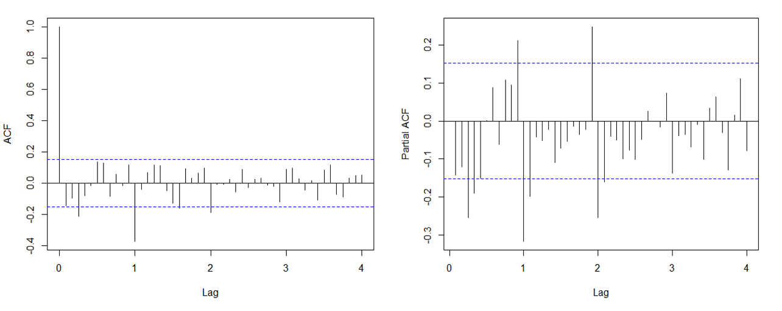

Supplementary Material 5. Autocorrelation Function (ACF) and partial autocorrelation function (PACF) plots from SARIMA (1,0,0) (2,1,0) _{[12]} model for the differenced scarlet fever time series to estimate the parameters.
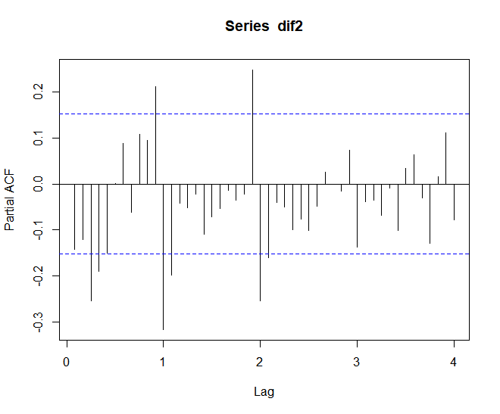
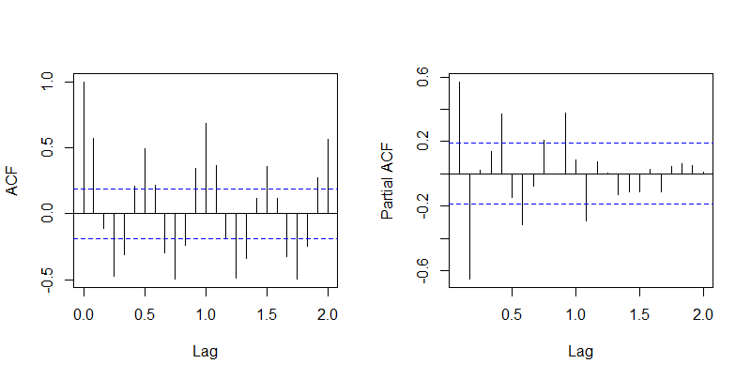

Supplementary Material 6. Changes in the yearly incidences (per 100,000 people) of scarlet fever between the observed and predicted values from 2020 to 2022.
Year | 2020 | 2021 | 2022
Actual incidence | 0.8538 | 1.8400 | 2.3903
Predicted incidence | 2.7205 | 2.4751 | 2.6735
Changes (%) | -68.61 | -25.66 | -10.59
P value | < 0.001 | < 0.001 | < 0.001
Notes: Changes = (x₁ − x₂)/x₂ × 100%; x₁: average yearly incidence (actual), x₂: average yearly incidence (predicted); the p value was computed through a two-proportion Z-test. Two-tailed hypothesis was tested.

