Supplementary material
Cardiovascular morbidity risk attributable to thermal stress: Analysis of emergency ambulance dispatch data from Shenzhen, China
Maidina Jingesi, Ziming Yin, Suli Huang, Ning Liu, Jiajia Ji, Ziquan Lv, Peng Wang, Ji Peng, Jinquan Cheng, Ping Yin

List of Tables and Figures
Table S1. Quasi-Akaike information criterion (Q-AIC) values for UTCI-model.
Table S2. Correlation coefficients between emergency ambulance dispatch for cardiovascular and thermal index or meteorological factors.
Table S3. Mean and standard deviation of the UTCI at each grid point during the study period (2013-2019) in Shenzhen.
Table S4. The relative risks (and 95% confidence interval) of EADs due to cardiovascular disease stratified by season for different levels of UTCI relative to season-specific optimal equivalent temperature.
Table S5. The relative risks (and 95% confidence interval) of EADs due to cardiovascular disease for exposure to thermal stress by varying time df.
Figure S1. Ranges of extreme cold stress, moderate cold stress, extreme heat stress, and moderate cold stress.
Figure S2. Time series of UTCI at each grid point in Shenzhen, 2013 to 2019.
Figure S3. Overall cumulative exposure-lag-response association over a lag of 25 days, 28 days, and 31 days, respectively.

Table S1. Quasi-Akaike information criterion (Q-AIC) values for UTCI-model.
df for UTCI | df for UTCI lag
df for UTCI | 2 | 3 | 4 | 5
2 | 15521.25 | 15522.98 | 15527.22 | 15530.73
3 | 15518.60 | 15522.27 | 15528.38 | 15533.08
4 | 15523.08 | 15528.79 | 15536.97 | 15543.22
5 | 15523.84 | 15531.58 | 15541.92 | 15549.62
Abbreviations: Q-AIC: Quasi Akaike Information Criterion. UTCI: Universal Thermal Climate Index.

Table S2. Correlation coefficients between emergency ambulance dispatch for cardiovascular and thermal index or meteorological factors.
 | Ambulance dispatch | UTCI | Mean temperature
UTCI | −0.15**
Mean temperature | −0.18** | 0.96**
Relative humidity | 0.01 | 0.30** | 0.21**
**p value<0.01; *p value<0.05.
Abbreviations: UTCI: Universal Thermal Climate Index.
Table S3. Mean and standard deviation of the UTCI at each grid point during the study period (2013-2019) in Shenzhen.
Latitude | Longitude | UTCI
Latitude | Longitude | Mean | Standard Deviation
22.5 | 113.9 | 22.64 | 8.62
22.5 | 114.1 | 23.24 | 8.02
22.5 | 114.2 | 22.74 | 8.16
22.5 | 114.3 | 22.02 | 8.61
22.6 | 113.9 | 22.49 | 8.54
22.6 | 114 | 23.08 | 8.26
22.6 | 114.1 | 23.60 | 8.03
22.6 | 114.2 | 23.03 | 8.16
22.6 | 114.3 | 22.55 | 8.38
22.6 | 114.5 | 21.21 | 8.69
22.7 | 113.8 | 22.37 | 8.72
22.7 | 113.9 | 22.61 | 8.48
22.7 | 114 | 23.28 | 8.19
22.7 | 114.1 | 23.70 | 8.02
22.7 | 114.2 | 23.43 | 8.10
22.7 | 114.3 | 23.07 | 8.25
22.7 | 114.4 | 22.53 | 8.37
22.7 | 114.5 | 21.85 | 8.49
22.8 | 113.8 | 22.84 | 8.45
22.8 | 113.9 | 23.05 | 8.27
22.8 | 114 | 23.49 | 8.12
22.8 | 114.1 | 23.73 | 7.99
22.8 | 114.2 | 23.49 | 8.00
22.8 | 114.3 | 23.37 | 8.01
22.8 | 114.4 | 23.12 | 8.12
22.8 | 114.5 | 22.69 | 8.23
Abbreviations: UTCI: Universal Thermal Climate Index

Table S4. The relative risks (and 95% confidence interval) of EADs due to cardiovascular disease stratified by season for different levels of UTCI relative to season-specific optimal equivalent temperature.
Lag days | Cold season (20.62°C) |  |  | Warm season (26.97°C)
Lag days | 1st (−2.23°C) | 5th (3.87°C) |  | 95th (33.47°C) | 99th (34.31°C)
0 | 1.04(1.02,1.05) | 1.03(1.02,1.04) |  | 1.01(1.001,1.02) | 1.01(1.00,1.02)
0-3 | 1.14(1.09,1.19) | 1.11(1.08,1.14) |  | 1.03(1.002,1.06) | 1.03(0.99,1.08)
0-7 | 1.25(1.17,1.35) | 1.20(1.14,1.26) |  | 1.05(1.004,1.11) | 1.05(0.98,1.13)
0-14 | 1.38(1.25,1.53) | 1.29(1.21,1.38) |  | 1.06(1.001,1.13) | 1.05(0.97,1.15)
0-21 | 1.39(1.22,1.59) | 1.30(1.20,1.40) |  | 1.04(0.97,1.115) | 1.02(0.92,1.13)
Statistically significant results (p<0.05) are marked in bold.
Abbreviations: EAD: emergency ambulance dispatch; UTCI: Universal Thermal Climate Index.
Table S5. The relative risks (and 95% confidence interval) of EADs due to cardiovascular disease for exposure to thermal stress by varying time df.
 | Lag days | 1st (-0.13°C) | 5th (7.67°C) | 95th (32.87°C) | 99th (34.00°C)
df=6
 | 0 | 1.04(1.03,1.06) | 1.04(1.03,1.05) | 1.00(1.00,1.01) | 1.01(1.00,1.01)
 | 0-3 | 1.18(1.03,1.23) | 1.15(1.10,1.20) | 1.01(0.99,1.04) | 1.02(0.99,1.05)
 | 0-7 | 1.34(1.23,1.46) | 1.28(1.19,1.38) | 1.02(0.98,1.07) | 1.04(0.98,1.10)
 | 0-14 | 1.55(1.35,1.77) | 1.47(1.32,1.64) | 1.04(0.98,1.11) | 1.06(0.97,1.16)
 | 0-21 | 1.63(1.35,1.96) | 1.56(1.34,1.81) | 1.05(0.96,1.14) | 1.07(0.96,1.20)
df=8
 | 0 | 1.04(1.03,1.05) | 1.03(1.02,1.04) | 1.00(1.00,1.01) | 1.00(0.99,1.01)
 | 0-3 | 1.15(1.10,1.21) | 1.12(1.07,1.17) | 1.01(0.98,1.03) | 1.01(0.98,1.04)
 | 0-7 | 1.29(1.18,1.41) | 1.22(1.13,1.32) | 1.01(0.97,1.05) | 1.02(0.96,1.08)
 | 0-14 | 1.46(1.26,1.68) | 1.34(1.18,1.52) | 1.01(0.95,1.08) | 1.02(0.94,1.11)
 | 0-21 | 1.49(1.22,1.82) | 1.36(1.15,1.61) | 1.01(0.92,1.10) | 1.01(0.90,1.14)
Statistically significant results (p<0.05) are marked in bold.
Abbreviations: EAD: emergency ambulance dispatch; UTCI: Universal Thermal Climate Index.
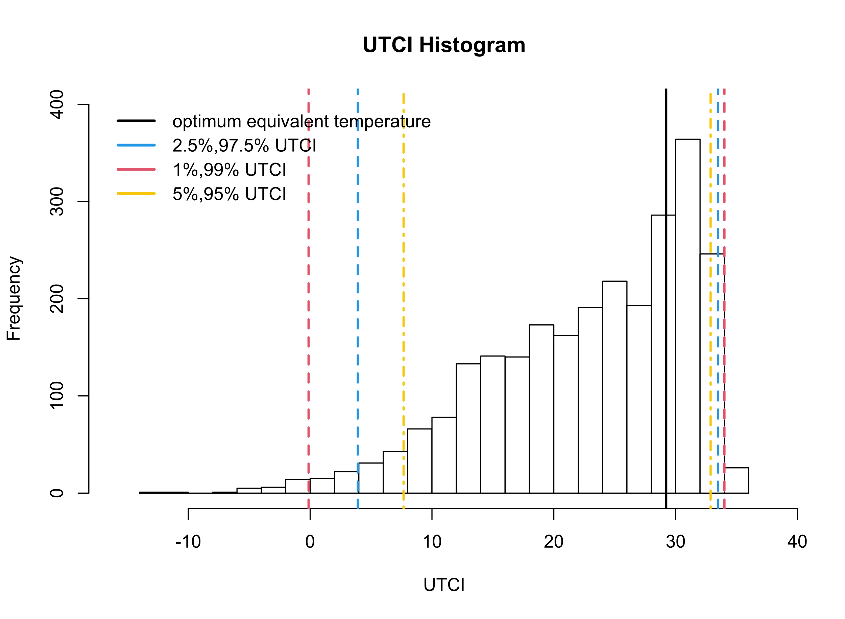
Figure S1. Ranges of extreme cold stress, moderate cold stress, extreme heat stress, and moderate cold stress. The optimal equivalent temperature (OET) is the UTCI of the lowest risk based on the UTCI-ambulance dispatch for cardiovascular curve. Abbreviations: UTCI: Universal Thermal Climate Index.

Figure S2 Time series of UTCI at each grid point in Shenzhen, 2013 to 2019.

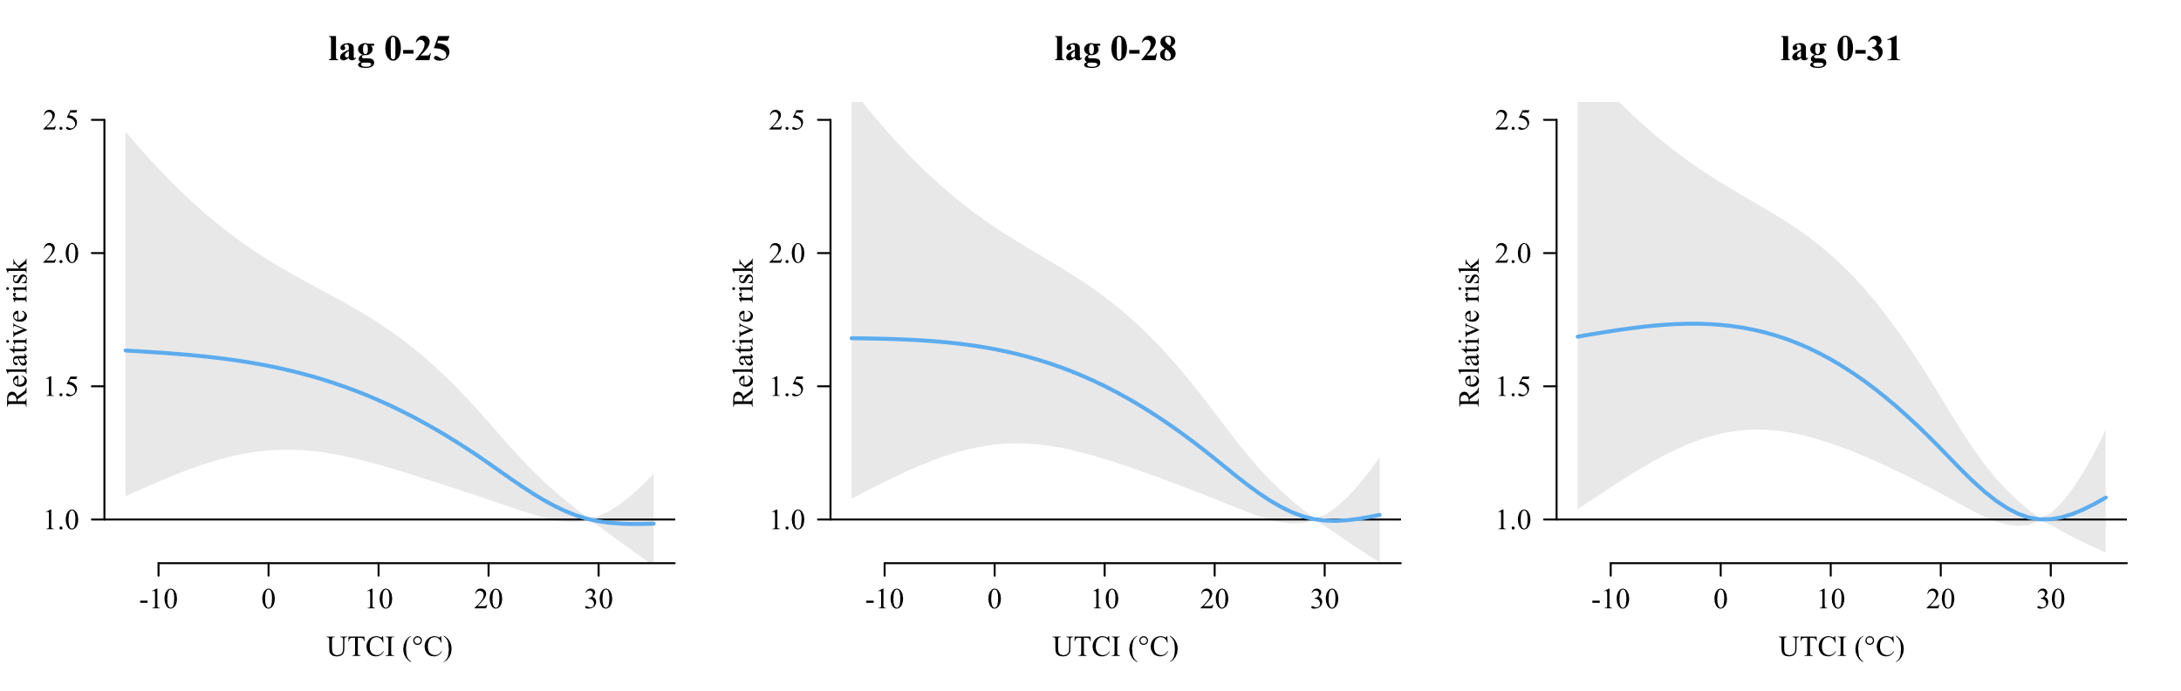
Figure S3. Overall cumulative exposure-lag-response association over a lag of 25 days, 28 days, and 31 days, respectively.

