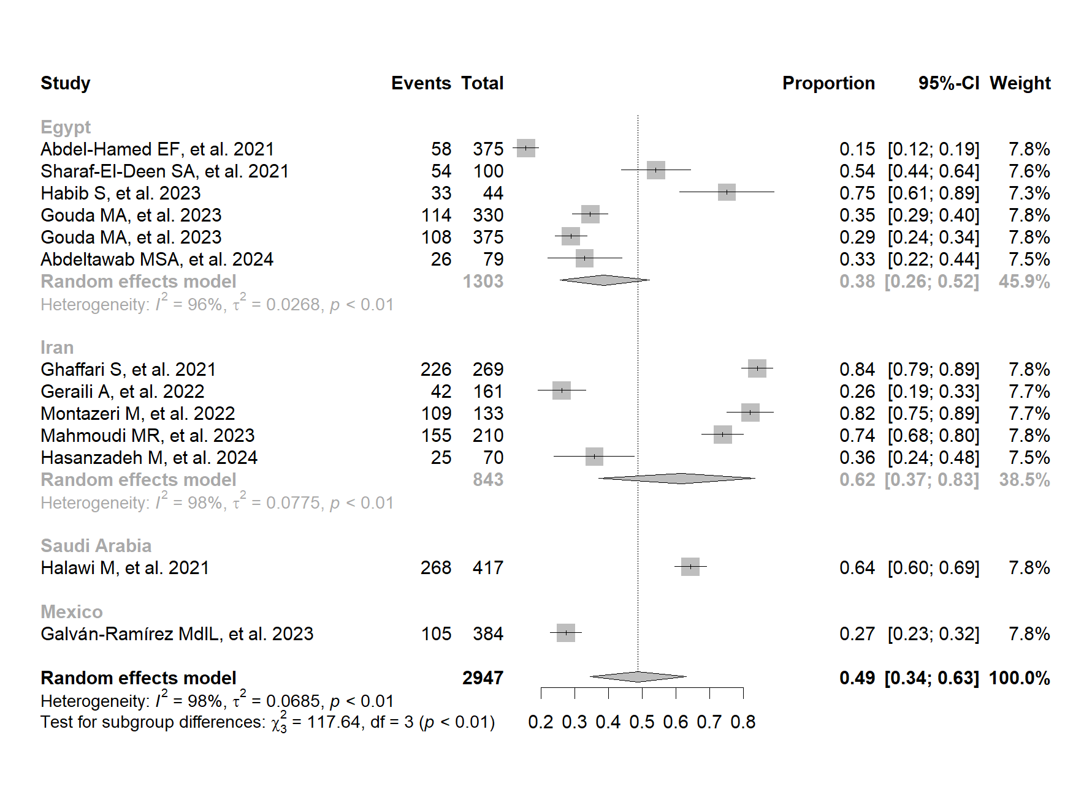

Figure S2. Country-based subgroup analysis of the frequency of T. gondii exposure by IgG antibody detection in patients with COVID-19.

