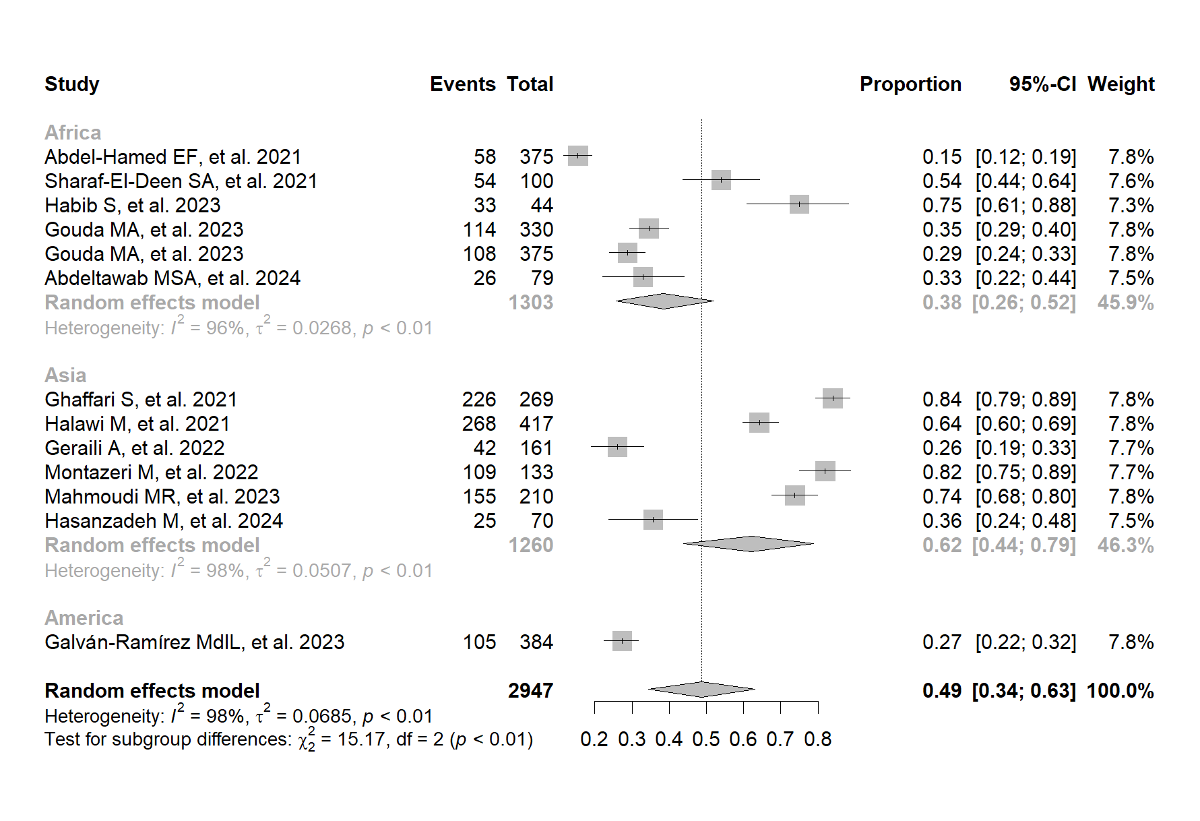
Figure S3. Subgroup analysis by continent of the frequency of exposure to T. gondii by IgG antibody detection in patients with COVID-19.

