Supplementary Material
The levels of ambient air pollutant concentration limits specified in China's ambient air quality standards (GB3095-2012) was shown in Table S1. According to the formula in method section and the Level Ⅱ standard, the scale of each pollutant evaluation factor was calculated. The different levels of each pollutant were shown in Table S2.

Table S1 Levels of ambient air pollution concentration limits
Pollutants | Concentration limits（ μg/m³）
Pollutants | LevelⅠ | Level Ⅱ
PM_{2.5} | 15 | 35
PM₁₀ | 40 | 70
SO₂ | 20 | 60
NO₂ | 40 | 40
CO | 4000 | 4000
O₃ | 100 | 160
Note：CO adopts the 24-hour average concentration limit and O₃ adopts the daily maximum 8-hour average concentration limit. The limits of other pollutants are annual average concentrations.

Table S2 Levels of AQI
Level | Ⅰ | Ⅱ | Ⅲ | Ⅳ | Ⅴ | Ⅵ
AQI | 0-50 | 51-100 | 101-150 | 151-200 | 201-300 | ＞300

Note: Level I represents excellent air quality; Level II represents good air quality; Level III represents light air pollution; Level IV represents moderate air pollution; Level V represents that heavy air pollution; Level VI represents serious pollution.

Table S3 Scale of each evaluation factor in the O-C_{i}、C_{i}-P₁、C_{i}-P₂ matrices for respiratory system from 2014-2018

Evaluation factor | O-C_{i} | C_{i}-P₁ | C_{i}-P₂
PM_{2.5} | 1.9509 | 0.0188 | 0.0300
SO₂ | 0.4265 | 0.1789 | 0.0291
NO₂ | 1.1808 | 0.1383 | 0.1383
CO | 0.3372 | 0.0004 | 0.0004
O₃ | 0.6323 | 0.8547 | 0.0170

The judgment matrices of different hierarchies were shown in Table S3 and Table S4.
Table S4 Judgment matrices of O-Ci
 | C₁(PM_{2.5}) | C₂(SO₂) | C₃(NO₂) | C₄(CO) | C₅(O₃) | Product by line | n-th root | Weight (W_{i)} | （OW）_{i}
C₁(PM_{2.5}) | 1.0000 | 4.5741 | 1.6522 | 5.7861 | 3.0853 | 134.9130 | 2.2647 | 0.3903 | 2.3112
C₂(SO₂) | 0.2186 | 1.0000 | 0.3612 | 1.2650 | 0.6745 | 0.0674 | 0.6379 | 0.1099 | 0.5053
C₃(NO₂) | 0.6052 | 2.7685 | 1.0000 | 3.5020 | 1.8674 | 10.9576 | 1.4903 | 0.2568 | 1.3988
C₄(CO) | 0.1728 | 0.7905 | 0.2855 | 1.0000 | 0.5332 | 0.0208 | 0.5244 | 0.0904 | 0.3994
C₅(O₃) | 0.3241 | 1.4826 | 0.5355 | 1.8754 | 1.0000 | 0.4826 | 0.8857 | 0.1526 | 0.7491

Table S5 Judgment matrices of Ci-P
 |  | P₁ | P₂ | Product by line | n-th root | Weight (W_{i)} | （OW）_{i}
C₁(PM_{2.5}) | P₁ | 1.0000 | 0.6246 | 0.6246 | 0.7903 | 0.3845 | 0.7689
C₁(PM_{2.5}) | P₂ | 1.6010 | 1.0000 | 1.6010 | 1.2653 | 0.6155 | 1.2311
C₃(SO₂) | P1 | 1.0000 | 6.1556 | 6.1556 | 2.4811 | 0.8602 | 1.7205
C₃(SO₂) | P2 | 0.1625 | 1.0000 | 0.1625 | 0.4031 | 0.1398 | 0.2795
C₄(NO₂) | P1 | 1.0000 | 1.0000 | 1.0000 | 1.0000 | 0.5000 | 1.0000
C₄(NO₂) | P2 | 1.0000 | 1.0000 | 1.0000 | 1.0000 | 0.5000 | 1.0000
C₅(CO) | P1 | 1.0000 | 1.0000 | 1.0000 | 1.0000 | 0.5000 | 1.0000
C₅(CO) | P2 | 1.0000 | 1.0000 | 1.0000 | 1.0000 | 0.5000 | 1.0000
C₆(O₃) | P1 | 1.0000 | 50.2821 | 50.2821 | 7.0910 | 0.9805 | 1.9610
C₆(O₃) | P2 | 0.0199 | 1.0000 | 0.0199 | 0.1410 | 0.0195 | 0.0390

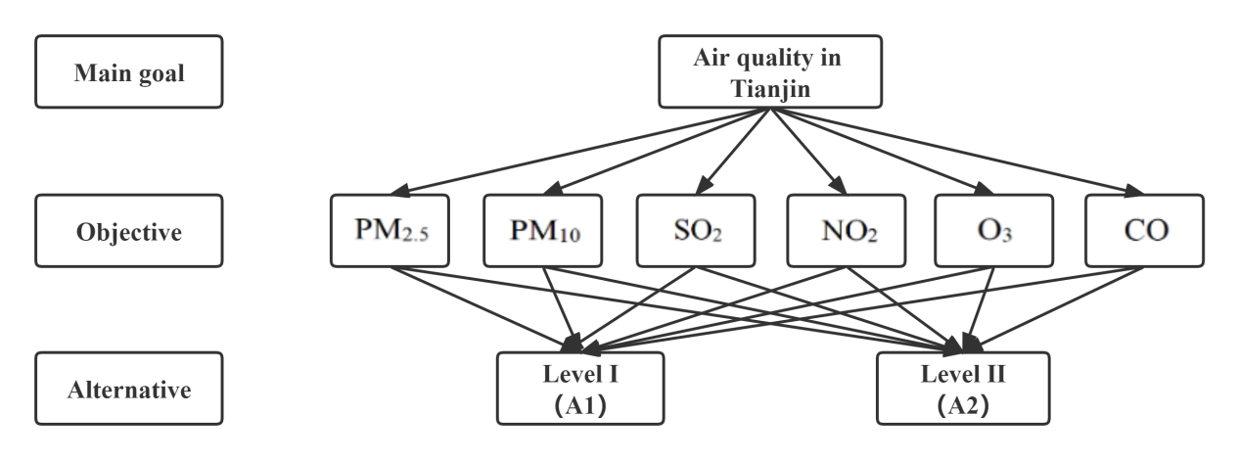
Figure S1 AHP for the evaluation of air quality in Tianjin

