Appendix 1.1: Data collection tool

Appendix 1.2: List of Faith Healers and Traditional/Herbal practitioners under surveillance of the Jasikan District Health Directorate
SN. | NAME OF HEALING CENTRE | AREA ADDRESS | NEAREST HEALTH FACILITY | TYPE
1 | Alpha and Omega Healing Centre | Akaa - Quarters | Akaa CHPS | Faith Healer
2 | Rhema Divine Camp | Lebanta, Kudje | Kudje CHPS | Faith Healer
3 | Nyame Ye Nyame Prayer Camp | Nsuta | Nsuta H/C | Faith Healer
4 | The Lords Healing Centre/ Bethel | Guaman, Bethel | Guaman CHPS | Faith Healer
5 | Christ The Lord Healing Church | Gabusu, Jasikan | Kabisayor CHPS | Faith Healer
6 | The Messiah Prayer Camp | Gabusu, Jasikan | Kabisayor CHPS | Faith Healer
7 | African Mission Centre/Afatsao Kofe | Dayigodo, New Ayoma | New Ayoma H/C | Traditional/Healer
8 | Togbe Glimdo Herbal Centre | Togbi Glimdo  Jasikan | Kabisayor CHPS | Traditional/Herbal
9 | Joshua Prayer Camp | New Ayoma-Dzolu Road | New Ayoma H/C | Faith Healer
10 | Agbetefe Mesiah Healing Centre | Kute | Kute H/C | Faith Healer
12 | Akofafanami Prayer Centre | Old Baika H/C | Baika H/C | Faith Healer
13 | Togbui Ketenu Healing Centre | Old Ayoma Near Health facility | Old Ayoma H/C | Traditional/Herbal
14 | Overflow Prayer Camp | Bodada | Bodada H/C | Faith Healer
Information valid as of 17/02/2021.
Appendix 2.0: An illustration of the complex interplay between modifying factors, individual beliefs, and actions in health-related contexts
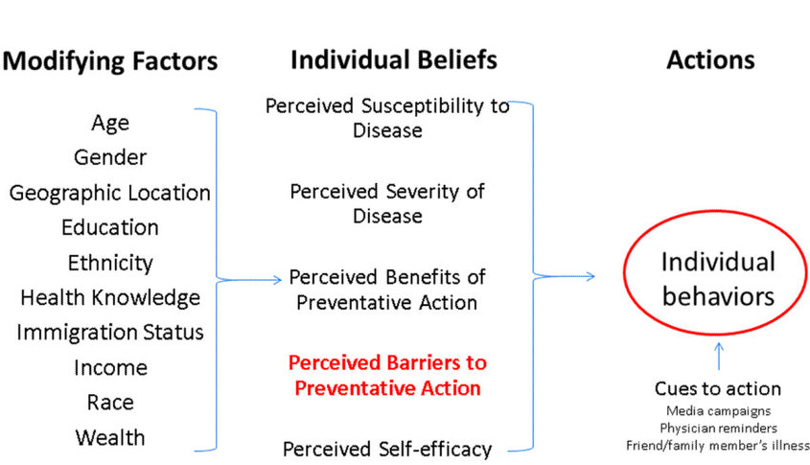

Appendix 3.0: Graphical Presentation of the Constructs of the HBM
Hypothesis | x² | P-Value
H1i: There is difference in the first choice of healthcare by age | 44.2 | 0.007
H1ii: There is difference in the first choice of healthcare by Sex | 12.561 | 0.05
H1iii: There is difference in the first choice of healthcare by Level of Education | 21.33 | 0.619
H1iv: There is difference in the first choice of healthcare by Religion | 98.456 | <0.001
H1v: There is difference in the first choice of healthcare by Marital Status | 22.714 | 0.202
H1vi: There is difference in the first choice of healthcare by Insurance Status | 66.359 | <0.001
H1vii: There is difference in the first choice of healthcare by income level | 10.809 | 0.545
H1viii: There is difference in the first choice of healthcare by Employment | 20.675 | 0.06
H3i: Good services by healthcare provider influences choice of care | 67.269 | <0.001
H3ii: Proximity to healthcare provider influences choice of care | 12.041 | 0.061
H3iii: Prompt attention by the healthcare provider influences choice of care | 24.549 | <0.001
H3iv: Readily available drugs influences choice of care | 10.749 | 0.096
H3v: Politeness and courtesy of healthcare workers influences choice of care | 26.884 | <0.001
H3vi: Affordable Services influences choice of care | 38.672 | <0.001
H3vii: Spiritual Component of care influences choice of care | 131.971 | <0.001
H3viii: The use of herbs influences choice of care | 137.365 | <0.001

