Additional files
Additional file 1: Survey instruments and tools.
Additional file 2: Availability, placement and promotion of foods and drinks in individual retail stores on the APY Lands.
Additional file 3: Cost of FARA Market Basket in individual retail stores on the APY Lands.
Additional file 4: Cost of habitual and healthy diets for a family of four per fortnight in individual retail stores on the APY Lands and comparison locations.
Additional file 5: Welfare incomes for a family of four per fortnight on the APY Lands and comparison locations

Additional files.

Additional File 1. Survey instruments and tools
- FARA Market Basket tool
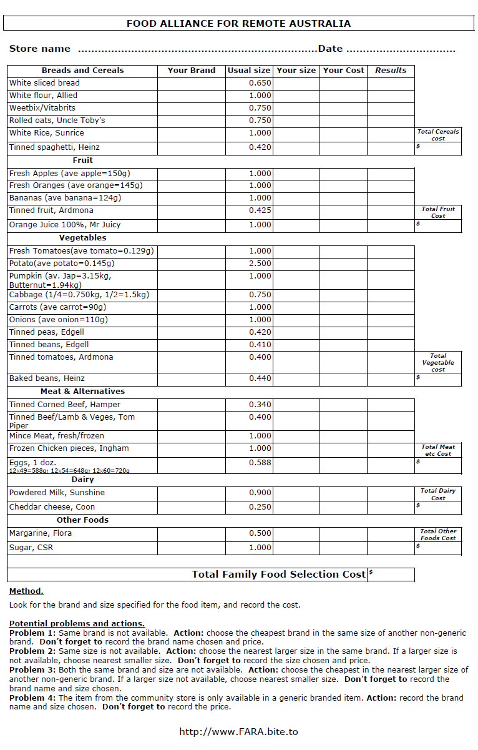
1B: Components of the FIRST survey tool
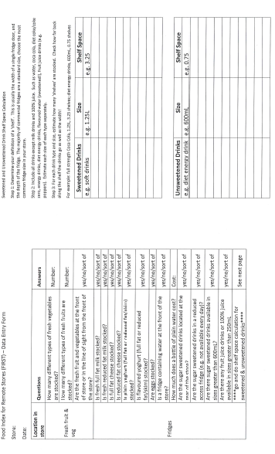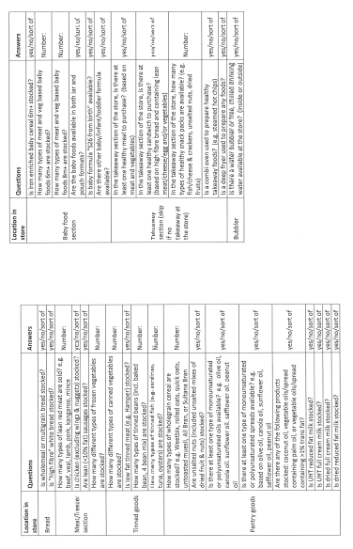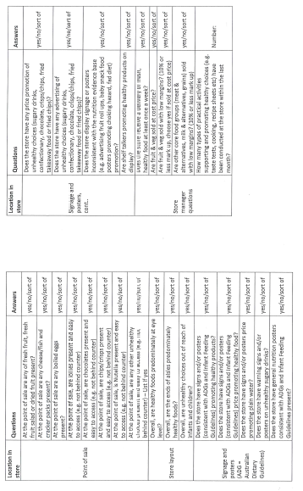
1C: Aboriginal and Torres Strait Islander Healthy Diets ASAP protocol tool
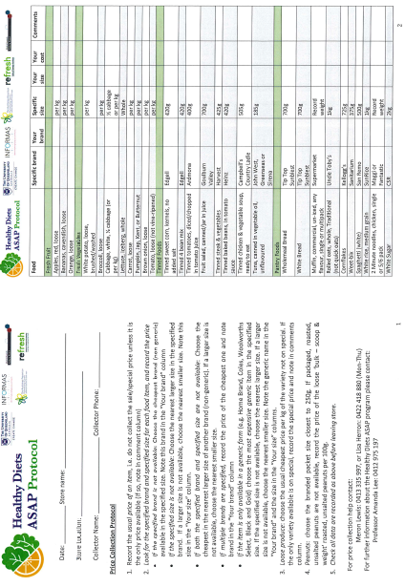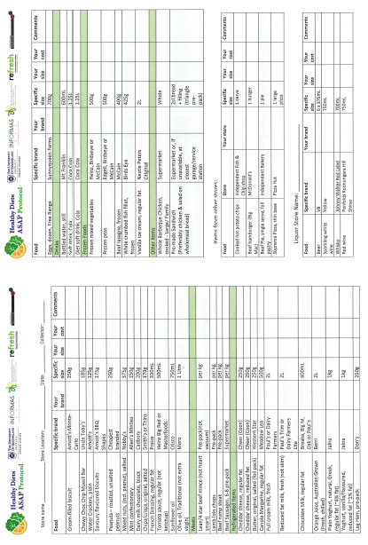

Additional File 2: Availability, placement and promotion of healthy and unhealthy foods in individual retail stores on the APY Lands.

Additional File 2A: Category of availability score of foods and drinks in individual retail stores on the APY Lands, 2014 to 2022

 | Mai Wiru stores on APY Lands |  |  |  |  | Other stores on APY Lands
 | Intervention focus communities |  | Store nutrition policy control communities |  |  | APY control communities
 | IMW1 | IMW2 | PCMW3 | PCMW4 | PCMW5 | CAPYS6 | CAPYS7 | CAPYS8
April 2014 | 71 | 67 | 64 | 66 | 64 | 71 | 79 | 57**
July 2015 | 61 | 75 | 79 | 73 | 77 | 71 | 88 | 57**
Oct 2016 | 83 | 100 | 83 | 69 | 79 | 83 | 86 | 57**
June 2017 | 75 | 89 | 82 | 71 | 88 | 75 | 82 | 50
April 2018 | 86 | 81 | 71 | 66 | 76 | 70 | 75 | 50
January 2019 | 94 | 89 | 91 | 80 | 88 | 90 | 92 | 57**
May 2019 | 98 | 98 | 88 | 89 | 85 | 94 | 86 | 57**
May 2021 | 81 | 82 | 80 | 84 | 78 | 62 | 70 | 59
June 2022 | 89 | 75 | 78 | 75** | 78 | 64 | 82 | 68
* prior to 2018 data were analysed against the RIST checklist; results have been moderated against the results of the FIRST checklist used from 2018
** missing data imputed as described in Methods

Colour coding category
Green = Good (86% to 100%)
Amber = Could be improved (70% to 85%)
Red = Poor (<70%)

Additional File 2B: Category of product placement and promotion score of food and drinks in individual retail stores on the APY Lands, 2014 to 2022

 | Mai Wiru stores on APY Lands |  |  |  |  | Other stores on APY Lands
 | Intervention focus communities |  | Store nutrition policy control communities |  |  | APY control communities
 | IMW1 | IMW2 | PCMW3 | PCMW4 | PCMW5 | CAPYS6 | CAPYS7 | CAPYS8
April 2014 | 85 | 45 | 45 | 85 | 45 | 20 | 70 | 29**
July 2015 | 35 | 50 | 75 | 50 | 10 | 20 | 100 | 29**
Oct 2016 | 45 | 100 | 80 | 70 | 50 | 80 | 100 | 29**
Jun 2017 | 65 | 100 | 80 | 60 | 40 | 80 | 100 | 10
April 2018 | 45 | 73 | 71 | 42 | 58 | 33 | 86 | 10
January 2019 | 78 | 80 | 73 | 55 | 63 | 40 | 82 | 29**
May 2019 | 96 | 96 | 79 | 74 | 88 | 70 | 83 | 29**
May 2021 | 71 | 77 | 75 | 75 | 76 | 34 | 39 | 68
June 2022 | 68 | 62 | 60 | 64* | 54 | 39 | 61 | 29
* prior to 2018 data were analysed against the RIST checklist; results have been moderated against the results of the FIRST checklist used from 2018
** missing data imputed as described in Methods

Colour coding category
Green = Good (86% to 100%)
Amber = Could be improved (70% to 85%)
Red = Poor (<70%)

Additional File 3: Cost of FARA Market Basket in individual retail stores on the APY Lands

Additional File 4: Cost of habitual and healthy diets for a family of four per fortnight in individual retail stores on the APY Lands and comparison locations

 | IMW1 |  | IMW2 |  | PCMW3 |  | PCMW4 |  | PCMW5 |  | CAPYS6 |  | CAPYS7 |  | CAPYS8 |  | CS9 |  | Regional centre comparison stores (mean ± std. error)
 | Habitual diet | Healthy diet | Habitual diet | Healthy diet | Habitual diet | Healthy diet | Habitual diet | Healthy diet | Habitual diet | Healthy diet | Habitual diet | Healthy diet | Habitual diet | Healthy diet | Habitual diet | Healthy diet | Habitual diet | Healthy diet | Habitual diet | Healthy diet
Apr 2018 | $1067 | $836 | $1212 | $827 | $1091 | $822 | $1101 | $822 | $1141 | $831 | $1070 | $915 | $1095 | $817 | $1129 | $886 | $1118 | $862 | $832 ± 54 | $683 ± 54
Jan 2019 | $1150 | $880 | $1224 | $855 | $1080 | $855 | $1165 | $842 | $1165 | $839 | $1134 | $938 | $1082 | $867 | $1158 | $910 | $1147 | $886 | $918 ± 54 | $710 ± 40
May 2019 | $1167 | $847 | $1162 | $842 | $1060 | $821 | $1164 | $897 | $1146 | $830 | $1186 | $970 | $1203 | $903 | $1171 | $915 | $1174 | $898 | $905 ± 59 | $718 ± 63
May 2021 | $1235 | $771 | $1167 | $919 | $1087 | $801 | $1216 | $802 | $1142 | $848 | $1089 | $847 | $1021 | $916 | $1122 | $870 | $1213 | $911 | $949 ± 49 | $739 ± 59
Jun 2022 | $1198 | $872 | $1157 | $829 | $1201 | $888 | $1274 | $876 | $1247 | $894 | $1138 | $988 | $1178 | $946 | $1226 | $1116 | $1413 | $1051 | $958 ± 60 | $807 ± 82

Additional File 5. Welfare incomes for a family of four per fortnight on the APY Lands and comparison locations

Welfare Income | APY Lands | Alice Springs
April 2018 | $1,600.00 | $1,680.00
January 2019 | $1,645.14 | $1,725.71
May 2019 | $1,645.14 | $1,725.71
May 2021 | $1,766.68 | $1,766.68
June 2022 | $1,829.45 | $1,909.95

