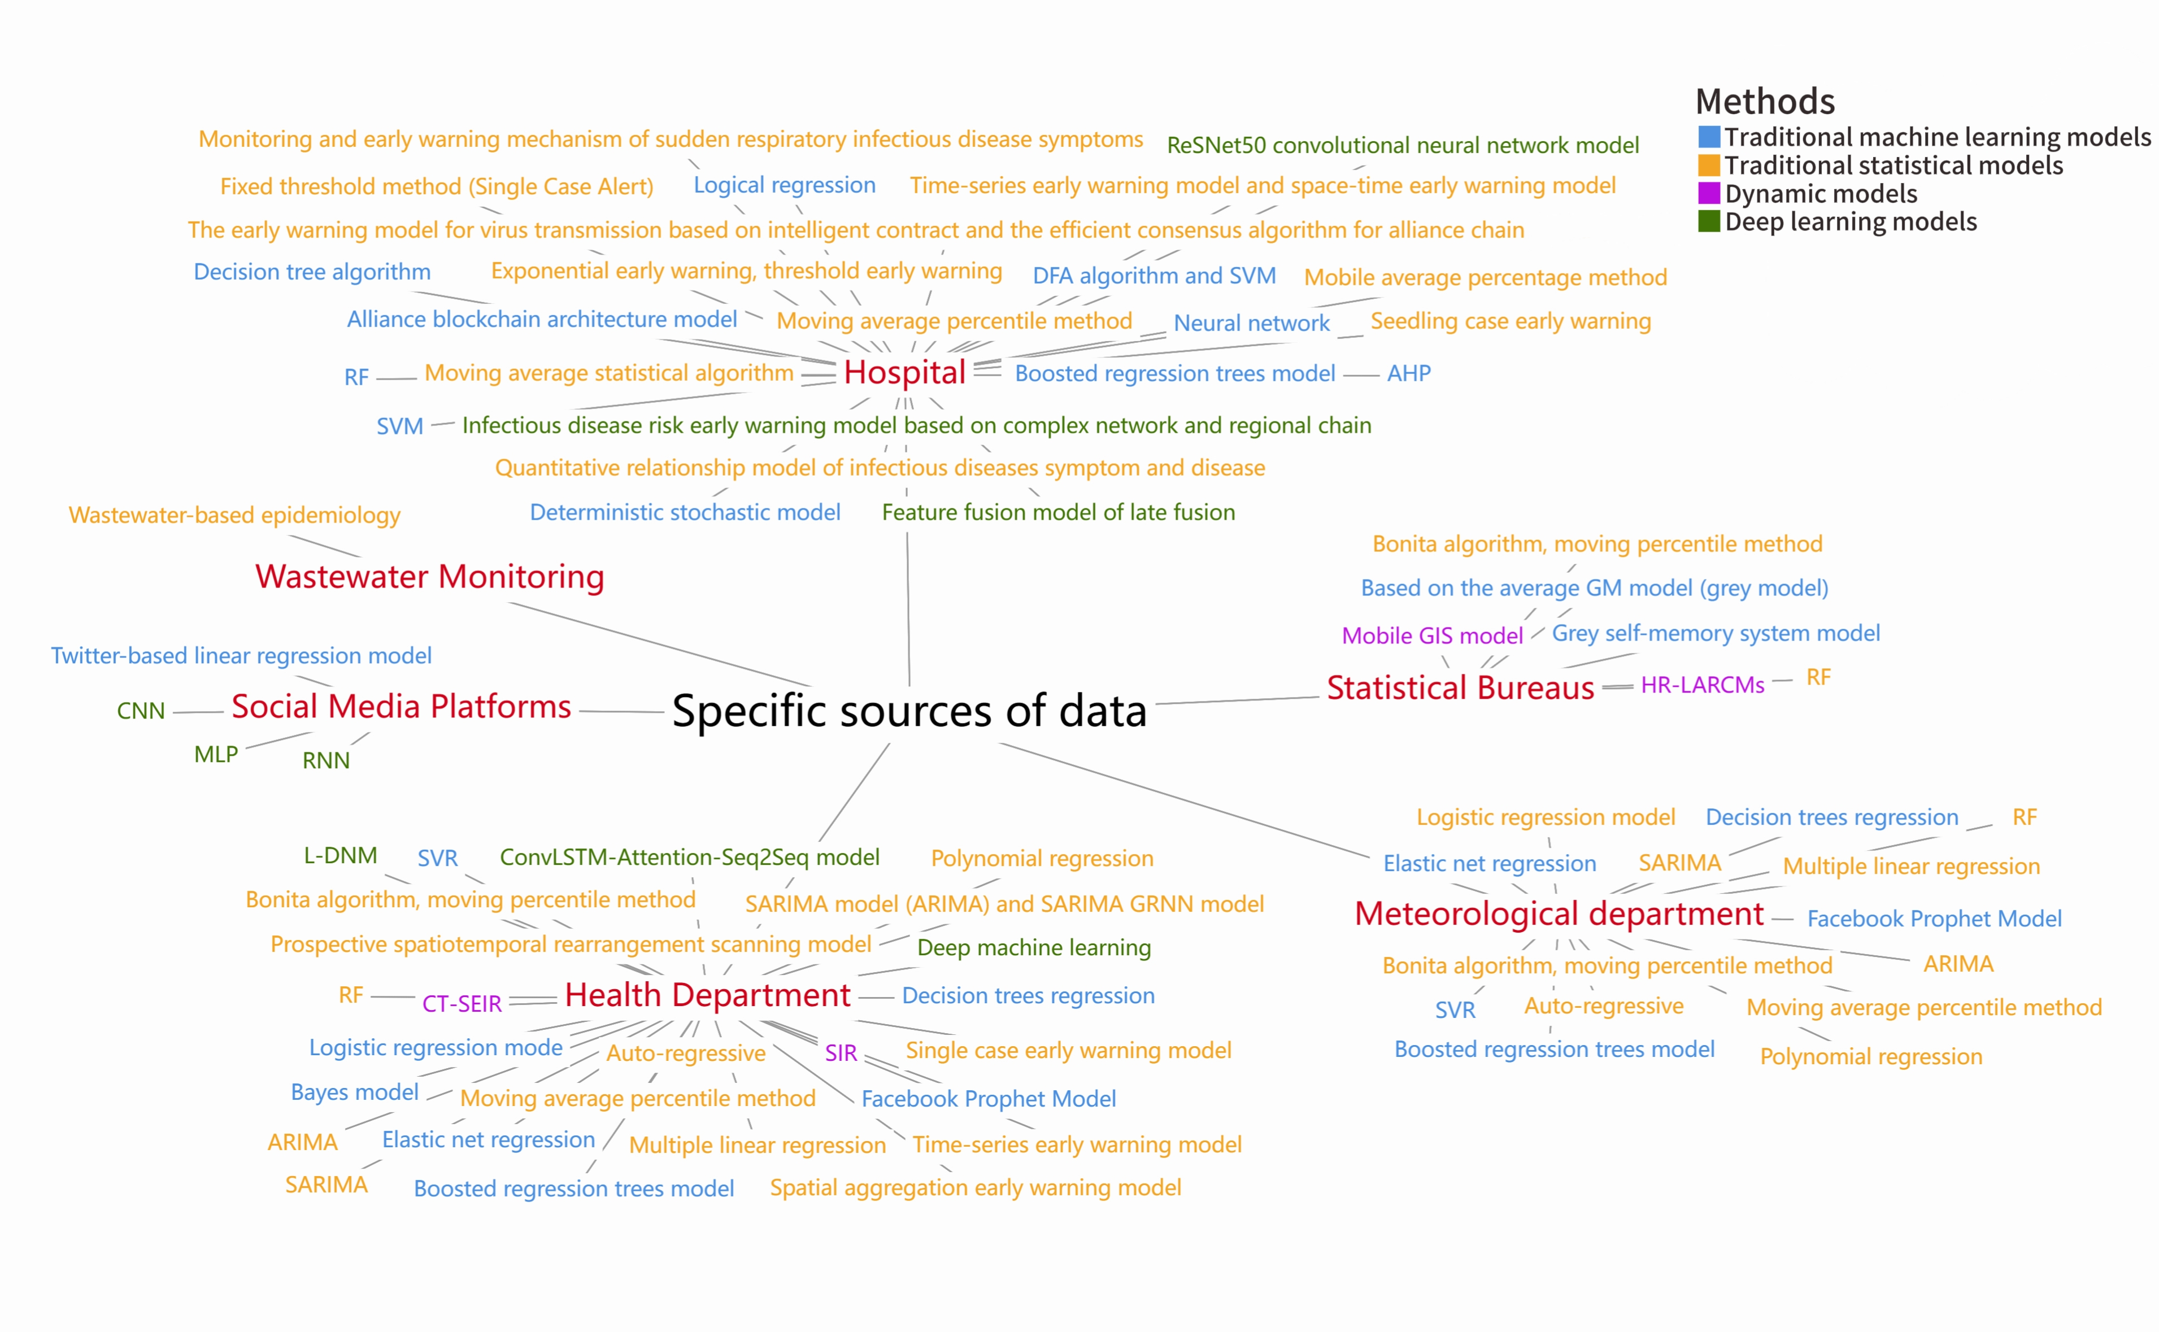
Figure S1 Force Conduction Diagram of Infectious Disease Early Warning Systems Categorized by Data Source.

