Supplementary Information for

Factors related to sedentary behavior of pregnancy women during the second/third trimester: prospective results from the large-scale Japan Environment and Children’s Study

Makie Nagai, Akiko Tsuchida, Kenta Matsumura, Haruka Kasamatsu, Hidekuni Inadera,
and the Japan Environment and Children’s Study Group

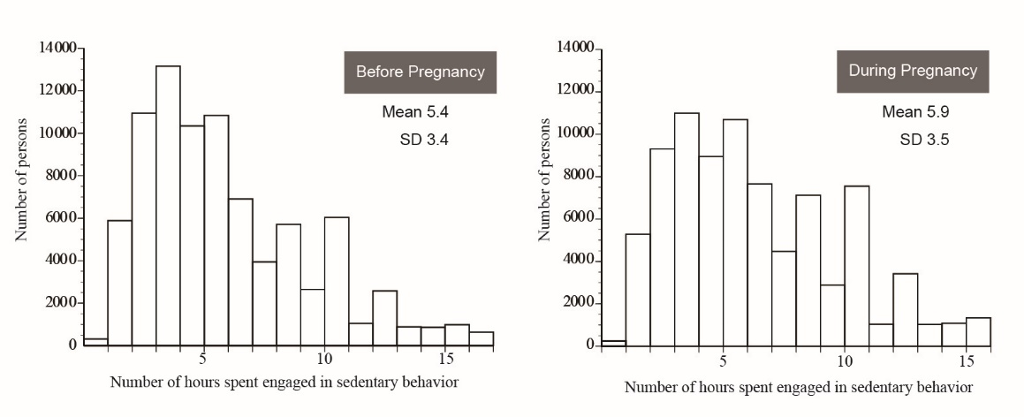

Supplementary Figure 1. Distribution of number of hours spent engaged in sedentary behavior (N=83,733).

