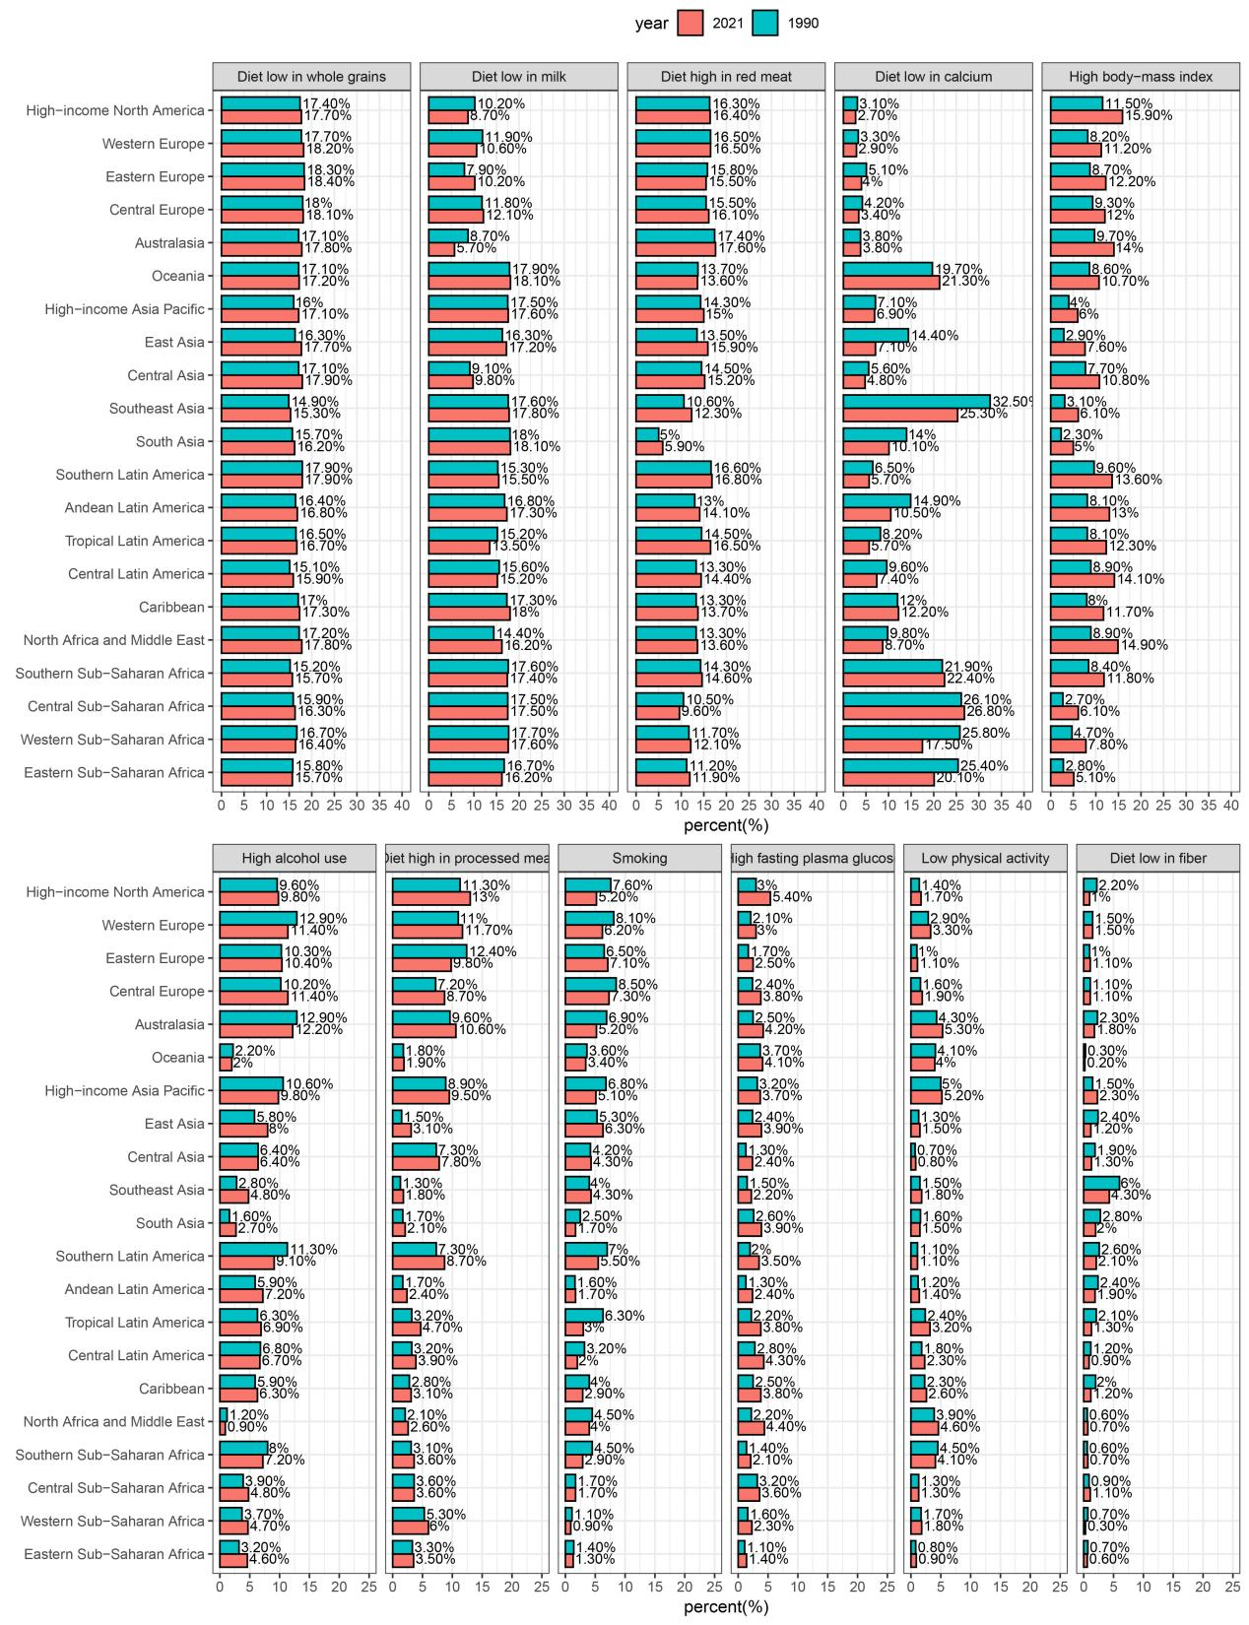
Fig. S1 Percentage contribution of 11 risk factors to the DALYs of EO-CRC in 21 GBD regions for the years 1990 and 2021. DALYs disability-adjusted life years, EO-CRC early-onset colorectal cancer, SDI Socio-demographic index

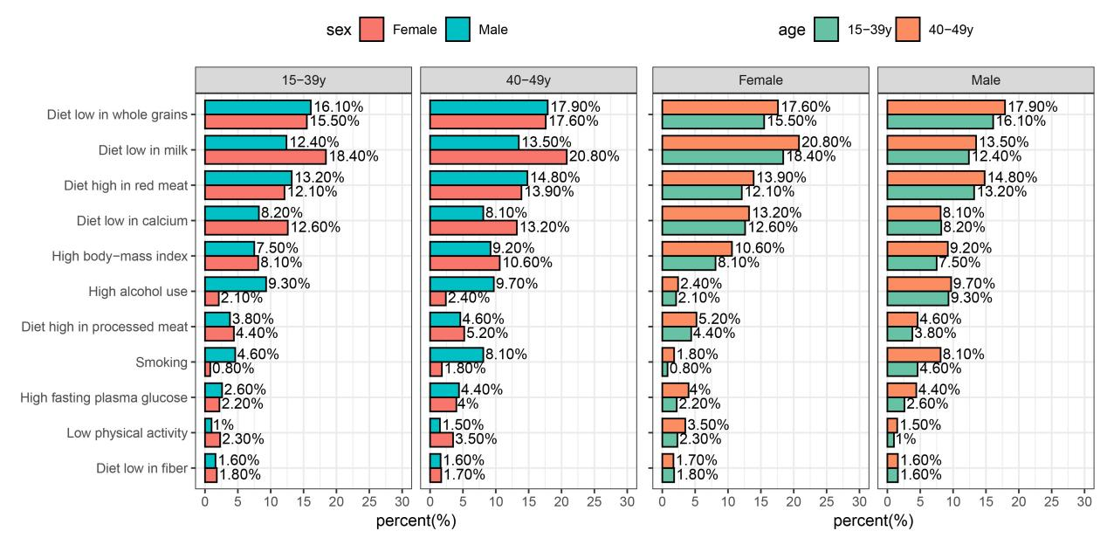
Fig. S2 Percentage contribution of 11 risk factors to the DALYs of EO-CRC stratified by age and gender, globally in 2021. DALYs disability-adjusted life years, EO-CRC early-onset colorectal

