Supplementary Table 1. Odds ratios (ORs) and 95% confidence intervals (CIs) for the associations between screen time and obesity prevalence, after additionally adjustment for school
Screen time | Pooled population |  | Stratified by grade in school
Screen time |  |  | 4th grade students |  | 7th grade students
Screen time | Cases / N | OR (95% CI) ª | Cases / N | OR (95% CI) ^{b} | Cases / N | OR (95% CI) ^{b} | p-int ^{c}
Combined screen time, m/d
<120 | 85 / 1464 | 1.00 (ref) | 63 / 1062 | 1.00 (ref) | 22 /402 | 1.00 (ref)
120 to <180 | 87 / 1028 | 1.54 (1.12, 2.11) ^{e} | 51 / 556 | 1.49 (1.01, 2.20) | 36 / 472 | 1.39 (0.80, 2.42)
180 to <240 | 106 / 970 | 2.05 (1.51, 2.78) ^{e} | 64 / 441 | 2.42 (1.67, 3.52) ^{e} | 42 / 529 | 1.41 (0.82, 2.41)
≥240 | 220 / 1718 | 2.41 (1.82, 3.18) ^{e} | 91 / 535 | 2.76 (1.95, 3.92) ^{e} | 129 / 1183 | 1.80 (1.12, 2.89)
p-trend ^{d} |  | <0.0001 ^{e} |  | <0.0001 ^{f} |  | 0.01 | 0.22
Smartphone use, m/d
<60 | 122 / 1925 | 1.00 (ref) | 90 / 1382 | 1.00 (ref) | 32 / 543 | 1.00 (ref)
60 to <120 | 138 / 1417 | 1.69 (1.30, 2.19) ^{e} | 71 / 662 | 1.62 (1.17, 2.26) ^{e} | 67 / 755 | 1.54 (0.99, 2.40)
120 to <180 | 115 / 968 | 2.24 (1.69, 2.96) ^{e} | 57 / 323 | 2.83 (1.97, 4.08) ^{e} | 58 / 645 | 1.57 (1.00, 2.47)
≥180 | 123 / 870 | 2.74 (2.05, 3.67) ^{e} | 51 / 227 | 3.58 (2.41, 5.32) ^{e} | 72 / 643 | 2.00 (1.28, 3.13) ^{e}
p-trend ^{d} |  | <0.0001 ^{e} |  | <0.0001 ^{f} |  | 0.004 e | 0.05
Computer use, m/d
<60 | 381 / 4140 | 1.00 (ref) | 235 / 2374 | 1.00 (ref) | 146 / 1766 | 1.00 (ref)
60 to <120 | 59 / 607 | 0.95 (0.70, 1.29) | 20 / 146 | 1.30 (0.79, 2.14) | 39 / 461 | 0.76 (0.52, 1.12)
≥120 | 58 / 433 | 1.26 (0.91, 1.74) | 14 / 74 | 1.72 (0.93, 3.19) | 44 / 359 | 1.07 (0.73, 1.57)
p-trend ^{d} |  | 0.27 |  | 0.05 |  | 0.97 | 0.18
Television watching, m/d
<60 | 278 / 3217 | 1.00 (ref) | 130 / 1531 | 1.00 (ref) | 148 / 1686 | 1.00 (ref)
60 to <120 | 125 / 1273 | 1.16 (0.92, 1.45) | 72 / 689 | 1.25 (0.92, 1.69) | 53 / 584 | 1.08 (0.77, 1.50)
≥120 | 95 / 690 | 1.53 (1.19, 1.97) ^{e} | 67 / 374 | 2.08 (1.50, 2.88) ^{e} | 28 / 316 | 0.97 (0.63, 1.49)
p-trend ^{d} |  | 0.001 e |  | <0.0001 e |  | 0.96 | 0.02
Abbreviation: OR, Odds Ratios; CI, Confidence intervals.
ª Adjusted for grade (4th; 7th grade), sex (boy; girl), parental co-residence (none or one parent; both parents), parents’ highest education (high school or lower; college or higher), monthly household income (<2,000,000; 2,000,000 to <4,000,000; 4,000,000 to <6,000,000; 6,000,000 to <8,000,000; ≥8,000,000 KRW), academic performance (poor or fair; good; missing), perceived parental control score (continuous), and school ID (continuous).
^{b} Adjusted for sex (boy; girl), parental co-residence (none or one parent; both parents), parents’ highest education (high school or lower; college or higher), monthly household income (<2,000,000; 2,000,000 to <4,000,000; 4,000,000 to <6,000,000; 6,000,000 to <8,000,000; ≥8,000,000 KRW), academic performance (poor or fair; good; missing), perceived parental control score (continuous), and school ID (continuous).
^{c} P-interaction was estimated using the Wald test for the production term between screen time and grade.
^{d} P-trend was estimated using the Wald test for continuous screen time variables.
^{e} Statistical significance at Bonferroni-corrected α level of 0.0125 (4 exposures)

Supplementary Table 2. Characteristics of study participants according to combined screen time categories in the pooled population of the KCYPS 2018
Characteristics | Combined screen time (min/d)
Characteristics | <120 |  | 120 to <180 |  | 180 to <240 |  | ≥240
 | N (%)
Grade
4th grade elementary students | 1062 (72.5) |  | 556 (54.1) |  | 441 (45.5) |  | 535 (31.1)
7th grade middle school students | 402 (27.5) |  | 472 (45.9) |  | 529 (54.5) |  | 1183 (68.9)
Sex
Boys | 702 (48.0) |  | 527 (51.3) |  | 510 (52.6) |  | 971 (56.5)
Girls | 762 (52.1) |  | 501 (48.7) |  | 460 (47.4) |  | 747 (43.5)
Obesity ª | 85 (5.8) |  | 87 (8.5) |  | 106 (10.9) |  | 220 (12.8)
Parental co-residence
None or one parent | 88 (6.0) |  | 78 (7.6) |  | 79 (8.1) |  | 207 (12.1)
Both parents | 1376 (94.0) |  | 950 (92.4) |  | 891 (91.9) |  | 1511 (87.9)
Parents’ highest education
High school or lower | 207 (14.2) |  | 201 (19.6) |  | 235 (24.2) |  | 542 (31.6)
College or higher | 1257 (85.9) |  | 827 (80.4) |  | 735 (75.8) |  | 1176 (68.4)
Monthly household income (KRW)
<2,000,000 | 62 (4.2) |  | 50 (4.9) |  | 50 (5.1) |  | 147 (8.6)
2,000,000 to <4,000,000 | 311 (21.2) |  | 266 (25.9) |  | 254 (26.2) |  | 521 (30.3)
4,000,000 to <6,000,000 | 604 (41.3) |  | 397 (38.6) |  | 410 (42.3) |  | 633 (36.8)
6,000,000 to <8,000,000 | 275 (18.8) |  | 186 (18.1) |  | 154 (15.9) |  | 254 (14.8)
≥8,000,000 | 212 (14.5) |  | 129 (12.5) |  | 102 (10.5) |  | 163 (9.5)
Academic performance
Poor or fair | 430 (29.4) |  | 371 (36.1) |  | 420 (43.3) |  | 869 (50.6)
Good | 964 (65.9) |  | 619 (60.2) |  | 515 (53.1) |  | 743 (43.2)
Missing | 70 (4.8) |  | 38 (3.7) |  | 35 (3.6) |  | 106 (6.2)
 | Mean | SD | Mean | SD | Mean | SD | Mean | SD
Parental psychological control score ^{b} | 8.5 | 2.6 | 8.5 | 2.5 | 8.7 | 2.6 | 8.7 | 2.6
Average duration of daily activities (h/d)
Using smartphone | 0.7 | 0.6 | 1.4 | 0.9 | 1.9 | 1.1 | 2.3 | 1.2
Using computer | 0.1 | 0.3 | 0.3 | 0.5 | 0.5 | 0.7 | 0.9 | 1.0
Watching television | 0.6 | 0.5 | 0.8 | 0.7 | 1.0 | 0.8 | 1.2 | 0.9
Combined screen time | 1.5 | 0.8 | 2.5 | 0.9 | 3.3 | 1.0 | 4.4 | 1.4
Sleeping | 9.1 | 0.9 | 8.9 | 0.9 | 8.8 | 0.9 | 8.5 | 1.0
Performing physical activity | 1.1 | 0.9 | 1.0 | 0.8 | 0.9 | 0.8 | 0.8 | 0.7
Hanging out with friends | 1.2 | 1.1 | 1.3 | 0.9 | 1.3 | 0.9 | 1.4 | 0.9
Chatting with parents | 1.9 | 1.2 | 1.7 | 1.0 | 1.5 | 0.9 | 1.3 | 0.8
Studying | 4.3 | 1.6 | 3.8 | 1.4 | 3.3 | 1.3 | 2.7 | 1.4
Reading | 0.9 | 0.8 | 0.6 | 0.6 | 0.5 | 0.5 | 0.4 | 0.4
Abbreviation: KCYPS, Korean Children and Youth Panel Survey; KRW: South Korean Won; SD, standard deviation.
ª Obesity was defined as age- and sex-specific body mass index ≥95th percentile based on the 2017 Korean National Growth Charts for children and adolescents
^{b} Perceived parental psychological control score (range 4-16) was calculated by summing the scores from the following 4 questions related to parental psychological control (My parents always push me to do something; My parents tell me what I do; My parents think that when they do something, their way is the only way to do it; My parents say “no” to everything). Each question had a score that ranged 1-4.

Supplementary Table 3. Odds Ratios (ORs) and 95% confidence intervals (CIs) for the associations between screen time and obesity prevalence, stratified by sex
Screen time | Stratified by sex
Screen time | Male |  | Female
Screen time | Cases / N | OR (95% CI) ^{b} | Cases / N | OR (95% CI) ^{b} | p-int ^{c}
Combined screen time, m/d
<120 | 54 / 702 | 1.00 (ref) | 31 / 762 | 1.00 (ref)
120 to <180 | 54 / 527 | 1.35 (0.91, 2.01) | 33 / 501 | 1.56 (0.94, 2.60)
180 to <240 | 68 / 510 | 1.81 (1.24, 2.65) ^{f} | 38 / 460 | 1.86 (1.13, 3.06)
≥240 | 149 / 971 | 2.04 (1.45, 2.86) ^{f} | 71 / 747 | 1.96 (1.25, 3.06) ^{f}
p-trend ^{d} |  | <0.0001 ^{f} |  | 0.003 | 0.93
Smartphone use, m/d
<60 | 81 / 1016 | 1.00 (ref) | 41 / 909 | 1.00 (ref)
60 to <120 | 96 / 782 | 1.59 (1.16, 2.18) ^{f} | 42 / 635 | 1.37 (0.87, 2.14)
120 to <180 | 74 / 506 | 1.91 (1.36, 2.69) ^{f} | 41 / 462 | 1.83 (1.16, 2.89) ^{f}
≥180 | 74 / 406 | 2.41 (1.69, 3.42) ^{f} | 49 / 464 | 1.92 (1.23, 3.01) ^{f}
p-trend ^{d} |  | <0.0001 ^{f} |  | 0.002 ^{f} | 0.97
Computer use, m/d
<60 | 223 / 1908 | 1.00 (ref) | 158 / 2232 | 1.00 (ref)
60 to <120 | 48 / 458 | 0.85 (0.61, 1.19) | 11 / 149 | 1.04 (0.55, 1.98)
≥120 | 54 / 344 | 1.28 (0.92, 1.78) | 4 / 89 | 0.50 (0.18, 1.40)
p-trend ^{d} |  | 0.34 |  | 0.28 | 0.25
Television watching, m/d
<60 | 183 / 1698 | 1.00 (ref) | 95 / 1519 | 1.00 (ref)
60 to <120 | 79 / 632 | 1.19 (0.90, 1.57) | 46 / 641 | 1.14 (0.79, 1.66)
≥120 | 63 / 380 | 1.60 (1.17, 2.19) ^{f} | 32 / 310 | 1.44 (0.94, 2.22)
p-trend ^{d} |  | 0.003 ^{f} |  | 0.10 | 0.98
Abbreviation: OR, Odds Ratios; CI, Confidence intervals.
ª Adjusted for grade (4th; 7th grade), parental co-residence (none or one parent; both parents), parents’ highest education (high school or lower; college or higher), monthly household income (<2,000,000; 2,000,000 to <4,000,000; 4,000,000 to <6,000,000; 6,000,000 to <8,000,000; ≥8,000,000 KRW), academic performance (poor or fair; good; missing), and perceived parental control score (continuous).
^{b} Adjusted for sex (boy; girl), parental co-residence (none or one parent; both parents), parents’ highest education (high school or lower; college or higher), monthly household income (<2,000,000; 2,000,000 to <4,000,000; 4,000,000 to <6,000,000; 6,000,000 to <8,000,000; ≥8,000,000 KRW), academic performance (poor or fair; good; missing), and perceived parental control score (continuous).
^{c} P-interaction was estimated using the Wald test for the production term between screen time and grade.
^{d} P-trend was estimated using the Wald test for continuous screen time variables.
^{f} Statistical significance at Bonferroni-corrected α level of 0.0125 (4 exposures)

Supplementary Figure 1. Flow chart of study participants

5,197 Korean students from the Korean Children and Youth Panel Survey 2018 (KCYPS 2018)
(2,607 in 4th grade students and 2,590 in 7th grade students)

17 students with missing information on weight or height were excluded
(13 in 4th grade students and 4 in 7th grade students)

5,180 final study participants
(2,594 in 4th grade students and 2,586 in 7th grade students)

Supplementary Figure 2. Odds ratios (ORs) and 95% confidence intervals (CIs) of obesity prevalence associated with substituting 1-hour of screen time for non-screen time activities among the 4th grade students
The graphs show the ORs and 95% CIs of obesity prevalence associated with increasing 1-hour of each non-screen time activity while decreasing 1-hour of (A) combined screen time, (B) smartphone use, (C) computer use, and (D) television watching among 4th grade students. Models adjusted for sex (boy; girl), parental co-residence (none or one parent; both parents), parents’ highest education (high school or lower; college or higher), monthly household income (<2,000,000; 2000,000 to <4,000,000; 4,000,000 to <6,000,000; 6,000,000 to <8,000,000; ≥8,000,000 KRW), academic performance (poor or fair; good; missing), perceived parental control (score 4-16, continuous), and all non-screen time activities (performing physical activity, sleeping, hanging out with friends, reading, studying, chatting with parents).

(A) | (B)
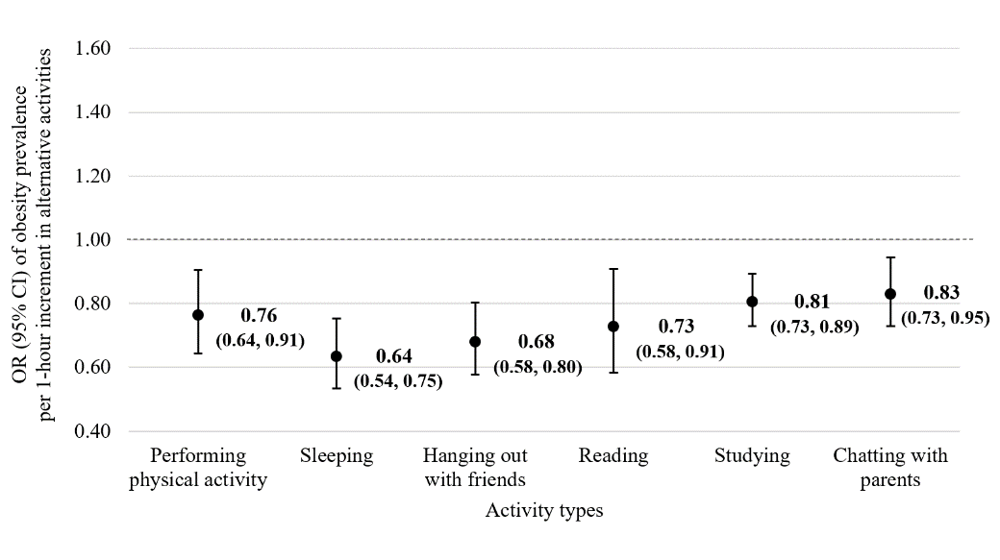 | 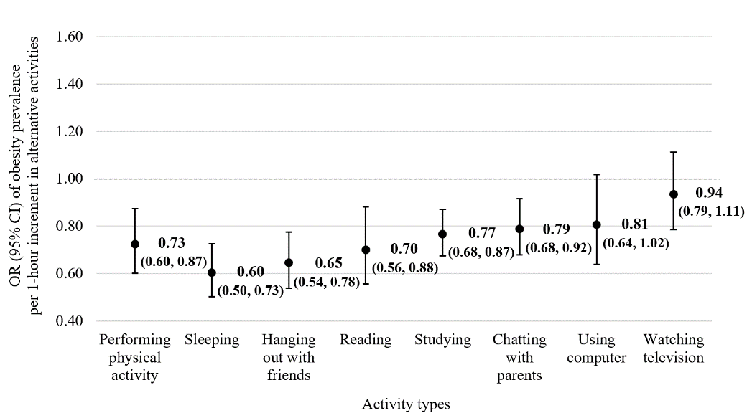
(C) | (D)
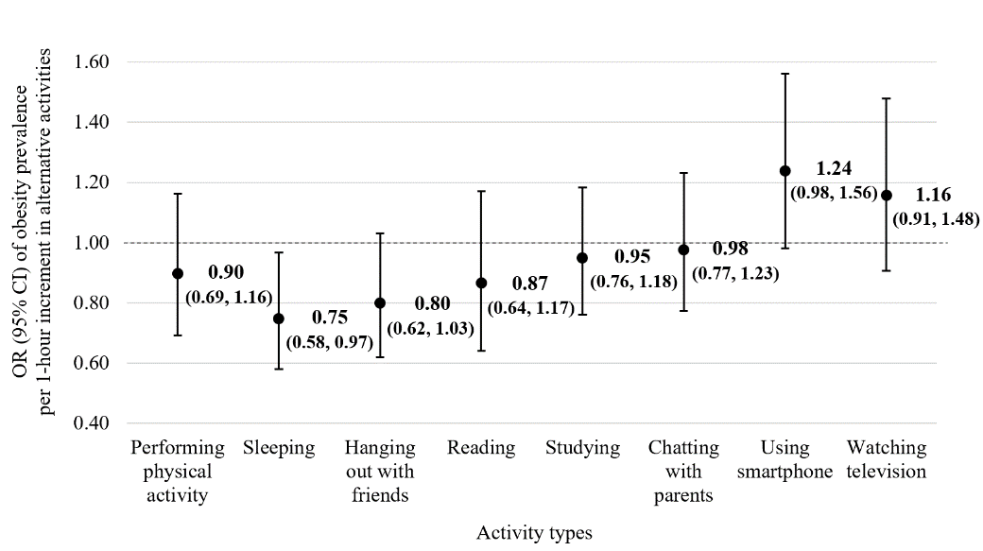 | 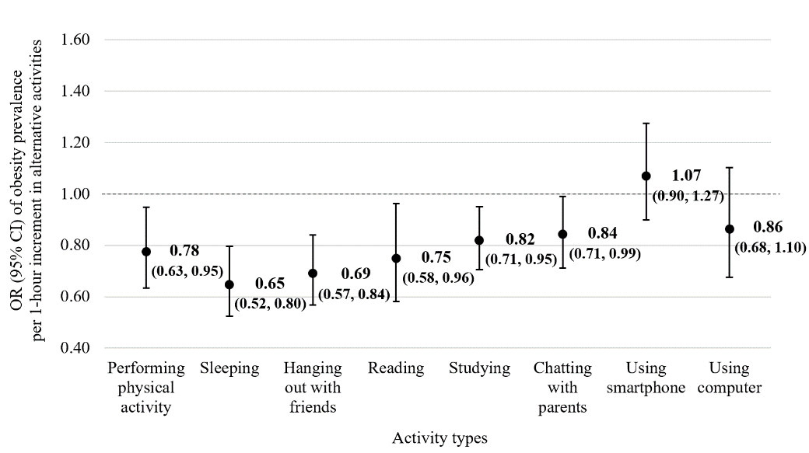
Supplementary Figure 3. Odds ratios (ORs) and 95% confidence intervals (CIs) of obesity prevalence associated with substituting 1-hour of screen time for non-screen time activities among the 7th grade students
The graphs show the ORs and 95% CIs of obesity prevalence associated with increasing 1-hour of each non-screen time activity while decreasing 1-hour of (A) combined screen time, (B) smartphone use, (C) computer use, and (D) television watching among 7th grade students. Models adjusted for sex (boy; girl), parental co-residence (none or one parent; both parents), parents’ highest education (high school or lower; college or higher), monthly household income (<2,000,000; 2000,000 to <4,000,000; 4,000,000 to <6,000,000; 6,000,000 to <8,000,000; ≥8,000,000 KRW), academic performance (poor or fair; good; missing), perceived parental control (score 4-16, continuous), and all non-screen time activities (performing physical activity, sleeping, hanging out with friends, reading, studying, chatting with parents).

(A) | (B)
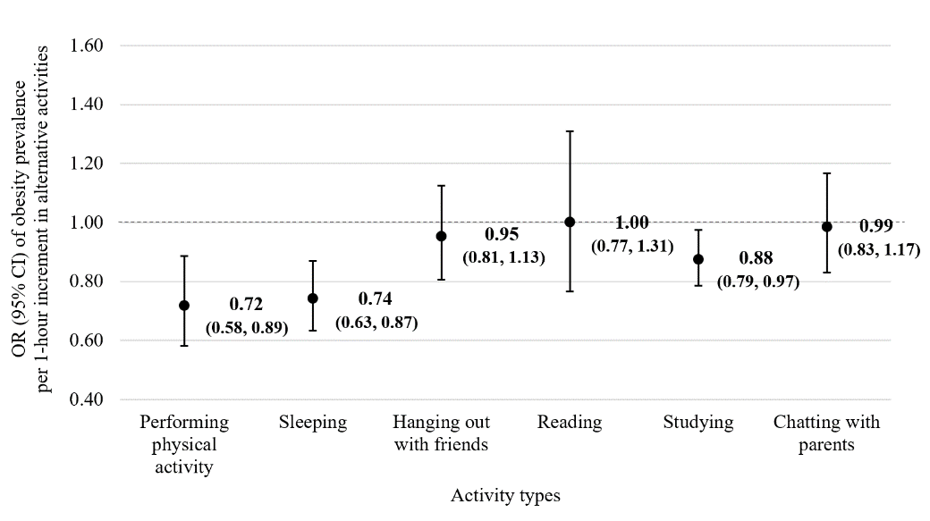 | 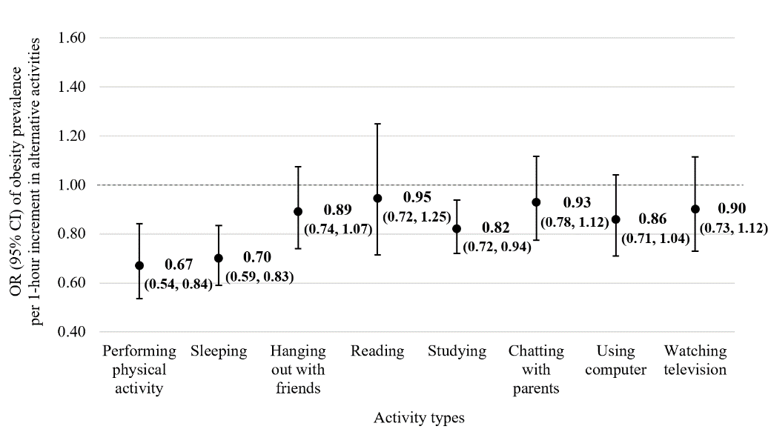
(C) | (D)
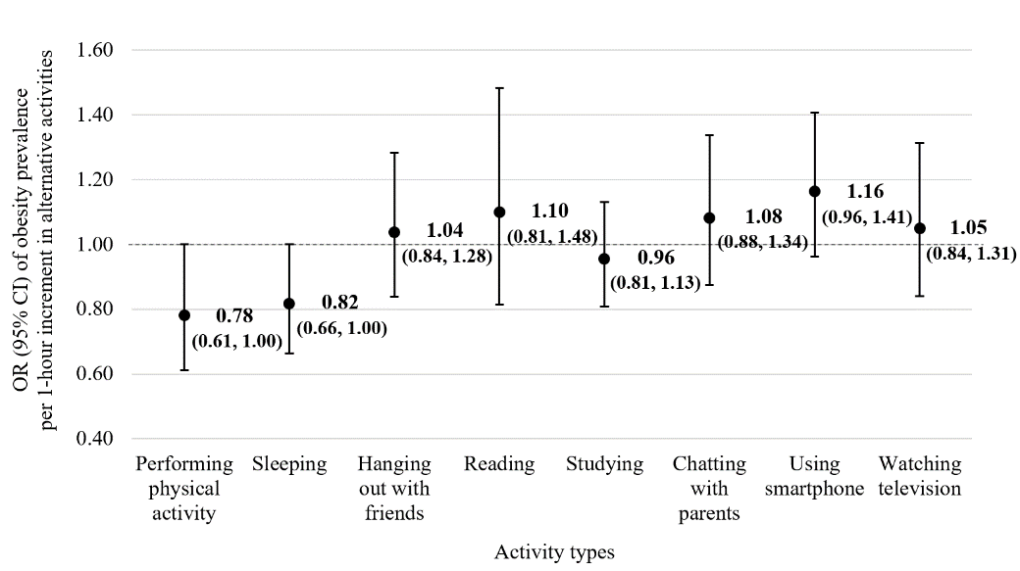 | 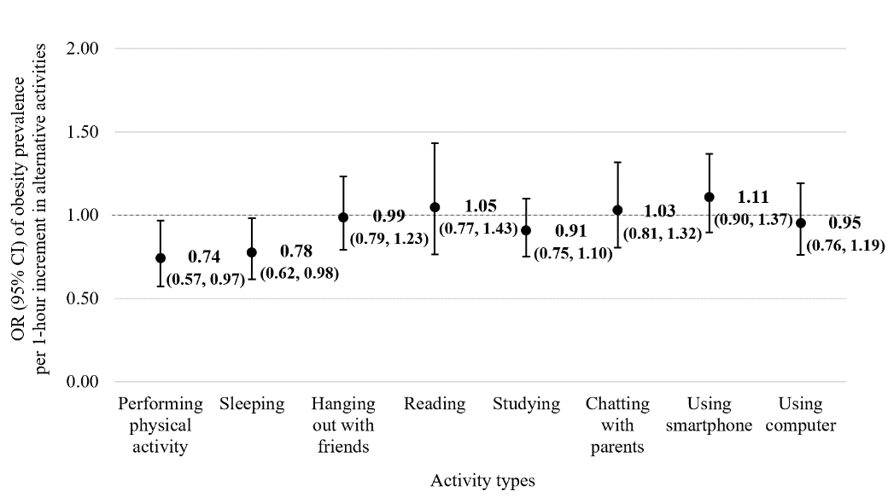

Supplementary Figure 4. Odds ratios (ORs) and 95% confidence intervals (CIs) of obesity prevalence associated with substituting 1-hour of screen time for non-screen time activities among boys
The graphs show the ORs and 95% CIs of obesity prevalence associated with increasing 1-hour of each alternative activity while decreasing 1-hour of (A) combined screen time, (B) smartphone use, (C) computer use, and (D) television watching among boys. Models adjusted for school grade (4th, 7th grade), parental co-residence (none or one parent; both parents), parents’ highest education (high school or lower; college or higher), monthly household income (<2,000,000; 2000,000 to <4,000,000; 4,000,000 to <6,000,000; 6,000,000 to <8,000,000; ≥8,000,000 KRW), academic performance (poor or fair; good; missing), parental psychological control score (continuous), and all alternative after-school activities (sleeping, performing physical activity, hanging out with friends, chatting with parents, studying, reading).
(A) | (B)
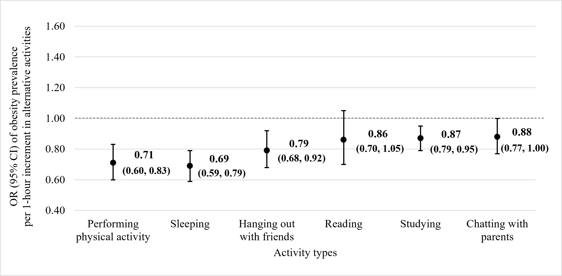 | 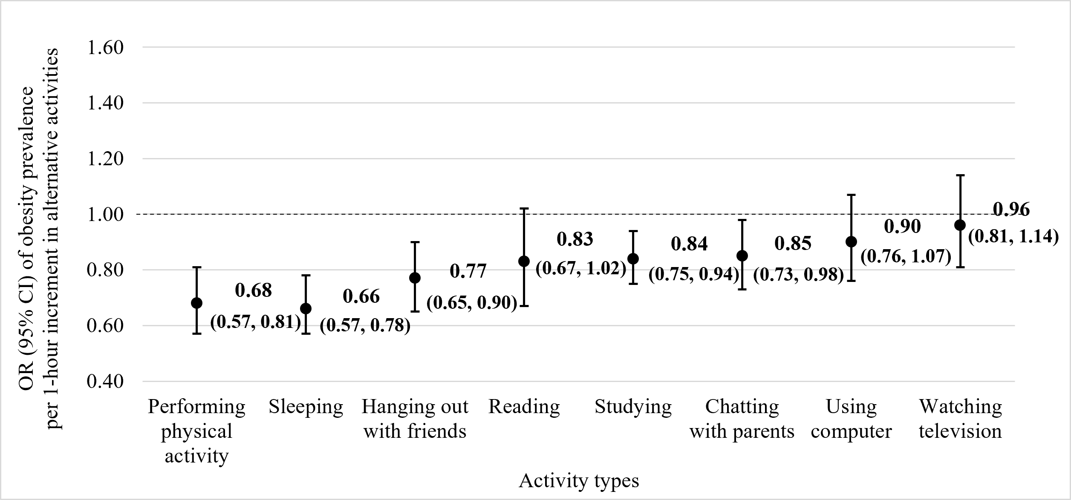
(C) | (D)
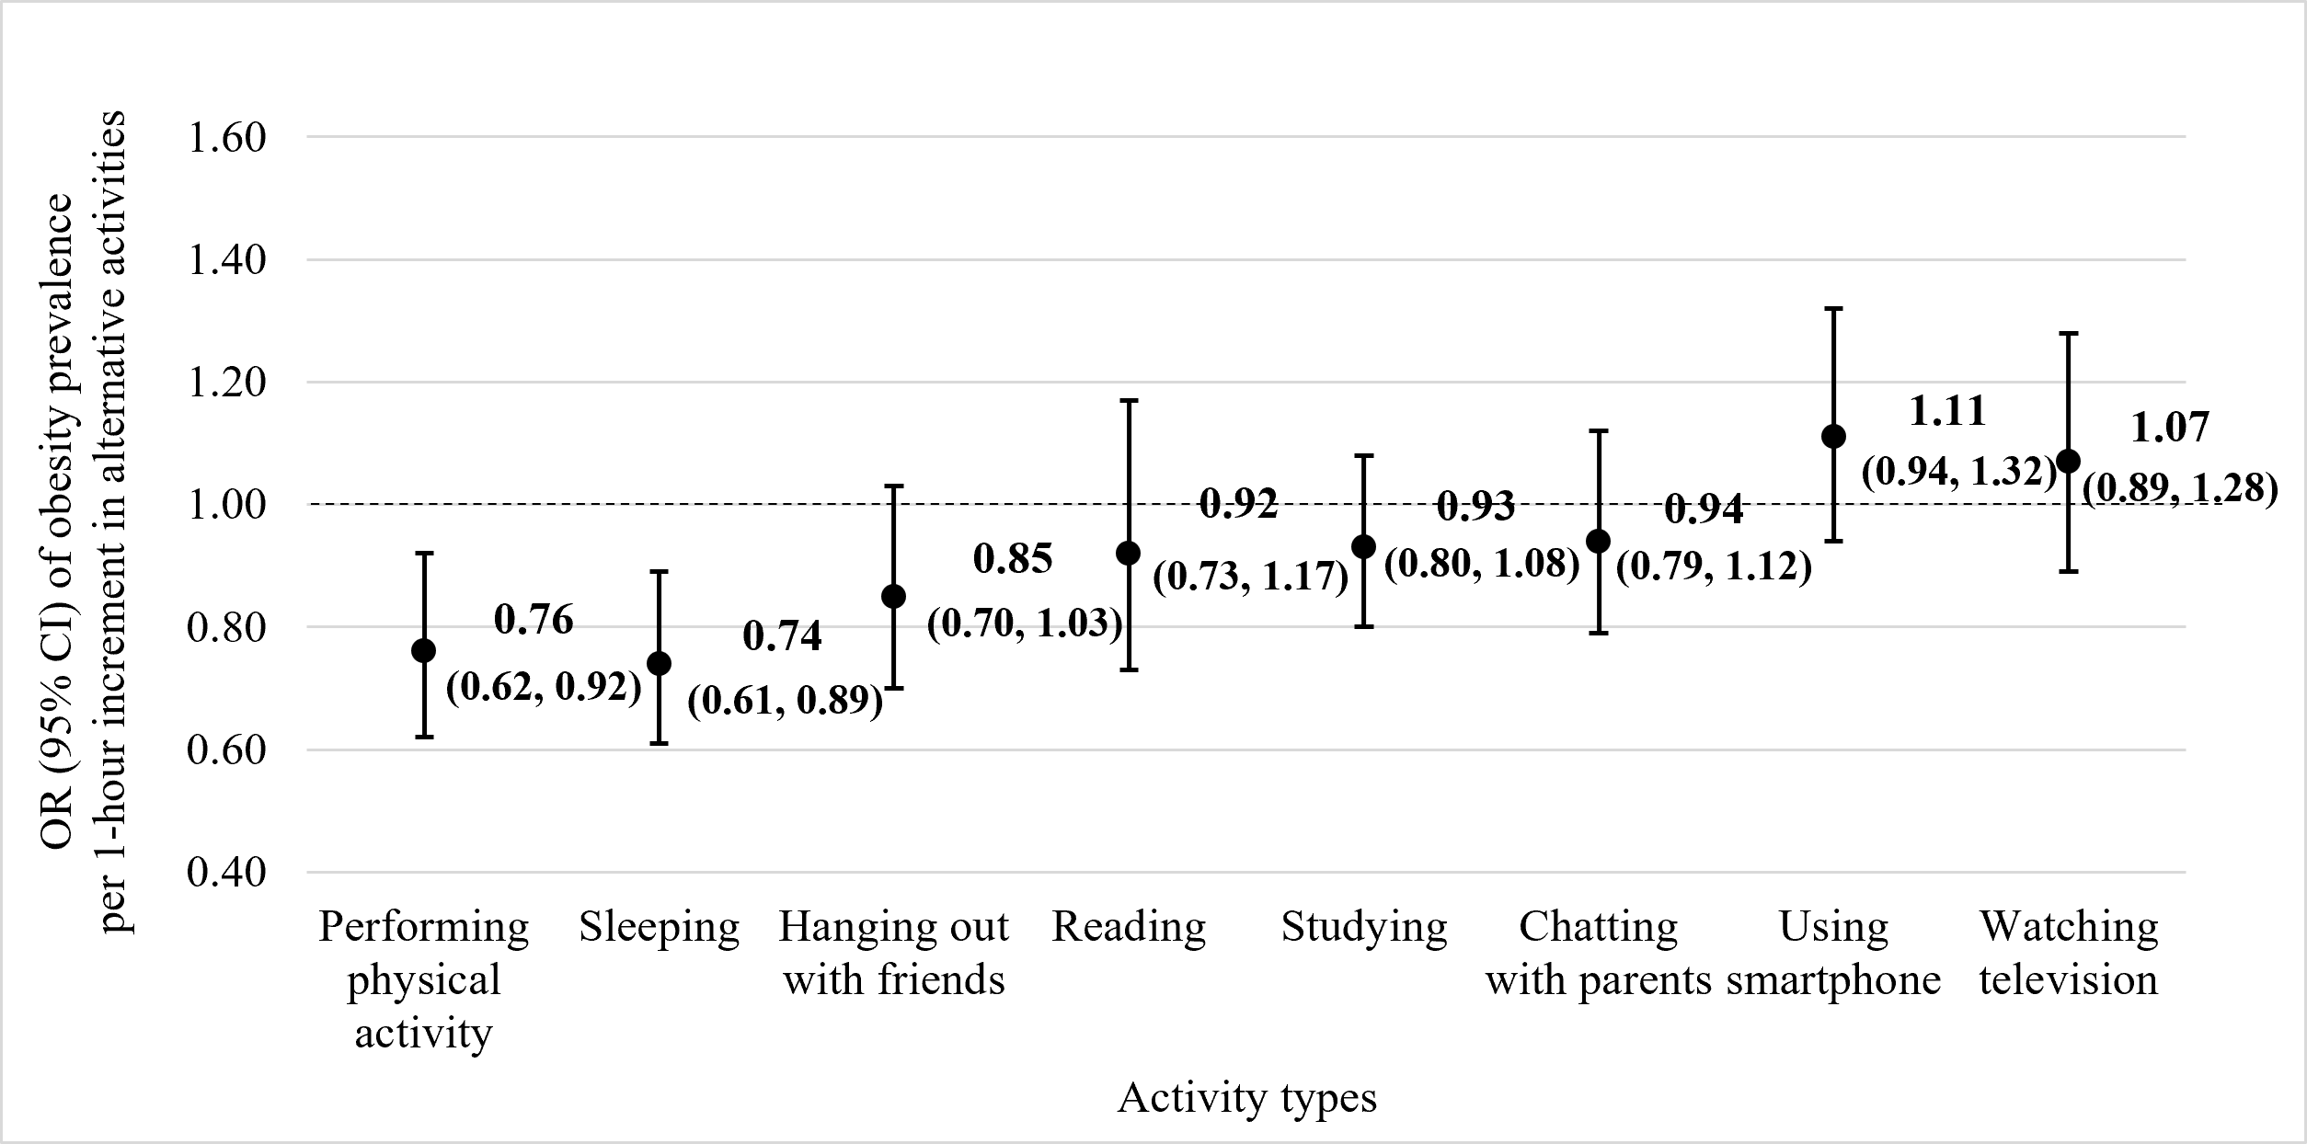 | 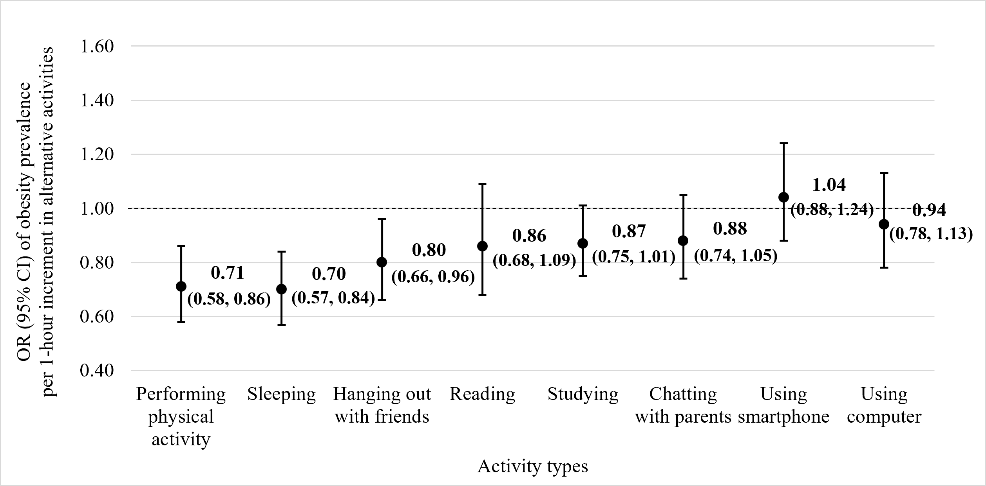

Supplementary Figure 5. Odds ratios (ORs) and 95% confidence intervals (CIs) of obesity prevalence associated with substituting 1-hour of screen time for non-screen time activities among girls
The graphs show the ORs and 95% CIs of obesity prevalence associated with increasing 1-hour of each alternative activity while decreasing 1-hour of (A) combined screen time, (B) smartphone use, (C) computer use, and (D) television watching among girls. Models adjusted for school grade (4th, 7th grade), parental co-residence (none or one parent; both parents), parents’ highest education (high school or lower; college or higher), monthly household income (<2,000,000; 2000,000 to <4,000,000; 4,000,000 to <6,000,000; 6,000,000 to <8,000,000; ≥8,000,000 KRW), academic performance (poor or fair; good; missing), parental psychological control score (continuous), and all alternative after-school activities (sleeping, performing physical activity, hanging out with friends, chatting with parents, studying, reading).
(A) | (B)
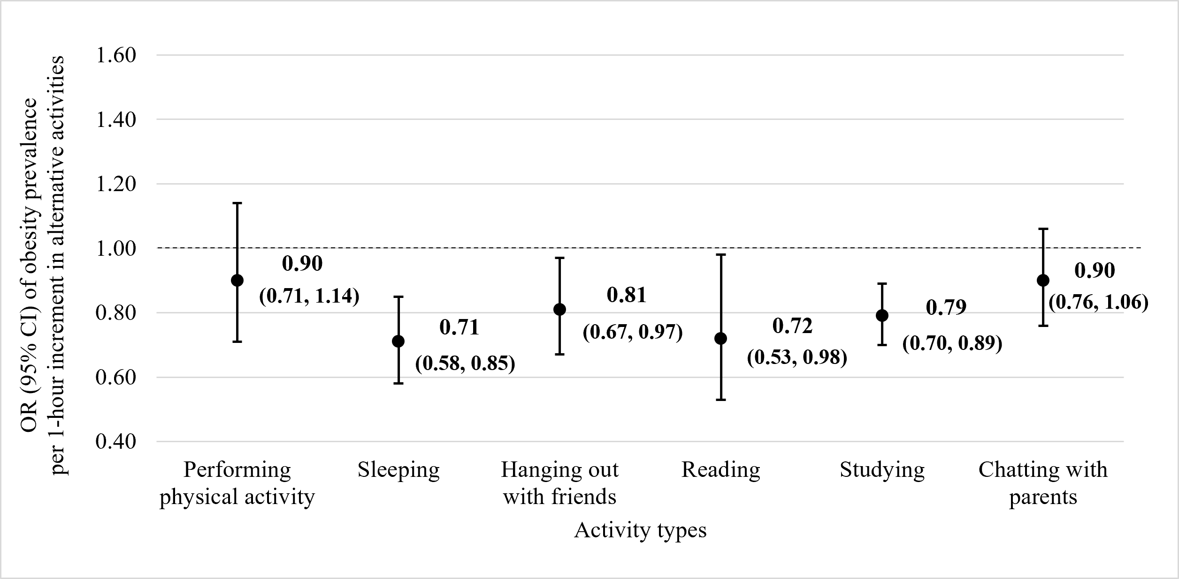 | 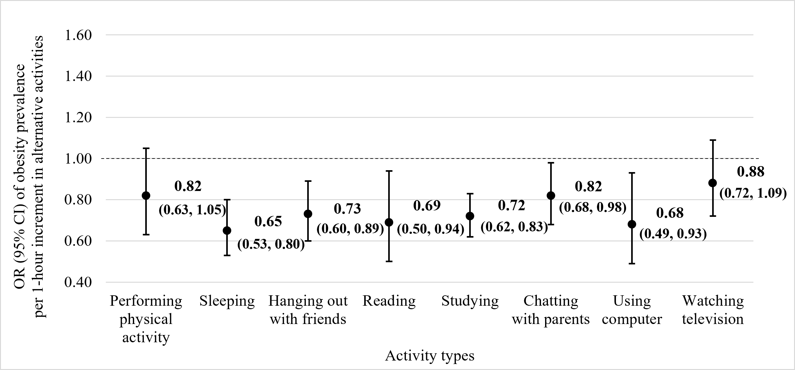
(C) | (D)
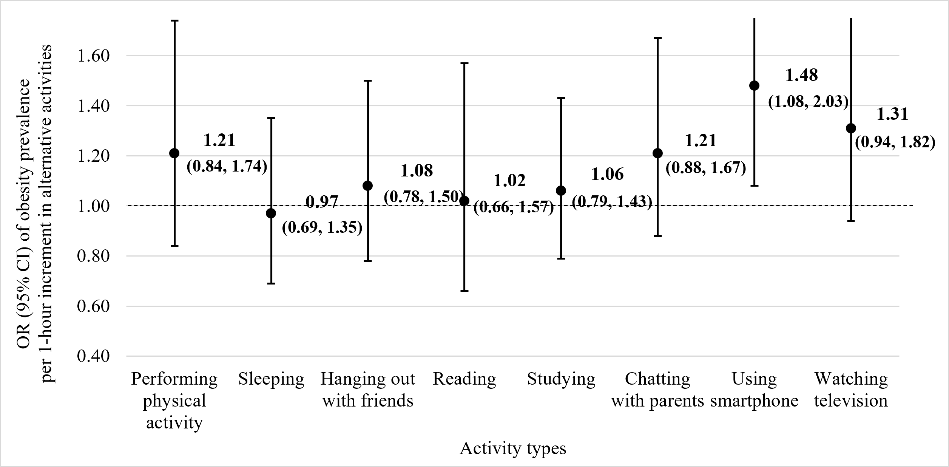 | 