Associations between cardiac arrhythmias and cardiovascular disease incidence and all-cause mortality: the Kailuan Study
Supplementary Material

Table and figure of contents
Supplemental Figure 1. Kaplan-Meier survival curves for incident cardiovascular disease (CVD) and all-cause mortality by atrial fibrillation and heart block
Supplemental Table 1. Association of atrial fibrillation and heart block with risks of cardiovascular disease, and all-cause mortality
Supplemental Table 2. Association of atrial fibrillation and heart block with risks of cardiovascular disease using competing risk model
Supplemental Table 3. Baseline characteristics of the 1:4 propensity score matched cohort for the cardiovascular disease analysis
Supplemental Table 4. Baseline characteristics of the 1:4 propensity score matched cohort for the all-cause mortality analysis
Supplemental Table 5. Cox proportional hazards model analysis of the incidence of endpoint events in the 1:4 propensity score matched cohort

Definitions of heart failure (HF), myocardial infarction (MI) and stroke:
- HF: Fatal HF cases outside the hospitals, we further searched the death certificates from provincial vital statistic offices. HF cases were ascertained when two of experienced cardiologists, blinded to current study protocol, agreed on first occurrence of HF by reviewing medical records. If disagreed, a third cardiologist was invited to give the final adjudication. Fatal HF cases were confirmed by medical records or death certificates with HF listed as the primary cause of death. HF was diagnosed according to 2005 American College of cardiology/American Heart Association Guideline by comprehensively evaluating individual clinical symptoms and signs, limitations during physical activity, biomarkers of cardiac injury and echocardiographic evidences. In the current study, specifically, we only identified case of symptomatic HF patients with New York Heart Association Classification at class II–class IV, with left ventricle ejection fraction (EF) ≤50% (measurement via modified Simpson’s rule) and/or serum level of N-terminal prob-type natriuretic peptide ≥125 pg/L.
- MI: MI was defined based on cardiac enzymes (i.e., levels of creatine kinase and troponin T or I), symptoms, electrocardiographic signs, and necropsy . Fatal MI, including sudden cardiac death due to cardiac arrest, was confirmed by hospital records or death certificates listing CHD or MI as the main cause of death.
Stroke incidence was ascertained from 4 complementary sources: (1) Municipal Social Insurance Institution which covered all study participants, (2) Hospital Discharge Register centers, (3) death certificates, and (4) questionnaire survey (biennially since 2006).
- Stroke: Potential stroke cases included those who were identified by the ninth and tenth revision of International Classification of Diseases based on the first three sources or those who self-reported in questionnaire survey. According to the World Health Organization criteria combined with a brain computed tomography or magnetic resonance imaging scans, three cardiologist and neurologists reviewed the medical records to confirm the stroke diagnosis. Nonfatal strokes were defined as the sudden onset of focal neurological deficit with vascular mechanism lasting >24 hours. Fatal stroke cases were confirmed by medical records, autopsy reports or death certificates, with stroke as the underlying cause of death. In the current study, only included were cerebral infarction and intracerebral hemorrhage, and not included were epidural, subdural, or subarachnoid hemorrhage.

Measurement of blood pressure
Blood pressure measurements were performed by specially trained health care workers. Smoking, drinking tea and coffee were not allowed within 30 minutes before blood pressure measurement, and the patients were seated with their back for 15 minutes. The measurements were repeated with a mercury blood pressure meter at intervals of 1 to 2 minutes according to the operating standards. After 2014, blood pressure was measured by Omron HBP-1300 electronic sphygmomanometer.
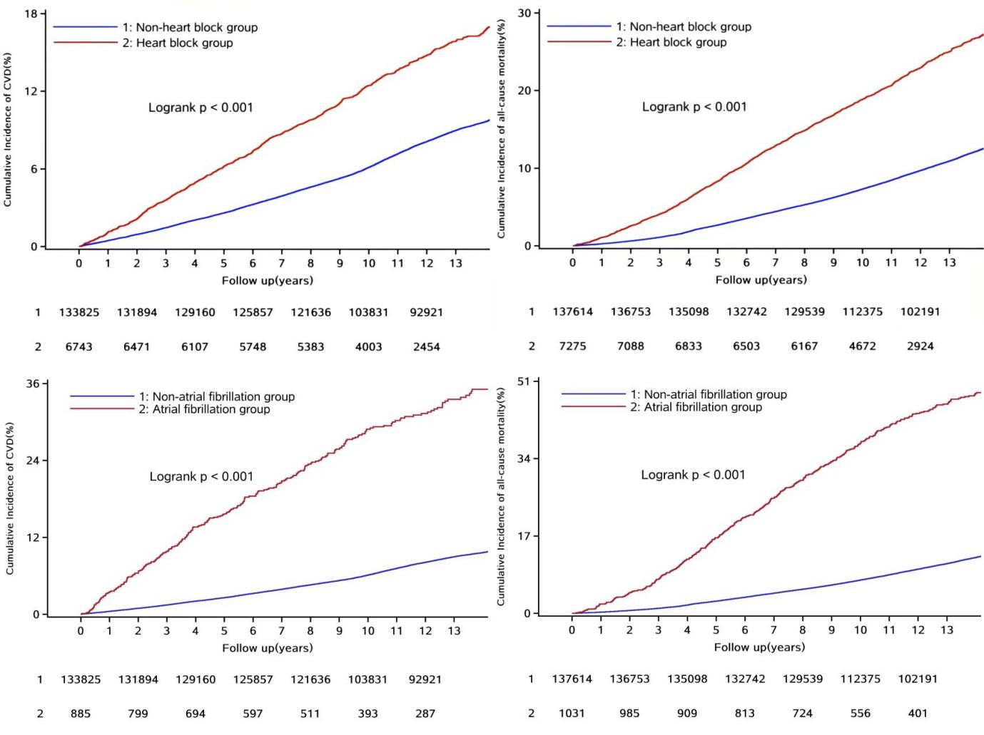
Supplemental Figure 1. Kaplan-Meier survival curves for incident cardiovascular disease (CVD) and all-cause mortality by atrial fibrillation and heart block

Supplemental Table 1. Association of atrial fibrillation and heart block with risks of cardiovascular disease, and all-cause mortality
Sensitive analyses | Arrhythmia status | Events/total population | Cardiovascular disease |  | Events/total population | All-cause mortality
Sensitive analyses | Arrhythmia status | Events/total population | HR (95%CI) | P | Events/total population | HR (95%CI) | P
Excluded patients with follow-up time less than 2 years | Non-arrhythmia | 10,816/131,894 | Ref |  | 15,337/136,753 | Ref
Excluded patients with follow-up time less than 2 years | Atrial fibrillation | 195/799 | 1.92 (1.66-2.23) | <0.01 | 425/979 | 1.70 (1.54-1.87) | <0.01
Excluded patients with follow-up time less than 2 years | Heart block | 776/6471 | 1.25 (1.16-1.35) | <0.01 | 1494/7087 | 1.24 (1.18-1.31) | <0.01
Excluded patients with pre-excitation syndrome | Non-arrhythmia | 12,045/133,557 | Ref |  | 16,170/137,339 | Ref
Excluded patients with pre-excitation syndrome | Atrial fibrillation | 250/884 | 2.10 (1.85-2.39) | <0.01 | 477/1030 | 1.76 (1.61-1.93) | <0.01
Excluded patients with pre-excitation syndrome | Heart block | 917/6717 | 1.27 (1.18-1.35) | <0.01 | 1679/7249 | 1.31 (1.24-1.38) | <0.01
Excluded patients with taking drugs | Non-arrhythmia | 6371/103,699 | Ref |  | 10,600/105,105 | Ref
Excluded patients with taking drugs | Atrial fibrillation | 135/541 | 2.20 (1.85-2.62) | <0.01 | 283/604 | 1.68 (1.49-1.89) | <0.01
Excluded patients with taking drugs | Heart block | 498/4680 | 1.30 (1.19-1.43) | <0.01 | 990/4889 | 1.20 (1.12-1.28) | <0.01
Excluded patients with Cardiac pacemaker | Non-arrhythmia | 12,049/133,696 | Ref |  | 16,179/137,508 | Ref
Excluded patients with Cardiac pacemaker | Atrial fibrillation | 250/884 | 2.10 (1.85-2.39) | <0.01 | 475/1024 | 1.77 (1.62-1.95) | <0.01
Excluded patients with Cardiac pacemaker | Heart block | 917/6734 | 1.27 (1.18-1.35) | <0.01 | 1677/7242 | 1.31 (1.25-1.38) | <0.01
HRs were adjusted for age, sex, smoking, drinking, physical activity, education, body mass index, hypertension, diabetes, high-density lipoprotein cholesterol, low-density lipoprotein cholesterol, estimated glomerular filtration rate, high-sensitivity C-reactive protein, family history of cardiovascular disease, cardiovascular disease (only for all-cause mortality), hypotensive drugs, hypoglycemic drugs, lipid-lowering drugs, and antiplatelet drugs.

Supplemental Table 2. Association of atrial fibrillation and heart block with risks of cardiovascular disease using competing risk model
Arrhythmia status | HR (95%CI) | P
Non-arrhythmia | Ref
Atrial fibrillation | 2.11 (1.86-2.40) | <0.01
Heart block | 1.26 (1.18-1.35) | <0.01
HRs were adjusted for age, sex, smoking, drinking, physical activity, education, body mass index, hypertension, diabetes, high-density lipoprotein cholesterol, low-density lipoprotein cholesterol, estimated glomerular filtration rate, high-sensitivity C-reactive protein, family history of cardiovascular disease, hypotensive drugs, hypoglycemic drugs, lipid-lowering drugs, and antiplatelet drugs.

Supplemental Table 3. Baseline characteristics of the 1:4 propensity score matched cohort for the cardiovascular disease analysis
Variables | Non-atrial fibrillation  (n=3540) | Atrial fibrillation  (n=885) | Standardized  difference | Non-heart block (n=26,972) | Heart block (n=6743) | Standardized  difference
Men n (%) | 3132 (88.5) | 787 (88.9) | -0.013 | 24,286 (90.0) | 6091 (90.3) | -0.008
Age (Years) | 64.14 ± 11.37 | 64.0 ± 11.2 | -0.012 | 56.62 ± 13.38 | 56.6 ± 13.5 | -0.001
Current smoking n (%) | 939 (26.5) | 231 (26.1) | 0.009 | 9442 (35.0) | 2392 (35.5) | -0.009
Current drinking n (%) | 1029 (29.1) | 252 (28.5) | 0.013 | 9933 (36.8) | 2487 (36.9) | -0.001
Higher education n (%) | 229 (6.47) | 62 (7.01) | -0.017 | 2759 (10.2) | 680 (10.1) | 0.004
Physical exercise n (%) | 777 (21.95) | 191 (21.6) | 0.010 | 4970 (18.4) | 1236 (18.3) | 0.003
BMI kg/m² | 25.59 ± 3.58 | 25.6 ± 3.78 | -0.003 | 25.2 ± 3.45 | 25.2 ± 3.61 | -0.001
LDL-c mmol/L | 2.25 ± 0.93 | 2.24 ± 0.99 | -0.004 | 2.32 ± 0.90 | 2.32 ± 0.93 | 0.004
HDL-c mmol/L | 1.55 ± 0.43 | 1.54 ± 0.42 | -0.017 | 1.54 ± 0.43 | 1.54 ± 0.41 | -0.003
CRP mg/L | 1.60 (0.60-3.39) | 1.50 (0.60-3.75) | 0.031 | 1.20 (0.46-2.60) | 1.10 (0.41-2.90) | 0.000
eGFR mL/min | 75.4 ± 18.6 | 75.07 ± 19.7 | -0.017 | 81.4 ± 20.7 | 81.5 ± 21.6 | 0.002
Hypertension n (%) | 2197 (61.6) | 546 (61.7) | -0.003 | 13,460 (49.9) | 3358 (49.8) | 0.002
Diabetes n (%) | 812 (22.9) | 196 (22.2) | -0.020 | 5138 (19.1) | 1276 (18.9) | -0.003
Hypotensive drugs n (%) | 1234 (34.9) | 317 (35.8) | -0.022 | 7230 (26.8) | 1802 (26.7) | 0.002
Lipid lowing treatment n (%) | 117 (3.31) | 32 (3.62) | -0.018 | 811 (3.01) | 201 (2.98) | 0.002
Hypoglycemic drugs n (%) | 377 (10.7) | 86 (9.72) | 0.034 | 2419 (8.97) | 601 (8.91) | 0.002
Antiplatelet drugs n (%) | 26 (0.73) | 7 (0.79) | -0.007 | 171 (0.63) | 45 (0.67) | -0.004
Family history of CVD n (%) | 281 (7.94) | 71 (8.02) | -0.003 | 2611 (9.68) | 660 (9.79) | -0.004
Data are presented as mean ± SD, median (IQR) or N (%).
Abbreviations: BMI, body mass index; CRP, C-reactive protein; CVD, cardiovascular disease; eGFR, estimated glomerular filtration rate; HDL-C, high density lipoprotein cholesterol; LDL-C, low density lipoprotein cholesterol.

Supplemental Table 4. Baseline characteristics of the 1:4 propensity score matched cohort for the all-cause mortality analysis
 | Non-atrial fibrillation (n=4124) | Atrial fibrillation (n=1013) | Standardized  difference | Non-heart block (n=29,100) | Heart block (n=7275) | Standardized  difference
Male n (%) | 3631 (88.1) | 909 (88.2) | -0.003 | 26,356 (90.6) | 6596 (90.7) | -0.003
Age (Years) | 64.4 ± 11.1 | 64.2 ± 11.1 | -0.012 | 57.29 ± 13.25 | 57.3 ± 13.5 | -0.003
Current smoking n (%) | 1036 (25.1) | 266 (25.8) | -0.015 | 10,287 (35.4) | 2596 (35.7) | -0.007
Current drinking n (%) | 1148 (27.8) | 289 (28.0) | -0.004 | 10,562 (36.3) | 2668 (36.7) | -0.008
Higher education n (%) | 271 (6.57) | 72 (7.11) | -0.013 | 2860 (9.83) | 712 (9.79) | 0.001
Physical exercise n (%) | 957 (23.2) | 228 (22.1) | 0.028 | 5531 (19.0) | 1394 (19.2) | -0.004
BMI kg/m² | 25.6 ± 3.54 | 25.6 ± 3.74 | -0.009 | 25.19 ± 3.42 | 25.2 ± 3.61 | 0.004
LDL-c mmol/L | 2.26 ± 0.90 | 2.24 ± 0.98 | -0.021 | 2.32 ± 0.90 | 2.32 ± 0.94 | 0.003
HDL-c mmol/L | 1.54 ± 0.44 | 1.54 ± 0.44 | 0.000 | 1.54 ± 0.43 | 1.54 ± 0.42 | -0.001
CRP mg/L | 1.56 (0.60-3.51) | 1.58 (0.61-3.75) | 0.024 | 1.20 (0.49-2.70) | 1.15 (0.42-1.75) | 0.006
eGFR mL/min | 75.1 ± 18.1 | 74.7 ± 19.9 | -0.022 | 80.89 ± 20.74 | 80.87 ± 21.44 | -0.001
Hypertension n (%) | 2558 (62.0) | 644 (62.5) | -0.009 | 14,979 (51.5) | 3748 (51.5) | 0.001
Diabetes n (%) | 974 (23.6) | 238 (23.1) | -0.014 | 5619 (19.3) | 1418 (19.5) | 0.000
Hypotensive drugs n (%) | 1605 (38.9) | 395 (38.3) | 0.014 | 8360 (28.3) | 2091 (28.7) | 0.002
Lipid lowing treatment n (%) | 175 (4.24) | 45 (4.44) | -0.007 | 1011 (3.47) | 253 (3.48) | 0.000
Hypoglycemic drugs n (%) | 456 (11.1) | 106 (10.3) | 0.028 | 2776 (9.53) | 688 (9.46) | 0.003
Antiplatelet drugs n (%) | 49 (1.19) | 12 (1.18) | 0.003 | 204 (0.70) | 45 (0.62) | -0.005
Cardiovascular disease | 1353 (32.8) | 346 (33.6) | -0.019 | 4709 (16.2) | 1173 (16.1) | 0.002
Family history of CVD n (%) | 370 (8.97) | 91 (8.98) | 0.005 | 2874 (9.88) | 729 (10.0) | -0.005
Data are presented as mean ± SD, median (IQR) or N (%).
Abbreviations: BMI, body mass index; CRP, C-reactive protein; CVD, cardiovascular disease; eGFR, estimated glomerular filtration rate; HDL-C, high density lipoprotein cholesterol; LDL-C, low density lipoprotein cholesterol.

Supplemental Table 5. Cox proportional hazards model analysis of the incidence of endpoint events in the 1:4 propensity score matched cohort
Outcome | Arrhythmia status | Case | HR (95%CI)
Cardiovascular disease | Non- atrial fibrillation | 611 | Ref
Cardiovascular disease | Atrial fibrillation | 251 | 2.10 (1.81-2.43)
Cardiovascular disease | Non-heart block | 3566 | Ref
Cardiovascular disease | Heart block | 918 | 1.25 (1.16-1.34)
Myocardial infarction | Non- atrial fibrillation | 75 | Ref
Myocardial infarction | Atrial fibrillation | 20 | 1.22 (0.73-2.02)
Myocardial infarction | Non-heart block | 558 | Ref
Myocardial infarction | Heart block | 115 | 0.98 (0.80-1.20)
Stroke | Non- atrial fibrillation | 381 | Ref
Stroke | Atrial fibrillation | 111 | 1.51 (1.22-1.87)
Stroke | Non-heart block | 2186 | Ref
Stroke | Heart block | 555 | 1.26 (1.14-1.38)
Hemorrhagic stroke | Non- atrial fibrillation | 69 | Ref
Hemorrhagic stroke | Atrial fibrillation | 19 | 1.37 (0.82-2.28)
Hemorrhagic stroke | Non-heart block | 324 | Ref
Hemorrhagic stroke | Heart block | 91 | 1.28 (1.01-1.62)
Ischemic stroke | Non- atrial fibrillation | 318 | Ref
Ischemic stroke | Atrial fibrillation | 95 | 1.57 (1.25-1.98)
Ischemic stroke | Non-heart block | 1896 | Ref
Ischemic stroke | Heart block | 477 | 1.27 (1.15-1.40)
Heart failure | Non- atrial fibrillation | 170 | Ref
Heart failure | Atrial fibrillation | 127 | 3.84 (3.05-4.84)
Heart failure | Non-heart block | 897 | Ref
Heart failure | Heart block | 258 | 1.33 (1.15-1.52)
All-cause mortality | Non- atrial fibrillation | 1366 | Ref
All-cause mortality | Atrial fibrillation | 477 | 1.79 (1.61-1.99)
All-cause mortality | Non-heart block | 6358 | Ref
All-cause mortality | Heart block | 1682 | 1.32 (1.25-1.40)

